**第一段：描述图表**

**图表（graph/diagram）包括柱状图（bar/column chart）、表格（table）、饼状图（pie chart）、折线图（line chart）、曲线图（curve chart）、流程图（flow chart）、组图（a set of charts）等。**

**graph / diagram**

**increase rise grow climb go up ascend**

**soar surge leap**

**decrease fall reduce decline descend diminish**

**drop plunge crash**

**fluctuate vary wave range**

**fluctuation variation**

**remain stay keep stabilize**

**steady stable constant**

**the trend of**

**sharply rapidly dramatically at a considerably rate**

**slightly steadily modestly**

**respectively 分别地**

**reach the peak of**

**register the bottom of**

**account for / take up / occupy the largest proportion/percentage/number of**

**rank the second**

**comprise / consist of / compose / constitute**

**about / around / approximately**

**expect / predict / forecast**

**display / demonstrate / illustrate / indicate / depict**

**5种句型**

**1. 动词 + 副词 ：**

**increased/grew/rose sharply/rapidly/dramatically**

**2. There was a + 形容词 + 名词 + in + 描述对象 + 时间：**

**There was a sharp/rapid/dramatic increase/growth/rise**

**3. 时间 + saw/experienced/witnessed a + 形容词 + 名词：**

**A 10-year period saw a sharp/rapid/dramatic increase/growth/rise in**

**4. A + 形容词 + 名词 + took place/occurred + in + 描述对象+ 时间：**

**A sharp/rapid/dramatic increase/growth/rise took place in**

**第二段：说明图表数据增长or下降的原因。**

**1. 表述原因总起句**

**There are many reasons explaining this phenomenon.**

**2. 分条描述原因**

**（主要原因）The main reason is that due to (the progress in economy / the improvement of living standards), a growing number of people ……  
（第二个原因）What is more, there is no doubt in saying that , with (the pace of modern society speeding up / the advance of technology) , a majority of people （try their best to catch up with the times and improve themselves） by （pursuing further education）.  
（第三个原因）Thirdly , (under the background of modernization / with the rapid development of economy and society) , xx may have gradually become an unstoppable trend（趋势）in recent years.**

**3. 形容大环境常用的表达方式**

**with the progress in economy**

**with the improvement of living standards**

**with the pace of modern society speeding upwith the advance of technologywith the rapid development of economy and society  
under the background of modernization / urbanization / industrialization**

**第三段：表达自己对此现象的看法以及面对此现象我们该怎么去做。**

**积极的：Considering all these, I believe that we should take a reasonable attitude toward  xx. In conclusion, from my point of view, such a phenomenon is （positive） and （acceptable）.**

**积极的：Taking into account what has been argued so far, it is not surprising to see the results in the above diagram. Thus, such phenomenon proves to be quite normal and acceptable. And I believe the trend will not change in the near future.**

**积极的：Definitely, the boom of (the mobile industry) tends to exert a beneficial influence on people’s lives, and hence, it should be, from every aspect, encouraged and further advocated.**

**消极的：In view of the description and analysis above, I’m convinced that actions have to be taken to cope with the problems arising from ……**

**趋势预测：From what has been discussed above, a trend can be predicted from the chart that ……**

**趋势预测：XX will be a growing trend in today's （busy） society.**

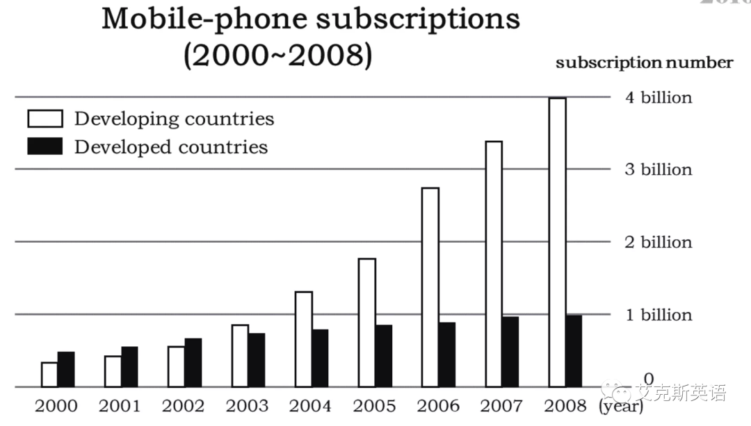

**The bar chart conveys to us the contrast between developing and developed countries in terms of mobile-phone subscriptions from the year 2000 to 2008. We cannot fail to see that a striking increase has taken place in developing countries since 2000, growing from half a billion to four billion in 2008. Meanwhile, it is also not difficult to find that the increase rate of developed countries is not as fast as that of developing countries - no more than 1 billion.**

**Three major reasons give rise to the phenomenon mentioned above. In the first instance, due to the improvement of living standards, a growing number of people in developing countries are able to afford mobile phones. What’s more, the advance of technology has lowered the price of mobile phones. In reference to the developed countries, the small population and relatively saturated market restrict the rapid increase.**

**From what has been discussed above, a trend can be predicted from the chart that with the rapid development of economy and society, mobile-phone subscriptions in developing countries will probably continue to go up in the following years, and that the rising rate will be higher than that of developed countries. Definitely, the boom of the mobile industry tends to exert a beneficial influence on people’s lives, and hence, it should be, from every aspect, encouraged and further advocated.**

