|  |  |  |  |
| --- | --- | --- | --- |
| **STUDENT USE** | | **STAFF USE** | |
| Module Name | Internet of Things | First Marker’s  (acts as signature) |  |
| Module Code | 6COSC014C | Second Marker’s  (acts as signature) |  |
| Lecturer Name | Shirin Primkulova | Agreed Mark |  |
| UoW Student IDs | 18162204/1 | **For Registrar’s office use only (hard copy submission)** | |
| WIUT Student IDs | 00011622 |
| Deadline date | 01.12.2023 |
| Assignment Type | Individual |

**COURSEWORK SUBMISSION FORM**

**SUBMISSION INSTRUCTIONS**

**COURSEWORKS *must* be submitted in *both* HARD COPY (to the Registrar’s Office) *and* ELECTRONIC unless instructed otherwise.**

For hardcopy submission instructions refer to: <http://intranet.wiut.uz/Shared%20Documents/Forms/AllItems.aspx> - Coursework hard copy submission instructions.doc

For online submission instructions refer to: <http://intranet.wiut.uz/Shared%20Documents/Forms/AllItems.aspx> - Coursework online submission instructions.doc

|  |
| --- |
| **MARKERS FEEDBACK** |
|  |

Table of Contents

Introduction 3

Objectives and Scope 3

Limitations and Opportunities for Improvement 4

Addressing the Shortcomings 4

Proposed Solution 5

Conceptual Design 5

Enhanced User Experience 5

Cost-Effective and Sustainable Approach 6

Flexibility and Scalability 6

Detailed Component Description 7

Cost Analysis and Comparison 7

Implementation 7

Circuit Design and Setup 8

Programming the Arduino Nano 8

Integration with ESP8266 NodeMCU 8

Creating the LED Effects 9

Reflection and Future Work 9

Reflection on Project Outcomes 10

Limitations and Challenges 10

Future Work 10

Conclusion 11

Bibliography 11

# Introduction

The concept of smart homes and interconnected devices has been steadily gaining momentum, reshaping how we interact with our living and working spaces. In this evolving landscape, the role of lighting has transcended mere functionality, becoming an integral part of home aesthetics, personal comfort, and energy management. Recognizing this shift, this project was initiated to explore the potential of IoT in enhancing lighting solutions. The inspiration was drawn from existing products like the **Xiaomi Yeelight**, which have set benchmarks in smart lighting but come with limitations, particularly in terms of cost and customizable effects.

### Objectives and Scope

The primary objective of this project was to design and develop an IoT-based desk lamp that not only addresses the limitations of existing products but also introduces unique features that enhance user interaction and experience. The scope of the project included:

1. **Designing a customizable lighting solution**: Developing a lamp that offers a range of lighting effects, going beyond basic brightness adjustment and color change.
2. **Incorporating intuitive control mechanisms**: Utilizing a touch sensor for ease of use, and providing remote control capabilities through a web interface.
3. **Achieving cost-effectiveness**: Constructing the lamp with affordable components and repurposed materials to keep the overall cost low.
4. **Ensuring sustainability**: Considering environmental impact through the choice of materials and energy-efficient LED technology.

This project aimed not just to create a functional lighting device but to craft an experience that resonates with the modern user's desire for technology that is both interactive and harmonious with their lifestyle. The following sections of this report detail the journey from conceptualization to realization of this IoT desk lamp, highlighting the innovative approaches taken in design, component selection, and implementation.

Case Study: Comparison with Xiaomi Yeelight

Xiaomi Yeelight stands as a prominent example in the smart lighting industry, renowned for its sleek design, color-changing capabilities, and smart home integration. It offers users control via smartphone apps and is compatible with various home automation systems. Despite its advanced features, the Yeelight has certain limitations, particularly in terms of its price point and the range of customizable lighting effects it offers.

### Limitations and Opportunities for Improvement

The Xiaomi Yeelight, while innovative, presents a few areas where enhancements are desirable:

1. **Cost**: One of the significant barriers to the widespread adoption of the Yeelight is its cost. A more budget-friendly alternative could make smart lighting accessible to a broader audience.
2. **Customizable Effects**: The Yeelight provides basic color changes and dimming options. However, it lacks the ability to display more complex and dynamic lighting patterns, which can enhance the aesthetic appeal and user interaction.
3. **Material and Design Flexibility**: The Yeelight's design, while modern, doesn't offer much in the way of customization or personalization in terms of physical appearance.

### Addressing the Shortcomings

In response to these limitations, this project was envisioned to offer an alternative that not only matches the capabilities of the Yeelight but also introduces additional features:

1. **Enhanced Lighting Effects**: By using an addressable WS2812b LED strip, this project extends the range of possible lighting effects, including intricate patterns and animations, which are not feasible with the standard RGB LEDs used in the Yeelight.
2. **Cost-Effective Design**: The project utilizes cost-effective components like the Arduino Nano and a repurposed container for the lamp’s body, significantly reducing the overall expense compared to the Yeelight.
3. **Intuitive Physical Interaction**: The incorporation of a TTP223 touch sensor adds a layer of physical interaction, making the lamp more user-friendly and accessible than app-only control schemes.
4. **Open Source and Customizable**: Unlike the proprietary nature of the Yeelight, this project is built on open-source technology, allowing for greater customization and adaptability in both hardware and software aspects.

This comparison highlights how this IoT desk lamp project not only addresses the gaps in current smart lighting solutions but also pushes the boundaries in terms of cost, customization, and user experience. The subsequent sections will delve deeper into the technicalities of the proposed solution, demonstrating how these improvements are practically implemented.

# Proposed Solution

In addressing the identified needs and limitations in the current smart lighting market, this project proposes a unique and innovative solution. The primary focus is on enhancing user experience, accessibility, and customization, while maintaining affordability.

### Conceptual Design

The proposed IoT desk lamp is a fusion of technology and user-centric design. It features a WS2812b LED strip, known for its ability to individually control each LED, thus providing an expansive range of lighting effects far surpassing those of conventional smart lamps like the Xiaomi Yeelight. This capability allows for the creation of dynamic, customizable light patterns and animations, enhancing the aesthetic appeal and functionality of the lamp.

In addition to the advanced lighting features, the lamp incorporates a TTP223 touch sensor. This sensor facilitates intuitive and effortless control, allowing users to switch the lamp on and off, change modes, or adjust brightness with a simple touch. This physical interaction is an essential aspect of the design, providing a more tactile and immediate response compared to app-based controls.

### Enhanced User Experience

The integration of the ESP8266 NodeMCU module adds another dimension of functionality to the lamp. It enables the lamp to connect to a WiFi network, allowing users to control it remotely via a custom-developed web interface. This feature not only adds convenience but also allows the lamp to be integrated into broader smart home systems.

### Cost-Effective and Sustainable Approach

A significant aspect of the proposed solution is its cost-effectiveness. By employing readily available and affordable components such as the Arduino Nano and ESP8266 NodeMCU, the project keeps costs substantially lower than commercial alternatives. Moreover, the innovative use of a repurposed bulk product container for the housing of the lamp not only reduces material costs but also demonstrates a commitment to sustainability.

### Flexibility and Scalability

The open-source nature of the project's technology stack ensures that the lamp is not just a static product but a platform for continuous development and customization. Users with technical know-how can modify or extend the lamp's capabilities, tailoring it to their specific needs or preferences.

To sum up, proposed IoT desk lamp represents a significant step forward in smart home lighting solutions. It offers an array of features and functionalities that are not only on par with existing products like the Xiaomi Yeelight but also introduces new elements that enhance user experience, customization, and accessibility, all while maintaining an affordable price point.

System Design and Components

The IoT desk lamp is engineered with a blend of simplicity and sophistication in its system design, using a combination of carefully selected components. Each component plays a crucial role in ensuring the lamp’s functionality, affordability, and user-friendliness.

The lamp's design centers around two main components: the control unit and the lighting unit. The control unit comprises an Arduino Nano and an ESP8266 NodeMCU, responsible for processing inputs and managing wireless communications. The lighting unit is driven by a WS2812b LED strip, known for its vibrant colors and programmability.

### Detailed Component Description

1. **Arduino Nano**: This compact microcontroller serves as the brain of the lamp. It manages the LED strip, processes inputs from the touch sensor, and communicates with the ESP8266 for remote operations.
2. **TTP223 Touch Sensor**: This capacitive touch sensor enhances the lamp's interactivity, allowing users to control the lamp through simple touch gestures. Its integration provides a modern and intuitive user interface.
3. **Resistor 220 Ohm**: A crucial component in protecting the circuit, the resistor ensures the safe operation of the touch sensor with the Arduino Nano, preventing potential damage from overcurrent.
4. **ESP8266 NodeMCU**: This WiFi module enables the lamp to connect to the internet, facilitating remote control through a web interface. It communicates with the Arduino Nano to relay user commands from the web interface to the lamp's control system.
5. **WS2812b LED Strip**: The centerpiece of the lamp’s lighting system, this strip allows for individual control of each LED, enabling a wide array of customizable lighting effects that surpass traditional RGB LED capabilities.

### Cost Analysis and Comparison

The overall cost of the components was kept to a minimum by selecting affordable yet reliable parts. The use of a repurposed container for the housing further reduced the cost, making the lamp significantly more economical than commercial alternatives like the Xiaomi Yeelight, without compromising on functionality or aesthetic appeal.

# Implementation

The implementation of the IoT desk lamp involved a meticulous process, encompassing the assembly of hardware components, programming of the microcontrollers, and integration of the entire system to function cohesively.

### Circuit Design and Setup

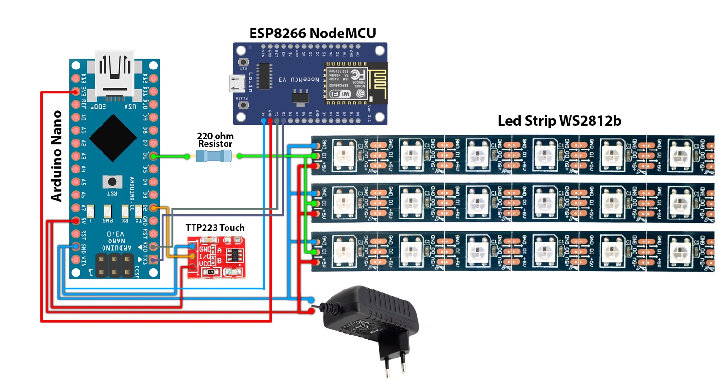The circuitry of the lamp is centered around the Arduino Nano, which controls the WS2812b LED strip and interprets input from the TTP223 touch sensor. The 220-ohm resistor is used in line with the touch sensor to ensure stable operation. The ESP8266 NodeMCU is integrated into the system for its WiFi capabilities, enabling remote access and control

### Programming the Arduino Nano

The Arduino Nano is programmed to control the lighting effects of the LED strip and to respond to touch inputs from the TTP223 sensor. The code includes various lighting patterns, as well as logic for adjusting brightness and switching between modes based on touch inputs.

Main Control Logic:

if (touchSensor.isTouched()) {

   changeMode();

   updateLEDStrip();

}

​

This snippet illustrates the responsiveness of the lamp to touch inputs, triggering changes in lighting modes.

### Integration with ESP8266 NodeMCU

The ESP8266 NodeMCU runs a simple web server, presenting a user interface for remote control. It interprets user commands received over WiFi and communicates them to the Arduino Nano.

Web Server Setup:

server.on("/", handleRoot);

server.on("/change_mode", []() {

   sendCommandToArduino('mode');

   server.send(200, "text/plain", "Mode Changed");

});

​

This snippet shows the basic setup for handling HTTP requests, allowing users to change the lamp's mode through the web interface.

### Creating the LED Effects

The WS2812b LED strip is programmed to display a variety of effects, from simple color changes to complex animations. The Arduino's code includes functions to create these effects, dynamically changing the LEDs based on the current mode.

Example LED Effect:

void rainbowEffect() {

   for(int i = 0; i < NUM_LEDS; i++) {

       leds[i] = Wheel((i + counter) & 255);

  }

   FastLED.show();

   counter++;

}

​

The implementation phase of the IoT desk lamp project successfully brought together various components and technologies to create a fully functional and interactive lighting device. The seamless integration of hardware and software components not only demonstrates the technical feasibility of the project but also highlights the potential of IoT in enhancing everyday objects with added functionality and user engagement.

# Reflection and Future Work

Reflecting on the IoT desk lamp project reveals a journey filled with learning, innovation, and the successful merging of technology with user-centric design. This project not only achieved its objectives but also opened avenues for future enhancements.

### Reflection on Project Outcomes

The successful completion of this project demonstrated the potential of integrating IoT technologies into everyday objects. Key achievements include:

* **Innovation in Lighting**: The project pushed the boundaries of traditional desk lamps, introducing dynamic and customizable lighting.
* **User-Centric Design**: By integrating touch and remote web-based controls, the lamp was made more accessible and user-friendly.
* **Cost-Effectiveness and Sustainability**: Using affordable components and a repurposed container, the project highlighted how sustainable practices can be incorporated into technology projects.

### Limitations and Challenges

While the project met most of its goals, certain limitations were encountered:

* **Hardware Constraints**: The current design has limitations in terms of scalability and integration with broader smart home systems.
* **Design Aesthetics**: While functional, the use of a repurposed container might not appeal to all users, particularly those seeking a more polished look.

### Future Work

Looking ahead, there are several exciting directions in which this project can be expanded:

1. **Development of a Dedicated Mobile Application**: A key future objective is to develop a mobile application for both Android and iOS systems. This app would enable users to control the lamp seamlessly from their smartphones, offering features like scheduling, preset modes, and integration with other smart devices.
2. **Smart Home Integration**: Expanding the lamp's compatibility with popular smart home ecosystems like Siri, or Amazon Alexa would enhance its functionality, allowing users to control it via voice commands.
3. **Design Enhancements**: Future iterations could explore more sophisticated designs for the lamp’s housing, potentially using 3D printing or custom-crafted materials for a more refined appearance.

The IoT desk lamp project represents a significant step forward in DIY IoT and smart home devices. As the project evolves, the focus will remain on enhancing user experience, design aesthetics, and functionality. The journey of this lamp from a concept to a functional prototype serves as a testament to the power of innovation and the endless possibilities in the realm of IoT.

# Conclusion

The journey of creating the IoT desk lamp has been a vivid demonstration of how innovative thinking and technology can transform a simple concept into a tangible, functional, and appealing product. This project successfully bridged the gap between technical feasibility and user-centric design, resulting in a lamp that not only illuminates a space but also enriches it with interactive and customizable features.

Reflecting on the project's objectives, it is clear that the lamp not only matches but, in many aspects, surpasses the capabilities of its commercial counterparts like the Xiaomi Yeelight. The use of an addressable LED strip, a touch sensor for interactive control, and the integration of a WiFi module for remote access, collectively elevated the lamp’s functionality. Furthermore, the project’s commitment to affordability and sustainability, as evidenced by the use of cost-effective components and repurposed materials, adds another layer of value.

# GitHub Repository

**GitHub Repository:** <https://github.com/sherryuser/ArduinoWebLamp.git>

# Used Libraries

**GyverButton:** https://github.com/GyverLibs/GyverButton.git

**GyverTimer:** https://github.com/GyverLibs/GyverTimer.git