**Predict Flights Delay**

Please use the dataset(“Delay_v3.csv”) to explore the following questions.

Departure Time: DEP_TIME

Flight Date: FL_DATE

Flight Number: FL_NUM

Day of the Week: DAY_WEEK

Flight Status (where it’s ontime or delayed)

Q1. Understand the Data (Range, Data type, Visualize the variables, etc.)

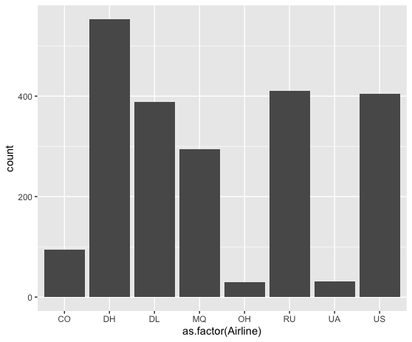

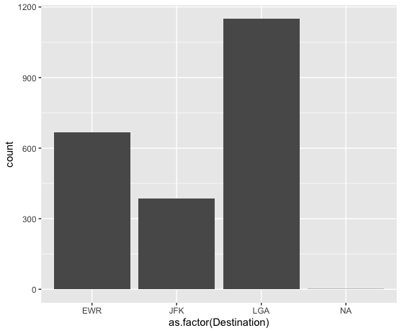

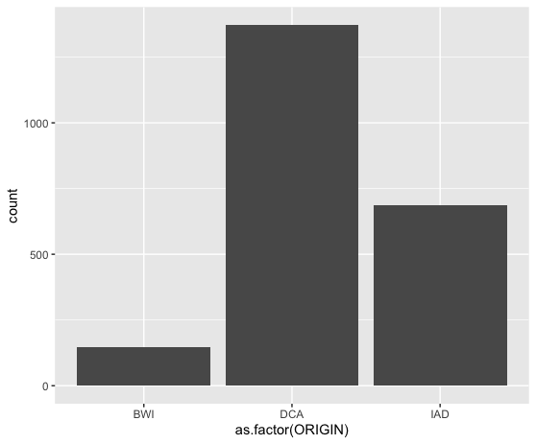

Q2. Remove missing values

There’s one missing value in the ‘Destination’ column.

Q3. Remove duplicated in the dataset

Use *unique()* function to remove duplicates.

Q4. Convert the data type

1. Convert to factor: Weather, Day_week

Use *factor()* function.

1. Convert Scheduled “DEP_TIME” to Date data type

Use *as.time()* function in the *datetime* library.

Q5. Insights

5.1 Which day of the week sees the most delays?

Day 1

5.2 Which Destination sees the most delay?

LGA

Q6. Predict flights delay by using logistic regression and evaluate model performance

pchisq(null.deviance - deviance, df.null - df.residual, lower.tail = FALSE)

2.298644e-42

|  |  |  |
| --- | --- | --- |
| predict |  |  |
|  | ontime | delay |
| ontime | 1156 | 617 |
| delay | 139 | 289 |

Accuracy = (1156 + 289) / (1156 + 617 + 139 + 289) = 65.65%