Python Assignment

# Task 1: Student Grades Management (Lists + Dictionaries + Functions)

Write a program that takes input for multiple students (name and marks in 3 subjects).  
- Store the data in a dictionary of dictionaries:  
 {"Ali": {"Math": 85, "Science": 90, "English": 78}, ...}  
- Calculate each student’s average score and assign a grade (A, B, C, D, F).  
- Print the results in a neat table format.

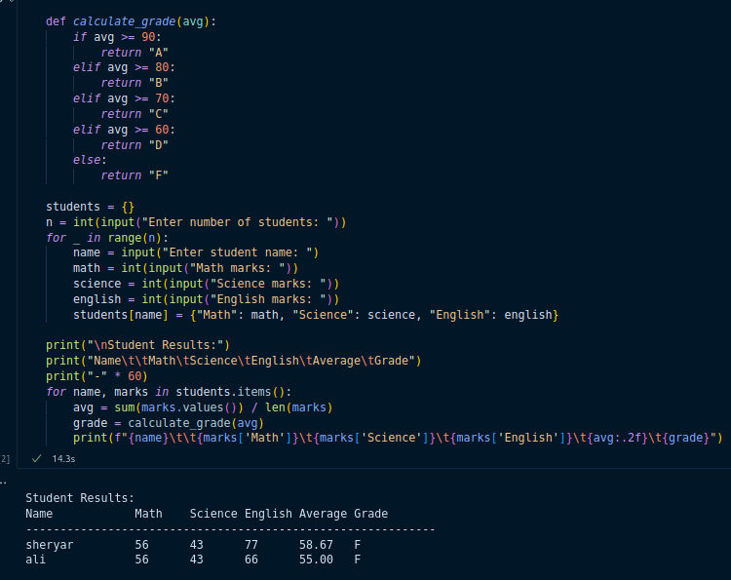

# Task 2: Word Frequency Counter (Strings + Dictionaries + File Handling)

- Ask the user to enter a paragraph and save it into a text file.  
- Read the file and count how many times each unique word appears.  
- Ignore case sensitivity (The and the should be treated the same).  
- Display the top 5 most frequent words.

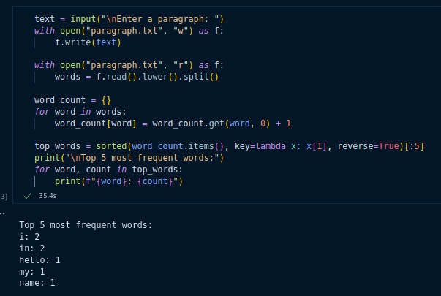

# Task 3: Prime Number Analyzer (Functions + Loops + List Comprehension)

- Write a function to check whether a number is prime.  
- Generate a list of prime numbers between 1 and 200 using list comprehension.  
- Find the sum of these prime numbers.

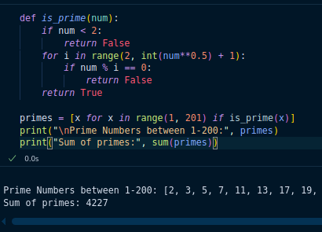

# Task 4: Mini ATM Simulation (Conditional Statements + Loops + Functions)

Create a mini ATM program with the following features:  
- User must enter PIN (predefined).  
- Menu: Check Balance, Deposit, Withdraw, Exit.  
- Ensure withdrawals cannot exceed the balance.  
- Use functions to implement each feature.

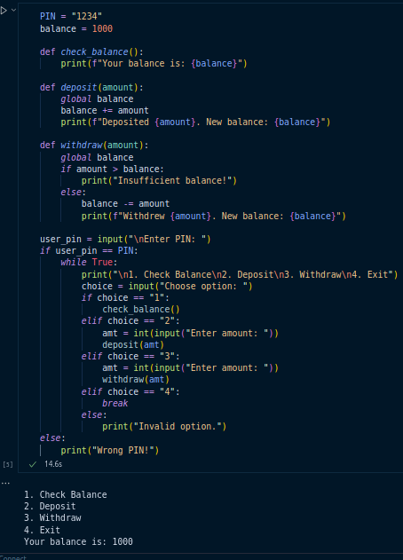

# Task 5: Data Filtering with Lambda + Map + Filter

Given a list of dictionaries of employees:  
employees = [  
 {"name": "Sara", "age": 25, "salary": 50000},  
 {"name": "Ali", "age": 30, "salary": 70000},  
 {"name": "John", "age": 22, "salary": 40000},  
]  
- Use filter to find employees with salary > 50,000.  
- Use map to increase all employees’ salary by 10%.  
- Print the updated data.

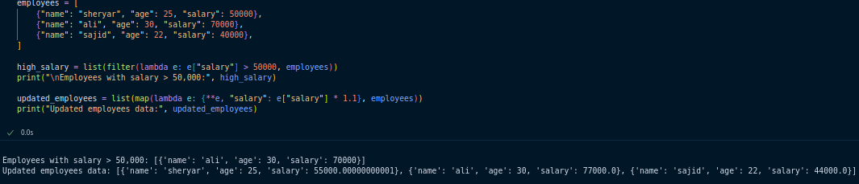

# Task 6: Matrix Operations (Nested Loops + List Comprehension)

- Take two 3x3 matrices (lists of lists) as input.  
- Perform matrix addition and matrix multiplication manually (without NumPy).  
- Display the results.

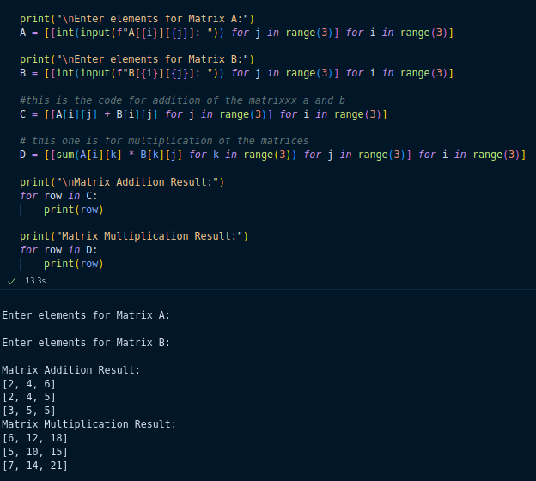

# Task 7: File Handling + Exception Handling (Error-Proof Program)

- Write a program that asks the user for a filename and tries to read it.  
- If the file doesn’t exist, handle the exception gracefully and ask again.  
- Count how many lines, words, and characters the file contains.

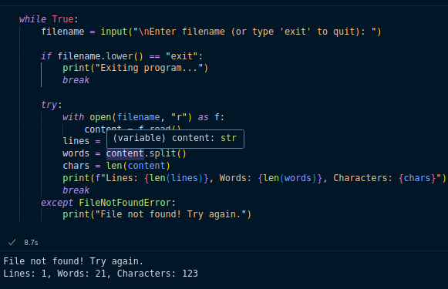

# Task 8: Student Registration System (Sets + Dictionaries + Loops)

- Maintain two sets: registered_students and new_applicants.  
- Allow user to:  
 1. Add a new applicant  
 2. Register an applicant  
 3. Show all registered students  
 4. Remove a student  
- Ensure no duplicate registrations are possible.

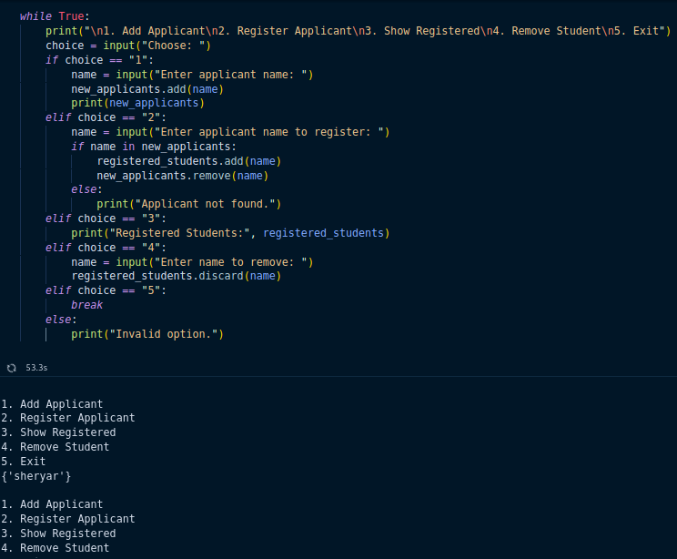

# Task 9: Nested Functions + Scope

- Write a program that contains a nested function.  
- Outer function should take a sentence as input.  
- Inner function should count vowels inside the sentence.  
- The outer function should return both the original sentence and the vowel count.

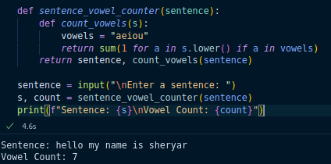

# Task 10: Mini Shopping Cart (Dictionaries + Loops + Functions)

- Predefine a product catalog (dictionary with product name → price).  
- Let the user add items to the cart until they type "done".  
- Calculate total bill, apply 10% discount if total > 5000, and print the final bill.  
- Save the bill in a text file.

