# Seaborn Plot Types — Description & Examples

Below each plot type is described (what it shows and why you would use it), followed by a simple illustrative drawing. The drawings are created with matplotlib as compact examples.

## Scatter plot

A scatter plot shows the relationship between two continuous variables. Useful to identify correlations, clusters, and outliers.

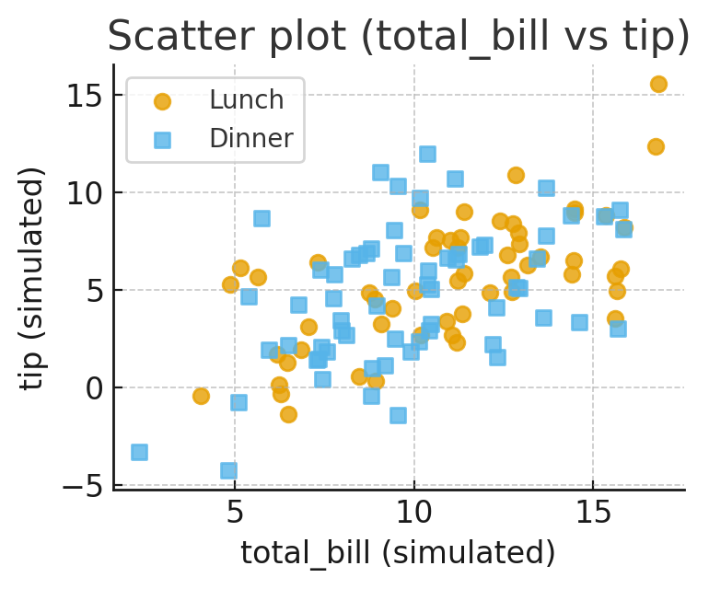

## Line plot

A line plot displays trends over an ordered variable (often time). Useful for showing changes and smoothing/averages across time.

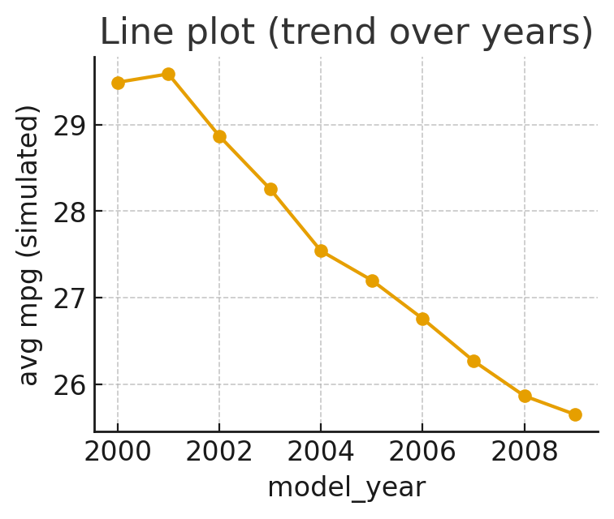

## Relational plot (scatter w/ category)

Relational plots show relationships while encoding additional categorical information (color/marker). Useful to compare subgroups.

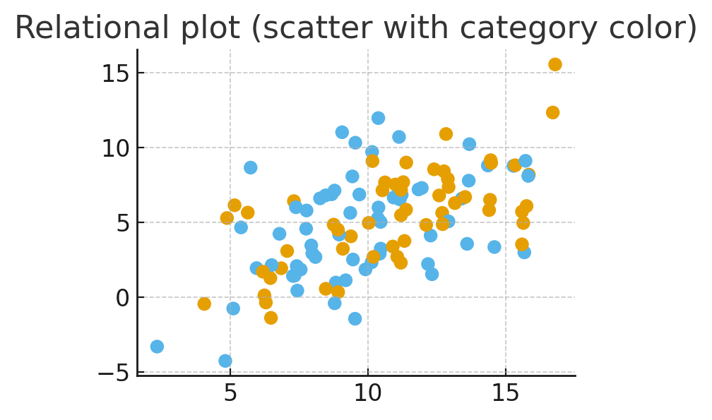

## Boxplot

Boxplots summarize distribution with median, quartiles, and outliers; useful for comparing distributions across categories.

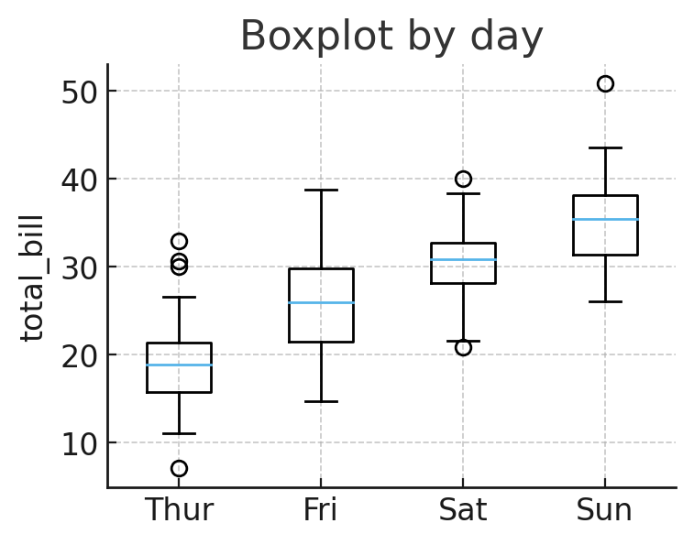

## Violinplot

Violin plots combine a KDE with a boxplot-like summary to show distribution shape per category.

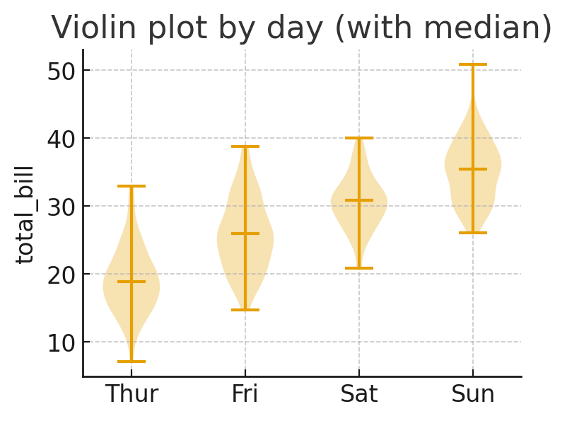

## Stripplot

Stripplots show individual observations (with jitter) per category — useful to view data points alongside summaries.

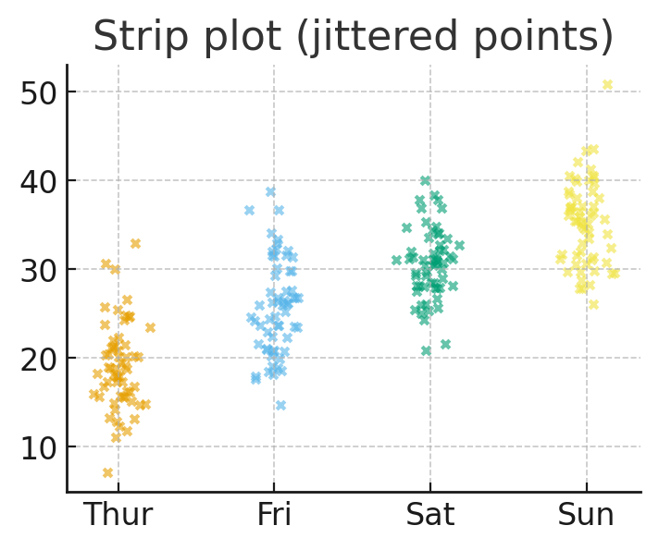

## Categorical bar plot

Bar plots show aggregated statistics (mean, counts) across categories; useful for comparing group summaries.

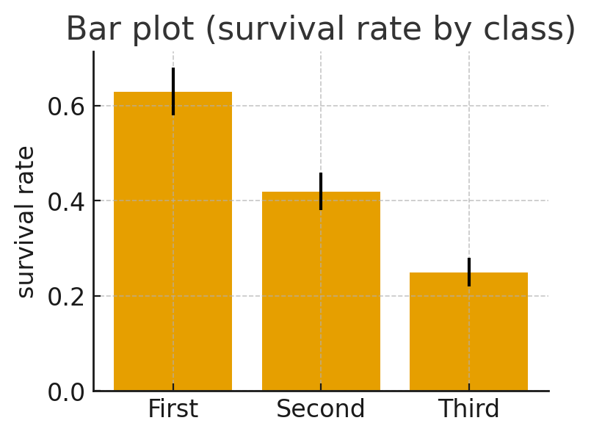

## Histogram + KDE

Histograms show frequency distributions; KDEs estimate continuous density — plotting both helps visualize shape and smoothness.

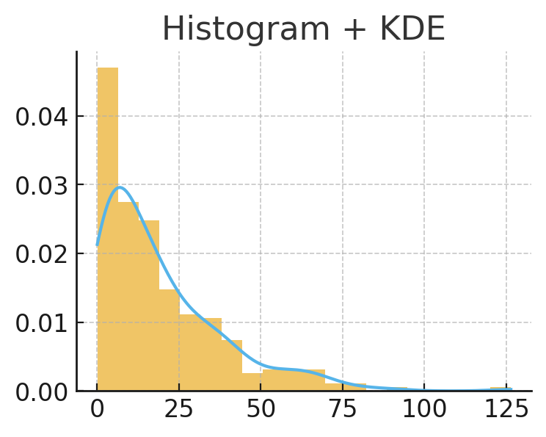

## KDE plot

Kernel Density Estimate shows a smoothed estimate of a variable's distribution; useful for comparing shapes and modality.

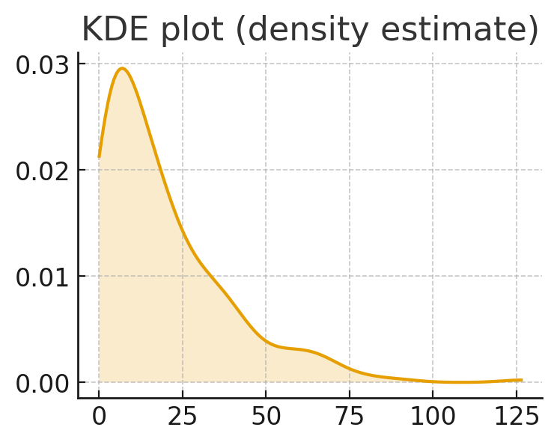

## Displot-like

A figure-level distribution plot used for faceting; here is a single-panel histogram as an example.

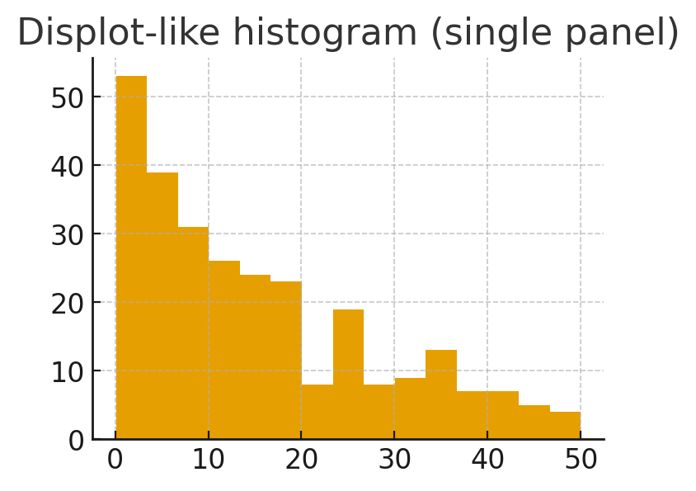

## Regression plot

Shows scatter of data with a fitted regression line; useful for visualizing relationships and linear trends.

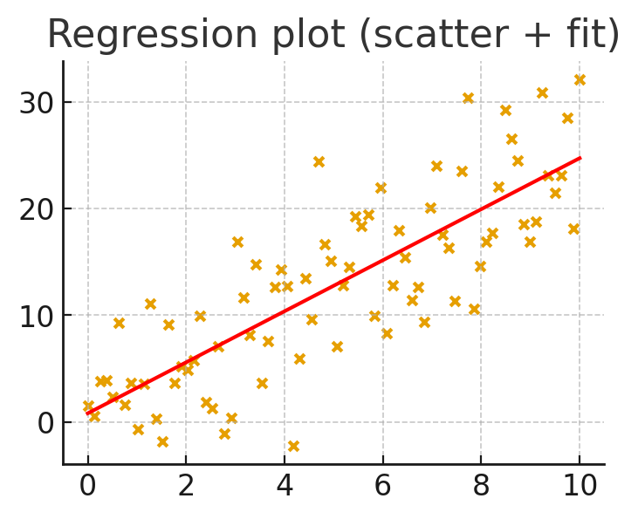

## LMPlot-like (group regressions)

Displays regression lines for multiple groups on the same axes to compare trends across categories.

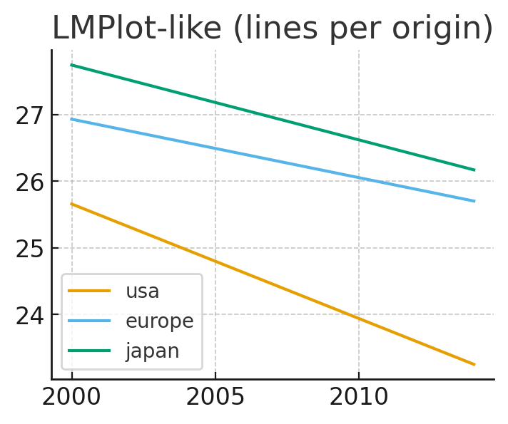

## Heatmap

A heatmap visualizes a matrix (e.g., correlation or pivot table); useful to spot patterns across two dimensions.

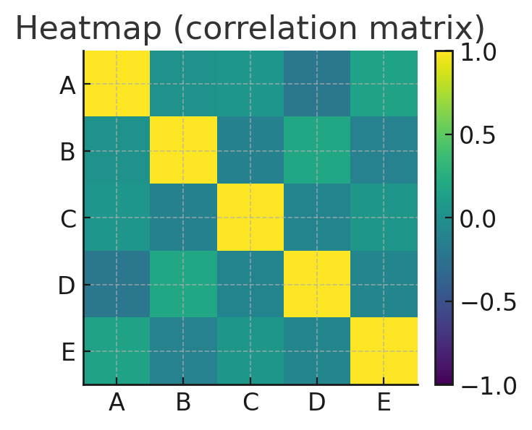

## Pairplot (scatter matrix)

A grid of pairwise scatterplots and marginals to examine relationships across many variables simultaneously.

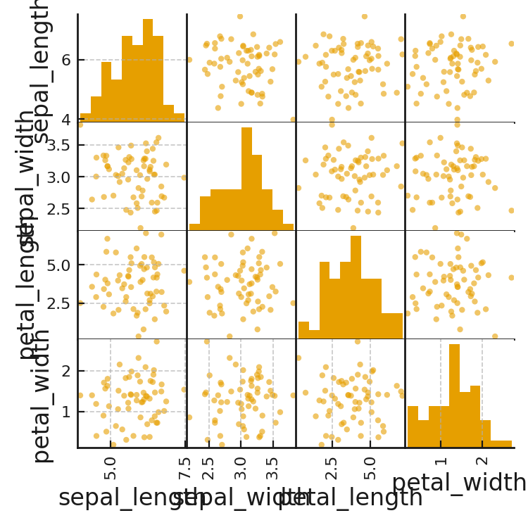

## PairGrid-like

Lower-level grid allowing custom plotting in each cell (e.g., scatter in upper, kde in lower).

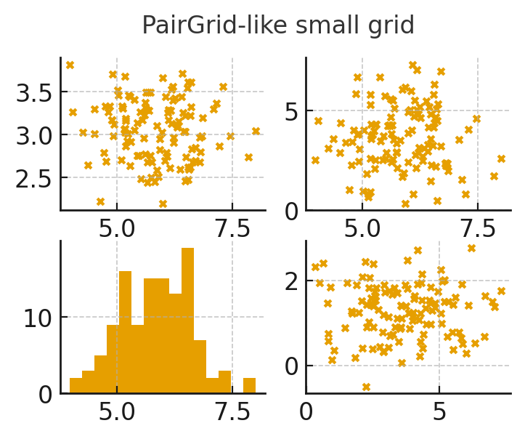

## Jointplot (hexbin)

Shows bivariate relationship with density via hexbin; useful when plotting many points to see density regions.

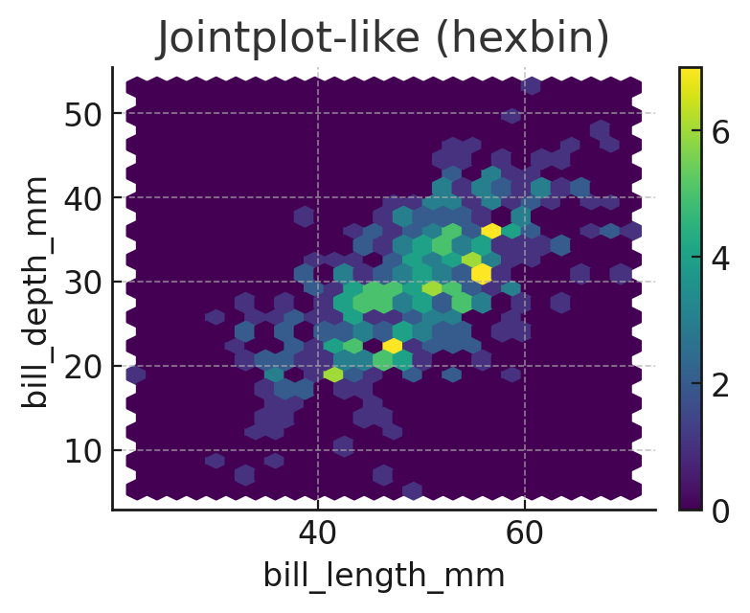

## FacetGrid-like

Faceting creates small multiples (panels) by category to compare distributions or relationships across subgroups.

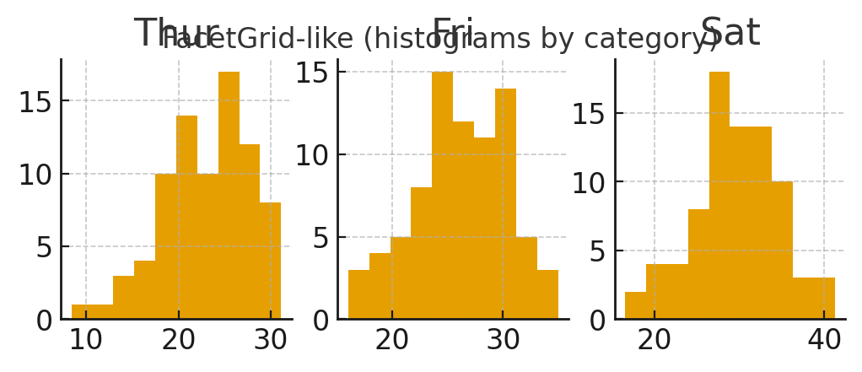

## Palette example (palplot)

Displays a selected color palette; useful to choose color schemes for consistent styling.

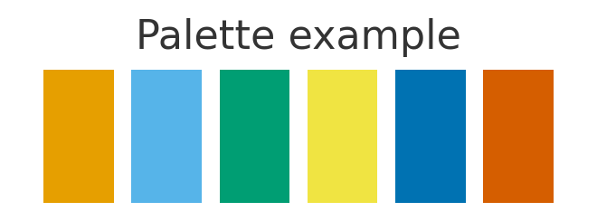

## Despine

A styling tweak that removes top/right spines for a cleaner, publication-ready look.

