# Python Data Structures - Exercises

## Lists

1. Create a list of 5 fruits. Print the second fruit and check if 'apple' exists in the list.

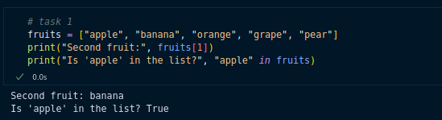

2. Add 'mango' to the list, remove one fruit, and then sort the list in ascending order.

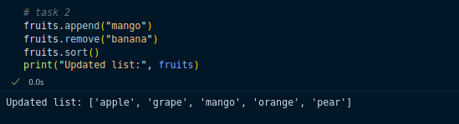

3. Take two lists: list1 = [1, 2, 3], list2 = [4, 5, 6]. Join them and print the result.

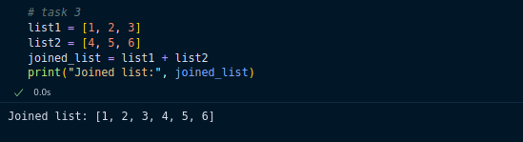

## Tuples

1. Create a tuple of 5 numbers. Print the first and last elements.

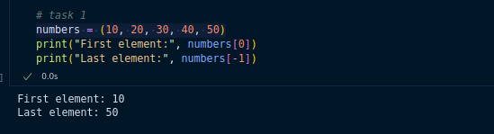

2. Write a program to find the index of a number in a tuple.

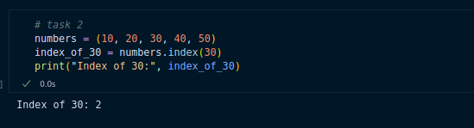

3. Convert a tuple into a list, add one new element, and convert it back to a tuple.

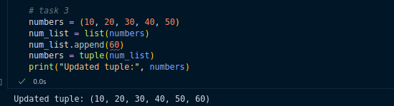

## Dictionaries

1. Create a dictionary with keys 'name', 'age', and 'city'. Print the value of 'name'.

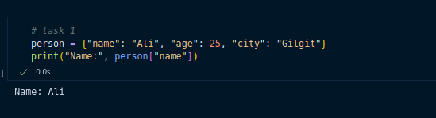

2. Add a new key 'country' with a value. Update 'age' to a new number.

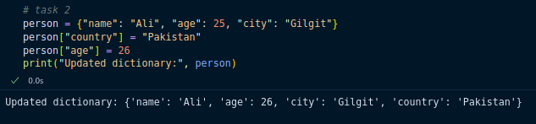

3. Write a program that loops through a dictionary and prints all keys and values.

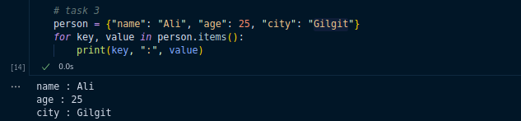

## Sets

1. Create a set of 5 numbers. Check if the number 3 exists in the set.

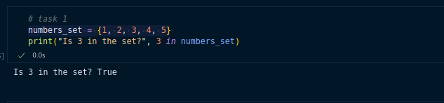

2. Add a new number to the set and remove an existing number.

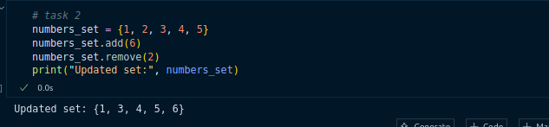

3. Create two sets: set1 = {1, 2, 3, 4}, set2 = {3, 4, 5, 6}. Find the union, intersection, and difference.

