Python Programming Tasks: Functions, Scope, Lambda, Map/Filter, Nested Functions, File & Exception Handling

# Tasks

1. Write a simple function `greet` that takes a name as input and prints 'Hello, <name>!'

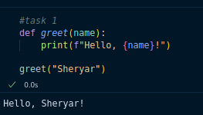

2. Create a function that calculates the square of a number. Demonstrate it with a loop for numbers 1 to 5.

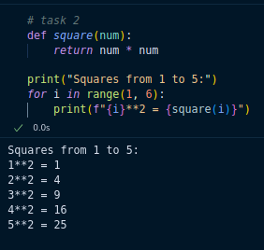

3. Write a function `add_numbers(a, b)` that returns the sum of two numbers. Call it using keyword arguments.

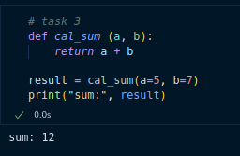

4. Demonstrate variable scope by creating a global variable and a local variable with the same name inside a function. Print both values.

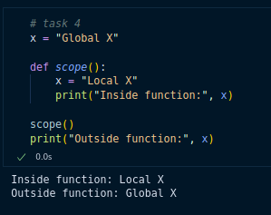

5. Use a lambda function to return the cube of a number. Show its result for the number 4.

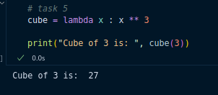

6. Given a list of numbers, use `map` with a lambda to return their squares.

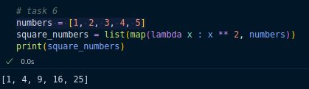

7. Given a list of numbers, use `filter` with a lambda to return only odd numbers.

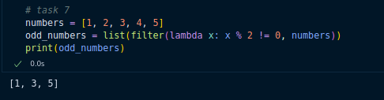

8. Write a nested function `outer` with an inner function `inner` that returns the square of a number. Call the inner function through `outer`.

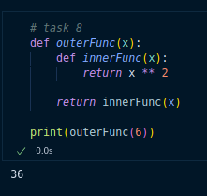

9. Write a program that opens a text file, writes three lines to it, and then reads it back to print its contents.

10. (Advanced) Implement a safe division function `safe_divide(a, b)` that uses exception handling. It should return the result if division is possible, otherwise print a meaningful error message (e.g., 'Cannot divide by zero').