**Name:-** Davinder Verma

**Student ID:-**121802201

**Email:-** dverma22@myseneca.ca

**Section:-** DCF255-NDD

**1(A).**

1. **Go to the International airport in Toronto:-**

In this layer. I will first take the taxi to the airport from my home. Firstly, I will collect all the things that I have to take with me and collect them in a place where they are ready to go.

1. **Pass the security clearance and do the check-in:-**

As soon as I reach the airport. I will go to my airline counter and then do the check-in of the bags and collect my boarding pass and wait till the boarding time.

1. **Board the airplane and take-off:-**

In this I will board the plane. Then I will find my seat and place the carry-on bag in the hand luggage compartment. Then I will buckle up the seat belt and the plane will take off.

1. **Land at London airport:-**

As soon as the plane lands. I will walk out of the plane and go towards the immigration counter.

1. **Do the border security clearance and collect the bags:-**

As I am done with the immigration clearance. Then I will collect my luggage and get out of the airport. Then I will take the taxi to the hotel.

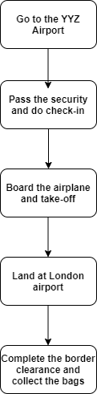**1(B).**

**2(A).**

* First, I will start my laptop and connect it to the internet using Wi-Fi. Then I will open a internet browser and search the Seneca server link.
* Then my laptop will make a TCP segment carrying the HTTP request with the TCP header. It will then compose an IP packet with the source and destination IP address.
* Now the router will transmit all the information in the ethernet cable, and it will be received by the Seneca server.
* The information will be converted from analog to digital form from the NIC driver.
* Now the IP layer will extract all the information layer and then process and send the information to the server.
* This process will run back and forth while I am using the Seneca website.

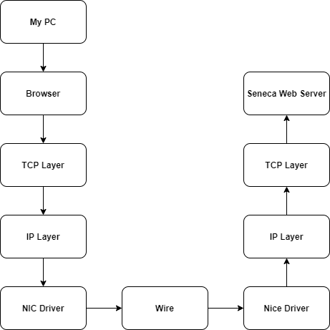**2(B).**