Table of Contents
Spring 4
Spring Boot 4
Spring Boot Specific Annotation 4
@SpringBootApplication 4
SpringApplication.run(AccountsApplication.class, args); 4
RestAPI 5
Hibernate 5
Lombok 6
Swagger/OpenAPI 6
NodeJS 7
Python Data types 7
Disadvantage 7
Launch EC2 instance 7
Best Practice 7
EC2 interview questions 8
Stopping and terminating an instance 8
AMI component 9
Template for Root Volume 9

Spring

Spring Boot

Spring Boot Specific Annotation

@SpringBootApplication

Combine Behavior of: @Configuration, @EnableAutoConfiguration, and @ComponentScan
- Auto-Configuration: Automatically configures Spring Boot applications based on the classpath and property settings.
- Component Scanning: Automatically detects and registers beans in the package and sub-packages of the annotated class.
- Configuration: Defines the annotated class as a configuration class for the Spring context.
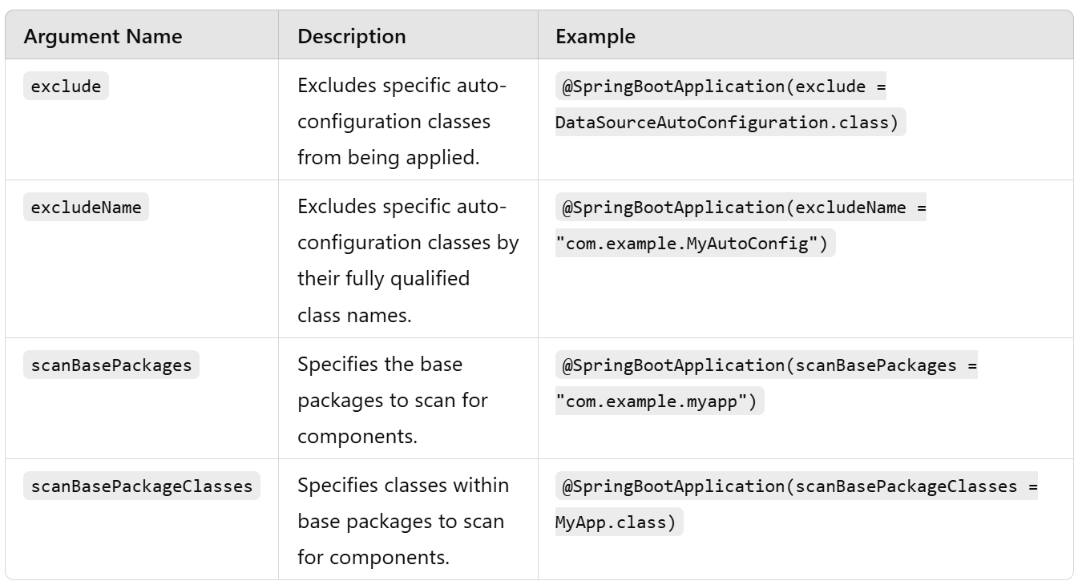

SpringApplication.run(AccountsApplication.class, args);

The SpringApplication.run() method is the primary way to start a Spring Boot application. It sets up the Spring application context, performs dependency injection, and starts the embedded web server (if applicable). This method is typically invoked in the main method of the application's entry class.
- Bootstraps the Application: Initializes the Spring ApplicationContext.
- Loads Application Properties: Reads and applies configuration from application.properties or application.yml.
- Performs Auto-Configuration: Configures components based on the application's dependencies.
- Starts Embedded Server: If the application is a web application, it starts an embedded server (like Tomcat, Jetty, or Undertow).
- Supports Command-Line Arguments: Passes command-line arguments to the application.

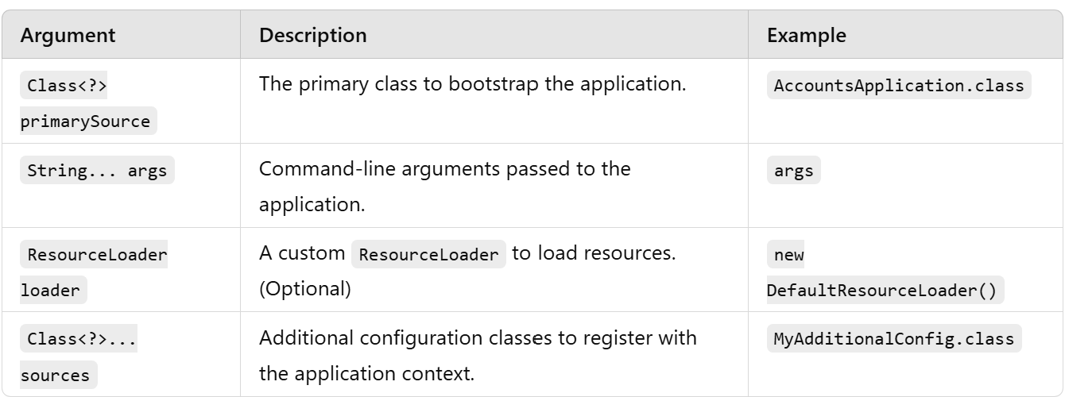

Web development/RestAPI

@RestController

Combine Behavior of: @Controller and @ResponseBody.
- Simplifies the creation of RESTful APIs.
- Automatically serializes returned objects to JSON or XML.
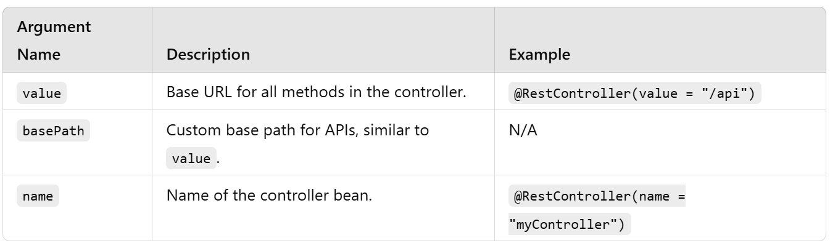

@RequestMapping

@RequestMapping(path="/api", produces = {MediaType.APPLICATION_JSON_VALUE})
- Maps a specific request or pattern to a controller method.
- Can be applied at the class level (to define a base path) or the method level (to handle specific endpoints).
- Supports multiple HTTP methods, media types, and request attributes.
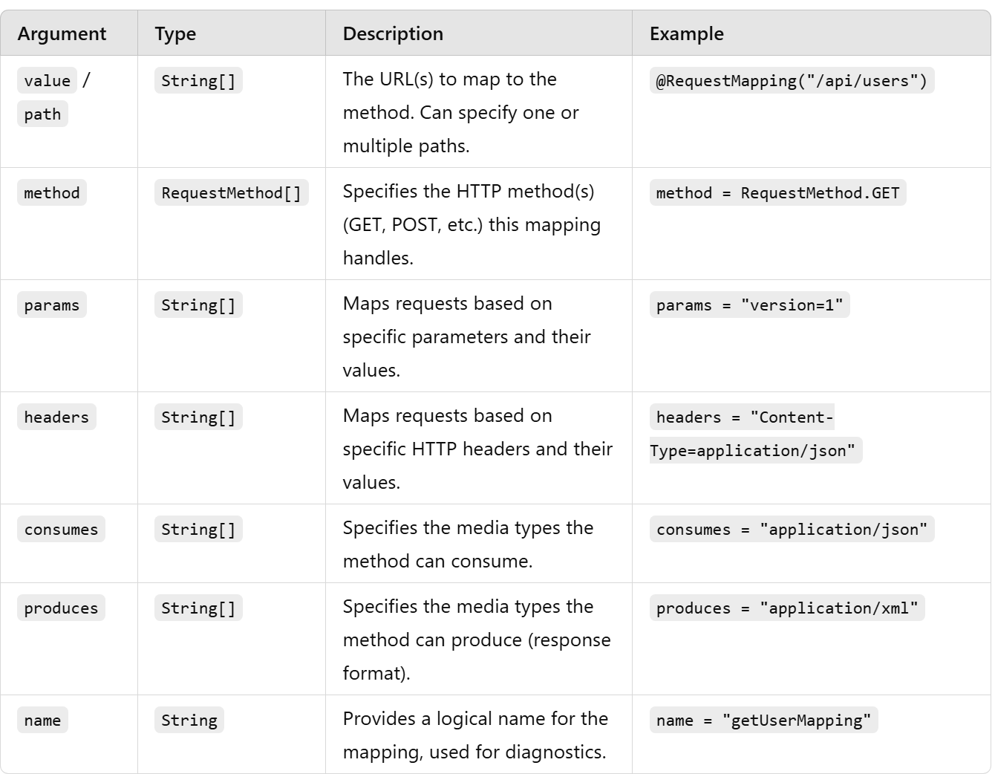

@RequestMapping serves as a base for several specialized annotations:
- @GetMapping: Maps GET requests.
- @PostMapping: Maps POST requests.
- @PutMapping: Maps PUT requests.
- @DeleteMapping: Maps DELETE requests.
- @PatchMapping: Maps PATCH requests.

@Valid, @RequestBody

- @Valid: Used to trigger validation on annotated object. It works in conjunction with validation annotations in the object's class, such as @NotNull, @Size, etc.
- @RequestBody: Maps the HTTP request body to a Java object. It's used to deserialize the request body into the corresponding Java type.

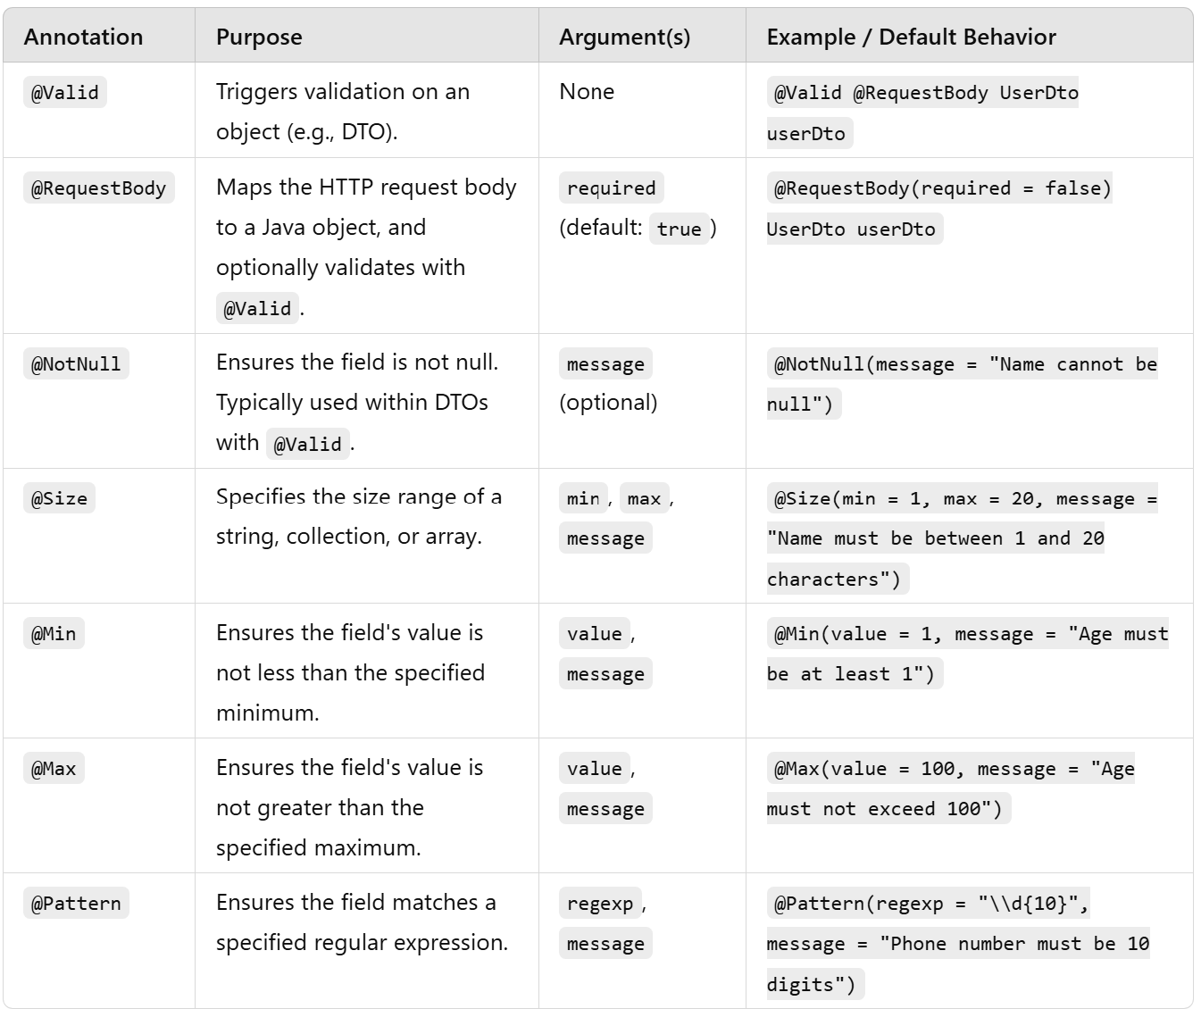

ResponseEntity

ResponseEntity
.status(HttpStatus.CREATED)
.body(new ResponseDto(AccountsConstants.STATUS_201, AccountsConstants.MESSAGE_201));
Note:
Return type for this is : ResponseEntity<ResponseDto>

ResponseEntity.status(HttpStatus.CREATED):
- Sets the HTTP status of the response to 201 Created, which indicates that the request has been fulfilled and a new resource has been created.
.body(new ResponseDto(...))
- Adds a response body to the ResponseEntity. In this case, the body is an instance of ResponseDto that carries information about the operation's status and message.
Note:
AccountsConstants.STATUS_201, AccountsConstants.MESSAGE_201
These constants are likely defined in the AccountsConstants class to store standard values for a successful resource creation response

Hibernate

@NotEmpty(message = "AccountNumber can not be a null or empty")
The @NotEmpty annotation is part of the Java Bean Validation API (specifically from Hibernate Validator) and is used to validate that a string or collection is not null or empty.
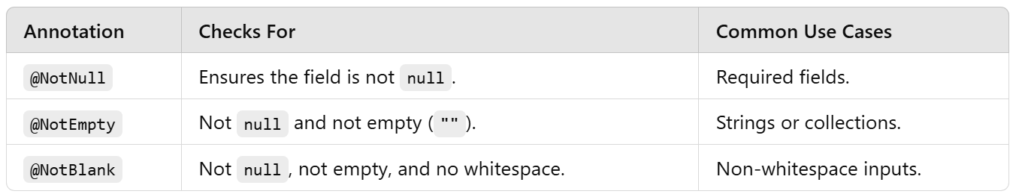

@Pattern(regexp="(^$|[0-9]{10})",message = "AccountNumber must be 10 digits")
The @Pattern annotation is part of the Java Bean Validation API and is used to validate that a string matches a specified regular expression (regex). It is particularly useful for validating formats, such as email addresses, phone numbers, or other structured strings.
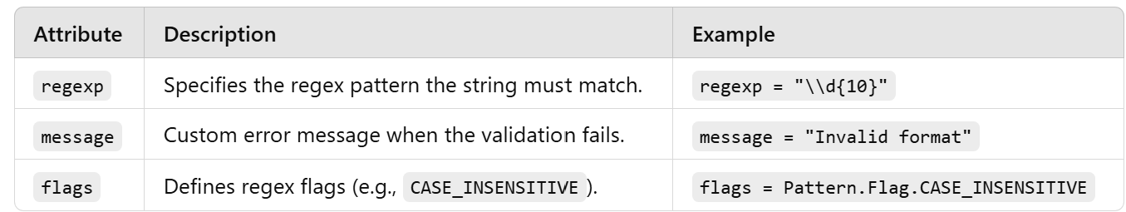

Lombok

@Data
Lombok annotation that is commonly used in Java to reduce boilerplate code for data objects.
It automatically generates getters, setters, toString(), equals(), hashCode().

Swagger/OpenAPI

@Schema(
name = "Accounts",
description = "Schema to hold Account information"
)
@Schema annotation is part of the Swagger/OpenAPI specifications provided by the springdoc-openapi
library or similar tools. It's used to describe the schema of a class or a field when generating
OpenAPI documentation.
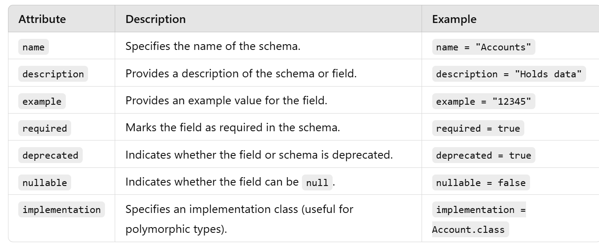

NodeJS

Python Data types

Disadvantage

- Variable Costs and Complex Pricing Structure: pricing options (On-Demand, Reserved, Spot Instances), and additional costs for data transfer, storage, etc.
- Performance Variability: Underlying physical hardware is shared with other users, which can sometimes lead to inconsistent performance.
- Network performance can vary, especially in lower-tier or older instance types, which might not be suitable for network-intensive applications.
- Learning Curve and Complexity (need to know AWS ecosystem)
- Users have limited visibility and control over the physical hardware running their instances.

Launch EC2 instance

Click button to Launch Instance
Choose an Amazon Machine Image (AMI)
Choose an Instance Type.
Configure Instance Details (instances, network, subnet, choose to auto assign public ip, IAM role, and more) – join to directory (Windows)
Add Storage ie. default storage settings or add additional EBS (Elastic Block Store) volumes.
Configure Security Group (to allow the required traffic).
Review and launch.

Note:
Non-root volumes

Best Practice

- Use strong, RSA 2048-bit (public-key cryptosystems, widely used for secure data transmission) key pairs for SSH access.
- Store private keys securely and never share them.
- Rotate key pairs regularly.

Note:
RSA 2048-bit keys are used in various digital security processes, including SSL/TLS certificates, digital signatures, and secure shell (SSH) for secure communications. They ensure that data encrypted with the public key can only be decrypted with the corresponding private key, and vice versa for digital signatures.
RSA keys longer than 2048 bits (like 4096-bit) offer higher security but at the cost of performance.
Most modern browsers and systems support RSA 2048-bit

Category | Purpose/Design/Usecase
General Purpose  Mac, T4g, T3, T3a, T2, M6g, M6i, M5, M5a, M5n, M5zn, M5, A1 | Balanced mix of computing, memory, and networking resources.  Use Cases: Suitable for a wide range of applications like web servers, development environments, small and medium databases, and business applications.  Note: T2 unlimited allows applications to burst past CPU performance baselines as required (chargeable).
Compute Optimized  C6g, C6gn, C6i, C5, C5a, C5n, C4 | High CPU performance relative to memory.  Use Cases: Ideal for compute-bound applications that benefit from high processor speeds, such as batch processing, media transcoding, high-performance web servers, and high-performance computing (HPC)

EC2 interview questions

Stopping and terminating an instance

Stopping an Instance | Terminating an Instance
Stopping an instance is akin to shutting down a physical server | Terminating an instance effectively deletes it.
Instance can be restarted at any time, and it retains its configuration, including its instance ID, private IP addresses, Elastic IP addresses (if associated), and all attached EBS (Elastic Block Store) volumes.  Data on EBS volumes is persisted. | Any data on instance store volumes is lost permanently.  Default, EBS volumes are automatically deleted when the instance is terminated. However, this behavior can be changed so that EBS volumes are preserved after termination.
You are not billed for compute hours.  You are still billed for any EBS volume storage and any Elastic IP addresses. | You are no longer billed for any compute hours for the terminated instance. If any EBS volumes are retained after termination, you continue to be billed for the storage.
Useful for temporarily halting instances for cost-saving during periods they are not needed, without losing data or having to reconfigure them later | Appropriate when an instance is no longer needed at all, and you want to avoid incurring further costs associated with it.

Amazon Provided AMIs | Community AMIs | Marketplace AMIs | Private AMIs
Provided by Amazon | Created and shared by AWS users | Provided by third-party vendors | Created by individual users or organizations for their private use
Pre-configured and ready for immediate use | community AMIs includes configurations for specific applications or setups | Available through the AWS Marketplace | Fully customizable to the specific needs of an organization or project
Amazon manages updates and security patches  support from Amazon or the OS vendor | User-generated, it's essential to ensure trustworthiness and security before use | Commercial Software Integration  Support provided by third-party vendor | Users have complete control over the configuration, updates, and security.
AWS cost if any | Some may include licensed software that incurs additional costs | Often come with additional licensing costs or usage fees. | Individual user / Organization decide what software to use

AMI component

Template for Root Volume

On demand instances | Spot instances | Reserved instances
Ideal for short-term, irregular workloads that cannot be interrupted. You can increase or decrease your compute capacity depending on the demands of your application and only pay the specified hourly rate for the instances you use. | These instances can be terminated by AWS with just a two-minute notice if AWS needs the capacity back. Therefore, they are best for workloads that are flexible and can tolerate interruptions, like batch processing, background processing, or optional tasks. | Less flexible than On-Demand Instances as you commit to a specific instance type in a specific region for a term of 1 or 3 years.
Pay for compute capacity by the hour or second depending on the instance used, with no long-term commitments or upfront payments. | Offer the ability to purchase unused EC2 capacity at a significant discount compared to On-Demand prices, up to 90% in some cases.  No commitment, charged by hour or second | Provide a significant discount (up to 75%) compared to On-Demand pricing, in exchange for committing to use the instance for a 1 or 3-year term. Payments can be made all upfront, partially upfront, or no upfront.  charged by hour or second
Suitable for applications with unpredictable workloads, auto scaling or those being tested or developed for the first time. | Ideal for applications with flexible start and end times or those that can withstand interruptions. Eg: big data, containerized workloads, CI/CD, web servers, high-performance computing (HPC), and other test & development workloads  Application can withstand interruption. | Best suited for steady-state, predictable usage where you can commit to using EC2 over a longer period. They are ideal for applications that require a reserved capacity.

