Algorithmic Assignment​:

The task at hand is to design algorithms to determine the

1.The ​different appliances(tag##)​ whose similar instantaneous power/load** consumption pattern is observed in many days.(##You just need to tag appliance in which a common pattern is observed or they exhibit with any name like ’Appliance 1’)

2.The ​time intervals​ (​basically time ranges like 08:00 to 08:30​) in which the instantaneous power/load* consumption pattern is observed of those appliances.

The observation are as follows –

- From the plots we can see here that it is showing periodical behavior over time.

- From our data we can see here that it is not belong to the trending type, it has seasonality, so we are working on it further.

- and some interesting points we can also pick from here that like our data is stationary and looks like constant mean over time interval.

Since here we are looking for the pattern in our data to identify the use of electricity by appliances.

~ So, we do not need to go further in details for moving average analysis and modelling.

~ From above b-phase and r-phase variance looks similar, so that we can mix them and use it as single entity.

Data observations -

- - We can see common seasonality is being followed in blue and red from the graph, and the spikes.

# Approach

- sliding windows

- It can be a approach but it turns out that after setting only a number of windows as a fix parameter it will not going to perform well.

- The solution came up, I think should be implemented is that we need to divide the data into crunches, then we will implement the clustering over pattern in the data for the appliances.

- - As from the b-phase and r-phase current, the observation is comes as having same variance.

- - Finally, the approach which I want to implement is to perform subsequent time series, from that I can be able to identify the pattern where the possible appliances use found.

- ---- reference - https://www.hindawi.com/journals/tswj/2014/312521/

- ---- reference - https://backend.orbit.dtu.dk/ws/files/125918724/ecogridEvaluation_final.pdf

- I did tried to implement it using Facebook package prophet but looks like for our purpose, we need to think through a bit of another approach.

Approach

(With little improvement)

Let’s just initially discuss for the 1 phase only.

* This is the initial view of the raw data

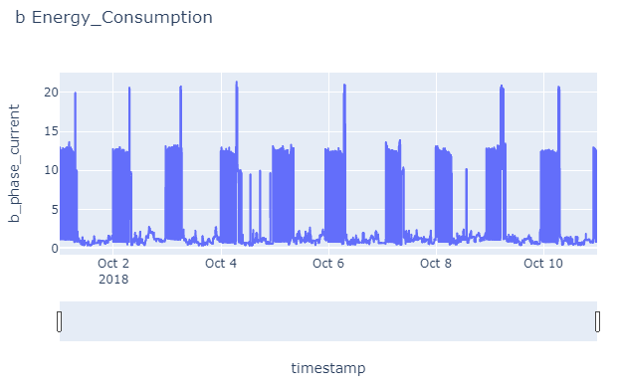

* Since we have recorded data of per 30 seconds, but it at instance of 30 sec in a minute not the average, so we can able to see the fluctuations in the current here, let’s have a closer look on the data.

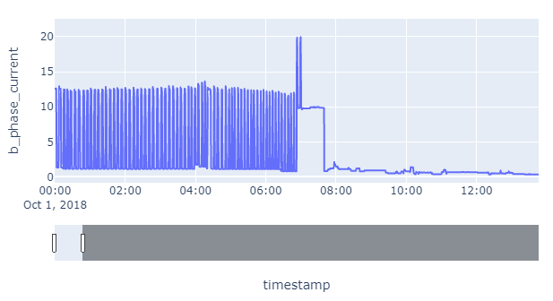

* It’s general if we think like, how any device will work, not consuming constant current, but if we consider over a period of time like 30 sec or 1 minute, we can able to find some changes when the devices switch in between or turns on and off.

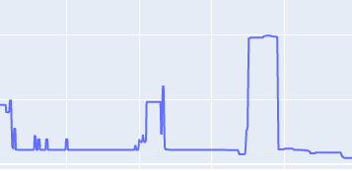



and if we consider as an overview we can found here, that we have the appliance are switching over a period of time, and we can easily able to distinguish between different appliance by their initial start and continue uses of power.

* Based on the above graph, now we are taking some assumptions like
  + Only one device is running at a time.
  + Any device will at least run for some minutes.

Using the above consideration, rest is the easy part, now we can cluster our data so that if our appliance repeating over days, then we can easily able to identify them.

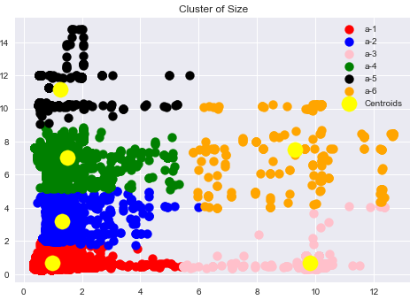

And it turns out using the above theory, that we just assumed, based on our result, is matching with the result.

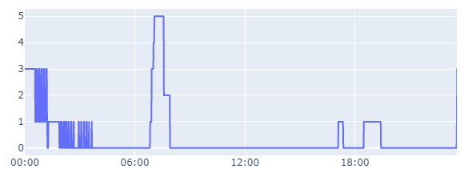



Here we able to figure out, we have 5 appliances running on different days, as above we can see here for one day analysis, how the different appliances are running on different time slots.

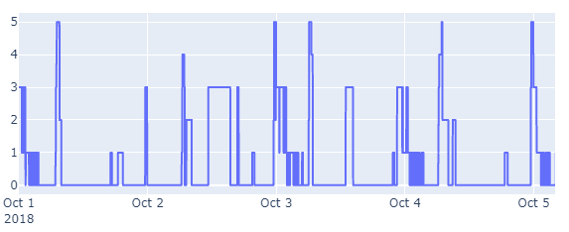

and if try to find in different days the appliances are repeating approx. on the same time.

Future Work and Improvements

Let’s consider some of the points that

If using threshold value difference between the switches of appliances, the results can be improved.

Using more feature can get better results on distinguishing the appliances.

Since right now we have data per 30 seconds, if we have records of per seconds, then it will be easier to identify the switches or ON/OFF status of any appliance.

Using neural network, the daily repetition of appliances can be observed more accurately.