ECE469 Lab report

Laser Diode

1.

Based on Figure 2, the threshold current for lasing to occur is approximately 41.5mA.

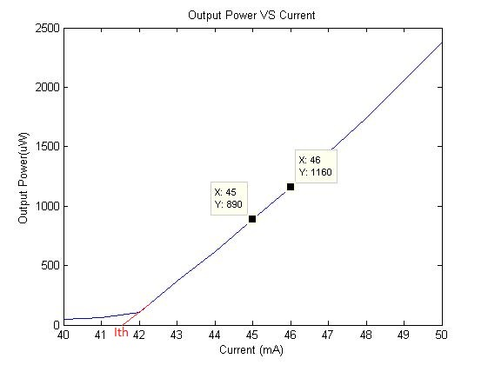

Figure 2. Power VS Current with zoom in interval from 40 to 50 mA

2. The slope efficiency is defined as the slope of P-I curve at which I>Ith. From Figure 2, the slope efficiency of the laser is 270uW/mA.

3. As Shown in Table 1, the wall-plug efficiency of the laser diode increases as current increases. The maximum wall-plug efficiency obtained is 7.10%.

$$Voltage across Laser Diode=\frac{Photon Energy at 660nm}{1 Coloumb Charge }=\frac{h\frac{c}{λ}}{1.6*{10}^{-19}}=1.88V$$

$$Wall-plug Efficiency=\frac{ouput power of laser}{input power to the laser}=\frac{P_{L}}{IV}$$

|  |  |  |
| --- | --- | --- |
| Current(mA) | Power Output(mW) | Wall-plug Efficiency |
| 45 | 0.89 | 1.05% |
| 50 | 2.38 | 2.53% |
| 60 | 5.75 | 5.09% |
| 70 | 9.34 | 7.10% |

Table 1. Wall-plug Efficiency at different current level

4.

In Figure 3, there are no noticeable power peak at one single wavelength. Instead, the power ranging from 655 to 662nm is very consistent, ranging from-20 to -30 dBm. The FWHM of this output spectrum is 5nm(??not sure). On the other hand, when the current just passed the current threshold, a clear peak appears around 658nm with power at -12.85dBm as illustrated in Figure 4. At the same time, the spectrum from 640 to 650 nm and from 665 to 680 nm are excited at this moment as well. The power increases from under -200 dBm to -45dBm. At last, once the laser entered the linear region , a peak appears at 658nm with power up to 0.78dBm. Also as the current increases, the output power from the laser also increases. Comparing the peak value between Figure 5 and Figure 6, the peak power increase from 0.78 dBm to 2.42 dBm. The wavelength at which the peak power occurs are 658.5nm for both figures. This is because the output wavelength of the laser is dependent on the energy band gap of the material of the active layer. The amplifying process is caused by the stimulated emission of electron releasing energy as photon when degrading to valence band.

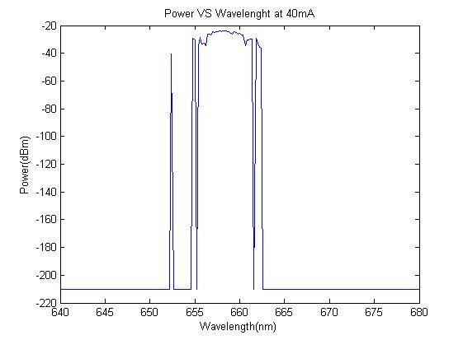

Figure 3. Output spectrum of the laser diode below the threshold current

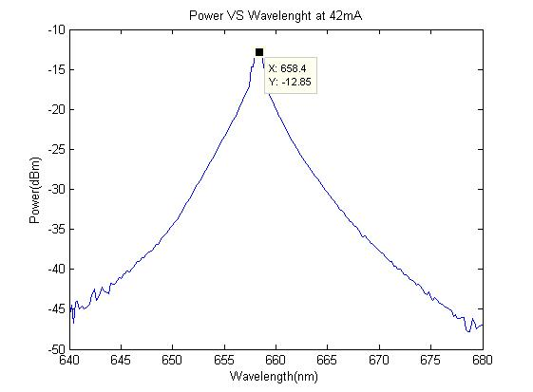

Figure 4. Output spectrum of the laser diode just above the threshold current

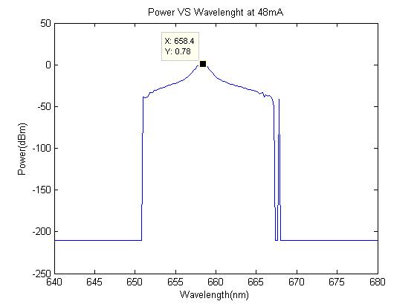

Figure 5. Output Spectrum of the laser diode in the linear LI region with current at 48mA

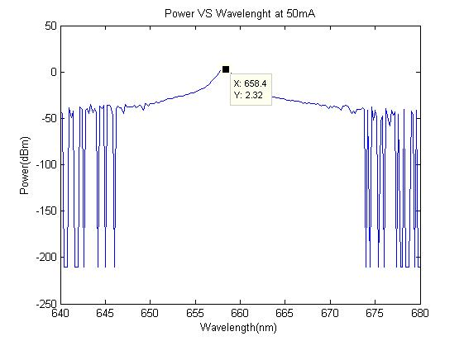

Figure 6. Output Spectrum of the laser diode in the linear LI region with current at 50mA

5.

From the result observed in Figure 5, it is clear that this laser diode is single mode, because the output power only peak at one specific wavelength, which is 658.4nm.

6.

In Figure 7, the maximum amplitude is -20dBm. Since y-axis is express as dB, the half maximum is the maximum value minus 3dB.

$$Length of laser=\frac{c}{2n_{g}∆v}$$

$$∆v=\frac{c}{λ^{2}}Δλ$$

Δλ(FWHM)=4.8nm

Δv=3.3*1012 Hz

Length of the laser=12.4um

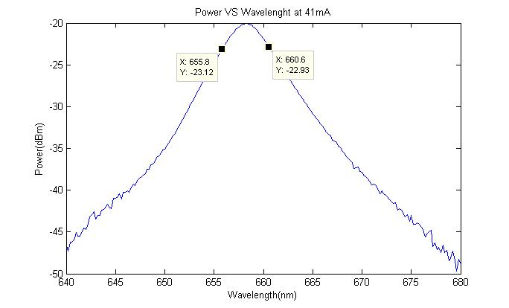

Figure 7. Output spectrum of laser diode just before passing the threshold current

Light Emitting Diode (LED)



Figure 8. Output Power vs Current graph for an LED. The best fit line for the curve is shown in red.

7.

The gradient of the L-I curve is approximately 0.595uW/mA. The saturation of optical power cannot be seen in the graph plotted for the range of current 0-100mA. If the range is increased beyond 100mA, the output power will saturate giving us a value of the saturation current.

8.



Figure 9: Output spectrum of the light emitting diode (LED) at 40 mA current



Figure 10: Output spectrum of the light emitting diode (LED) at 50 mA current



Figure 11: Output spectrum of the light emitting diode (LED) at 60 mA current



Figure 12: Output spectrum of the light emitting diode (LED) at 70 mA current

Figures 9-12 are zoomed in. The main peak wavelength of the light emitting diode (LED) is approximately equal to 836 nm. The spectral width (FWHM) of the LED is approximately equal to 47 nm.

Comparison

9.

The output power of a laser diode increases significantly after a specific value of current which is also called the threshold current. The output power of an LED increases linearly with the current and no threshold value of current exits above which the output power increases drastically. The output power for the laser diode is much higher as compared to an LED for the same range of current (2400uW vs 35uW respectively at 50 mA). The output power for an LED should saturate after some value of current (not shown in the graph above whereas the output power of a diode laser keeps on increasing with current. The gradient of the linear portion of the L-I curve for the laser diode (region above threshold current) is also much greater than the gradient for the same curve for an LED (270uW/mA vs 0.595uW/mA).

10.

LED’s have greater dispersion than Lasers which is because LED’s have a greater spectral content than lasers. This can be seen from the FWHM values obtained for both an LED and a laser diode and the FWHM is much greater for LED’s as compared to lasers which will result in less dispersion. The data rate possible when using a laser is much larger than the date rate possible when using an LED therefore lasers are used for long distance transmission while LED’s are used for local networks. This is because lasers have an on/off cycle in GHz or greater frequency range as compared to the on/off cycle for LED’s in MHz range.