C373 Final Assessment – Graded Assignment
Individual Roles and Responsibilities

There are Four Sections in this document. Do complete ALL Sections:
- Section 1: Project Declaration of Compliance
- Section 2: Individual Roles and Responsibilities Record
- Section 3: Individual Reflection
- Section 4: AI Interaction Journal
Note: Write succinctly this evidence-based report.

Section1: Project Declaration of Compliance

Student ID | 24046565
Student Name | Chow Sherwin
Class-Team | e.g. C002-Team4

Academic Integrity Compliance Statement
I declare that:
- This submission is my original work – all sources have been properly referenced and acknowledged.
- I have neither received nor rendered any assistance (either paid or unpaid) on work that requires individual effort.
- I have fully complied with the RP rules and regulations for students pertaining to assessments and academic integrity outlined here and

If found guilty of committing any act of academic dishonesty, I understand that I will be liable:
- for disciplinary action by the School
- to the full extent of penalties, including immediate failure for this assessment and other disciplinary actions such as dismissal
Retention of Backup Copy
I declare that I have a back-up electronic copy of this submission for immediate resubmission.
Digital Signature | Chow SHerwin | Date | 12/12/2025
IMPORTANT: Non-compliance to these clauses will result in unconditional rejection of your submission.

Section 2: Individual Role and Responsibilities Record

- Deliverable 1 [Team Prototype]: Evidence of your contributions to team’s Business Prototype.
<A brief description of what you did. Provide screenshot(s) if available>
Created whole figma , using figma ai under my account and share with the team .
prompted AI to create a website which suits able to track orders and reviews as the main issues were regarding trust , shipping transparency and reviews integrity
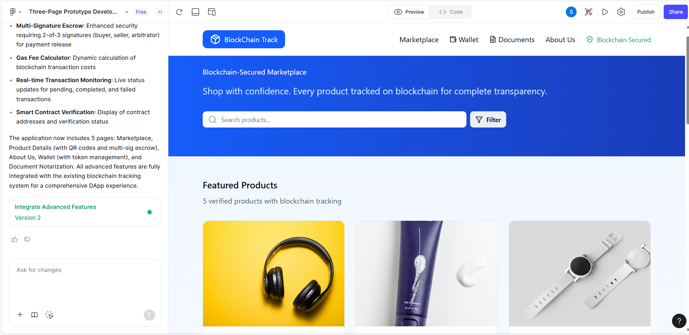

- Deliverable 2 [Team Report]:
  - Deliverable 2a [Team Report]: Evidence of your contributions to team’s Research.
<A brief description of what you did. Provide screenshot(s) if available>
Collaborated in the ‘how research influenced our design’
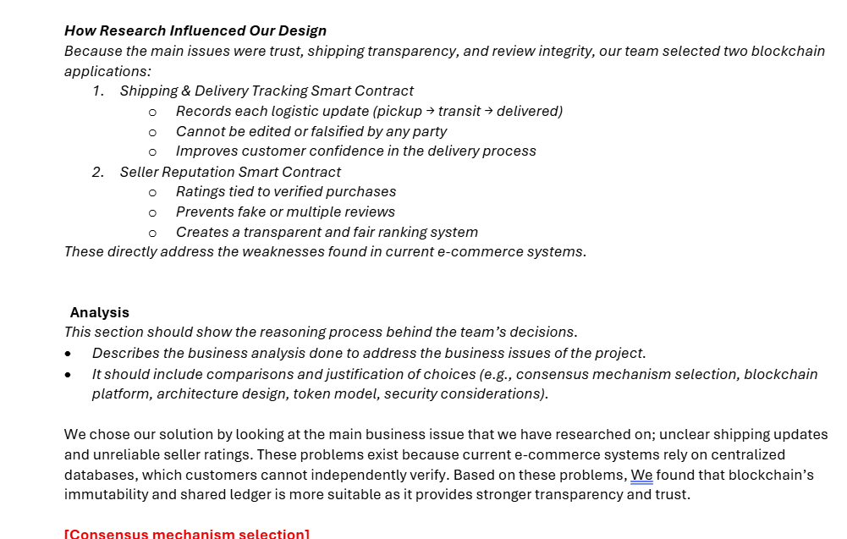

  - Deliverable 2b [Team Report]: Provide evidence of your contributions to team’s Analysis.
<A brief description of what you did. Provide screenshot(s) if available>
Did mention RBAC for security consideration part
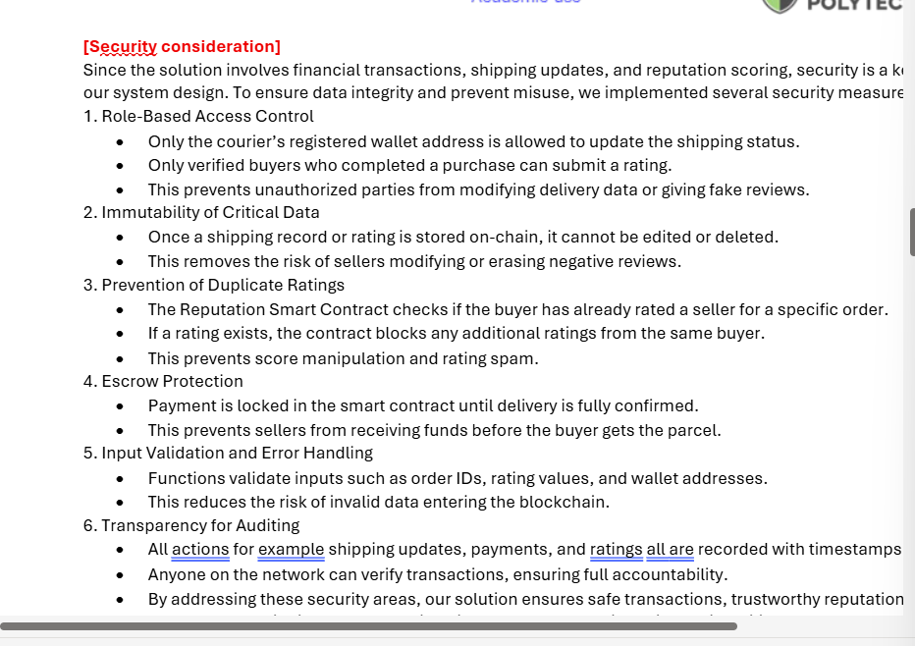

  - Deliverable 2c [Team Report]: Provide evidence of your contributions to team’s Discussions.
<A brief description of what you did. Provide screenshot(s) if available>
Suggested problem statement on ms teams and Prototype
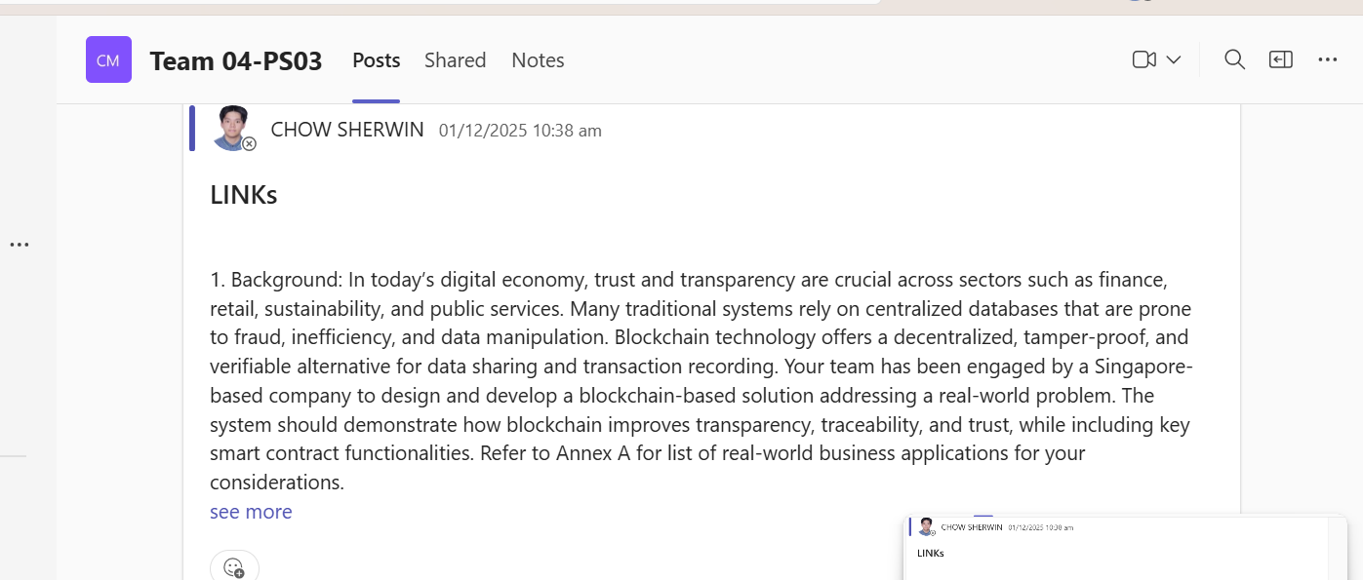
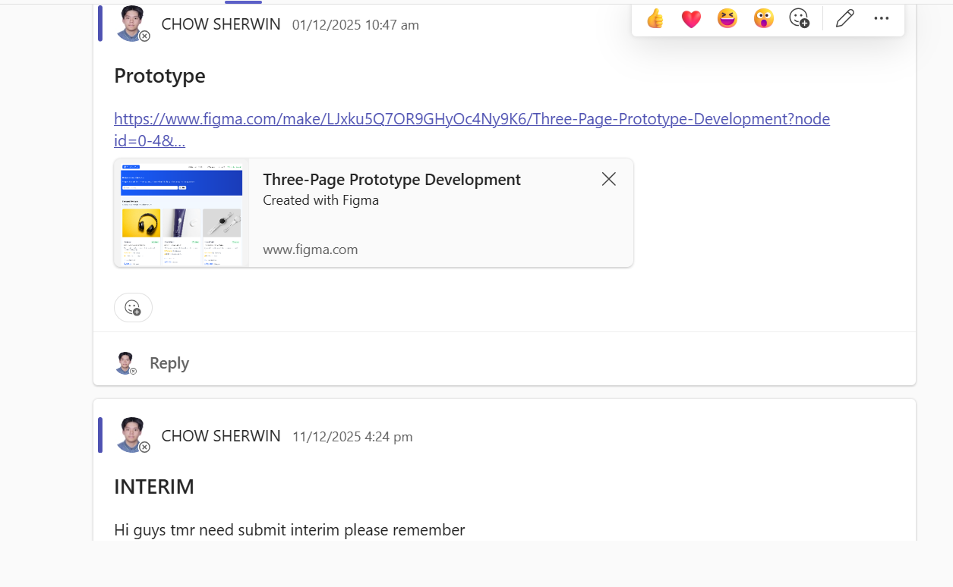
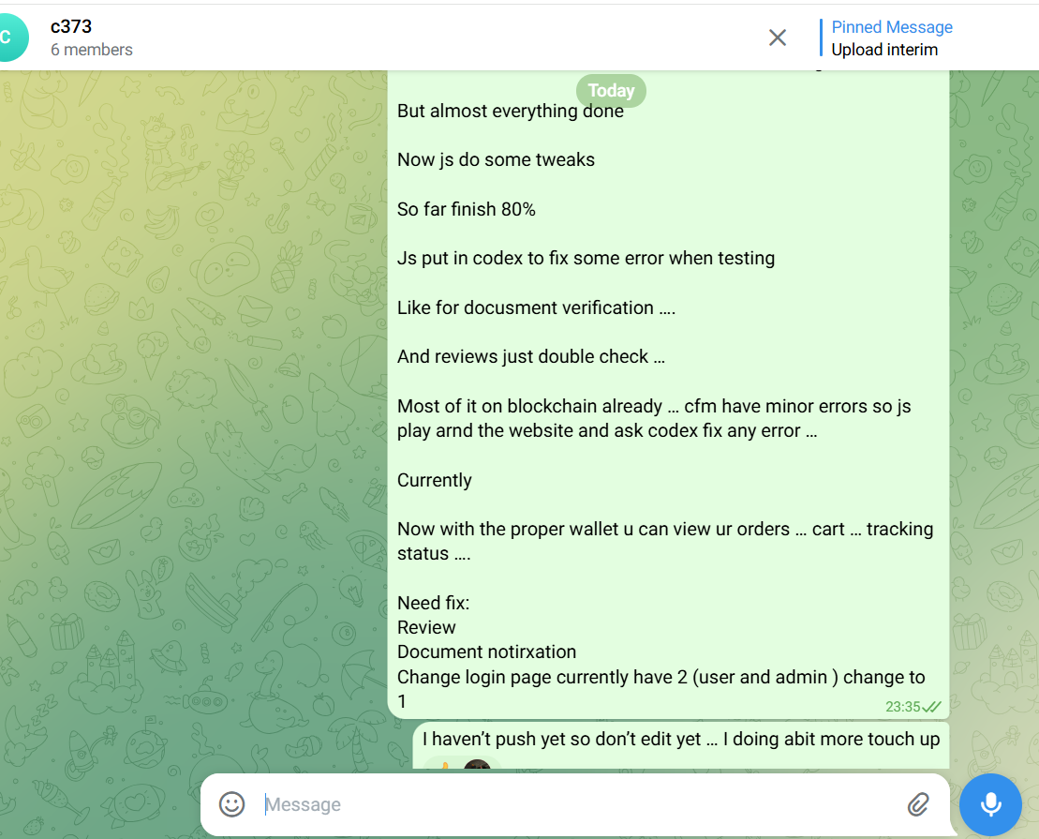

- Deliverable 3a: Team Project Codes – Functions and Test Cases

- List the full functions name in your smart contract that you have written including the parameters.
<List the function names. Provide screenshot(s) if available>
ReviewContract.sol
- submitReview(uint256 productId, bytes32 purchaseId, uint8 rating, string commentHash, bytes32 deliveryTxHash)
- getReviews(uint256 productId)
- getAverageRating(uint256 productId)
- hasReviewed(bytes32 purchaseId)
ReputationContract.sol
- constructor()
- rateSeller(address seller, bytes32 orderId, uint8 score, uint8 quality, uint8 shipping, uint8 communication)
- verifySeller(address seller, bool verified)
- addSales(address seller, uint256 increment)
- setSales(address seller, uint256 totalSales)
- getSellerReputation(address seller)
- getSellerDistribution(address seller)
- getRatings(address seller)
- hasRated(address seller, bytes32 orderId)
- _computeWeight(uint256 timestamp) (internal)
- _weightForBand(WeightBand band) (internal)
UserManagementContract.sol
- constructor()
- registerUser(address user)
- promoteToAdmin(address user)
- demoteToUser(address user)
- transferSuperAdmin(address newSuperAdmin)
- setStatus(address user, bool active)
- getUser(address user)
- _setRole(address user, Role role) (internal)
WalletContract.sol
- constructor()
- balanceOf(address account)
- topUp() payable
- mintCredit(address to, uint256 amount)
- transfer(address to, uint256 amount)
- createEscrow(bytes32 escrowId, address seller, uint256 amount)
- releaseEscrow(bytes32 escrowId)
- refundEscrow(bytes32 escrowId)
- quoteGas(uint256 gasUnits, uint256 gasPriceWei)
- currentGasPrice()
- getTransactionCount()
- getTransaction(uint256 txId)
- getAccountTransactions(address account)
- _recordTransaction(address from, address to, uint256 amount, TxType txType, bytes32 txReference) (internal)
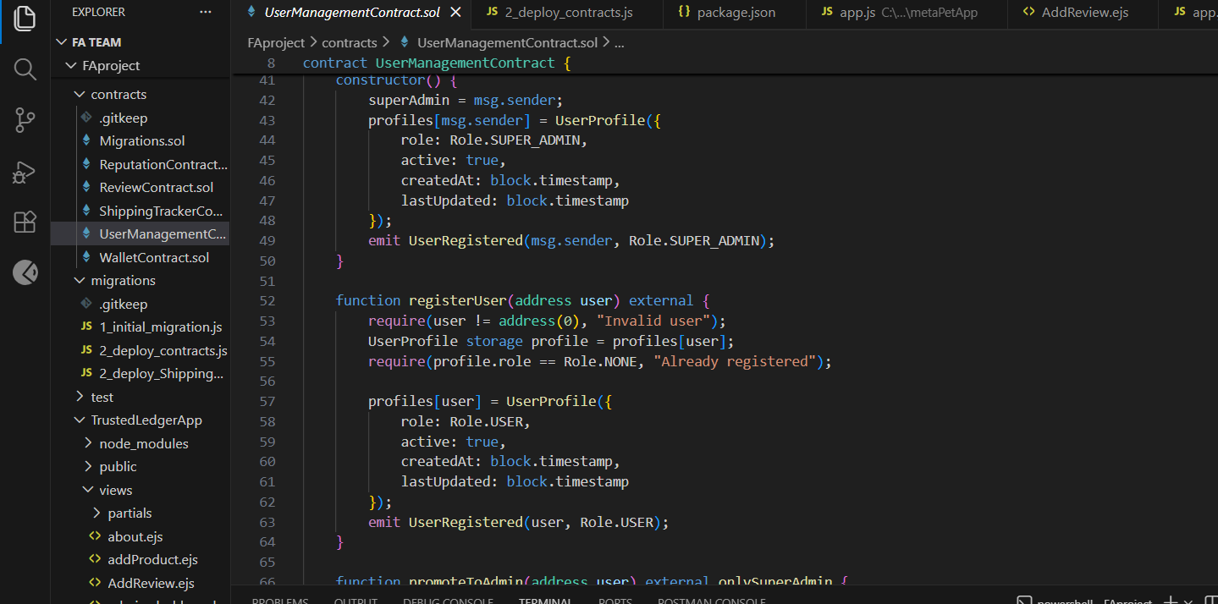

- List down the name of the test cases that you have written for your GA
<List the test cases names. Provide screenshot(s) if available>
Test case 6 : 06_notary_buyer_only.test.js
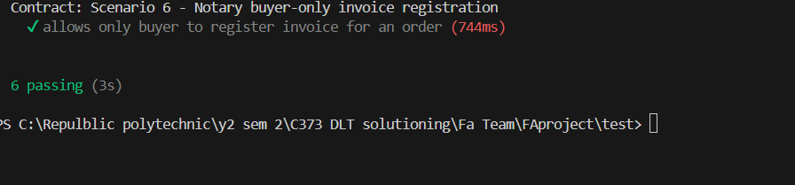

- Provide any other evidence(s) of your coding contributions
<Describe briefly. Provide screenshot(s) if available>

- Deliverable 3b: Team Project Codes – Migration and Deployment

- Compile the smart contract (*.js). Provide evidence of the output of your project.
<Provide brief description of what you do. Provide screenshot(s) if available>
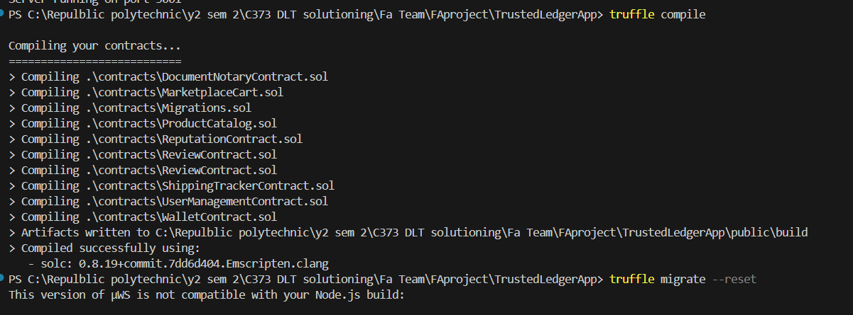

- Deploy and Migrate to the Testnet (Sepolia/Goerli etc)
< Provide brief description of what you do. Provide screenshot(s) if available>

- Provide any other evidence(s) of your migration and deployment contributions
<Describe briefly. Provide screenshot(s) if available>
PS C:\Repulblic polytechnic\y2 sem 2\C373 DLT solutioning\Fa Team\FAproject\TrustedLedgerApp> truffle migrate --reset
This version of µWS is not compatible with your Node.js build:

Error: Cannot find module '../binaries/uws_win32_x64_137.node'
Require stack:
- C:\Users\24046565\AppData\Roaming\npm\node_modules\truffle\node_modules\ganache\node_modules\@trufflesuite\uws-js-unofficial\src\uws.js
- C:\Users\24046565\AppData\Roaming\npm\node_modules\truffle\node_modules\ganache\dist\node\core.js
- C:\Users\24046565\AppData\Roaming\npm\node_modules\truffle\build\migrate.bundled.js
- C:\Users\24046565\AppData\Roaming\npm\node_modules\truffle\node_modules\original-require\index.js
- C:\Users\24046565\AppData\Roaming\npm\node_modules\truffle\build\cli.bundled.js
Falling back to a NodeJS implementation; performance may be degraded.

Compiling your contracts...
===========================
> Compiling .\contracts\DocumentNotaryContract.sol
> Compiling .\contracts\MarketplaceCart.sol
> Compiling .\contracts\Migrations.sol
> Compiling .\contracts\ProductCatalog.sol
> Compiling .\contracts\ReputationContract.sol
> Compiling .\contracts\ReviewContract.sol
> Compiling .\contracts\ShippingTrackerContract.sol
> Compiling .\contracts\UserManagementContract.sol
> Compiling .\contracts\WalletContract.sol
> Artifacts written to C:\Repulblic polytechnic\y2 sem 2\C373 DLT solutioning\Fa Team\FAproject\TrustedLedgerApp\public\build
> Compiled successfully using:
- solc: 0.8.19+commit.7dd6d404.Emscripten.clang

Starting migrations...
======================
> Network name: 'development'
> Network id: 5777
> Block gas limit: 6721975 (0x6691b7)

1_initial_migration.js
======================

Replacing 'Migrations'
----------------------
> transaction hash: 0x9293864bde7600e69b033f81b5f7bf58c24c1e5401fd54019ad1099a736b0e27
> Blocks: 0 Seconds: 0
> contract address: 0xb889d0B50e1b712E6b652aEA574b33973d065535
> block number: 110
> block timestamp: 1769614863
> account: 0x46EB73Cb66991C07622b3aB77a6E9A93139EE661
> balance: 99.945100167838481124
> gas used: 147922 (0x241d2)
> gas price: 2.500016499 gwei
> value sent: 0 ETH
> total cost: 0.000369807440565078 ETH

> Saving migration to chain.
> Saving artifacts
-------------------------------------
> Total cost: 0.000369807440565078 ETH

2_deploy_contracts.js
=====================

Replacing 'UserManagementContract'
----------------------------------
> transaction hash: 0x3a7d26a0a7b2400d5350c5448ecf3ce8fce656b4f451faf4e0c0b9cdd7de4969
> Blocks: 0 Seconds: 0
> contract address: 0xF188039cDc39D3193FF99CE0D76C2b15B81EED3C
> block number: 112
> block timestamp: 1769614863
> account: 0x46EB73Cb66991C07622b3aB77a6E9A93139EE661
> balance: 99.943488659546482221
> gas used: 598967 (0x923b7)
> gas price: 2.500012737 gwei
> value sent: 0 ETH
> total cost: 0.001497425129042679 ETH

Replacing 'WalletContract'
--------------------------
> transaction hash: 0x9df5a578ef2c990b920629d0f07c39d68b6cf8fca0bd5e70e8eab0e007deb3eb
> Blocks: 0 Seconds: 0
> contract address: 0xa1F467008f66206007cD7f7c45dB3197E1E2cd79
> block number: 113
> block timestamp: 1769614863
> account: 0x46EB73Cb66991C07622b3aB77a6E9A93139EE661
> balance: 99.94063054898040369
> gas used: 1143239 (0x1171c7)
> gas price: 2.500011429 gwei
> value sent: 0 ETH
> total cost: 0.002858110566078531 ETH

Replacing 'ReputationContract'
------------------------------
> transaction hash: 0x650dcbc2eaed4a32ddda2e23904a08f0be55597710c0917fa4c3742574c26631
> Blocks: 0 Seconds: 0
> contract address: 0x6016F622C4C832855470656346d5Ec2244a9C79f
> block number: 114
> block timestamp: 1769614863
> account: 0x46EB73Cb66991C07622b3aB77a6E9A93139EE661
> balance: 99.938524992648053037
> gas used: 842219 (0xcd9eb)
> gas price: 2.500010487 gwei
> value sent: 0 ETH
> total cost: 0.002105556332350653 ETH

Replacing 'ReviewContract'
--------------------------
> transaction hash: 0x68b267bb151356181841f1c73277833e6d7f35fdea8b7dd3c9516a7e9f39e43f
> Blocks: 0 Seconds: 0
> contract address: 0xd515B5bBb108B85570fef9D391164e7D33308015
> block number: 115
> block timestamp: 1769614863
> account: 0x46EB73Cb66991C07622b3aB77a6E9A93139EE661
> balance: 99.935888470124032512
> gas used: 1054605 (0x10178d)
> gas price: 2.500009505 gwei
> value sent: 0 ETH
> total cost: 0.002636522524020525 ETH

Replacing 'DocumentNotaryContract'
----------------------------------
> transaction hash: 0x86b05d2a5ab86828ecdffb8cfff21e938a0ee2bc2ff6bf824a42a675e0bfc883
> Blocks: 0 Seconds: 0
> contract address: 0x122847d8c85b05B77Abbe5E2753637D44fDD2bE5
> block number: 116
> block timestamp: 1769614863
> account: 0x46EB73Cb66991C07622b3aB77a6E9A93139EE661
> balance: 99.934501290302212212
> gas used: 554870 (0x87776)
> gas price: 2.50000869 gwei
> value sent: 0 ETH
> total cost: 0.0013871798218203 ETH

> Saving migration to chain.
> Saving artifacts
-------------------------------------
> Total cost: 0.010484794373312688 ETH

2_deploy_ShippingTrackerContract.js
===================================

Replacing 'ShippingTrackerContract'
-----------------------------------
> transaction hash: 0x57d19a8ea57edad07c723d8cbb7d054dd9ce85e4fde1843ccb64e775a9dddd0c
> Blocks: 0 Seconds: 0
> contract address: 0x8205C3d83A9680e604df7915e907Eb037e3CBea8
> block number: 118
> block timestamp: 1769614864
> account: 0x46EB73Cb66991C07622b3aB77a6E9A93139EE661
> balance: 99.92784454961516742
> gas used: 2634156 (0x2831ac)
> gas price: 2.50000682 gwei
> value sent: 0 ETH
> total cost: 0.00658540796494392 ETH

> Saving migration to chain.
> Saving artifacts
-------------------------------------
> Total cost: 0.00658540796494392 ETH

3_deploy_product_catalog.js
===========================

Replacing 'ProductCatalog'
--------------------------
> transaction hash: 0xfae3dae9833ccc9c472e8fa78b483eb8581a9332ce6cdf2a6265f8c3afa90fc9
> Blocks: 0 Seconds: 0
> contract address: 0x0137a5C2Fb1fea70C589C48C0e165Ea2fCA533b4
> block number: 120
> block timestamp: 1769614864
> account: 0x46EB73Cb66991C07622b3aB77a6E9A93139EE661
> balance: 99.923958108057256312
> gas used: 1528840 (0x175408)
> gas price: 2.500005813 gwei
> value sent: 0 ETH
> total cost: 0.00382210888714692 ETH

> Saving migration to chain.
> Saving artifacts
-------------------------------------
> Total cost: 0.00382210888714692 ETH

4_wire_marketplace.js
=====================

Replacing 'MarketplaceCart'
---------------------------
> transaction hash: 0xed26bae043d61919733b94f620fa5010a9b2adfbee088a7465b99312a28cc5ec
> Blocks: 0 Seconds: 0
> contract address: 0x57c69d33F07e36d24A2C5A8994820ceCDF251DBC
> block number: 126
> block timestamp: 1769614865
> account: 0x46EB73Cb66991C07622b3aB77a6E9A93139EE661
> balance: 99.914326205761619993
> gas used: 556014 (0x87bee)
> gas price: 2.500003191 gwei
> value sent: 0 ETH
> total cost: 0.001390036774240674 ETH

> Saving migration to chain.
> Saving artifacts
-------------------------------------
> Total cost: 0.001390036774240674 ETH

Summary
=======
> Total deployments: 9
> Final cost: 0.02265215544020928 ETH

PS C:\Repulblic polytechnic\y2 sem 2\C373 DLT solutioning\Fa Team\FAproject\TrustedLedgerApp>
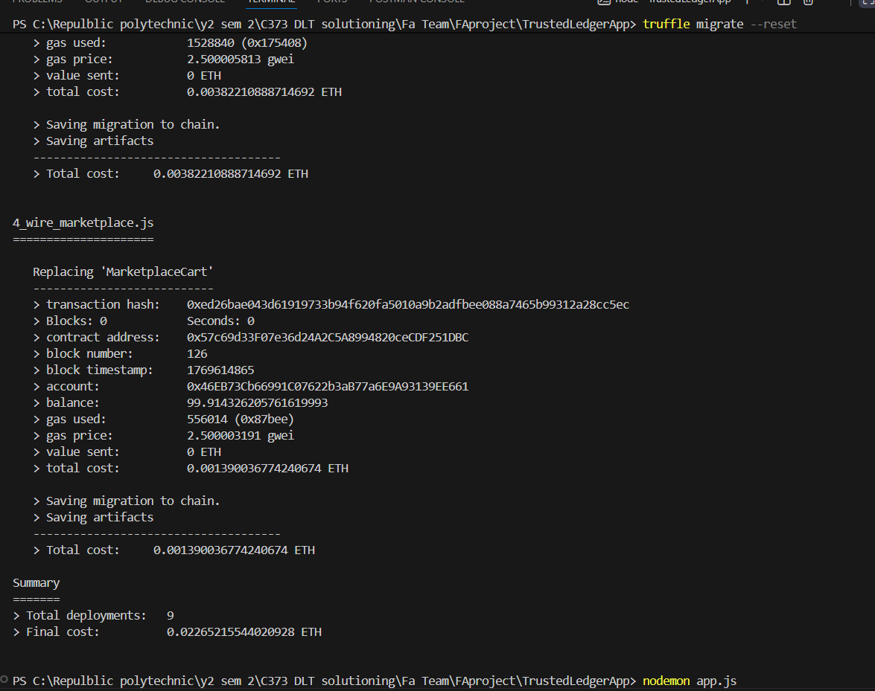

Section 3: Individual Reflection

- Write succinctly (200-500 words only) reflection. Your discussion includes challenges faced and how you overcome them.

- Individual – Additional tasks performed individually e.g. Integration to wallet etc

<A brief description of what you did. Provide screenshot(s) if available>
- Smartcontracts: authored ReviewContract.sol, ReputationContract.sol, UserManagementContract.sol, and WalletContract.sol with full on-chain logic for reviews, weighted seller reputation, role/status registry, and custodial wallet + escrow (*.sol).
- Auth & session flows: built email/password login, admin login gating, registration, session storage, and route guards requireLogin / requireAdmin to protect wallet/admin pages (app.js).
- Wallet UX (mocked backend): created /wallet route that renders balances, token metadata, and transaction history for the user session (app.js).
- Product catalog & admin add flow: mock product data, product detail view, rating distribution, and an /addproduct form with validation + dynamic product creation (app.js).
- Shipping/Web3 integration: endpoints for MetaMask/web3 connection and shipment lifecycle—/web3Connect (load ABI, connect to contract, get shipment count), /shipments (list seller shipments), /createShipment, /track/:trackingId, /updateStatus/:trackingId, /confirmDelivery/:trackingId—including input validation and gas estimates (app.js).

Section 4: AI Interaction Journal
- Provide the prompts that you have executed during this assignment. DO NOT INCLUDE THE RESPONSES
- Declare the AI, LLMs tools/ URLs that you used
- For each prompt: Explain its usage and usefulness in your - research, analysis, coding, etc.

Format:
- Prompt Executed:
  - Tool used (URL if online):
  - Usage and usefulness:

- Prompt Executed:
  - Tool used (URL if online):
  - Usage and usefulness:

