//program1

#include<stdio.h>

#include<stdlib.h>

struct employee

{

char name[30];

char q[40];

int salary;

int age;

};

typedef struct employee e;

int main()

{

void input(e *);

void average(e *,int);

void display(e *);

int n, i=0;

printf("How many entries do you need?\n");

scanf("%d",&n);

e *a=(e *)malloc(n*sizeof(e));

for(i=0;i<n;i++)

input(&a[i]);

printf("The entries are as follows\n\n");

for(i=0;i<n;i++)

display(&a[i]);

average(a,n);

}

void input(e *a)

{

printf("Enter name:");

scanf("%s",a->name);

while((getchar()!='\n'));

printf("\nEnter Qualification:");

gets(a->q);

printf("\nEnter age:");

scanf("%d",&a->age);

printf("\nEnter salary:");

scanf("%d",&a->salary);

printf("\n\n");

}

void display(e *a)

{

printf("Name:%s\n",a->name);

printf("Qualification:%s\n",a->q);

printf("Age:%d\n",a->age);

printf("Salary:%d\n",a->salary);

printf("\n\n");

}

void average(e *a,int n)

{

int sum=0,i;

for(i=0;i<n;i++)

sum+=a[i].salary;

printf("The average salary of these employees is %f\n",(float)sum/n);

}

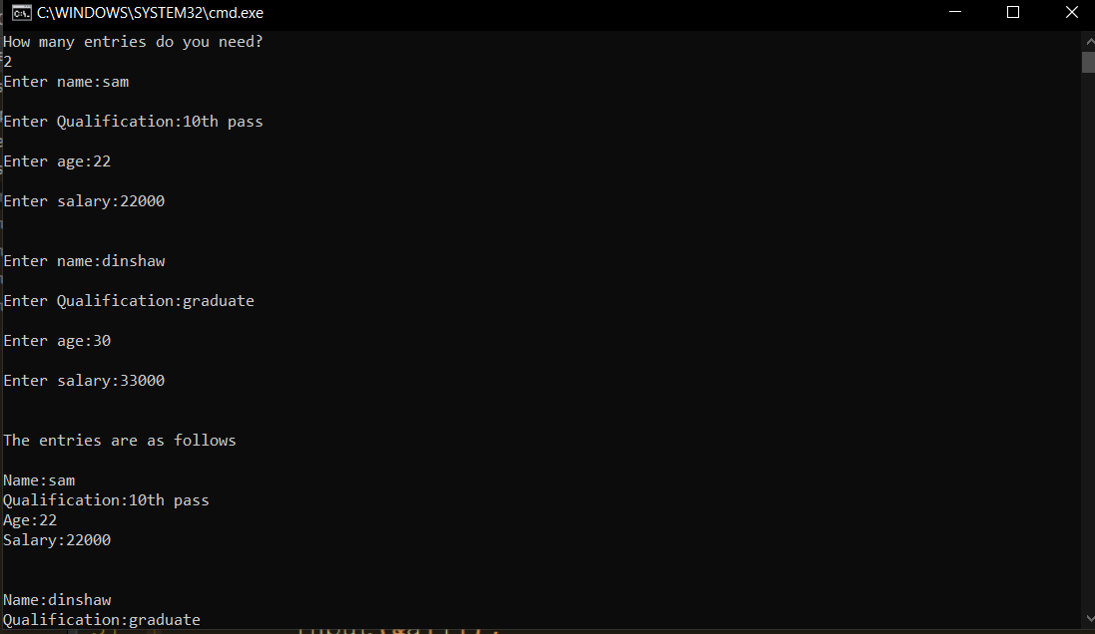

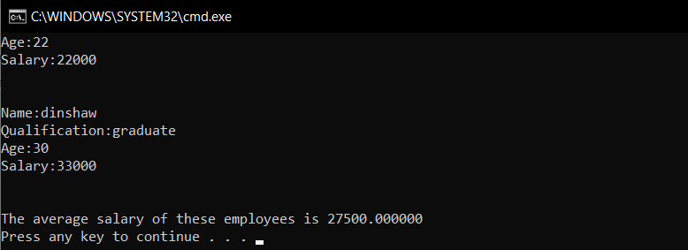

//Program 3

#include<stdio.h>

#include<stdlib.h>

struct student

{

int id;

int age;

float percent;

};

typedef struct student s;

int main()

{

void smallest(s *,int);

void input(s *);

void display(s *);

int n, i=0;

printf("How many entries do you need?\n");

scanf("%d",&n);

while((getchar()!='\n'));

s *a=(s *)malloc(n*sizeof(s));

for(i=0;i<n;i++)

input(&a[i]);

printf("The entries of students are as follows\n");

for(i=0;i<n;i++)

display(&a[i]);

printf("Displaying the details of student(s) having lowest percentage...\n\n");

smallest(a,n);

}

void input(s *a)

{

printf("\nEnter Student ID:");

scanf("%d",&a->id);

printf("\nEnter age:");

scanf("%d",&a->age);

printf("\nEnter Percentage:");

scanf("%f",&a->percent);

printf("\n\n");

}

void display(s *a)

{

printf("ID:%d\n",a->id);

printf("Age:%d\n",a->age);

printf("Percentage:%f\n",a->percent);

printf("\n");

}

void smallest(s* a,int n)

{

int i;

float small=a[0].percent;

for(i=1;i<n;i++)

if(small>a[i].percent)

small=a[i].percent;

for(i=0;i<n;i++)

if(a[i].percent==small)

display(&a[i]);

}

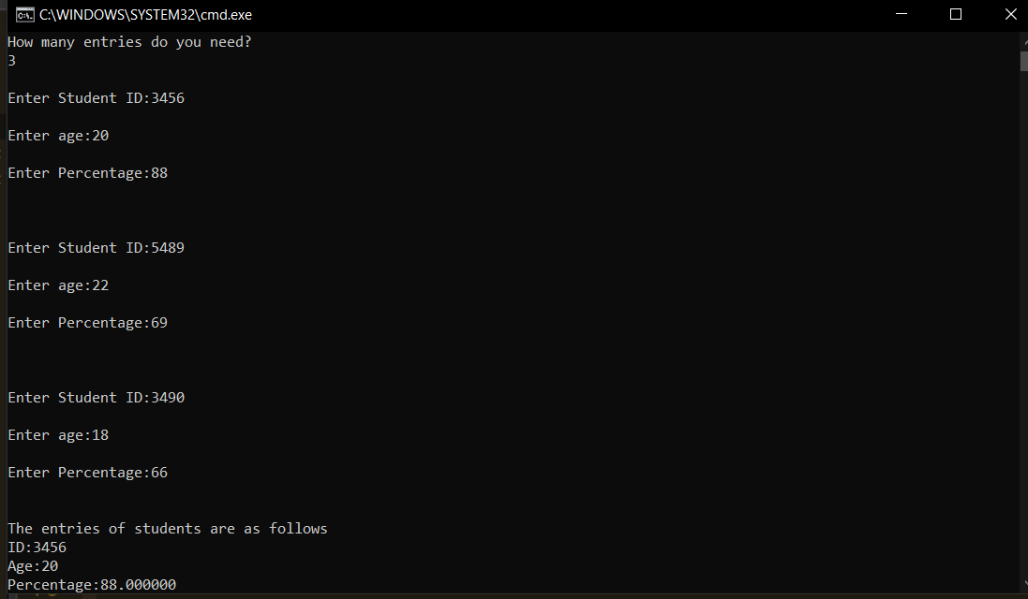

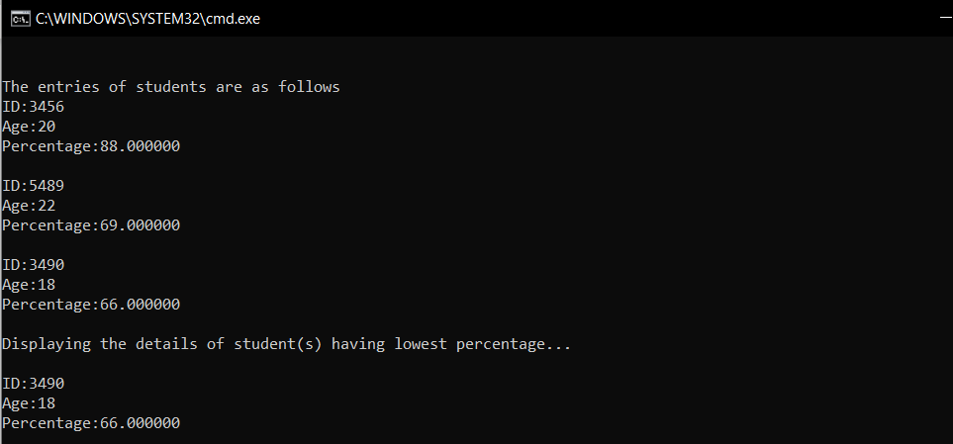

//Program 2

#include<stdio.h>

#include<stdlib.h>

struct student

{

char name[30];

char branch[30];

int id;

int age;

};

typedef struct student s;

int main()

{

void greater(s *,int);

void input(s *);

void display(s *);

int n, i=0;

printf("How many entries do you need?\n");

scanf("%d",&n);

while((getchar()!='\n'));

s *a=(s *)malloc(n*sizeof(s));

for(i=0;i<n;i++)

input(&a[i]);

printf("The entries of students are as follows\n");

for(i=0;i<n;i++)

display(&a[i]);

printf("Displaying the details of students who are 20 years old or above...\n\n");

greater(a,n);

}

void input(s *a)

{

printf("Enter name:");

gets(a->name);

printf("\nEnter ID:");

scanf("%d",&a->id);

printf("\nEnter age:");

scanf("%d",&a->age);

while((getchar()!='\n'));

printf("\nEnter branch:");

gets(a->branch);

printf("\n\n");

}

void display(s *a)

{

printf("ID:%d\n",a->id);

printf("Name:%s\n",a->name);

printf("Age:%d\n",a->age);

printf("Branch:%s\n",a->branch);

printf("\n\n");

}

void greater(s *a,int n)

{

int i,c=0;

for(i=0;i<n;i++)

if(a[i].age>=20)

{

display(&a[i]);

c=1;

}

if(!c)

printf("There is no student whose age is greater than or equal to 20\n");

}

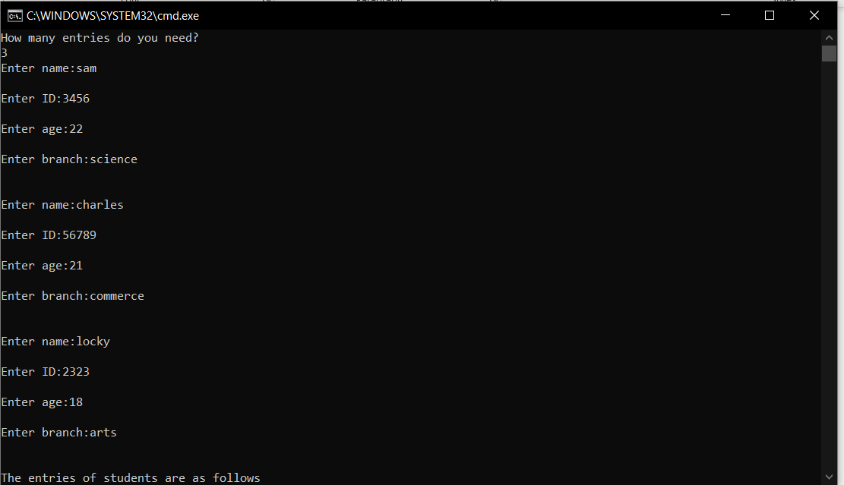

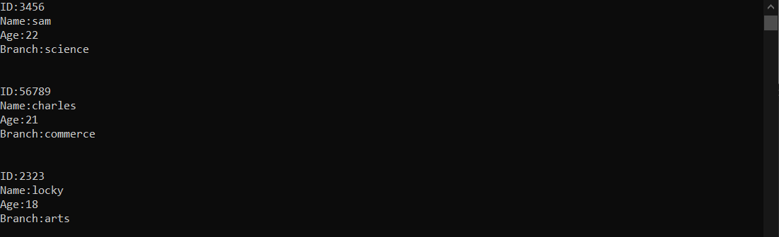

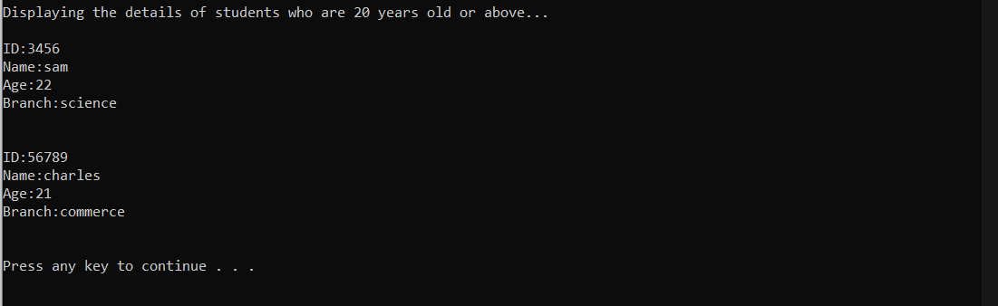

//program 4

#include<stdio.h>

#include<stdlib.h>

struct subject

{

int sub[6];

};

typedef struct subject s;

struct student

{

char name[30];

char class[30];

int roll;

int sem;

s a;

};

typedef struct student st;

int main()

{

void total(st *);

void input(st *);

int i=0;

st *arr=(st *)malloc(1*sizeof(st));

input(&arr[i]);

total(&arr[i]);

}

void input(st* arr)

{

int i=0;

printf("Enter name:");

gets(arr->name);

printf("\nEnter ID:");

scanf("%d",&arr->roll);

while((getchar()!='\n'));

printf("\nEnter class:");

gets(arr->class);

printf("\nEnter Semester:");

scanf("%d",&arr->sem);

printf("Enter marks(out of 100) obtained in the following subjects of the Semester\n");

printf("English:\n");

scanf("%d",&arr->a.sub[i]);

i++;

printf("French:\n");

scanf("%d",&arr->a.sub[i]);

i++;

printf("Maths:\n");

scanf("%d",&arr->a.sub[i]);

i++;

printf("Computer Science:\n");

scanf("%d",&arr->a.sub[i]);

i++;

printf("Geography:\n");

scanf("%d",&arr->a.sub[i]);

i++;

printf("History:\n");

scanf("%d",&arr->a.sub[i]);

}

void total(st *arr)

{

int i,sum=0;

float p;

for(i=0;i<6;i++)

sum+=arr->a.sub[i];

p=sum/6.0;

printf("Your total is %d\n",sum);

if(p>=75)

printf("You have achieved class Distinction!\n");

else if(p>=60)

printf("You have achieved First Class\n");

else if(p>=55)

printf("You have passed with Second Class\n");

else

printf("You have achieved Pass Class\n");

printf("\n\n");

}

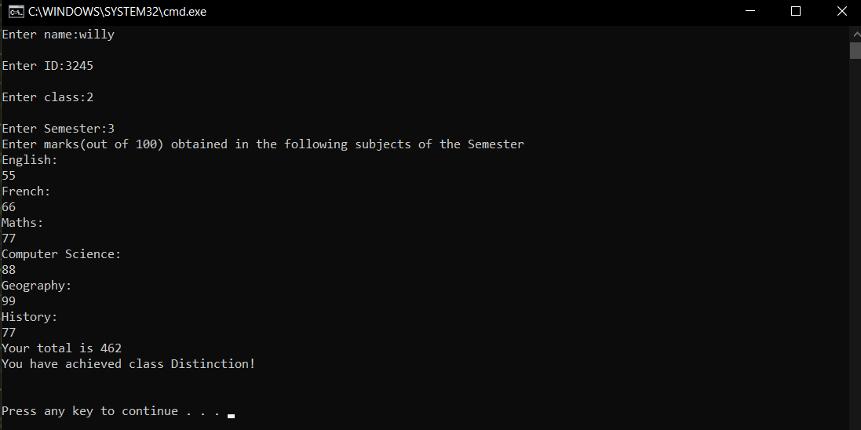

//Program 5

#include<stdio.h>

#include<stdlib.h>

struct date

{

int d,m,y;

};

typedef struct date dof;

struct employee

{

int id;

dof b,j;

};

typedef struct employee e;

int main()

{

void retire(e *);

void input(e *);

e *a=(e *)malloc(1*sizeof(e));

input(a);

retire(a);

}

void input(e *a)

{

printf("\nEnter Employee ID:");

scanf("%d",&a->id);

printf("\nEnter date of birth DD-MM-YYY:");

scanf("%d %d %d",&a->b.d,&a->b.m,&a->b.y);

printf("\nEnter date of joining DD-MM-YYY:");

scanf("%d %d %d",&a->j.d,&a->j.m,&a->j.y);

}

void retire(e *a)

{

int years,day,month,years_left,months_left,days_left;

years=a->j.y-a->b.y;

month=a->j.m-a->b.m;

day=a->j.d-a->b.d;

if(month<0)

month=month*-1;

if(day<0)

day*=-1;

if(a->j.m<a->b.m)

{ years-=1;

month=12-month;

}

if(a->j.d<a->b.d)

{

month-=1;

day=31-day;

}

years_left=60-years;

months_left=month;

days_left=day;

if(month!=0 || day!=0)

years_left-=1;

if(month!=0)

months_left=12-month;

if(day<0)

day=-1*day;

if(day!=0)

{

months_left-=1;

days_left=31-day;

}

if(days_left<0)

days_left=days_left*-1;

if(months_left<0)

months_left=months_left*-1;

printf("You will retire in exactly %d years, %d month(s) and %d day(s)\n\n",years_left,months_left,days_left);

}

