1: WRITE A PROGRAM OF DOUBLY LINKED LIST WITH THE FOLLOWING OPERATIONS

* CREATE LIST
* DISPLAY THE LL
* ADD TO EMPTY LSIT
* ADD AT THE BEGINNING
* ADD AT THE END
* ADD AFTER A SPECIFIED NODE
* ADD BEFORE A SPECIFIED NODE
* DELETE

Program:

#include<stdio.h>

#include<stdlib.h>

struct node {

struct node *prev;

int info;

struct node *next;

};

struct node *create_list(struct node *start);

void display(struct node *start);

struct node *addtoempty(struct node *start,int data);

struct node *addatbeg(struct node *start,int data);

struct node *addatend(struct node *start,int data);

struct node *addafter(struct node *start,int data,int item);

struct node *addbefore(struct node *start,int data,int item);

struct node *del(struct node *start,int data);

int main() {

int choice,data,item;

struct node *start=NULL;

while(1) {

printf("1.Create the List\n");

printf("2.Display the list\n");

printf("3.Add to empty list\n");

printf("4.Add at beginning of the list\n");

printf("5.Add at end of the list\n");

printf("6.Add after\n");

printf("7.Add before\n");

printf("8.Delete\n");

printf("9.Quit\n");

printf("Enter choice : ");

scanf("%d",&choice);

switch(choice) {

case 1:

start=create_list(start);

break;

case 2:

display(start);

break;

case 3:

printf("Enter the element to be inserted : ");

scanf("%d",&data);

start=addtoempty(start,data);

break;

case 4:

printf("Enter the element to be inserted : ");

scanf("%d",&data);

start=addatbeg(start,data);

break;

case 5:

printf("Enter the element to be inserted : ");

scanf("%d",&data);

start=addatend(start,data);

break;

case 6:

printf("Enter the element to be inserted : ");

scanf("%d",&data);

printf("Enter the element after which to insert : ");

scanf("%d",&item);

start=addafter(start,data,item);

break;

case 7:

printf("Enter the element to be inserted : ");

scanf("%d",&data);

printf("Enter the element before which to insert : ");

scanf("%d",&item);

start=addbefore(start,data,item);

break;

case 8:

printf("Enter the element to be deleted : ");

scanf("%d",&data);

start=del(start,data);

break;

case 9:

exit(1);

default:

printf("Wrong choice\n");

}/*End of switch*/

printf("\n\n\n");

}/*End of while*/

return 0;

}/*End of main()*/

struct node *create_list(struct node *start) {

int i,n,data;

printf("Enter the number of nodes : ");

scanf("%d",&n);

start=NULL;

if(n==0)

return start;

printf("Enter the element to be inserted : ");

scanf("%d",&data);

start=addtoempty(start,data);

for(i=2;i<=n;i++) {

printf("Enter the element to be inserted : ");

scanf("%d",&data);

start=addatend(start,data);

}

return start;

}/*End of create_list()*/

void display(struct node *start) {

struct node *p;

if(start==NULL) {

printf("List is empty\n");

return;

}

p=start;

printf("List is :\n");

while(p!=NULL) {

printf("%d ",p->info);

p=p->next;

}

printf("\n");

}/*End of display() */

struct node *addtoempty(struct node *start,int data) {

struct node *tmp;

tmp=(struct node *)malloc(sizeof(struct node));

tmp->info=data;

tmp->prev=NULL;

tmp->next=NULL;

start=tmp;

return start;

}/*End of addtoempty( )*/

struct node *addatbeg(struct node *start,int data) {

struct node *tmp;

tmp = (struct node *)malloc(sizeof(struct node));

tmp->info=data;

tmp->prev=NULL;

tmp->next=start;

start->prev=tmp;

start=tmp;

return start;

}/*End of addatbeg( )*/

struct node *addatend(struct node *start,int data) {

struct node *tmp,*p;

tmp=(struct node *)malloc(sizeof(struct node));

tmp->info=data;

p=start;

while(p->next!=NULL) p=p->next;

p->next=tmp;

tmp->next=NULL;

tmp->prev=p;

return start;

}/*End of addatend( )*/

struct node *addafter(struct node *start,int data,int item) {

struct node *tmp,*p;

tmp=(struct node *)malloc(sizeof(struct node));

tmp->info=data;

p=start;

while(p!=NULL) {

if(p->info==item) {

tmp->prev=p;

tmp->next=p->next;

if(p->next!=NULL) p->next->prev=tmp;

p->next=tmp;

return start;

}

p=p->next;

}

printf("%d not present in the list\n\n",item);

return start;

}/*End of addafter()*/

struct node *addbefore(struct node *start,int data,int item) {

struct node *tmp,*q;

if(start==NULL ) {

printf("List is empty\n");

return start;

}

if(start->info==item) {

tmp = (struct node *)malloc(sizeof(struct node));

tmp->info=data;

tmp->prev=NULL;

tmp->next=start;

start->prev=tmp;

start=tmp;

return start;

}

q=start;

while(q!=NULL) {

if(q->info==item) {

tmp=(struct node *)malloc(sizeof(struct node));

tmp->info=data;

tmp->prev=q->prev;

tmp->next = q;

q->prev->next=tmp;

q->prev=tmp;

return start;

}

q=q->next;

}

printf("%d not present in the list\n",item);

return start;

}

struct node *del(struct node *start,int data) {

struct node *tmp;

if(start==NULL) {

printf("List is empty\n");

return start;

}

if(start->next==NULL)

if(start->info==data) {

tmp=start;

start=NULL;

free(tmp);

return start;

}

else

{

printf("Element %d not found\n",data);

return start;

}

if(start->info==data)

{

tmp=start;

start=start->next;

start->prev=NULL;

free(tmp);

return start;

}

/*Deletion in between*/

tmp=start->next;

while(tmp->next!=NULL ) {

if(tmp->info==data) {

tmp->prev->next=tmp->next;

tmp->next->prev=tmp->prev;

free(tmp);

return start;

}

tmp=tmp->next;

}

/*Deletion of last node*/

if(tmp->info==data) {

tmp->prev->next=NULL;

free(tmp);

return start;

}

printf("Element %d not found\n",data);

return start;

}

Output 1:

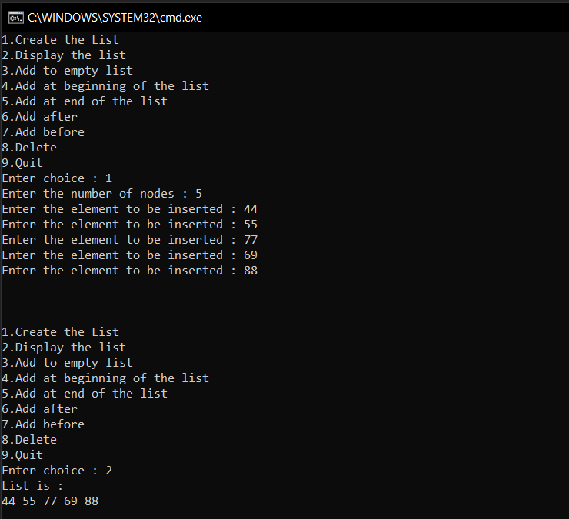

Output 2:

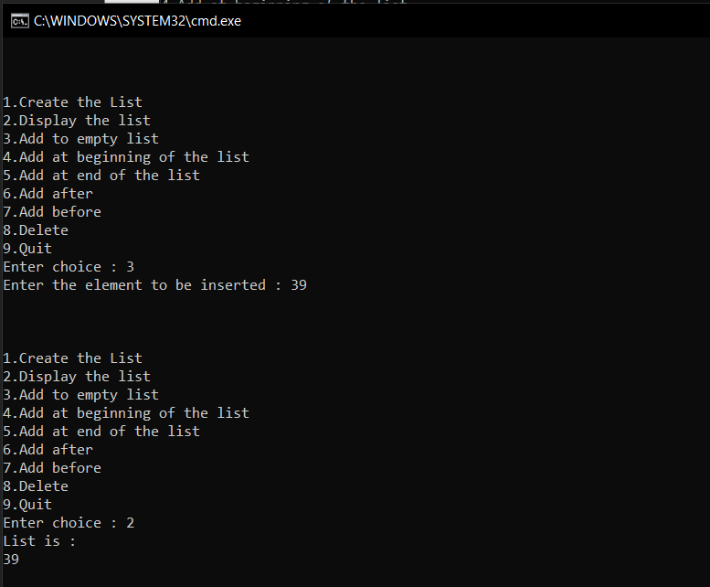

Output 3:

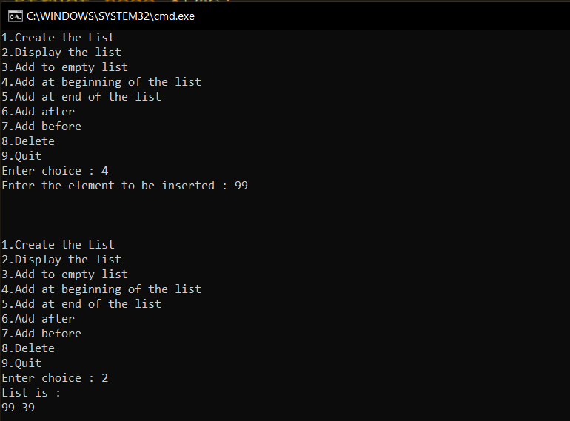

Output 4:

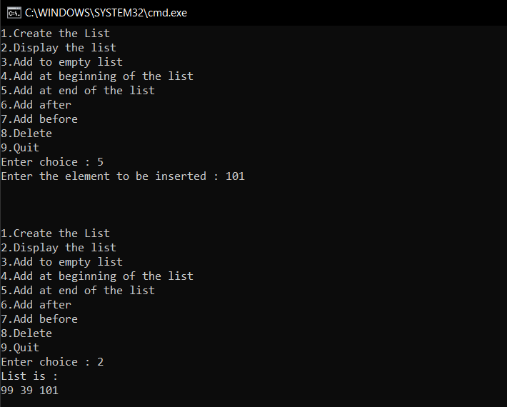

Output 5:

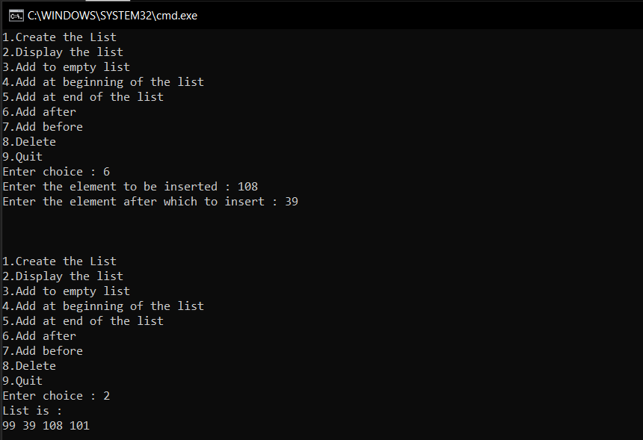

Output 6:

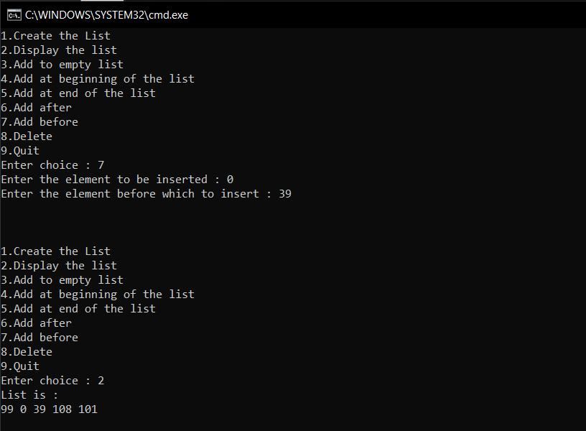

Output 7:

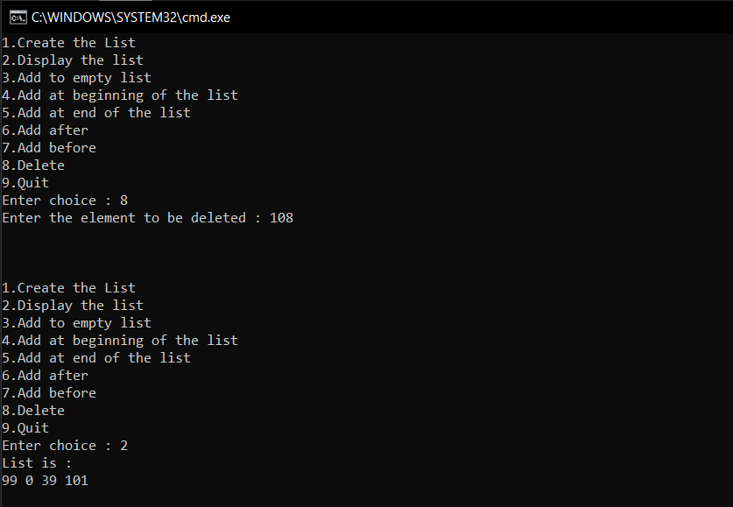

2. Write a program of circular linked list with the following

operations

* Create LL
* Display the LL
* Add to empty list
* Add at the beginning
* Add at the end
* Add after a specified node
* Add before a specified node
* Delete a specified node

Program:

#include<stdio.h>

#include<stdlib.h>

struct node {

int info;

struct node *link;

};

struct node *create_list(struct node *last);

void display(struct node *last);

struct node *addtoempty(struct node *last,int data);

struct node *addatbeg(struct node *last,int data);

struct node *addatend(struct node *last,int data);

struct node *addafter(struct node *last,int data,int item);

struct node *addbefore(struct node *last,int data,int item);

struct node *del(struct node *last,int data);

int main( ) {

int choice,data,item;

struct node *last=NULL;

while(1) {

printf("1.Create the List\n");

printf("2.Display the list\n");

printf("3.Add to empty list\n");

printf("4.Add at beginning\n");

printf("5.Add at end\n");

printf("6.Add after \n");

printf("7.Add before \n");

printf("8.Delete\n");

printf("9.Quit\n");

printf("Enter your choice : ");

scanf("%d",&choice);

switch(choice) {

case 1:

last=create_list(last);

break;

case 2:

display(last);

break;

case 3:

printf("Enter the element to be inserted : ");

scanf("%d",&data);

last=addtoempty(last,data);

break;

case 4:

printf("Enter the element to be inserted : ");

scanf("%d",&data);

last=addatbeg(last,data);

break;

case 5:

printf("Enter the element to be inserted : ");

scanf("%d",&data);

last=addatend(last,data);

break;

case 6:

printf("Enter the element to be inserted : ");

scanf("%d",&data);

printf("Enter the element after which to insert : ");

scanf("%d",&item);

last=addafter(last,data,item);

break;

case 7:

printf("Enter the element to be inserted : ");

scanf("%d",&data);

printf("Enter the element before which to insert : ");

scanf("%d",&item);

last=addbefore(last,data,item);

break;

case 8:

printf("Enter the element to be deleted : ");

scanf("%d",&data);

last=del(last,data);

break;

case 9:

exit(1);

default:

printf("Wrong choice\n");

}/*End of switch*/

printf("\n\n\n");

}/*End of while*/

return 0;

}/*End of main( )*/

struct node *create_list(struct node *last) {

int i,n,data;

printf("Enter the number of nodes : ");

scanf("%d",&n);

last=NULL;

if(n==0) return last;

printf("Enter the element to be inserted : ");

scanf("%d",&data);

last=addtoempty(last,data);

for(i=2;i<=n;i++) {

printf("Enter the element to be inserted : ");

scanf("%d",&data);

last=addatend(last,data);

}

return last;

}/*End of create_list()*/

struct node *addtoempty(struct node *last,int data) {

struct node *tmp;

tmp=(struct node *)malloc(sizeof(struct node));

tmp->info=data;

last=tmp;

last->link=last;

return last;

}/*End of addtoempty( )*/

struct node *addatbeg(struct node *last,int data) {

struct node *tmp;

tmp=(struct node *)malloc(sizeof(struct node));

tmp->info=data;

tmp->link=last->link;

last->link=tmp;

return last;

}/*End of addatbeg( )*/

struct node *addatend(struct node *last,int data) {

struct node *tmp;

tmp=(struct node *)malloc(sizeof(struct node));

tmp->info=data;

tmp->link=last->link;

last->link=tmp;

last=tmp;

return last;

}/*End of addatend( )*/

struct node *addafter(struct node *last,int data,int item) {

struct node *tmp,*p;

p=last->link;

do {

if(p->info==item) {

tmp=(struct node *)malloc(sizeof(struct node));

tmp->info=data;

tmp->link=p->link;

p->link=tmp;

if(p==last)

last=tmp;

return last;

}

p=p->link;

}while(p!=last->link);

printf("%d not present in the list\n",item);

return last;

}/*End of addafter()*/

struct node *addbefore(struct node *last,int data,int item) {

struct node *tmp,*p;

if(last==NULL ) {

printf("List is empty\n");

return last;

}

if(last->link->info==item) {

tmp=(struct node *)malloc(sizeof(struct node));

tmp->info=data;

tmp->link=last->link;

last->link=tmp;

return last;

}

p=last->link;

do {

if(p->link->info==item) {

tmp=(struct node *)malloc(sizeof(struct node));

tmp->info=data;

tmp->link=p->link;

p->link=tmp;

return last;

}

p=p->link;

}while(p!=last->link);

printf("%d not present in list\n",item);

return last;

}/*End of addbefore()*/

struct node *del(struct node *last,int data) {

struct node *tmp,*p;

if(last==NULL) {

printf("List is empty\n");

return last;

}

/*Deletion of only node*/

if(last->link==last && last->info==data) {

tmp=last;

last=NULL;

free(tmp);

return last;

}

/*Deletion of first node*/

if(last->link->info==data) {

tmp=last->link;

last->link=tmp->link;

free(tmp);

return last;

}

/*Deletion in between*/

p=last->link;

while(p->link!=last) {

if(p->link->info==data) {

tmp=p->link;

p->link=tmp->link;

free(tmp);

return last;

}

p=p->link;

}

/*Deletion of last node*/

if(last->info==data) {

tmp=last;

p->link=last->link;

last=p;

free(tmp);

return last;

}

printf("Element %d not found\n",data);

return last;

}/*End of del( )*/

void display(struct node *last) {

struct node *p;

if(last==NULL) {

printf("List is empty\n");

return;

}

printf("List is:\n");

p=last->link;

do {

printf("%d ",p->info);

p=p->link;

}while(p!=last->link);

printf("\n");

}

Output 1:

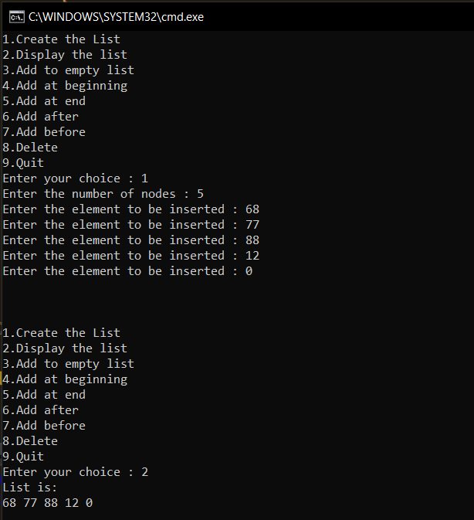

Output 2:

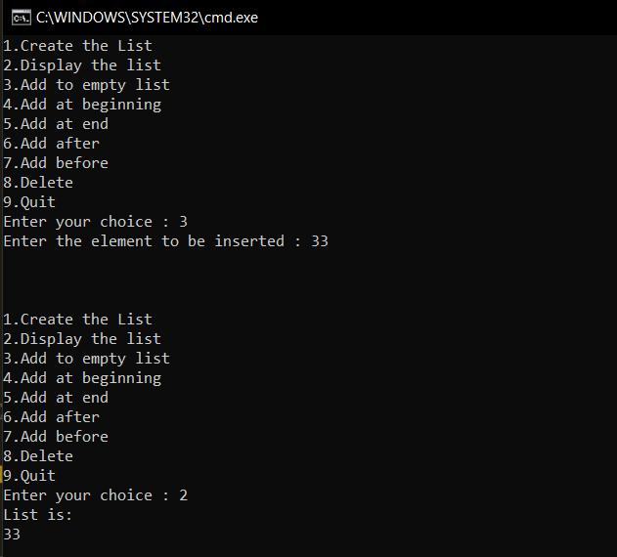

Output 3:

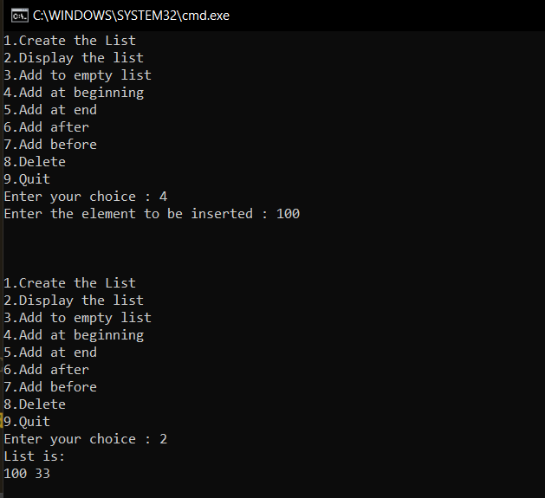

Output 4:

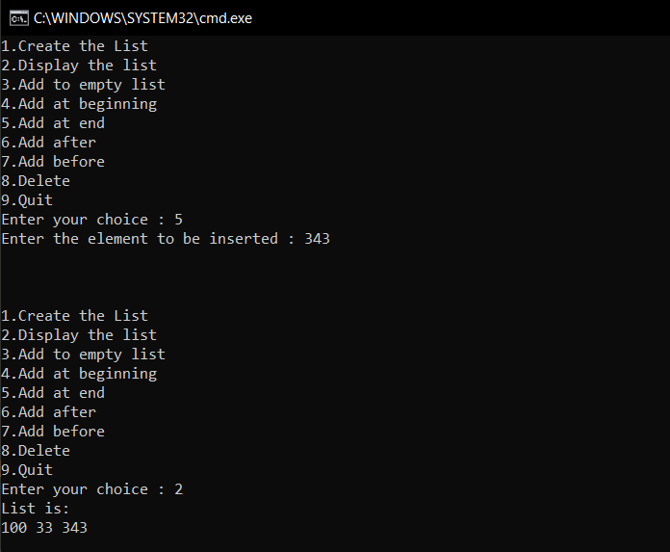

Output 5:

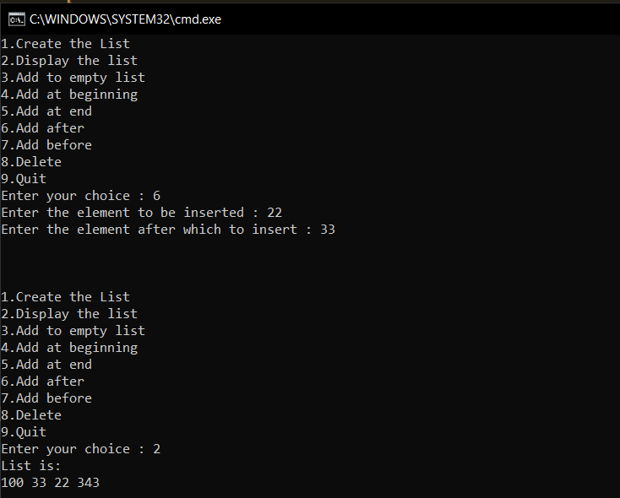

Output 6:

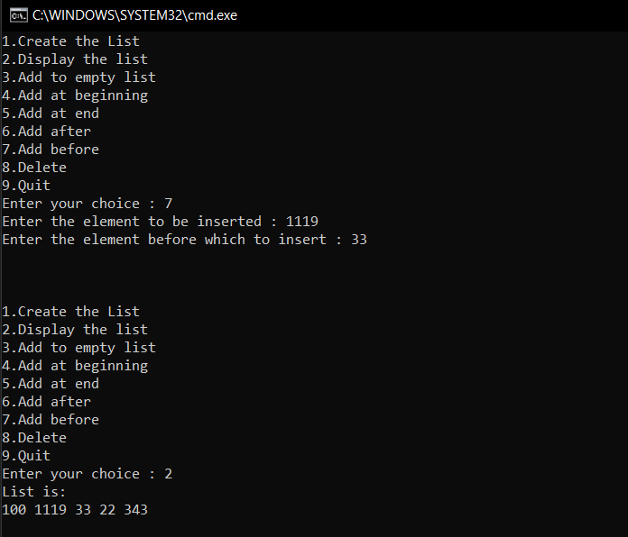

Output 7:

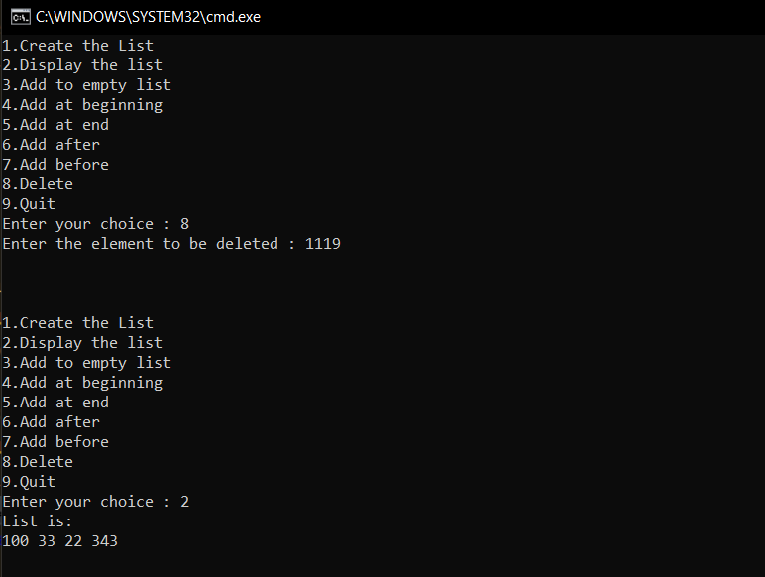

3. Write a program to add two polynomials using linked lists

Program:

#include<stdio.h>

#include<conio.h>

#include<stdlib.h>

struct node {

float coef;

int expo;

struct node *link;

};

struct node *create(struct node *);

struct node *insert_s(struct node *,float,int);

struct node *insert(struct node *,float,int);

void display(struct node *ptr);

void poly_add(struct node *,struct node *);

int main( ) {

struct node *start1=NULL,*start2=NULL;

printf("__________________________________\n");

printf("Enter polynomial 1 :\n");

start1=create(start1);

printf("__________________________________\n");

printf("Enter polynomial 2 :\n");

start2=create(start2);

printf("__________________________________\n\n");

printf("Polynomial 1 is : ");

display(start1);

printf("Polynomial 2 is : ");

display(start2);

poly_add(start1, start2);

getch();

return 0;

}/*End of main()*/

struct node *create(struct node *start) {

int i,n,ex;

float co;

printf("Enter the number of terms : ");

scanf("%d",&n);

for(i=1;i<=n;i++) {

printf("Enter coeficient for term %d : ",i);

scanf("%f",&co);

printf("Enter exponent for term %d : ",i);

scanf("%d",&ex);

start=insert_s(start,co,ex);

}

return start;

}/*End of create()*/

struct node *insert_s(struct node *start,float co,int ex) {

struct node *ptr,*tmp;

tmp=(struct node *)malloc(sizeof(struct node));

tmp->coef=co;

tmp->expo=ex;

/*list empty or exp greater than first one */

if(start==NULL || ex > start->expo) {

tmp->link=start;

start=tmp;

}

else {

ptr=start;

while(ptr->link!=NULL && ptr->link->expo >= ex) ptr=ptr->link;

tmp->link=ptr->link;

ptr->link=tmp;

}

return start;

}/*End of insert()*/

struct node *insert(struct node *start,float co,int ex) {

struct node *ptr,*tmp;

tmp=(struct node *)malloc(sizeof(struct node));

tmp->coef=co;

tmp->expo=ex;

/*If list is empty*/

if(start==NULL) {

tmp->link=start;

start=tmp;

}

else { /*Insert at the end of the list*/

ptr=start;

while(ptr->link!=NULL)

ptr=ptr->link;

tmp->link=ptr->link;

ptr->link=tmp;

}

return start;

}/*End of insert()*/

void display(struct node *ptr) {

if(ptr==NULL) {

printf("Zero polynomial\n");

return;

}

while(ptr!=NULL) {

printf("(%.1fx^(%d))", ptr->coef,ptr->expo);

ptr=ptr->link;

if(ptr!=NULL) printf(" + ");

else printf("\n");

}

}/*End of display()*/

void poly_add(struct node *p1,struct node *p2) {

struct node *start3;

start3=NULL;

while(p1!=NULL && p2!=NULL) {

if(p1->expo > p2->expo) {

start3=insert(start3,p1->coef,p1->expo);

p1=p1->link;

}

else if(p2->expo > p1->expo) {

start3=insert(start3,p2->coef,p2->expo);

p2=p2->link;

}

else if(p1->expo==p2->expo) {

start3=insert(start3,p1->coef+p2->coef,p1->expo);

p1=p1->link;

p2=p2->link;

}

}

/*if poly2 has finished and elements left in poly1*/

while(p1!=NULL) {

start3=insert(start3,p1->coef,p1->expo);

p1=p1->link;

}

/*if poly1 has finished and elements left in poly2*/

while(p2!=NULL) {

start3=insert(start3,p2->coef,p2->expo);

p2=p2->link;

}

printf("Added polynomial is : ");

display(start3);

}

Output :

