1: Write a C Program to perform following operations on a threaded binary tree

* DISPLAY
* INSERT
* DELETE

Program:

#include <stdio.h>

#include <stdlib.h>

typedef enum {false,true} boolean;

struct node *in_succ(struct node *p);

struct node *in_pred(struct node *p);

struct node *insert(struct node *root, int ikey);

struct node *del(struct node *root, int dkey);

struct node *case_a(struct node *root, struct node *par,struct node *ptr);

struct node *case_b(struct node *root,struct node *par,struct node *ptr);

struct node *case_c(struct node *root, struct node *par,struct node *ptr);

void inorder( struct node *root);

void preorder( struct node *root);

struct node

{

struct node *left;

boolean lthread;

int info;

boolean rthread;

struct node *right;

};

int main( )

{

int choice,num;

struct node *root=NULL;

while(1)

{

printf("\n");

printf("1.Insert\n");

printf("2.Delete\n");

printf("3.Inorder Traversal\n");

printf("4.Preorder Traversal\n");

printf("5.Quit\n");

printf("Enter your choice : ");

scanf("%d",&choice);

switch(choice)

{

case 1:

printf("Enter the number to be inserted : ");

scanf("%d",&num);

root = insert(root,num);

break;

case 2:

printf("Enter the number to be deleted : ");

scanf("%d",&num);

root = del(root,num);

break;

case 3:

inorder(root);

break;

case 4:

preorder(root);

break;

case 5:

exit(1);

default:

printf("Wrong choice\n");

}

}

}

struct node *insert(struct node *root, int ikey)

{

struct node *tmp,*par,*ptr;

int found=0;

ptr = root;

par = NULL;

while( ptr!=NULL )

{

if( ikey == ptr->info)

{

found =1;

break;

}

par = ptr;

if(ikey<ptr->info)

{

if(ptr->lthread == false)

ptr = ptr->left;

else

break;

}

else

{

if(ptr->rthread == false)

ptr = ptr->right;

else

break;

}

}

if(found)

printf("Duplicate key");

else

{

tmp=(struct node *)malloc(sizeof(struct node));

tmp->info=ikey;

tmp->lthread = true;

tmp->rthread = true;

if(par==NULL)

{

root=tmp;

tmp->left=NULL;

tmp->right=NULL;

}

else if( ikey< par->info )

{

tmp->left=par->left;

tmp->right=par;

par->lthread=false;

par->left=tmp;

}

else

{

tmp->left=par;

tmp->right=par->right;

par->rthread=false;

par->right=tmp;

}

}

return root;

}

struct node *del(struct node *root, int dkey)

{

struct node *par,*ptr;

int found=0;

ptr = root;

par = NULL;

while( ptr!=NULL)

{

if( dkey == ptr->info)

{

found =1;

break;

}

par = ptr;

if(dkey<ptr->info)

{

if(ptr->lthread == false)

ptr = ptr->left;

else

break;

}

else

{

if(ptr->rthread == false)

ptr = ptr->right;

else

break;

}

}

if(found==0)

printf("dkey not present in tree");

else if(ptr->lthread==false &&ptr->rthread==false)/*2 children*/

root = case_c(root,par,ptr);

else if(ptr->lthread==false )/*only left child*/

root = case_b(root, par,ptr);

else if(ptr->rthread==false)/*only right child*/

root = case_b(root, par,ptr);

else /*no child*/

root = case_a(root,par,ptr);

return root;

}

struct node *case_a(struct node *root, struct node *par,struct node *ptr )

{

if(par==NULL) /*root node to be deleted*/

root=NULL;

else if(ptr==par->left)

{

par->lthread=true;

par->left=ptr->left;

}

else

{

par->rthread=true;

par->right=ptr->right;

}

free(ptr);

return root;

}

struct node *case_b(struct node *root,struct node *par,struct node *ptr)

{

struct node *child,*s,*p; /*Initialize child*/

if(ptr->lthread==false) /*node to be deleted has left child */

child=ptr->left;

else /*node to be deleted has right child */

child=ptr->right;

if(par==NULL ) /*node to be deleted is root node*/

root=child;

else if( ptr==par->left) /*node is left child of its parent*/

par->left=child;

else /*node is right child of its parent*/

par->right=child;

s=in_succ(ptr);

p=in_pred(ptr);

if(ptr->lthread==false) /*if ptr has left subtree */

p->right=s;

else

{

if(ptr->rthread==false) /*if ptr has right subtree*/

s->left=p;

}

free(ptr);

return root;

}

struct node *case_c(struct node *root, struct node *par,struct node *ptr)

{

struct node *succ,*parsucc; /*Find inorder successor and its parent*/

parsucc = ptr;

succ = ptr->right;

while(succ->left!=NULL)

{

parsucc = succ;

succ = succ->left;

}

ptr->info = succ->info;

if(succ->lthread==true &&succ->rthread==true)

root = case_a(root, parsucc,succ);

else

root = case_b(root, parsucc,succ);

return root;

}

struct node *in_succ(struct node *ptr)

{

if(ptr->rthread==true)

return ptr->right;

else

{

ptr=ptr->right;

while(ptr->lthread==false)

ptr=ptr->left;

return ptr;

}

}

struct node *in_pred(struct node *ptr)

{

if(ptr->lthread==true)

return ptr->left; else

{

ptr=ptr->left;

while(ptr->rthread==false)

ptr=ptr->right;

return ptr;

}

}

void inorder( struct node *root)

{

struct node *ptr; if(root == NULL )

{

printf("Tree is empty");

return;

}

ptr=root; /*Find the leftmost node */ while(ptr->lthread==false)

ptr=ptr->left;

while( ptr!=NULL )

{

printf("%d ",ptr->info);

ptr=in_succ(ptr);

}

printf("\n\n");

}

void preorder(struct node *root )

{

struct node *ptr; if(root==NULL)

{

printf("Tree is empty");

return;

}

ptr=root;

while(ptr!=NULL)

{

printf("%d ",ptr->info);

if(ptr->lthread==false)

ptr=ptr->left;

else if(ptr->rthread==false)

ptr=ptr->right;

else

{

while(ptr!=NULL &&ptr->rthread==true)

ptr=ptr->right;

if(ptr!=NULL)

ptr=ptr->right;

}

}

}

Output:

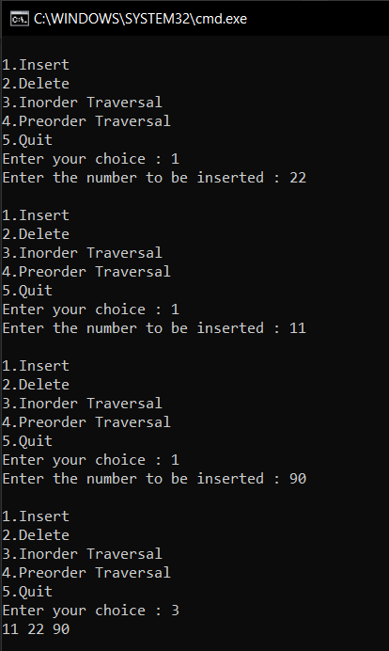 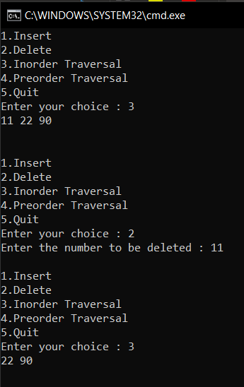

2. Write a program to implement following traversals in an in-threaded binary tree

* In order
* Pre Order

Program:

#include <stdio.h>

#include <stdlib.h>

typedef enum {false,true} boolean;

struct node *in_succ(struct node *p);

struct node *in_pred(struct node *p);

struct node *insert(struct node *root, int ikey);

struct node *del(struct node *root, int dkey);

struct node *case_a(struct node *root, struct node *par,struct node *ptr);

struct node *case_b(struct node *root,struct node *par,struct node *ptr);

struct node *case_c(struct node *root, struct node *par,struct node *ptr);

void inorder( struct node *root);

void preorder( struct node *root);

struct node

{

struct node *left;

boolean lthread;

int info;

boolean rthread;

struct node *right;

};

int main( )

{

int choice,num;

struct node *root=NULL;

while(1)

{

printf("\n");

printf("1.Insert\n");

printf("2.Inorder Traversal\n");

printf("3.Preorder Traversal\n");

printf("4.Quit\n");

printf("Enter your choice : ");

scanf("%d",&choice);

switch(choice)

{

case 1:

printf("Enter the number to be inserted : ");

scanf("%d",&num);

root = insert(root,num);

break;

case 2:

inorder(root);

break;

case 3:

preorder(root);

break;

case 4:

exit(1);

default:

printf("Wrong choice\n");

}

}

}

struct node *insert(struct node *root, int ikey)

{

struct node *tmp,*par,*ptr;

int found=0;

ptr = root;

par = NULL;

while( ptr!=NULL )

{

if( ikey == ptr->info)

{

found =1;

break;

}

par = ptr;

if(ikey<ptr->info)

{

if(ptr->lthread == false)

ptr = ptr->left;

else

break;

}

else

{

if(ptr->rthread == false)

ptr = ptr->right;

else

break;

}

}

if(found)

printf("Duplicate key");

else

{

tmp=(struct node *)malloc(sizeof(struct node));

tmp->info=ikey;

tmp->lthread = true;

tmp->rthread = true;

if(par==NULL)

{

root=tmp;

tmp->left=NULL;

tmp->right=NULL;

}

else if( ikey< par->info )

{

tmp->left=par->left;

tmp->right=par;

par->lthread=false;

par->left=tmp;

}

else

{

tmp->left=par;

tmp->right=par->right;

par->rthread=false;

par->right=tmp;

}

}

return root;

}

struct node *case_a(struct node *root, struct node *par,struct node *ptr )

{

if(par==NULL) /*root node to be deleted*/

root=NULL;

else if(ptr==par->left)

{

par->lthread=true;

par->left=ptr->left;

}

else

{

par->rthread=true;

par->right=ptr->right;

}

free(ptr);

return root;

}

struct node *case_b(struct node *root,struct node *par,struct node *ptr)

{

struct node *child,*s,*p; /*Initialize child*/

if(ptr->lthread==false) /*node to be deleted has left child */

child=ptr->left;

else /*node to be deleted has right child */

child=ptr->right;

if(par==NULL ) /*node to be deleted is root node*/

root=child;

else if( ptr==par->left) /*node is left child of its parent*/

par->left=child;

else /*node is right child of its parent*/

par->right=child;

s=in_succ(ptr);

p=in_pred(ptr);

if(ptr->lthread==false) /*if ptr has left subtree */

p->right=s;

else

{

if(ptr->rthread==false) /*if ptr has right subtree*/

s->left=p;

}

free(ptr);

return root;

}

struct node *case_c(struct node *root, struct node *par,struct node *ptr)

{

struct node *succ,*parsucc; /*Find inorder successor and its parent*/

parsucc = ptr;

succ = ptr->right;

while(succ->left!=NULL)

{

parsucc = succ;

succ = succ->left;

}

ptr->info = succ->info;

if(succ->lthread==true &&succ->rthread==true)

root = case_a(root, parsucc,succ);

else

root = case_b(root, parsucc,succ);

return root;

}

struct node *in_succ(struct node *ptr)

{

if(ptr->rthread==true)

return ptr->right;

else

{

ptr=ptr->right;

while(ptr->lthread==false)

ptr=ptr->left;

return ptr;

}

}

struct node *in_pred(struct node *ptr)

{

if(ptr->lthread==true)

return ptr->left; else

{

ptr=ptr->left;

while(ptr->rthread==false)

ptr=ptr->right;

return ptr;

}

}

void inorder( struct node *root)

{

struct node *ptr; if(root == NULL )

{

printf("Tree is empty");

return;

}

ptr=root; /*Find the leftmost node */ while(ptr->lthread==false)

ptr=ptr->left;

while( ptr!=NULL )

{

printf("%d ",ptr->info);

ptr=in_succ(ptr);

}

}

void preorder(struct node *root )

{

struct node *ptr; if(root==NULL)

{

printf("Tree is empty");

return;

}

ptr=root;

while(ptr!=NULL)

{

printf("%d ",ptr->info);

if(ptr->lthread==false)

ptr=ptr->left;

else if(ptr->rthread==false)

ptr=ptr->right;

else

{

while(ptr!=NULL &&ptr->rthread==true)

ptr=ptr->right;

if(ptr!=NULL)

ptr=ptr->right;

}

}

}

In order and Pre-order output:

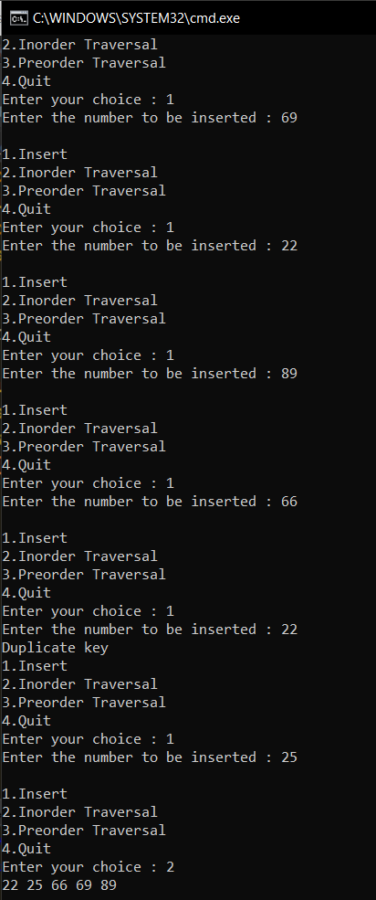 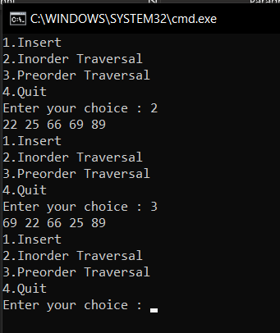

3. Write a program to implement following traversals in AVL trees

* Insertion in Left sub tree
* Insertion in Right Sub Tree

Program:

#include <stdio.h>

#include <stdlib.h>

#define FALSE 0

#define TRUE 1

struct node

{

struct node *lchild;

int info; struct node *rchild;

int balance;

};

void inorder(struct node *ptr);

struct node *RotateLeft(struct node *pptr);

struct node *RotateRight(struct node *pptr);

struct node *insert(struct node *pptr, int ikey);

struct node *insert_left_check(struct node *pptr, int *ptaller);

struct node *insert_right_check(struct node *pptr, int *ptaller);

struct node *insert_LeftBalance(struct node *pptr);

struct node *insert_RightBalance(struct node *pptr);

int main()

{

int choice,key;

struct node *root = NULL;

while(1)

{

printf("\n");

printf("1.Insert into subtree\n");

printf("2.Inorder Traversal\n");

printf("3.Quit\n");

printf("Enter your choice : ");

scanf("%d",&choice);

switch(choice)

{

case 1:

printf("Enter the key to be inserted : ");

scanf("%d",&key);

root = insert(root,key);

break;

case 2:

inorder(root);

break;

case 3:

exit(1);

default:

printf("Wrong choice\n");

}

}

}

struct node *insert(struct node *pptr, int ikey)

{

static int taller;

if(pptr==NULL) /*Base case*/

{

pptr = (struct node *) malloc(sizeof(struct node));

pptr->info = ikey;

pptr->lchild = NULL;

pptr->rchild = NULL;

pptr->balance = 0;

taller = TRUE;

}

else if(ikey<pptr->info) /*Insertion in left subtree*/

{

pptr->lchild = insert(pptr->lchild, ikey);

if(taller==TRUE)

pptr = insert_left_check( pptr, &taller );

}

else if(ikey>pptr->info) /*Insertion in right subtree */

{

pptr->rchild = insert(pptr->rchild, ikey);

if(taller==TRUE)

pptr = insert_right_check(pptr, &taller);

}

else /*Base Case*/

{

printf("Duplicate key\n");

taller = FALSE;

}

return pptr;

}

struct node *insert_left_check(struct node *pptr, int *ptaller )

{

switch(pptr->balance)

{

case 0: /* Case L_A : was balanced */

pptr->balance = 1; /* now left heavy */

break;

case -1: /* Case L_B: was right heavy */

pptr->balance = 0; /* now balanced */

*ptaller = FALSE;

break;

case 1: /* Case L_C: was left heavy */ pptr = insert_LeftBalance(pptr); /* Left Balancing */

*ptaller = FALSE;

}

return pptr;

}

struct node *insert_right_check(struct node *pptr, int *ptaller )

{

switch(pptr->balance)

{

case 0: /* Case R_A : was balanced */

pptr->balance = -1; /* now right heavy */

break;

case 1: /* Case R_B : was left heavy */

pptr->balance = 0; /* now balanced */

*ptaller = FALSE;

break;

case -1: /* Case R_C: Right heavy */

pptr = insert_RightBalance(pptr); /* Right Balancing */

*ptaller = FALSE;

}

return pptr;

}

struct node *insert_LeftBalance(struct node *pptr)

{

struct node *aptr, *bptr;

aptr = pptr->lchild;

if(aptr->balance == 1) /* Case L_C1 : Insertion in AL */

{

pptr->balance = 0;

aptr->balance = 0;

pptr = RotateRight(pptr);

}

else /* Case L_C2 : Insertion in AR */

{

bptr = aptr->rchild;

switch(bptr->balance)

{

case -1: /* Case L_C2a : Insertion in BR */

pptr->balance = 0;

aptr->balance = 1;

break;

case 1: /* Case L_C2b : Insertion in BL */

pptr->balance = -1;

aptr->balance = 0;

break;

case 0: /* Case L_C2c : B is the newly inserted node */

pptr->balance = 0;

aptr->balance = 0;

}

bptr->balance = 0;

pptr->lchild = RotateLeft(aptr);

pptr = RotateRight(pptr);

}

return pptr;

}

struct node *insert_RightBalance(struct node *pptr)

{

struct node *aptr, *bptr;

aptr = pptr->rchild;

if(aptr->balance == -1) /* Case R_C1 : Insertion in AR */

{

pptr->balance = 0;

aptr->balance = 0;

pptr = RotateLeft(pptr);

}

else /* Case R_C2 : Insertion in AL */

{

bptr = aptr->lchild;

switch(bptr->balance)

{

case -1: /* Case R_C2a : Insertion in BR */

pptr->balance = 1;

aptr->balance = 0;

break;

case 1: /* Case R_C2b : Insertion in BL */

pptr->balance = 0;

aptr->balance = -1;

break;

case 0: /* Case R_C2c : B is the newly inserted node */

pptr->balance = 0;

aptr->balance = 0;

}

bptr->balance = 0;

pptr->rchild = RotateRight(aptr);

pptr = RotateLeft(pptr);

}

return pptr;

}

struct node *RotateLeft(struct node *pptr)

{

struct node *aptr;

aptr = pptr->rchild; /*A is right child of P*/

pptr->rchild = aptr->lchild; /*Left child of A becomes right child of P */

aptr->lchild = pptr; /*P becomes left child of A*/

return aptr; /*A is the new root of the subtree initially rooted at P*/

}

struct node *RotateRight(struct node *pptr)

{

struct node *aptr;

aptr = pptr->lchild; /*A is left child of P */

pptr->lchild = aptr->rchild; /*Right child of A becomes left child of P*/

aptr->rchild = pptr; /*P becomes right child of A*/

return aptr; /*A is the new root of the subtree initially rooted at P*/

}

void inorder(struct node *ptr)

{

if(ptr!=NULL)

{

inorder(ptr->lchild);

printf("%d ",ptr->info);

inorder(ptr->rchild);

}

}

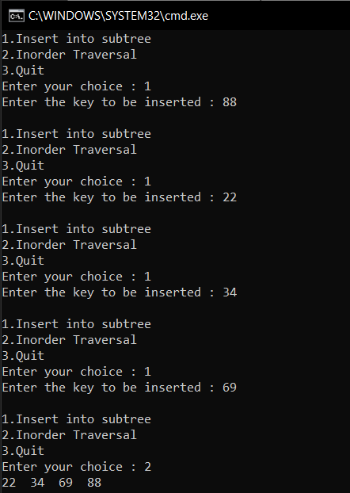

4. Write a program to implement following traversals in AVL trees

* Deletion in Left sub tree
* Deletion in Right Sub Tree

Program:

#include <stdio.h>

#include <stdlib.h>

#define FALSE 0

#define TRUE 1

struct node

{

struct node *lchild;

int info; struct node *rchild;

int balance;

};

void inorder(struct node *ptr);

struct node *RotateLeft(struct node *pptr);

struct node *RotateRight(struct node *pptr);

struct node *insert(struct node *pptr, int ikey);

struct node *insert_left_check(struct node *pptr, int *ptaller);

struct node *insert_right_check(struct node *pptr, int *ptaller);

struct node *insert_LeftBalance(struct node *pptr);

struct node *insert_RightBalance(struct node *pptr);

struct node *del(struct node *pptr, int dkey);

struct node *del_left_check(struct node *pptr, int *pshorter);

struct node *del_right_check(struct node *pptr, int *pshorter);

struct node *del_LeftBalance(struct node *pptr,int *pshorter);

struct node *del_RightBalance(struct node *pptr,int *pshorter);

int main()

{

int choice,key;

struct node *root = NULL;

while(1)

{

printf("\n");

printf("1.Insert into subtree\n");

printf("2.Delete from sub tree\n");

printf("3.Inorder Traversal\n");

printf("4.Quit\n");

printf("Enter your choice : ");

scanf("%d",&choice);

switch(choice)

{

case 1:

printf("Enter the key to be inserted : ");

scanf("%d",&key);

root = insert(root,key);

break;

case 2:

printf("Enter the key to be deleted : ");

scanf("%d",&key);

root = del(root,key);

break;

case 3:

inorder(root);

break;

case 4:

exit(1);

default:

printf("Wrong choice\n");

}

}

}

struct node *insert(struct node *pptr, int ikey)

{

static int taller;

if(pptr==NULL) /*Base case*/

{

pptr = (struct node *) malloc(sizeof(struct node));

pptr->info = ikey;

pptr->lchild = NULL;

pptr->rchild = NULL;

pptr->balance = 0;

taller = TRUE;

}

else if(ikey<pptr->info) /*Insertion in left subtree*/

{

pptr->lchild = insert(pptr->lchild, ikey);

if(taller==TRUE)

pptr = insert_left_check( pptr, &taller );

}

else if(ikey>pptr->info) /*Insertion in right subtree */

{

pptr->rchild = insert(pptr->rchild, ikey);

if(taller==TRUE)

pptr = insert_right_check(pptr, &taller);

}

else /*Base Case*/

{

printf("Duplicate key\n");

taller = FALSE;

}

return pptr;

}

struct node *insert_left_check(struct node *pptr, int *ptaller )

{

switch(pptr->balance)

{

case 0: /* Case L_A : was balanced */

pptr->balance = 1; /* now left heavy */

break;

case -1: /* Case L_B: was right heavy */

pptr->balance = 0; /* now balanced */

*ptaller = FALSE;

break;

case 1: /* Case L_C: was left heavy */ pptr = insert_LeftBalance(pptr); /* Left Balancing */

*ptaller = FALSE;

}

return pptr;

}

struct node *insert_right_check(struct node *pptr, int *ptaller )

{

switch(pptr->balance)

{

case 0: /* Case R_A : was balanced */

pptr->balance = -1; /* now right heavy */

break;

case 1: /* Case R_B : was left heavy */

pptr->balance = 0; /* now balanced */

*ptaller = FALSE;

break;

case -1: /* Case R_C: Right heavy */

pptr = insert_RightBalance(pptr); /* Right Balancing */

*ptaller = FALSE;

}

return pptr;

}

struct node *insert_LeftBalance(struct node *pptr)

{

struct node *aptr, *bptr;

aptr = pptr->lchild;

if(aptr->balance == 1) /* Case L_C1 : Insertion in AL */

{

pptr->balance = 0;

aptr->balance = 0;

pptr = RotateRight(pptr);

}

else /* Case L_C2 : Insertion in AR */

{

bptr = aptr->rchild;

switch(bptr->balance)

{

case -1: /* Case L_C2a : Insertion in BR */

pptr->balance = 0;

aptr->balance = 1;

break;

case 1: /* Case L_C2b : Insertion in BL */

pptr->balance = -1;

aptr->balance = 0;

break;

case 0: /* Case L_C2c : B is the newly inserted node */

pptr->balance = 0;

aptr->balance = 0;

}

bptr->balance = 0;

pptr->lchild = RotateLeft(aptr);

pptr = RotateRight(pptr);

}

return pptr;

}

struct node *insert_RightBalance(struct node *pptr)

{

struct node *aptr, *bptr;

aptr = pptr->rchild;

if(aptr->balance == -1) /* Case R_C1 : Insertion in AR */

{

pptr->balance = 0;

aptr->balance = 0;

pptr = RotateLeft(pptr);

}

else /* Case R_C2 : Insertion in AL */

{

bptr = aptr->lchild;

switch(bptr->balance)

{

case -1: /* Case R_C2a : Insertion in BR */

pptr->balance = 1;

aptr->balance = 0;

break;

case 1: /* Case R_C2b : Insertion in BL */

pptr->balance = 0;

aptr->balance = -1;

break;

case 0: /* Case R_C2c : B is the newly inserted node */

pptr->balance = 0;

aptr->balance = 0;

}

bptr->balance = 0;

pptr->rchild = RotateRight(aptr);

pptr = RotateLeft(pptr);

}

return pptr;

}

struct node *RotateLeft(struct node *pptr)

{

struct node *aptr;

aptr = pptr->rchild; /*A is right child of P*/

pptr->rchild = aptr->lchild; /*Left child of A becomes right child of P */

aptr->lchild = pptr; /*P becomes left child of A*/

return aptr; /*A is the new root of the subtree initially rooted at P*/

}

struct node *RotateRight(struct node *pptr)

{

struct node *aptr;

aptr = pptr->lchild; /*A is left child of P */

pptr->lchild = aptr->rchild; /*Right child of A becomes left child of P*/

aptr->rchild = pptr; /*P becomes right child of A*/

return aptr; /*A is the new root of the subtree initially rooted at P*/

}

struct node *del(struct node *pptr, int dkey)

{

struct node *tmp, *succ;

static int shorter;

if( pptr == NULL) /*Base Case*/

{

printf("Key not present \n");

shorter = FALSE;

return(pptr);

}

if( dkey<pptr->info )

{

pptr->lchild = del(pptr->lchild, dkey);

if(shorter == TRUE)

pptr = del_left_check(pptr, &shorter);

}

else if( dkey>pptr->info )

{

pptr->rchild = del(pptr->rchild, dkey);

if(shorter==TRUE)

pptr = del_right_check(pptr, &shorter);

}

else /* dkey == pptr->info, Base Case*/

{

/*pptr has 2 children*/

if( pptr->lchild!=NULL &&pptr->rchild!=NULL )

{

succ = pptr->rchild;

while(succ->lchild)

succ = succ->lchild;

pptr->info = succ->info;

pptr->rchild = del(pptr->rchild, succ->info);

if( shorter == TRUE )

pptr = del_right_check(pptr, &shorter);

}

else

{

tmp = pptr;

if( pptr->lchild != NULL ) /*only left child*/

pptr = pptr->lchild;

else if( pptr->rchild != NULL) /*only right child*/

pptr = pptr->rchild;

else /* no children */

pptr = NULL;

free(tmp);

shorter = TRUE;

}

}

return pptr;

}

struct node *del_left_check(struct node *pptr, int *pshorter)

{

switch(pptr->balance)

{

case 0: /* Case L_A : was balanced */

pptr->balance = -1; /* now right heavy */

*pshorter = FALSE;

break;

case 1: /* Case L_B : was left heavy */

pptr->balance = 0; /* now balanced */

break;

case -1: /* Case L_C : was right heavy */

pptr = del_RightBalance(pptr, pshorter); /*Right Balancing*/

}

return pptr;

}

struct node *del_right_check(struct node *pptr, int *pshorter)

{

switch(pptr->balance)

{

case 0: /* Case R_A : was balanced */ pptr->balance = 1; /* now left heavy */

*pshorter = FALSE;

break;

case -1: /* Case R_B : was right heavy */

pptr->balance = 0; /* now balanced */

break;

case 1: /* Case R_C : was left heavy */ pptr = del_LeftBalance(pptr, pshorter ); /*Left Balancing*/

}

return pptr;

}

struct node *del_LeftBalance(struct node *pptr,int *pshorter)

{

struct node *aptr, *bptr;

aptr = pptr->lchild;

if( aptr->balance == 0) /* Case R_C1 */

{

pptr->balance = 1;

aptr->balance = -1;

*pshorter = FALSE;

pptr = RotateRight(pptr);

}

else if(aptr->balance == 1 ) /* Case R_C2 */

{

pptr->balance = 0;

aptr->balance = 0;

pptr = RotateRight(pptr);

}

else /* Case R_C3 */

{

bptr = aptr->rchild;

switch(bptr->balance)

{

case 0: /* Case R_C3a */

pptr->balance = 0;

aptr->balance = 0;

break;

case 1: /* Case R_C3b */

pptr->balance = -1;

aptr->balance = 0;

break;

case -1: /* Case R_C3c */

pptr->balance = 0;

aptr->balance = 1;

}

bptr->balance = 0;

pptr->lchild = RotateLeft(aptr);

pptr = RotateRight(pptr);

}

return pptr;

}

struct node *del_RightBalance(struct node *pptr,int *pshorter)

{

struct node *aptr, *bptr;

aptr = pptr->rchild;

if (aptr->balance == 0) /* Case L_C1 */

{

pptr->balance = -1;

aptr->balance = 1;

*pshorter = FALSE;

pptr = RotateLeft(pptr);

}

else if(aptr->balance == -1 ) /* Case L_C2 */

{

pptr->balance = 0;

aptr->balance = 0;

pptr = RotateLeft(pptr);

}

else /* Case L_C3 */

{

bptr = aptr->lchild;

switch(bptr->balance)

{

case 0: /* Case L_C3a */

pptr->balance = 0;

aptr->balance = 0;

break;

case 1: /* Case L_C3b */

pptr->balance = 0;

aptr->balance = -1;

break;

case -1: /* Case L_C3c */

pptr->balance = 1;

aptr->balance = 0;

}

bptr->balance = 0;

pptr->rchild = RotateRight(aptr);

pptr = RotateLeft(pptr);

}

return pptr;

}

void inorder(struct node *ptr)

{

if(ptr!=NULL)

{

inorder(ptr->lchild);

printf("%d ",ptr->info);

inorder(ptr->rchild);

}

}

