**PRACTICAL EXAM**

**Date:- 25-08-2021**

**Programs to be implemented:**

**A] Write a C/C++ program to implement merge sort algorithm using divide & conquer and estimate its time and space complexity**

**B] Write a C/C++ program to implement master’s theorem to solve recurrence relations(code all 3 conditions) and estimate its time and space complexity**

PROGRAM [A] IMPLEMENTATION:

#include<iostream>

using namespace std;

void mergesort(int,int);

void merge(int,int,int);

int count=0;

int *a,*b;

int main()

{

int n;

cout<<"Enter number of elements\n";

count++;

cin>>n;

count++;

a = new int[n];

b = new int[n];

cout<<"Enter "<<n<<" elements to be sorted\n";

count++;

for(int i=0;i<n;i++)

{

count++;//for

cin>>a[i];

count++;

}

mergesort(0,n-1);

for(int i=0;i<n;i++)

cout<<a[i]<<" ";

cout<<endl;

cout<<"Count="<<count<<endl;

return 0;

}

void mergesort(int low, int high)

{

count++;

if(low<high)

{

int mid = (low+high)/2;

count++;

mergesort(low,mid);

mergesort(mid+1,high);

merge(low,mid,high);

}

}

void merge(int low, int mid, int high)

{

int i=low,j=mid+1,k=low;

while(i<=mid && j<=high)

{

count++; //while

count++; //if

if(a[i]<a[j])

{

count+=3;

b[k++] = a[i++];

}

else

{

b[k++] = a[j++];

count+=3;

}

}

count++; //while

while(i<=mid)

{

count++; //while statement

count++;

b[k++] = a[i++];

}

count++; //Last while

while(j<=high)

{

count++; //while statement

count++; //for

b[k++] = a[j++];

}

count++; //Last while

for(k=low;k<=high;k++)

{

count++; //for

a[k]=b[k];

count++;

}

}

OUTPUT:

1. When elements are already sorted

**Count=238**

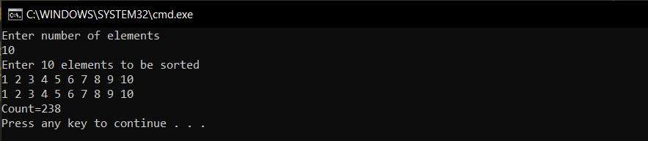

1. When elements are in random order

**Count=240**

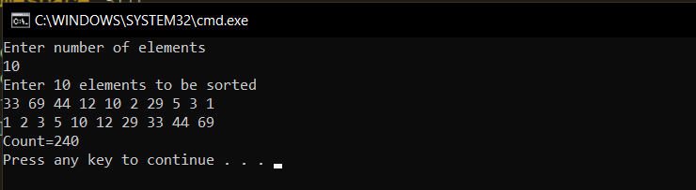

1. When n=20 and elements are in sorted order

**Count=582**

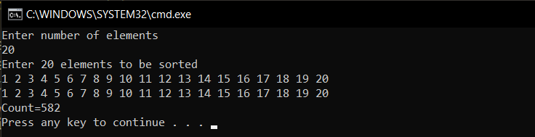

**Time Complexity:**

Merge sort uses the technique of Divide and Conquer. Hence, each time the problem is divided into equal halves and once it is broken to atomic level, we start arranging them either in Ascending or Descending order based on our requirement.

As the array is divided until there’s only one element, the n value will decrease by a factor of 2. Hence, the recurrence relation for this can be written as:

**T(n) = 2T(n/2) + n**

Hence, by using master’s theorem, the time complexity of the Recurrence Relation is computed to be O(n*logn).

**Therefore, Time complexity of MergeSort Algorithm is O(n*logn)**

**Space complexity:**

MergeSort requires space for the auxiliary array as well as the main array. Hence total space required is 2*n.

**Therefore, Space Complexity of MergeSort is of the order of O(n)**

PROGRAM [B] IMPLEMENTATION:

#include<iostream>

#include<math.h>

int count=0;

using namespace std;

float compute_UN( float lg, float n)

{

count++; //for if else

if(n>lg)

{

n-=lg; //for case O(n^r) r>0

count++;

}

else if((n==0 && n!=lg) || (n<lg && n!=0))

{

n=-1; //for case O(1)

//here h(n) = 1/n^r, hence r<0 or (n)=n^x/n^y where y>x

count+=2;

}

else if(n==lg)

{

n=0; //case when h(n)=1 hence r=0;

//ie i>=0 so logn^(i+1)/i+1

count+=2;

}

count++;

return n;

}

float log_a_base_b(float a, float b)

{

count++;

return log(a)/log(b);

}

void compute_RR( float n, float a, float b)

{

float lg; //this will be log value

lg = log_a_base_b(a,b); //this will be power of n while calculating T(n)

n= compute_UN(lg,n); //computes U(n) based on h(n)

count+=2;

count++; //if else

if(lg > n && n<0)

cout<<"Time Complexity of the recurrence relation is: O(n^"<<lg<<")"<<endl;

else if ((lg > n && n>0) || n>lg )

{

cout<<"Time Complexity of the recurrence relation is: O(n^"<<lg+n<<")"<<endl;

count++;

}

else if(lg==0 && n==0)

{

cout<<"Time Complexity of the recurrence relation is: O(logn)"<<endl;

count++;

}

else if (lg>0 && n==0)

{

cout<<"Time Complexity of the recurrence relation is: O((n^"<<lg<<")*logn)"<<endl;

count++;

}

}

int main()

{

cout<<"General form of Recurrence Relation to be solved using Master Theorem is: T(n) = aT(n/b) + f(n)"<<endl;

cout<<"a>=1 and b>1 are necessary conditions"<<endl;

float n; //variable n is power of n

float a,b;

cout<<"\nEnter values of a,b: ";

cin>>a>>b;

count++;

if(a<1 || b<=1 )

cout<<"This Recurrence Relation cant be solved using Master Theorem"<<endl;

else

{

cout<<"Enter power of n in f(n): ";

cin>>n;

compute_RR(n,a,b);

}

cout<<endl<<"STEPCOUNT = "<<count<<endl;

return 0;

}

**OUTPUT:**

**Time Complexity:**

This algorithm runs in constant time since it does not contain loops, recursion and call to any other non-constant time function.

**Hence, the time complexity is of the order of O(1)**

**Space Complexity:**

Space needs to be allocated for a fixed number of variables in this algorithm., and no auxiliary space is needed.

**Hence, the space complexity is of the order of O(1)**