**Data Structures**

**Arslan Azam**

**233089**

Code:

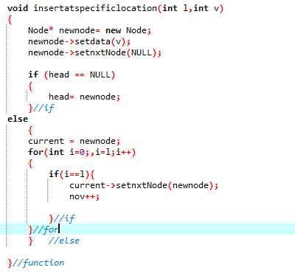

Display:

error