Name: Sheryl Fernandes

Csbs: 4th year

Roll.no. 57

**ERP EXPERIMENT NO.1**

**AIM**: RESEARCH ON ERP SYSTEM and ERP PACKAGE

**THEORY:**

Enterprise resource planning (ERP) is a platform companies use to manage and integrate the essential parts of their businesses.

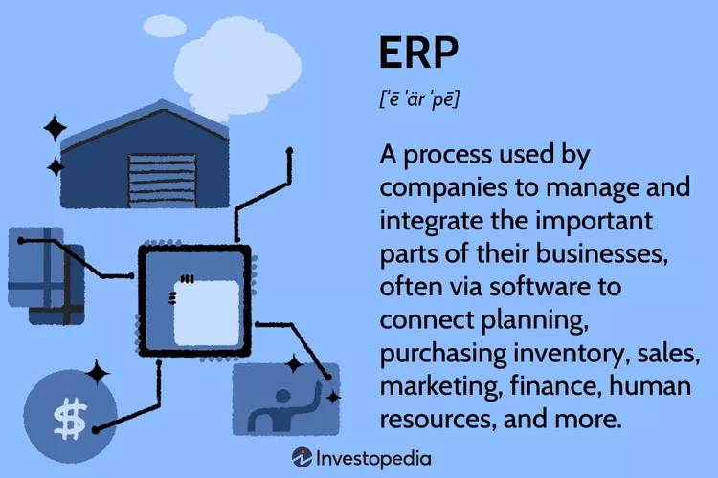

An ERP software system can also integrate planning, purchasing inventory, sales, marketing, finance, human resources, and more.

**What Does ERP Do?**

ERP applications also allow the different departments to communicate and share information more easily with the rest of the company. It collects information about the activity and state of different divisions, making this information available to other parts, where it can be used productively.

**Working of ERP :**

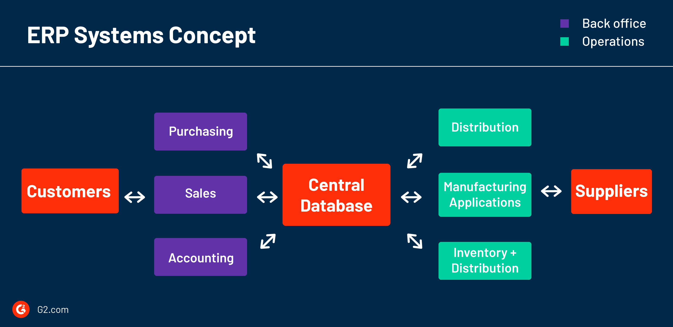

ERP functions as a single source of truth for the many disparate workflows that make up business operations. ERP systems streamline the data collected from all over the company into a single space, usually a curated dashboard, where everything from finances, production quotas, and inventory can be seen and analyzed.

Standardizing functions, data, and definitions across the entire enterprise-- some of which transcend linguistic and national barriers -- is the core intention of these systems.

Types of ERP System :

1. By organization size-

* Enterprise ERP
* Mid-market ERP
* Small business ERP

1. By software development-

* On-premise ERP
* Cloud ERP
* Hybrid ERP

1. By system model-

* Best-of-breed
* Modular

**ERP PACKAGE**

Erp softwares that are free and open source

|  |  |  |
| --- | --- | --- |
| **Name of erp package** | **Platform Technology** | **Description** |
| Adaxa Suite | Java | Integrated ERP built on Adempiere/iDempiere |
| All imagesAdempiere | Java | Began as a fork of Compiere |
| Apache OFBiz Beratung und Dienstleistungen - ecomify GmbHApache OFBiz | Java JavaScript FreeMarker Groovy XML | Business solutions and applications framework from the Apache Software Foundation |
| All imagesDolibarr | JavaScript, PHP, MySQL or PostgreSQL | Web application (LAMP-based system) to manage small and medium entities |
| All imagesKuali | Java | ERP for higher education institutions |
| All imagesTryton | Python, PostgreSQL, GTK+, JavaScript | Originally forked from TinyERP, cleaned-up code base with continuous update/migration path |
| All imagesSQL-Ledger | Perl, PostgreSQL | Double entry accounting and ERP system |