Name: Sheryl Fernandes

Csbs: 4th year

Roll.no. 57

**ERP EXPERIMENT NO.2**

**AIM**: OPEN SOURCE AND CLOUD ERP

**THEORY:**

**How Does Cloud ERP Work?**

Cloud ERP combines a host of technologies connected by high-speed internet networks. Security updates and upgrades are handled by the cloud ERP provider, which leads to a lower cost of ownership than ERP systems hosted with on-premises servers.

Cloud ERPs can be accessed remotely via mobile devices or desktop computers, provided that additional security steps are provided, e.g. access via an FTP server. Like any other ERP, this system will tie together your customer information, sales histories, HR management tools, supply chain management, operating metrics, inventory, and financial data into a single source of truth that you can access anywhere.

**Cloud ERP vs. On-Premises ERP Software Solutions: Which One Is Better?**

* On-premises ERP is installed by the company’s IT team or through a managed service provider. There are a few significant differences in how this software is managed, implemented, and paid for. On-premises ERP software is licensed upfront, and enterprise-grade servers are bought or leased to run and house the software and data. This approach results in hefty additional costs for maintenance, supplementary software, updates, customization, insurance, security, and backups.
* Cloud-based ERP is hosted and managed by a provider, usually with an “as-a-service” model through the cloud. The provider takes on the responsibility of data storage, maintenance, physical data center infrastructure, security updates, backups, and upgrades. This enables the company to roll out the ERP solution in a faster, cheaper, and more flexible way.

Types of cloud hosting for erp :

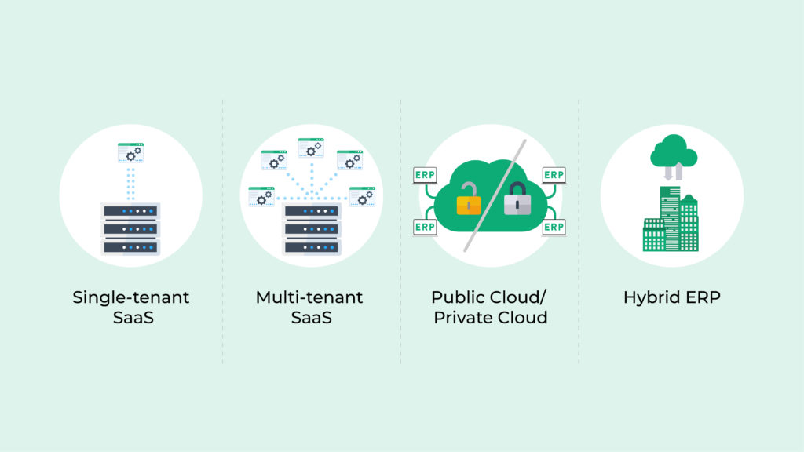

**Multi-tenant SaaS**

A single version of the ERP software and its associated infrastructure serves multiple organizations. Data is consolidated on as few servers as possible to minimize maintenance costs and simplify version updates. Companies can only access their own data.

**Single-tenant SaaS**

A single version of the ERP software and its infrastructure serves a single company, e.g., the data is hosted on private servers running a unique instance. Some cloud ERP companies offer a choice between a private instance or a shared instance.

**Public Cloud / Private Cloud**

In the public cloud, multiple organizations share cloud computing services, such as Amazon Web Services, Microsoft Azure, and Oracle Cloud. The private cloud is a service not shared by any other organization.

**Hybrid ERP**

Hybrid cloud hosting systems for ERP combine on-premises software with a private cloud that is used for computing, storage, and services so that companies can access the best of both worlds

Open source ERP :