Task
Write a WPF Application that consumes real-time data and displays it in a datagrid.

Requirements
- Use a WPF Application project, written in C#, that targets the .Net Framework 3.5
- If necessary, you can code it in Visual Studio Express available for free from Microsoft.
- The project should reference the provided Liquid.AssessmentLibrary.dll and use the DataSource class to subscribe to real-time data callbacks.
- The project should reference the provided WPFToolkit.dll and use its DataGrid WPF control to display data received from the DataSource. Note that the WPFToolkit and DataGrid control are Microsoft components; Many Examples and References are available online for using a DataGrid.
- Most of the data values are percentages, and thus should be displayed with a percent sign ‘%’ and with two decimal places. (Volatility, VolChange, and TickChange are percentages)
- Negative numbers should display Red instead of the default black.
- The data is categorized by ‘Pricing Spec’. A combobox should be added that fills with unique ‘Pricing Specs’. Selecting one of these pricing specs will display its contracts in the datagrid.
- The DataSource will call back every couple of seconds with new data. Just display the new data; do not bother keeping the old data around (We do not need a history of the last 10 minutes of data the application received, for example) (Also, the data is hardcoded and loops over the same data repeatedly)
- The data contains a timestamp. Display that timestamp on the UI somewhere.
- Provide a zip file with both the compiled executable and the source code.

Screenshot
The following is just a rough example of the UI we’re looking for. (It is only a rough example, as it does not correctly format the percentages or show negatives as red)
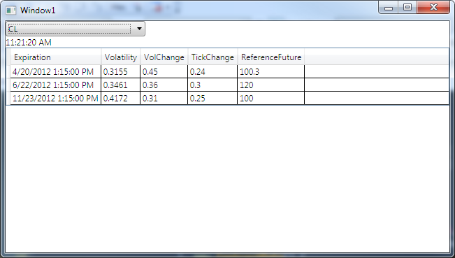

API
Liquid.AssessmentLibrary.DataSource
- DataSource (constructor) – Instantiates a DataSource which will begin pumping data to the client (via the callbacks provided by calling Subscribe())
- Dispose – Shuts down the data source which, after this call returns, should not end up calling back with any further data (unless calls are still sitting in the UI thread's message queue or queued up in a ThreadPool thread)
- Subscribe – Subscribes to receive data from the data source. Once this call returns the provided callback will begin to receive data updates ON A RANDOM THREADPOOL THREAD.
- SubscribeWithWPFSynchronization – Subscribes to receive data from the data source. Once this call returns the provided callback will begin to receive data invoked back onto the UI thread for the given WPF Framework Element.
- Unsubscribe - Removes the subscription indicated by the provided callback. Once this call returns the provided callback will no further calls will be made to the callback (unless calls are still sitting in the UI thread's message queue or queued up in a ThreadPool thread)

