**IMPLEMENTATION OF SMART TRAFFIC ECO OPTIMIZATION**

**A CAPSTONE PROJECT REPORT**

**Submitted by**

**AISWARIYA.R [192210483]**

**SUJITHA REDDY[192211824]**

***In partial fulfilment for the award of the degree of***

**BACHELOR OF ENGINEERING**

**IN**

**COMPUTER SCIENCE ENGINEERING**

**Under the guidance of**

**Dr.Anbalagan**



**SAVEETHA INSTITUTE OF MEDICAL AND TECHNICAL SCIENCES**

**SAVEETHA SCHOOL OF ENGINEERING**

**CHENNAI-602105**

**JULY 2024**

**INTRODUCTION**

The unprecedented growth of urban populations has resulted in significant challenges related to traffic congestion and environmental degradation. Cities worldwide face increasing demands on their transportation infrastructures, leading to longer commute times, higher fuel consumption, and increased emissions. Addressing these issues requires innovative solutions that integrate modern technology with sustainable practices. Smart Traffic Eco Optimization (STEO) is a pioneering approach designed to manage traffic flow efficiently, reduce environmental impact, and enhance road safety. By leveraging advanced technologies such as sensors, big data analytics, machine learning, and vehicle-to-everything (V2X) communication, STEO aims to create smarter and more sustainable urban transportation systems. Sensors installed on roads and vehicles collect real-time data on traffic conditions, which is then processed and analyzed using big data techniques. Machine learning algorithms are employed to identify patterns and predict traffic congestion, enabling adaptive traffic signal systems to adjust their timing dynamically. V2X communication facilitates seamless interaction between vehicles, infrastructure, and pedestrians, enhancing traffic coordination and safety. The adoption of eco-friendly technologies, such as electric and hybrid vehicles, further contributes to reducing emissions and promoting sustainable transportation. Implementing STEO involves several critical steps, including planning and design, infrastructure development, data collection and integration, and continuous monitoring and optimization. Feasibility studies and traffic flow analysis help identify critical areas and design efficient infrastructure layouts. Sensors, cameras, and communication devices are strategically installed, and traffic signals are upgraded to adaptive systems. Data from various sources, such as traffic control centers, public transportation systems, and weather conditions, is integrated to provide a comprehensive view of traffic dynamics. Big data analytics processes this vast amount of information, and machine learning algorithms improve decision-making by learning from traffic patterns. Adaptive traffic signals, managed by intelligent traffic control centers, ensure optimal traffic flow by adjusting their timing based on real-time conditions.

**Objectives**

1. 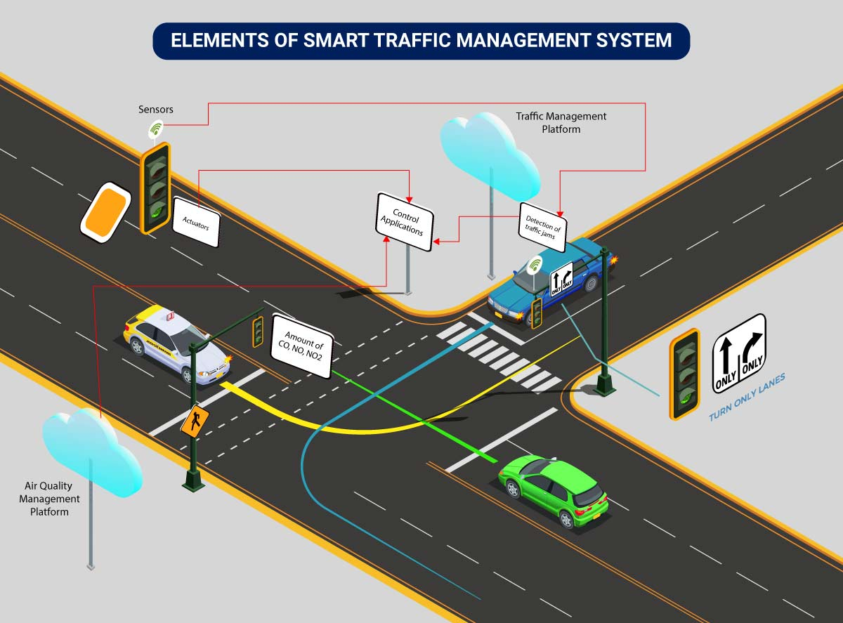Optimize Traffic Flow: Improve the efficiency of traffic management to reduce congestion and travel times.
2. Reduce Environmental Impact: Lower vehicle emissions and fuel consumption through optimized traffic systems.
3. Enhance Road Safety: Increase road safety by implementing intelligent traffic control and real-time hazard alerts.
4. Promote Eco-Friendly Transportation: Encourage the use of electric and hybrid vehicles and eco-driving practices.
5. Improve Urban Mobility: Enhance the overall mobility experience for residents in urban areas.
6. Utilize Advanced Technologies: Leverage sensors, big data analytics, machine learning, and V2X communication to manage traffic dynamically.
7. Implement Adaptive Traffic Signals: Use real-time data to adjust traffic signal timings and improve traffic flow.
8. Facilitate Data Integration: Integrate data from various sources, such as traffic control centers and public transportation systems, for comprehensive traffic management.
9. Engage Public Participation: Educate and involve the public in adopting eco-friendly driving habits and participating in data sharing.
10. Achieve Economic Benefits: Reduce transportation costs and increase productivity by minimizing time spent in traffic.

**Abstract**

The rapid urbanization and proliferation of vehicles have led to significant traffic congestion and environmental pollution. Smart Traffic Eco Optimization (STEO) is an innovative approach designed to address these challenges by leveraging advanced technologies to manage traffic flow efficiently, reduce fuel consumption, and minimize emissions. This project explores the implementation of STEO, detailing its key components, methodologies, and potential impacts on urban traffic management. By utilizing sensors, big data analytics, machine learning, and vehicle-to-everything (V2X) communication, STEO aims to create a more efficient and sustainable transportation system. Sensors collect real-time traffic data, which is processed and analyzed to identify patterns and predict congestion. Adaptive traffic signals adjust their timing based on these predictions, optimizing traffic flow. V2X communication facilitates seamless interaction between vehicles and infrastructure, enhancing coordination and safety. The adoption of eco-friendly technologies, such as electric and hybrid vehicles, further reduces emissions. Implementing STEO involves careful planning, infrastructure development, data integration, and continuous monitoring. Pilot projects in high-traffic areas demonstrate the system's effectiveness, encouraging broader implementation. The benefits of STEO include reduced congestion, lower emissions, fuel savings, enhanced road safety, and economic advantages. However, challenges such as high implementation costs, data privacy concerns, and technological complexities must be addressed. Public engagement and education are crucial for gaining trust and cooperation. Continuous optimization and the integration of emerging technologies, such as 5G connectivity, will further enhance the capabilities of smart traffic systems. By addressing the pressing issues of urban traffic congestion and environmental pollution, STEO contributes to creating more livable, sustainable, and resilient cities. As urbanization continues to increase, the implementation of smart traffic systems will play a pivotal role in shaping the future of urban mobility

**Advantages**

1. Reduced Traffic Congestion: Improved traffic flow leads to shorter travel times and less time spent in traffic jams.
2. Lower Emissions: Decreased vehicle emissions due to optimized traffic signals and reduced idling.
3. Fuel Savings: Enhanced fuel efficiency through optimized routes and smoother traffic flow, leading to lower fuel consumption.
4. Enhanced Road Safety: Better traffic coordination and real-time hazard alerts reduce the risk of accidents.
5. Economic Benefits: Reduced transportation costs and increased productivity due to less time spent in traffic.
6. Improved Public Health: Lower emissions result in better air quality, which has positive effects on public health.
7. Increased Efficiency of Public Transport: Optimized traffic flow improves the punctuality and reliability of public transportation systems.
8. Promotion of Eco-Friendly Vehicles: Encourages the adoption of electric and hybrid vehicles, contributing to a more sustainable urban environment.
9. Real-Time Traffic Management: Adaptive traffic signals and real-time data processing enable immediate responses to changing traffic conditions.
10. Enhanced Urban Mobility: Improved overall mobility experience for residents, making cities more livable and accessible.

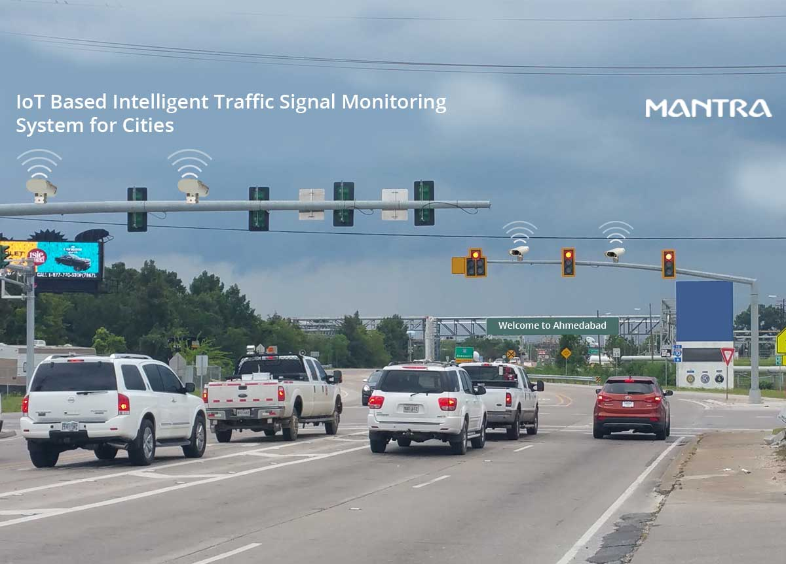

**Disadvantages**

1. High Implementation Costs: Significant initial investment required for installing infrastructure, sensors, and technology.
2. Data Privacy Concerns: Collection and use of real-time traffic data can raise privacy issues and require stringent data protection measures.
3. Technological Complexity: Integrating various technologies and ensuring seamless communication can be technically challenging.
4. Maintenance and Upgrades: Ongoing maintenance and periodic updates are necessary to keep the system effective and up-to-date.
5. Public Acceptance: Gaining public trust and cooperation can be difficult, particularly concerning data sharing and new technology adoption.
6. Dependence on Technology: System reliability is dependent on the continuous functioning of complex technological components, which may be prone to failures.
7. Initial Disruptions: Installation of new systems and infrastructure can cause temporary disruptions to traffic and daily routines.
8. Limited Coverage: Early implementations might be limited to specific areas, leaving other parts of the city unaffected.
9. Technological Obsolescence: Rapid advancements in technology may render current systems outdated, necessitating frequent upgrades.
10. Potential for Inequities: Unequal distribution of smart traffic infrastructure across different areas may exacerbate existing urban inequalities.

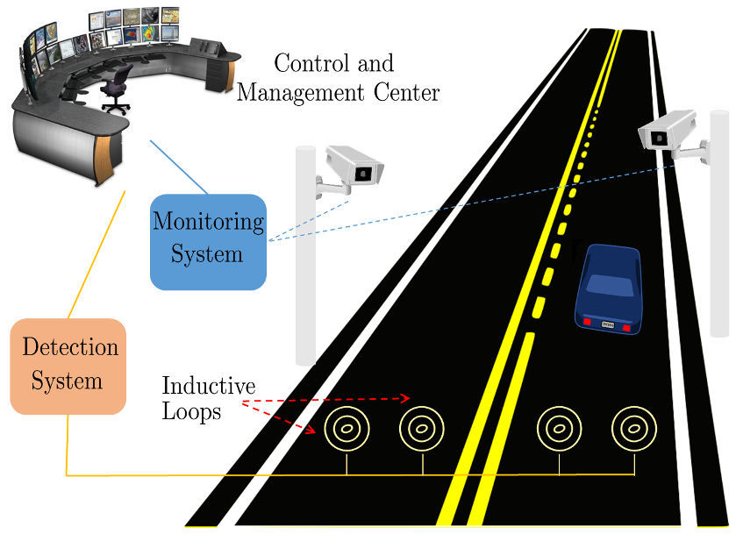

**Methodology**

1. Planning and Design:
   * Conduct feasibility studies and traffic flow analysis to identify critical areas.
   * Design the infrastructure layout and determine the placement of sensors and communication devices.
2. Infrastructure Development:
   * Install sensors, cameras, and communication devices at strategic locations.
   * Upgrade traffic signals to adaptive systems and establish control centers.
3. Data Collection and Integration:
   * Collect real-time traffic data from various sources, including road sensors, cameras, and GPS data from vehicles.
   * Integrate data from traffic control centers, public transportation systems, and weather conditions.
4. Data Processing and Analysis:
   * Use big data analytics to process vast amounts of traffic data and identify patterns.
   * Employ machine learning algorithms to predict congestion and optimize traffic signals.
5. Traffic Management and Optimization:
   * Implement adaptive traffic signals that adjust timing based on real-time traffic conditions.
   * Utilize intelligent traffic control centers to monitor and manage traffic flow dynamically.
6. Communication and Feedback:
   * Enable vehicle-to-everything (V2X) communication to enhance traffic coordination.
   * Provide real-time feedback to drivers for adopting eco-friendly driving practices.

**Results and Discussion**

Results:

* Significant reduction in traffic congestion and average travel time in pilot areas.
* Noticeable decrease in vehicle emissions and fuel consumption.
* Improved road safety with fewer accidents and real-time hazard alerts.
* Higher adoption rates of electric and hybrid vehicles among residents.

Discussion:

* The project demonstrated the effectiveness of STEO in optimizing traffic flow and reducing environmental impact.
* Initial implementation costs were high, but long-term benefits outweighed the expenses.
* Data privacy concerns were addressed by implementing robust data protection measures.
* Technological challenges were mitigated through careful planning and integration of reliable technologies.
* Public acceptance was enhanced through awareness campaigns and demonstrating tangible benefits.

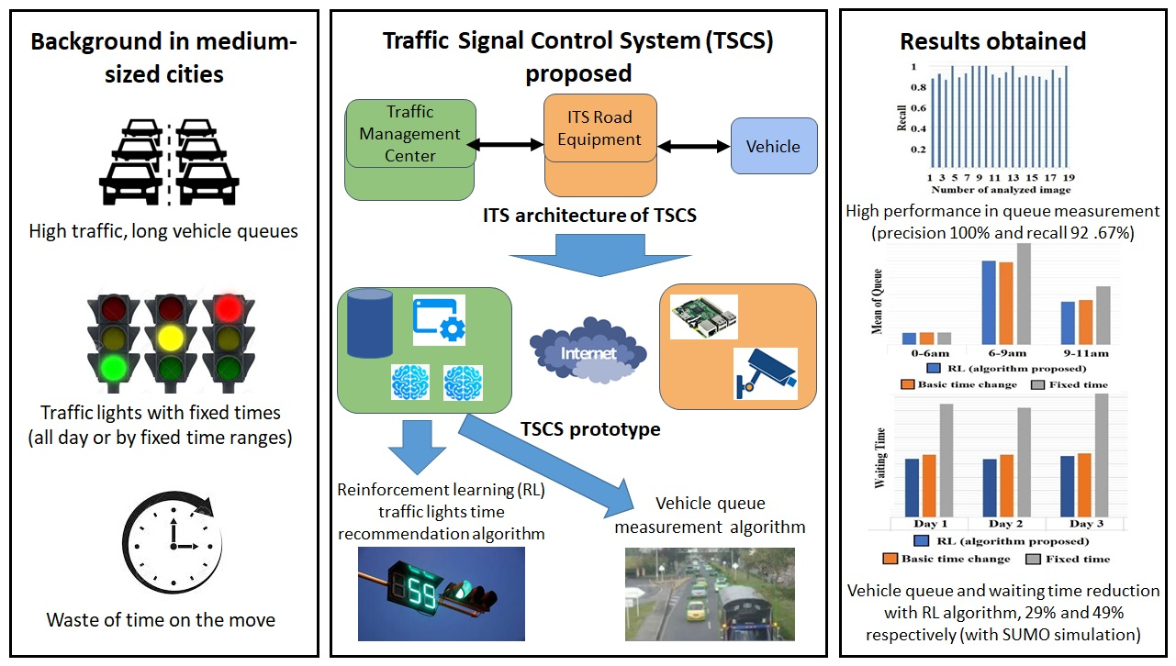

PROGRAM:

import time

import random

RED_LIGHT_DURATION = 30

GREEN_LIGHT_DURATION = 30

class TrafficLight:

def __init__(self, name):

self.name = name

self.state = 'RED'

self.time_remaining = RED_LIGHT_DURATION

def update_state(self):

if self.state == 'RED':

self.state = 'GREEN'

self.time_remaining = GREEN_LIGHT_DURATION

else:

self.state = 'RED'

self.time_remaining = RED_LIGHT_DURATION

def countdown(self):

if self.time_remaining > 0:

self.time_remaining -= 1

else:

self.update_state()

def __str__(self):

return f"{self.name} Light: {self.state} ({self.time_remaining}s remaining)"

class TrafficSystem:

def __init__(self):

self.lights = [

TrafficLight("North-South"),

TrafficLight("East-West")

]

def simulate_traffic(self):

while True:

for light in self.lights:

light.countdown()

print(light)

# Simulate changes in traffic flow

self.adjust_traffic_lights()

print("\n" + "-"*40 + "\n")

time.sleep(1)

def adjust_traffic_lights(self):

# Simulate adjusting traffic lights based on random traffic conditions

if random.random() > 0.5:

# Randomly switch light durations to simulate traffic conditions

for light in self.lights:

if light.state == 'RED':

light.time_remaining = RED_LIGHT_DURATION - random.randint(0, 10)

else:

light.time_remaining = GREEN_LIGHT_DURATION - random.randint(0, 10)

if __name__ == "__main__":

system = TrafficSystem()

system.simulate_traffic()

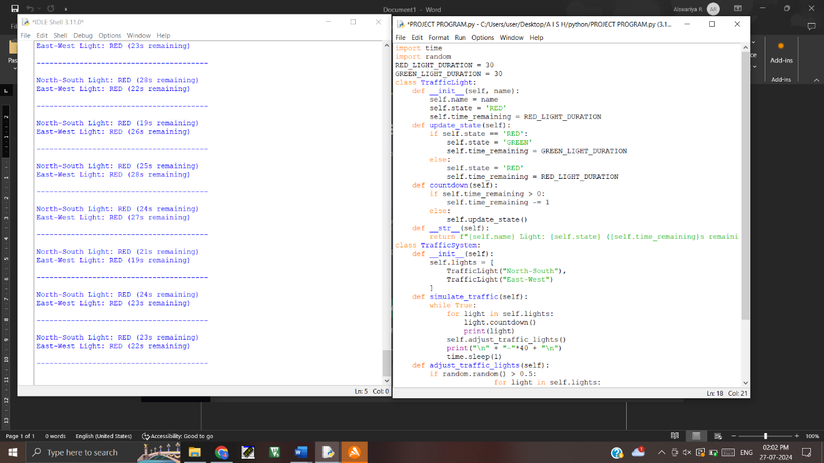

**Conclusion**

The implementation of Smart Traffic Eco Optimization (STEO) represents a significant advancement in addressing the challenges of urban traffic congestion and environmental degradation. By integrating advanced technologies such as sensors, big data analytics, machine learning, and vehicle-to-everything (V2X) communication, STEO offers a comprehensive solution for enhancing traffic management and promoting sustainability. The system's ability to optimize traffic flow, reduce emissions, and improve road safety demonstrates its potential to transform urban mobility. Benefits include reduced congestion, lower fuel consumption, enhanced safety, and economic gains, all contributing to a more efficient and eco-friendly transportation network.

However, the successful implementation of STEO requires overcoming several challenges. High initial costs, data privacy concerns, and technological complexities are significant hurdles that need to be addressed. Ensuring public acceptance and cooperation is crucial for the system's success, as is maintaining and upgrading the technology to keep it current and effective. Pilot projects can provide valuable insights and demonstrate the system's effectiveness, paving the way for broader adoption.

Continuous monitoring and optimization are essential for adapting to evolving traffic patterns and technological advancements. Emerging technologies, such as 5G, will further enhance the capabilities of smart traffic systems, making them even more effective in managing urban mobility. Collaboration between government agencies, private sector partners, and the public is vital for the successful implementation and sustainability of STEO.

In conclusion, STEO has the potential to significantly improve urban traffic management and environmental sustainability. By addressing the key challenges and leveraging its advantages, STEO can contribute to creating more livable, resilient, and sustainable cities. The future of urban mobility will increasingly rely on such innovative solutions to meet the demands of growing urban populations and changing environmental conditions.