Loginto ERP using user id and pwd

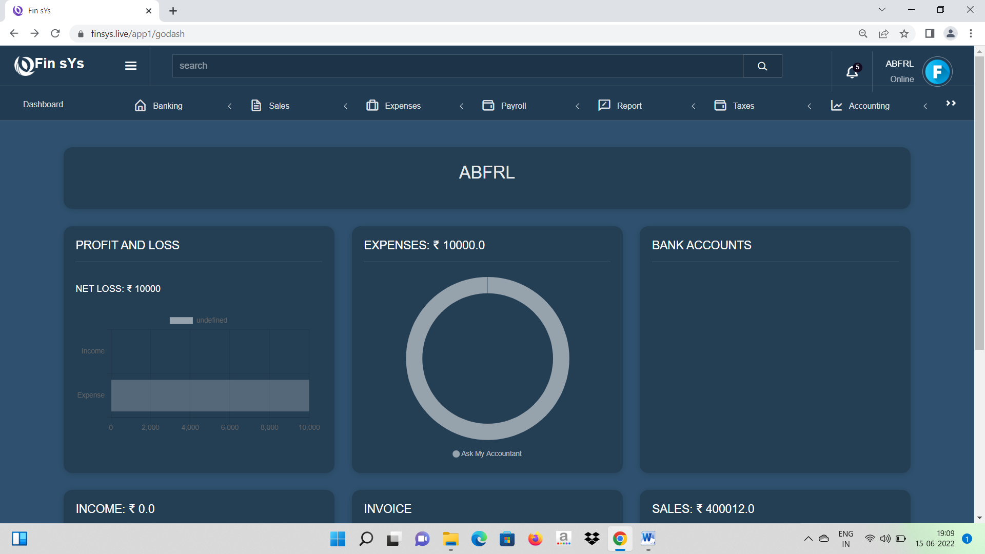

Logout

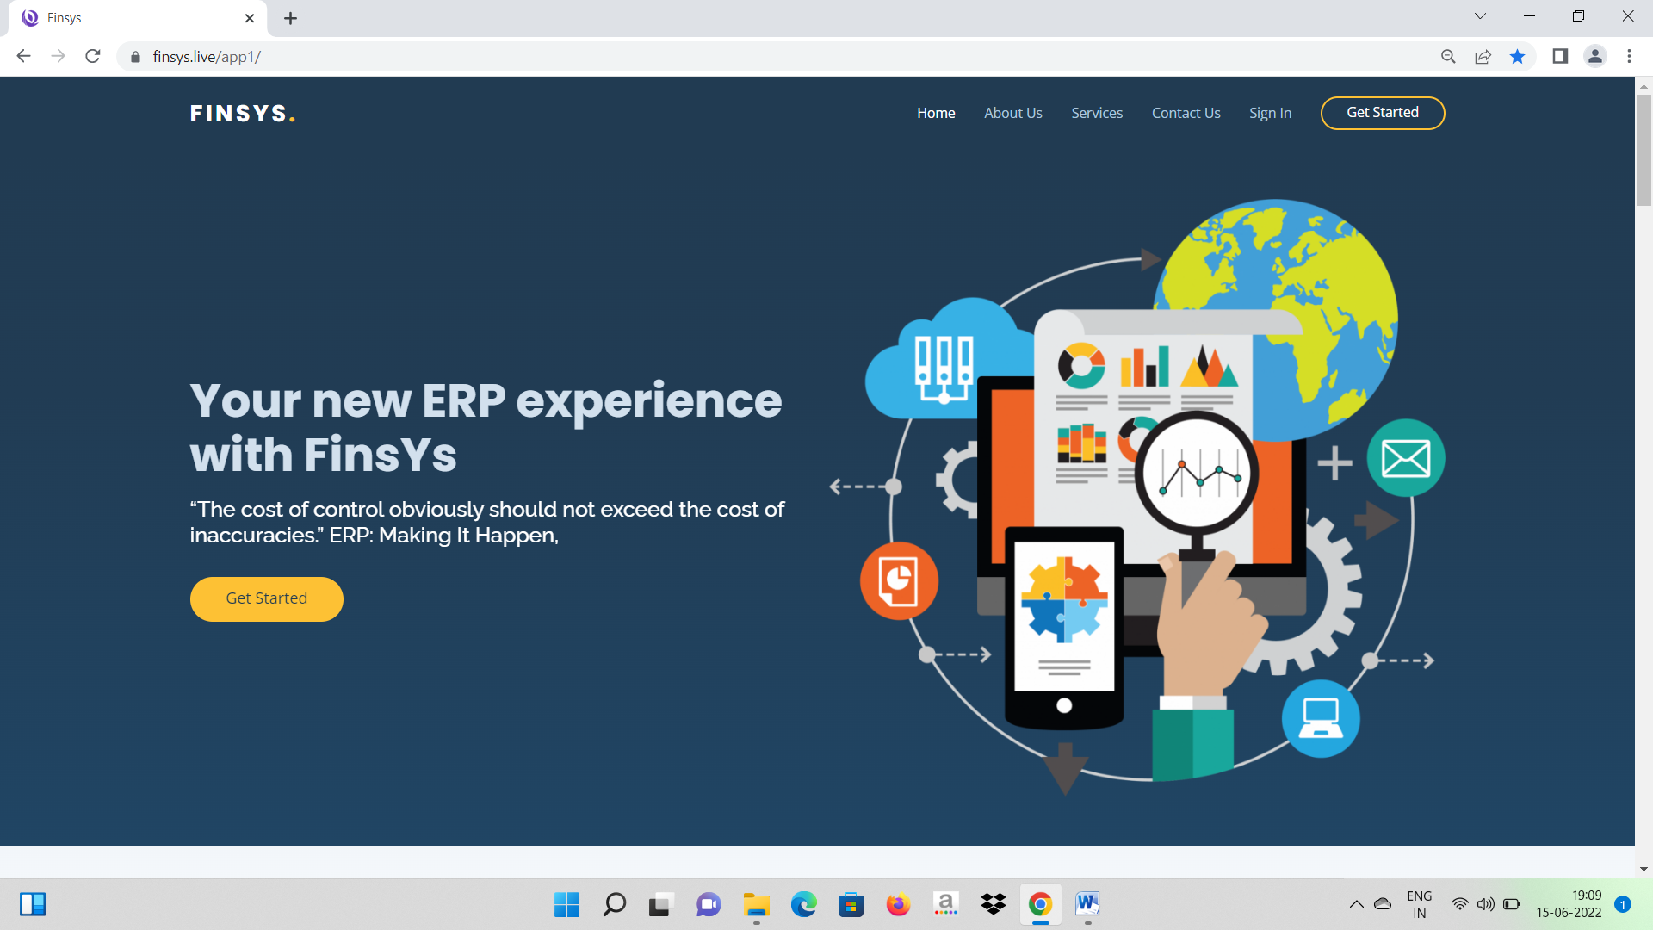

Click Back

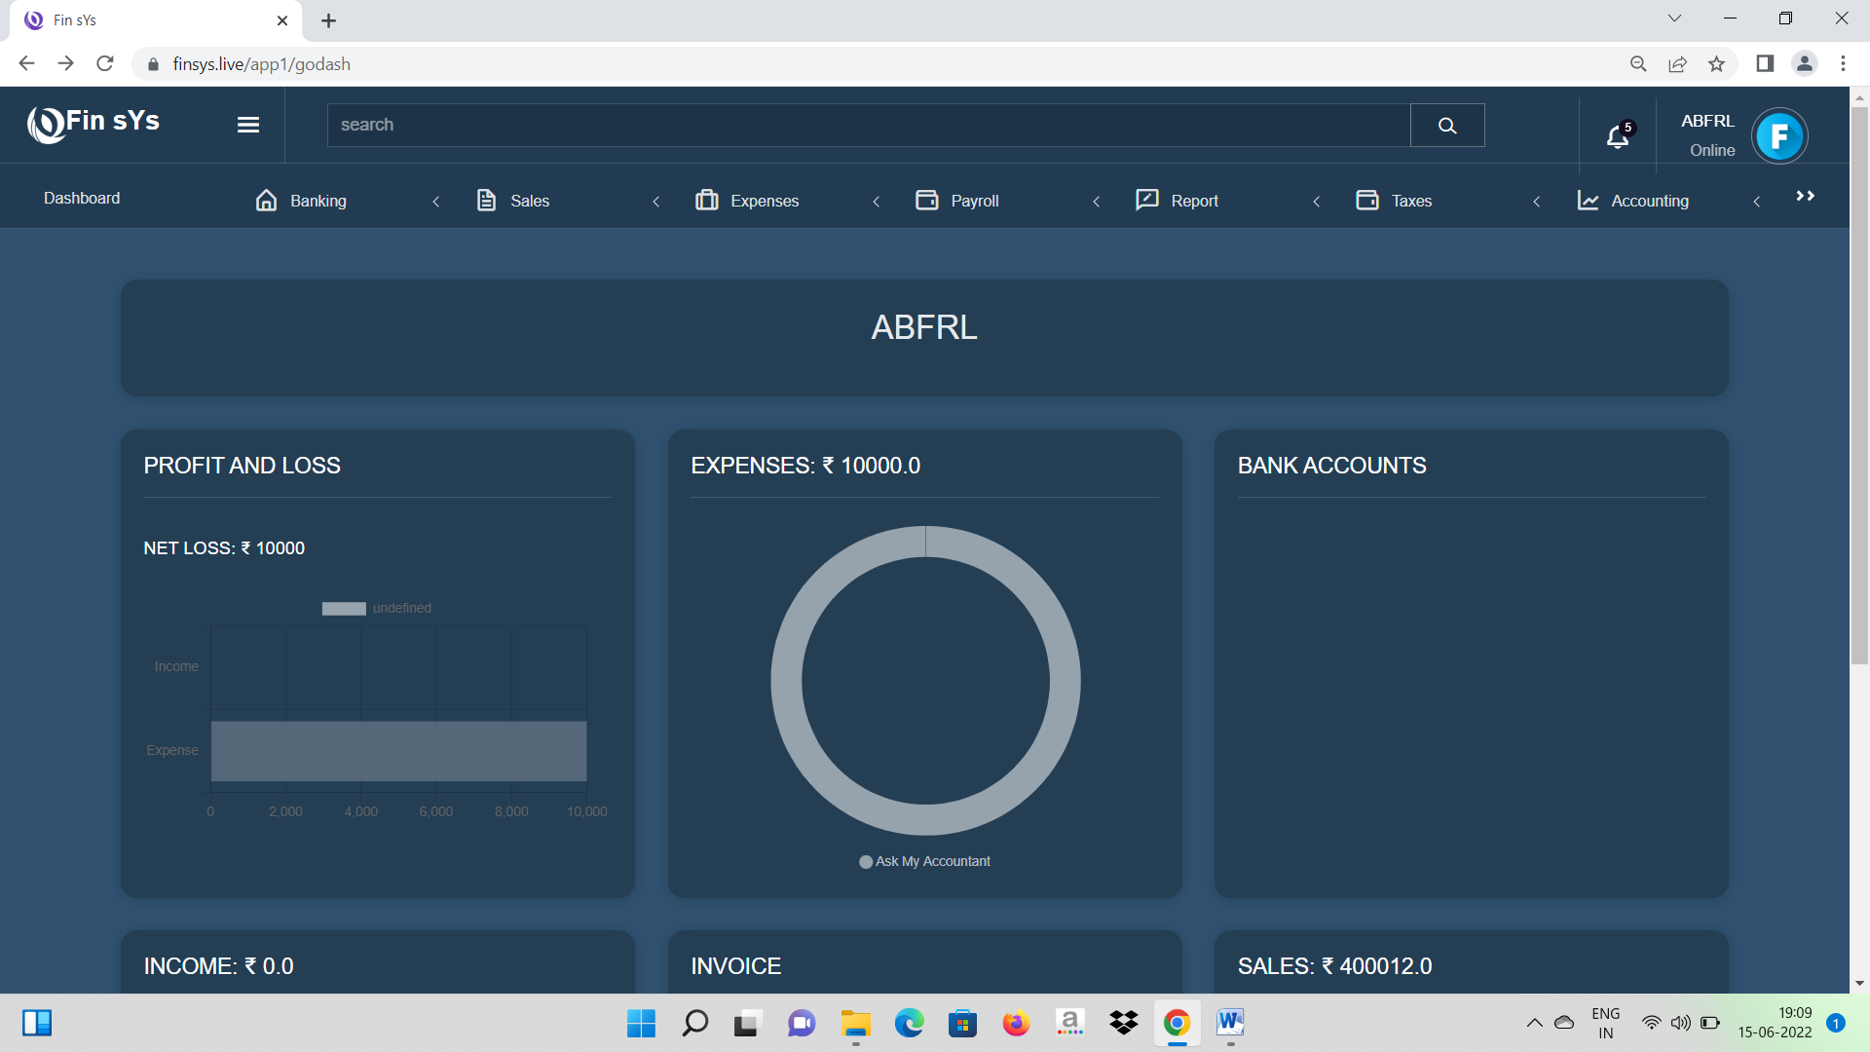

Back to dashboard without login and pwd

1. Log in to ERP and from the dashboard UI click log out.
2. Sign IN page will be displayed.
3. Click back button in browser
4. Dashboard UI displayed without entering User name and PWD

Message spell error

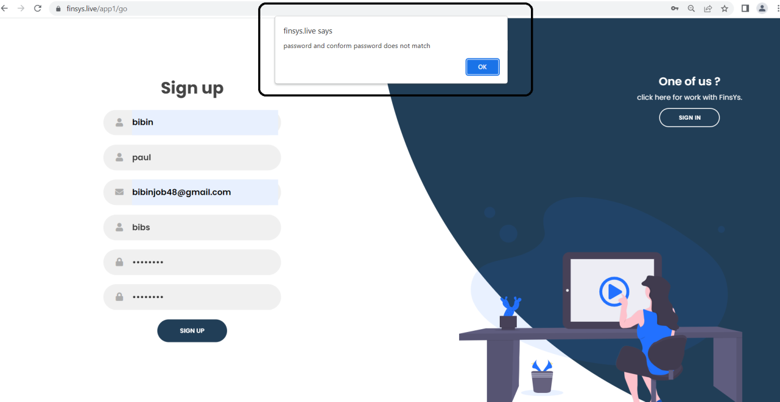

Online Banking module

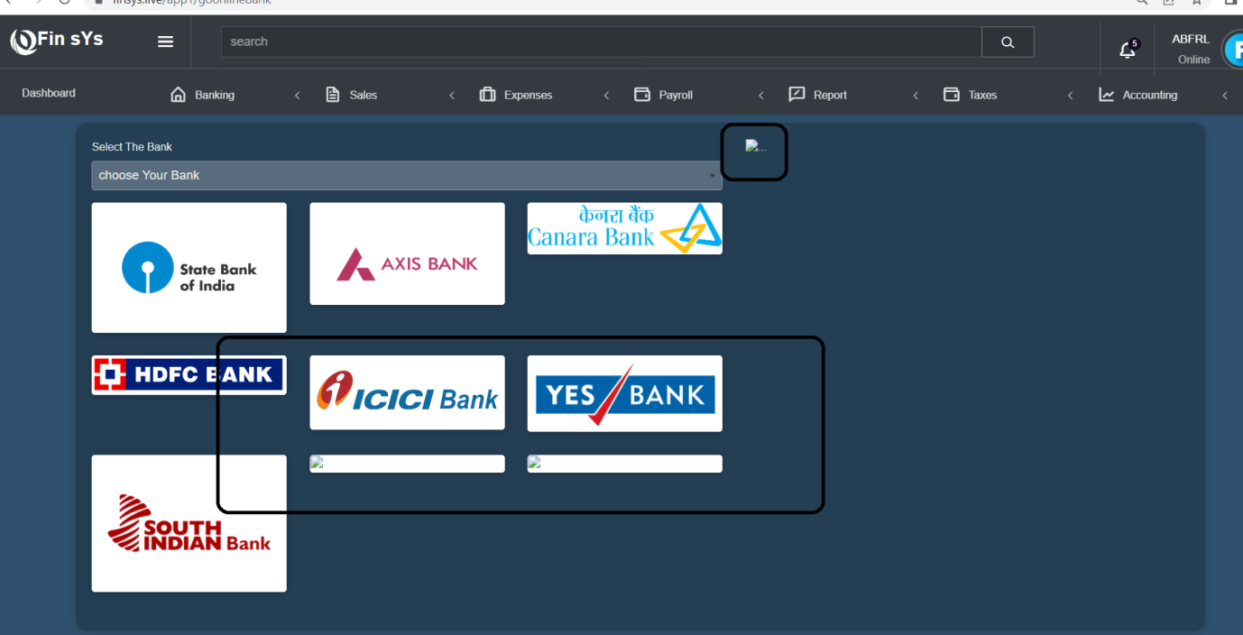

United Bank of India- Not redirecting to bank site

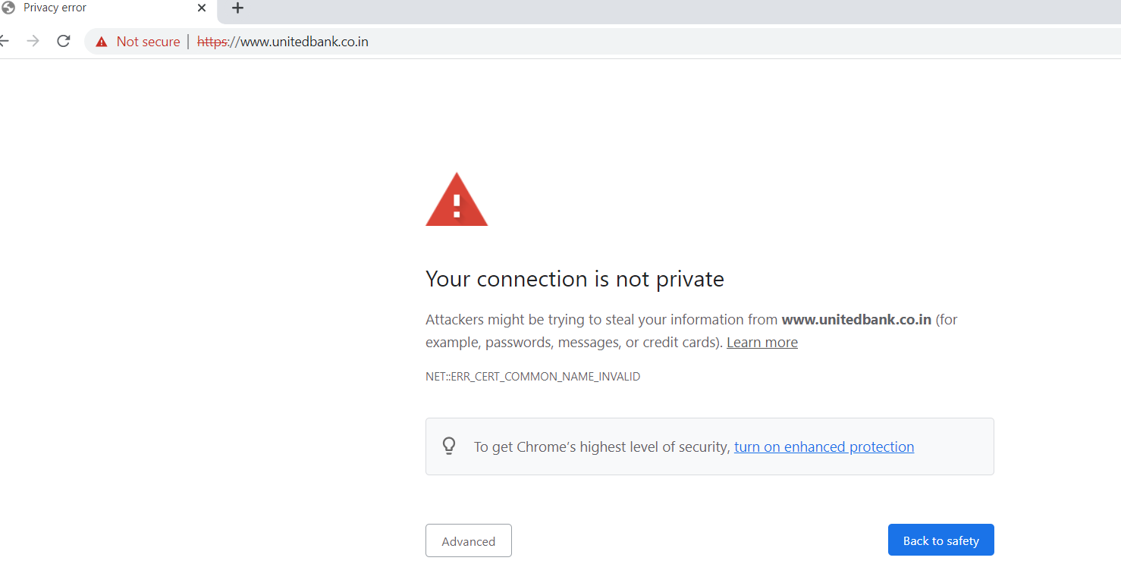

Offline Banking

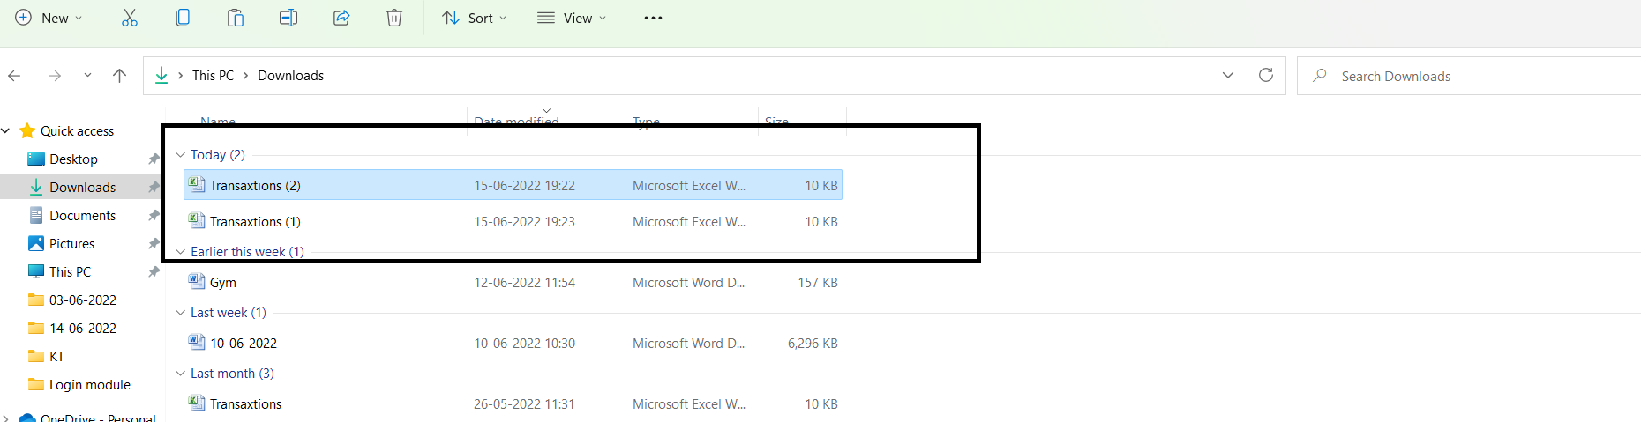

Transaxtions spell error- Transactions

Banking🡪Click Offline Banking🡪Download document🡪 enter values and upload

Click Uploaded statement

Click Add

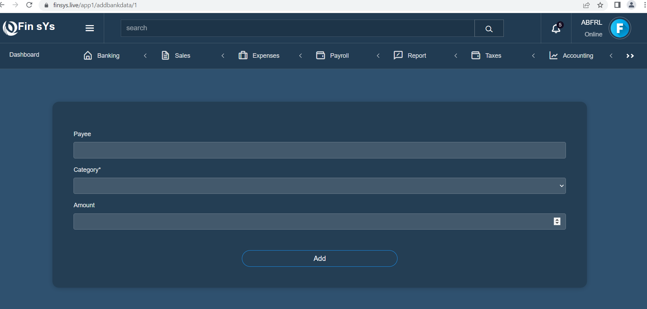

Enter the payee details and click Add

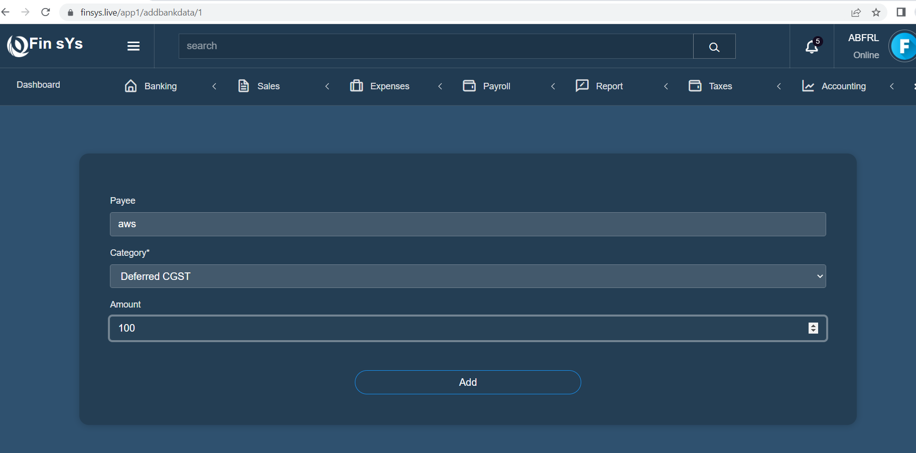

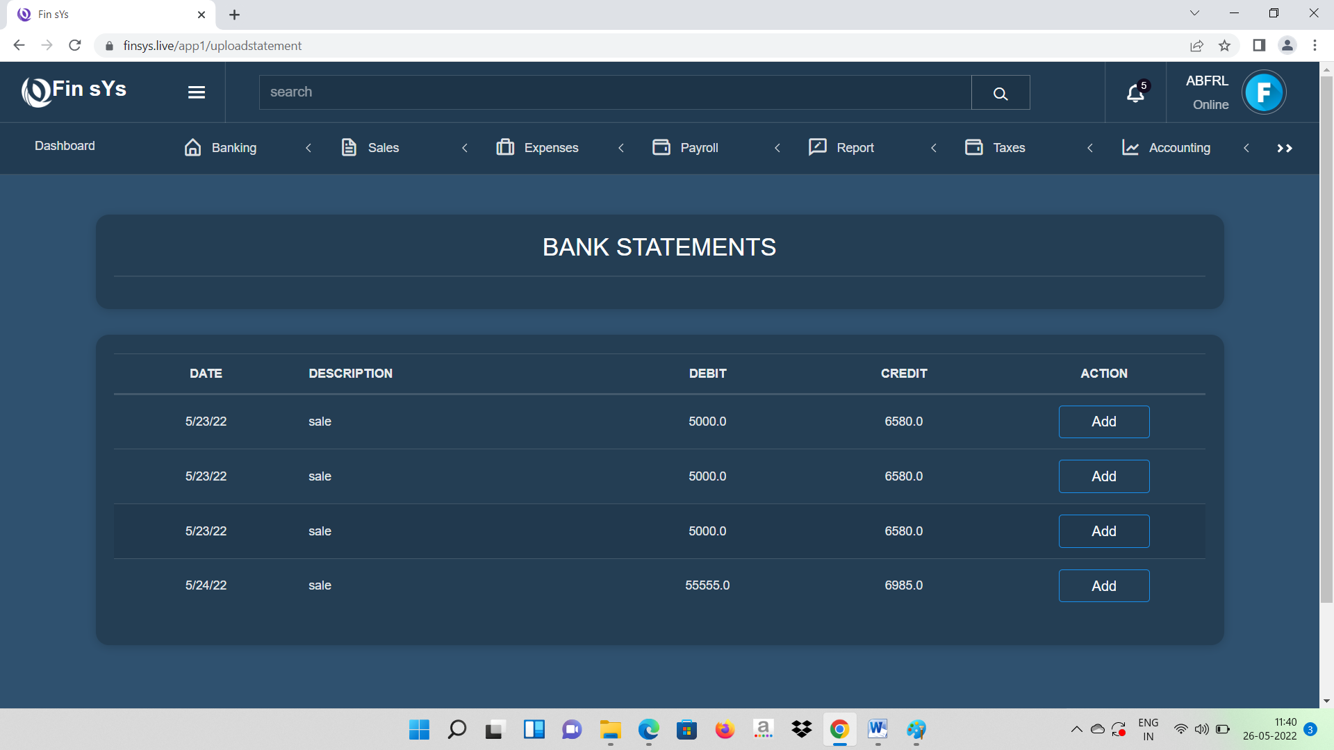

Entered value is not displayed in the list

No error messages in Adding products & Products cannot be added

Sale-> Product & Services

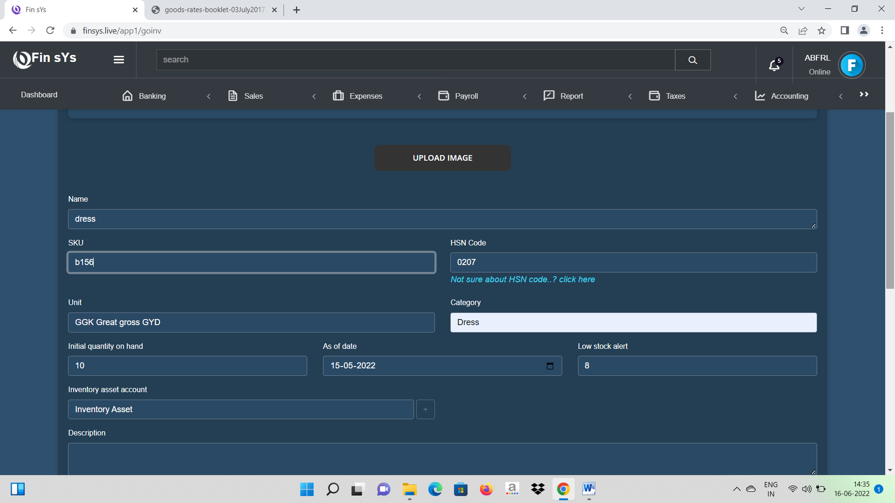

Employee module

No validation in Mail ID

