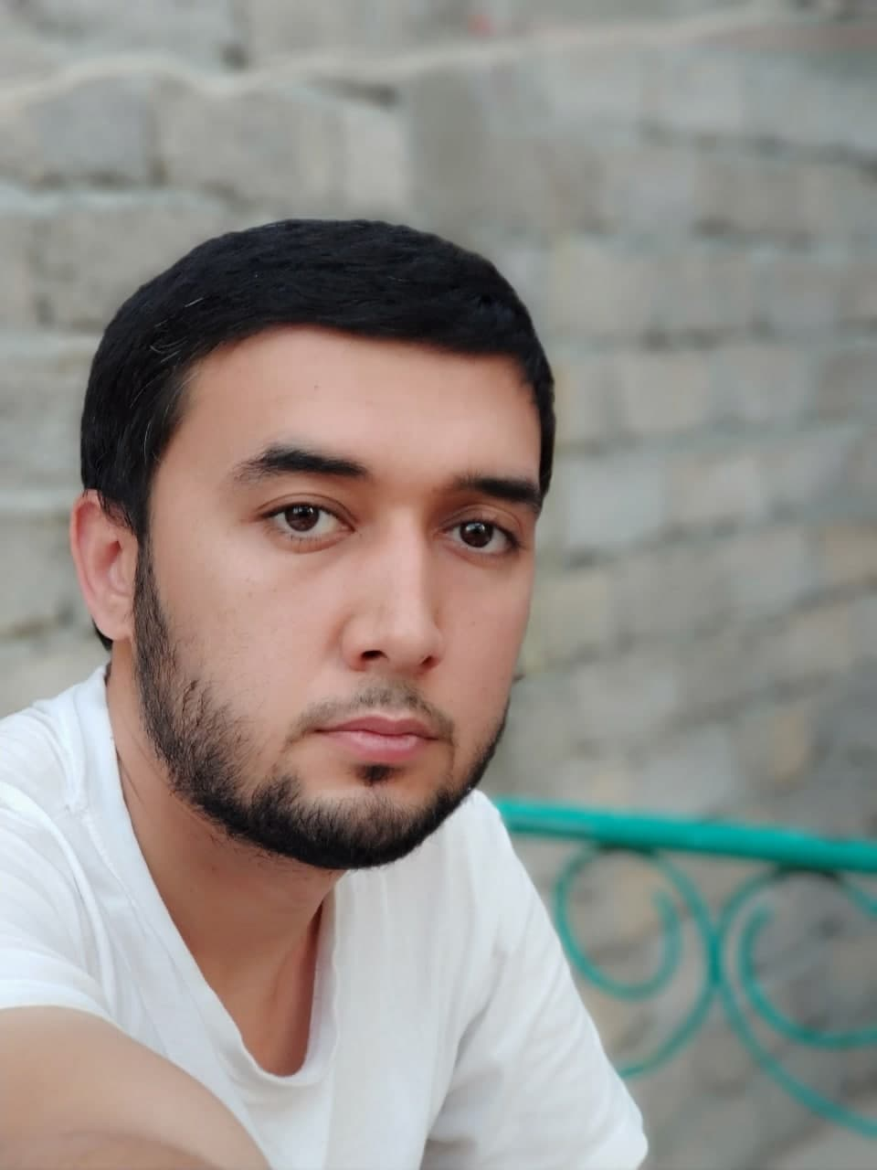  


Sherzod Kenjaev

|  |
| --- |
| Professional Profile |
| * F.N./L.N./M.N.: Kenjaev Sherzod Alisherovich * D.O.B.: 17.12.1991, Khorezm region, Yangiariq dist. * Nationality: Uzbek * Marital Status: Married * Address: Uchtepa dist., Chilanzar 23, 11/64, Tashkent * Telephone: +998 (97) 7453141 * E-mail: [kenjaevsherzod@gmail.com](mailto:kenjaevsherzod@gmail.com) |
| Education |
| * “Chiqirchi” profession college, accounting faculty (2008-2011) * English and Foundation courses at SEGi University, in Malaysia (2008-2009) * Completed Courses to prepare a "specialist commodity exchanges and exchanges real estate" in the Republican School of Business. (2009) * Graduated from Westminster International University in Tashkent. Business Information Systems faculty. (2011-2015) * Completed Full Stack Web Development Bootcamp online (03/2021-07/2021) |
| Relevant Work Experience  * Worked with English-speaking foreigners as a translator. (06/2013 - 09/2013) * Development of Web applications and systems for university assignments (.NET, C#). (10/2011 - 05/2015) * Worked at "Leader Finance" LLC Depository Company as a specialist of base program (iDepository) and stock operations. (01/2014 - 09/2014) * Worked at MST Group and CTRL+, IT Companies as Web-Developer (PHP, Laravel). (09/2015 - 02/2016) * Worked as LRC specialist at Westminster International University in Tashkent. (2016) * Worked as IRC specialist at INHA University in Tashkent (02/02016-05/2017) * Running own business (06/2017-untill now) |
| Language Skills |

* English: (advanced)
* Russian: (middle)
* Uzbek: (native)

|  |
| --- |
| Personal Qualities and other Skills  * Knowledge of programming languages:   + HTML, CSS, Bootstrap, Material UI   + JavaScript ES6   + React JS, React Redux, React Routing, Styled Components, React Reveal, React Toastify, React Flip Move   + jQuery   + Firebase |
| Objectives of Searching a New Job |

Find an interesting job with future career prospects, looking forward to get high experience by working with specialists and the ability to realize own potential and to be as helpful as possible to the overall team. I love developing thoughtful and purposeful websites. I try to complete products by using my maximum capability in delivering apps on time. My purpose of becoming the best in the sphere forces me to be up to date with industry standards.