Reference crop evapotranspiration (ETo) in Uzbekistan

26/10/2020

DRAFT

**Bahodir & Sons Farms**

Uzbekistan, 2020

$${ET}_{o}=\frac{0.408∆\left(R_{n}-G\right)+γ*\left(\frac{900}{T+273}\right)u_{2}*\left(e_{s}-e_{a}\right)}{∆+γ\left(1+0.34u_{2}\right)}$$

Based on “Irrigation and Drainage Paper - 56” by UN-FAO [1]

**WARNING!**

**This paper is daft copy of the work in progress. Published for the purpose of feedback and contributions. Following are the shortcomings of this report:**

Climate data must be verified independently based on other sources. Data in this report are based on arithmetic average calculations, instead of statistical analysis. No attempt is made to identify anomalies and outliers.

# Table of contents

Table of contents 3

List of figures 4

List of tables 4

In this revision 5

What is evapotranspiration 6

Process of calculating ETo 6

What information is required to calculate ETo? 6

How data were gathered? 7

How ETо calculation process organized? 7

Downloading the data 8

Evapotranspiration in Uzbekistan 9

Monthly ETo by regions. 11

Bi-weekly evapotranspiration by regions 11

Regions 13

Karakalpakstan Republic 13

Andijan 15

Fergana 16

Namangan 17

Tashkent 18

Syrdarya 19

Jizzakh 20

Samarkand 21

Kashkadarya 22

Surkhandarya 23

Navoiy 24

Bukhara 25

Khorezm 26

Bibliography 27

# List of figures

Figure 1 ETo in Uzbekistan 9

Figure 2 Solar radiation in MJ/m2/day 9

Figure 3 Wind speed vs relative humidity in Uzbekistan 10

Figure 4 Precipitation in Uzbekistan 10

Figure 5 ETo in Karakalpak Republic 13

Figure 6 Precipitation in Karakalpakstan Republic 14

Figure 7 ETo in Andijan 15

Figure 8 Precipitation in Andijan 15

Figure 9 ETo in Fergana 16

Figure 10 Precipitation in Fergana 16

Figure 11 ETo in Namangan 17

Figure 12 Precipitation in Namangan 17

Figure 13 ETo in Tashkent 18

Figure 14 Precipitation in Tashkent 18

Figure 15 ETo in Syrdarya 19

Figure 16 Precipitation in Syrdarya 19

Figure 17 ETo in Jizzakh 20

Figure 18 Precipitation in Jizzakh 20

Figure 19 ETo in Samarkand 21

Figure 20 Precipitation in Samarkand 21

Figure 21 ETo in Kashkadarya 22

Figure 22 Precipitation in Kashkadarya 22

Figure 23 ETo in Surkhandarya 23

Figure 24 Precipitation in Surkhandarya 23

Figure 25 ETo in Navoiy 24

Figure 26 Precipitation in Navoiy 24

Figure 27 ETo in Bukhara 25

Figure 28 Precipitation in Bukhara 25

Figure 29 ETo in Khorezm 26

Figure 30 Precipitation in Khorezm 26

# List of tables

Table 1 unit conversion 6

Table 2 ETo by regions 11

Table 3 Bi-weekly ETo by regions 11

Table 4 ETo in districts of Karakalpakstan Republic 13

Table 5 ETo in districts of Andijan 15

Table 6 ETo in districts of Fergana 16

Table 7 ETo in districts of Namangan 17

Table 8 Precipitation in districts of Tashkent 18

Table 9 ETo in districts of Jizzakh 20

Table 10 ETo in districts of Samarkand 21

Table 11 ETo in districts of Kashkadarya 22

Table 12 ETo in districts of Surkhandarya 23

Table 13 ETo in districts of Bukhara 25

Table 14 ETo in districts of Khorezm 26

# InformationIn this revision

This is the 1st publication of the report. Based on the 5th draft revision of the report in the Uzbek language.

# What is evapotranspiration

*“Evaporation is the process whereby liquid water is converted to water vapour (vaporization) and removed from the evaporating surface (vapour removal). Water evaporates from a variety of surfaces, such as lakes, rivers, pavements, soils and wet vegetation.*

*Energy is required to change the state of the molecules of water from liquid to vapour. Direct solar radiation and, to a lesser extent, the ambient temperature of the air provide this energy. The driving force to remove water vapour from the evaporating surface is the difference between the water vapour pressure at the evaporating surface and that of the surrounding atmosphere. As evaporation proceeds, the surrounding air becomes gradually saturated and the process will slow down and might stop if the wet air is not transferred to the atmosphere. The replacement of the saturated air with drier air depends greatly on wind speed. Hence, solar radiation, air temperature, air humidity and wind speed are climatological parameters to consider when assessing the evaporation process.*

*Where the evaporating surface is the soil surface, the degree of shading of the crop canopy and the amount of water available at the evaporating surface are other factors that affect the evaporation process. Frequent rains, irrigation and water transported upwards in a soil from a shallow water table wet the soil surface. Where the soil is able to supply water fast enough to satisfy the evaporation demand, the evaporation from the soil is determined only by the meteorological conditions. However, where the interval between rains and irrigation becomes large and the ability of the soil to conduct moisture to pear the surface is small, the water content in the topsoil drops and the soil surface dries out. Under these circumstances the limited availability of water exerts a controlling influence on soil evaporation. In the absence of any supply of water to the soil surface, evaporation decreases rapidly and may cease almost completely within a few days”. [1]*

**Unit of measure**

*We report ET in mm. To convert it to other widely used units:*

Table 1 unit conversion

|  |  |  |
| --- | --- | --- |
| *мм* | *m3 / га* | *MJ / м2 / кун* |
| *1мм* | *10м3/га* | *2.45 MJ/м2/кун* |



Above was the direct quote from FAO’s “Irrigation and Drainage Paper 56” [1], referred to as “the paper” from now on. We could not have stated any clearer even if we tried!

# Process of calculating ETo

We briefly want to look into the steps taken to generate this report.

## What information is required to calculate ETo?

To be able to calculate ETо based on the paper [1] we had to gather certain climatic data from specific locations. Namely:

* Latitude of the location
* Altitude of the location
* Daily high and low air temperature
* Daily mean relative humidity of the air
* Wind speed at 2 meters above soil surface
* Solar radiation, in MJ/m2/day

## How data were gathered?

We were able to download climate data from “Global Weather Data” project [2] of Texas A&M University. Data covered periods from 1979 through august of 2014 in daily resolutions. We used Google Earth® software to make sure to limit the data for agricultural areas only.

We were left with 70 files in *.csv* format.

Had we had a choice we would have used recorded data from National Weather Service of Uzbekistan [3]. This is something to consider for the future revisions of the report. Or at least to validate the data downloaded.

Collected data reported wind speed at 10m height. Though Penman-Monteith method required wind speed for 2m profile. We had to calibrate wind data for required height based on logarithmic wind speed profiling formula:

Equation 1 [1]

$$u_{2}=u_{z}\frac{4.87}{\ln\left(67.8z-5.42\right)}$$

**Where**:

*u2 – wind speed at 2m*

*uZ – wind speed at z m. height*

*z – anemometer height*

## How ETо calculation process organized?

According to the paper [1] Penman-Monteith equation was detailed as the most accurate method of calculating reference crop’s evapotranspiration.

Calculated values were comparable with data of the Davis Vantage Pro2 Plus weather station located in our orchard in Khorezm (interior, arid location)



Following algorithms outlined in the paper we created software module in Python programming language named **penmon.** Software module is freely available for download from the author’s github.com page [1].

Using ***pandas*** and ***penmon*** modules we were able to calculate ETo values for downloaded records. As the result final updated daraframe had the following layout:

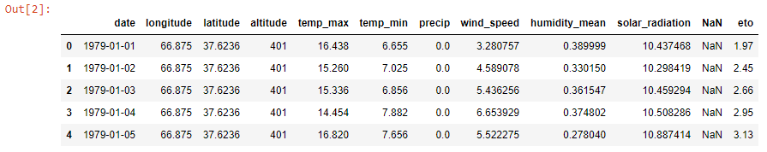

Dataframe was transferred to Excel. Using Power Pivot data were grouped and analyzed. Visualizations in this report are directly imported from the spreadsheet.

## Downloading the data

Data used to calculate ETo, analyze and generate this report are freely available for download from our github.com page, including the spreadsheet[2].

# **Evapotranspiration in Uzbekistan**



Reminder!

Reported water demand is for the reference crop. To convert them to your specific crop you need to multiply these values to your crop’s coefficient

Highest ETo was calculated for July. For March-October (usual irrigation season) 1,260mm of evapotranspiration was calculated. This accounts to 12,600 m3/ha water demand:

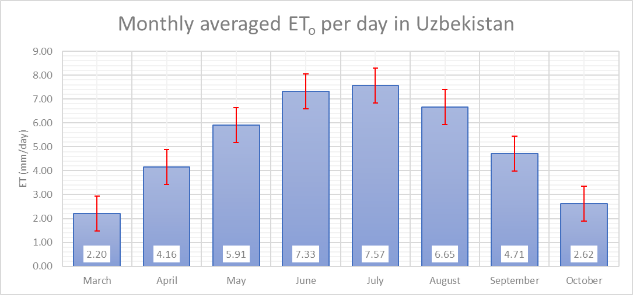

Figure 1 ETo in Uzbekistan

Highest values of solar radiation are observed during months of June and July. Total of 855 and 870 MJ/m2 solar radiation is observed during these months respectively:

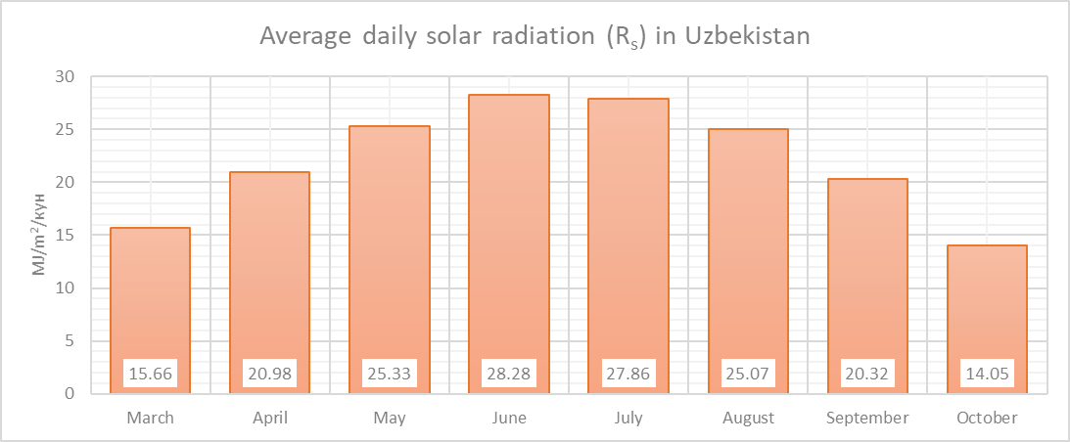

Figure 2 Solar radiation in MJ/m2/day

Most winds are observed during July, followed by June. This explains why highest amount of ETo is observed during July. Winds lower humidity levels which increases evapotranspiration.

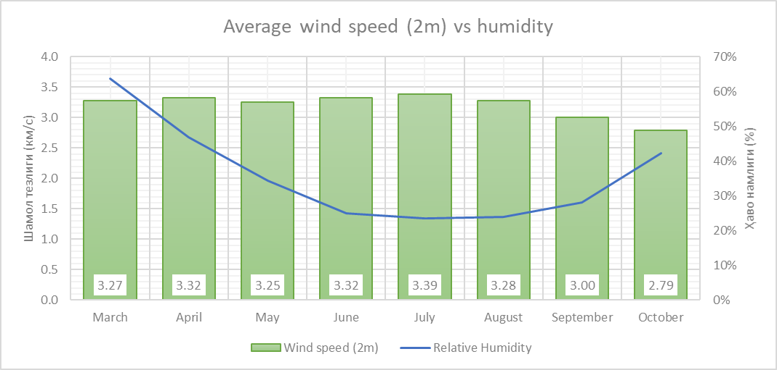

Figure 3 Wind speed vs relative humidity in Uzbekistan

55% of total precipitation is observed fall through winter. 85% of the precipitation is observed during months of September through April. Precipitation during the irrigation is usually not effective to cover plants water demand [5]. When planning irrigation system we suggest not to rely on precipitation.



**Note**

Up to 10mm/month of precipitation is ineffective to cover plants water demand. [5]

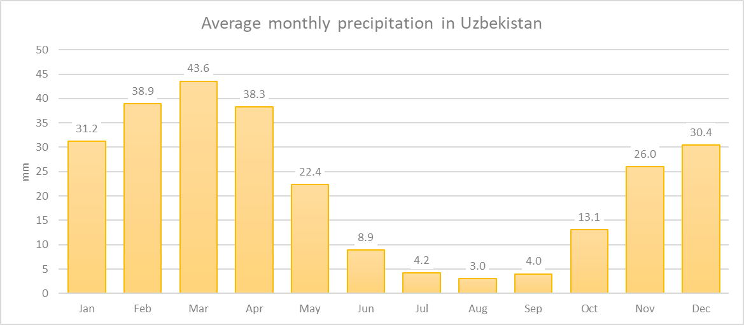

Figure 4 Precipitation in Uzbekistan

## Monthly ETo by regions.

35 years of data reveal the following average values of ETo grouped by regions:

Table 2 ETo by regions

|  |  |  |  |  |  |  |  |  |  |  |  |  |  |  |  |
| --- | --- | --- | --- | --- | --- | --- | --- | --- | --- | --- | --- | --- | --- | --- | --- |
|  |  |  | |  | |  |  | |  | |  | |  | | |
|  | **Mar** | | **Apr** | | **May** | | | **Jun** | | **Jul** | | **Aug** | | **Sep** | **Oct** |
| **Andijan** | **2.04** | | **3.56** | | **5.08** | | | **6.49** | | **6.83** | | **5.94** | | **4.08** | **2.17** |
| **Bukhara** | **2.77** | | **5.05** | | **7.10** | | | **8.88** | | **9.37** | | **8.37** | | **5.97** | **3.37** |
| **Fergana** | **2.26** | | **3.95** | | **5.52** | | | **6.86** | | **7.12** | | **6.19** | | **4.31** | **2.33** |
| **Jizzakh** | **2.00** | | **3.66** | | **5.38** | | | **6.71** | | **6.82** | | **5.95** | | **4.22** | **2.35** |
| **Namangan** | **1.82** | | **3.34** | | **4.78** | | | **6.14** | | **6.53** | | **5.82** | | **4.12** | **2.19** |
| **Navoiy** | **2.67** | | **4.94** | | **7.12** | | | **9.17** | | **9.88** | | **8.83** | | **6.15** | **3.28** |
| **Kashkadarya** | **2.36** | | **4.19** | | **6.09** | | | **7.81** | | **8.48** | | **7.39** | | **5.08** | **2.92** |
| **Karakalpakstan rep.** | **2.10** | | **4.49** | | **6.36** | | | **7.68** | | **7.74** | | **6.78** | | **4.76** | **2.59** |
| **Samarkand** | **2.20** | | **3.90** | | **5.64** | | | **7.20** | | **7.63** | | **6.78** | | **4.88** | **2.77** |
| **Syrdarya** | **2.01** | | **3.66** | | **5.29** | | | **6.51** | | **6.65** | | **5.88** | | **4.23** | **2.32** |
| **Surkhandarya** | **2.84** | | **4.70** | | **6.22** | | | **7.33** | | **7.27** | | **6.35** | | **4.84** | **3.28** |
| **Tashkent** | **2.07** | | **3.61** | | **5.27** | | | **6.79** | | **7.01** | | **6.17** | | **4.44** | **2.52** |
| **Khorezm** | **2.31** | | **4.65** | | **6.40** | | | **7.71** | | **7.78** | | **6.83** | | **4.90** | **2.74** |

## Bi-weekly evapotranspiration by regions

At our orchard we budget for irrigation volume on bi-weekly basis. Bi-weekly ETo report comes in handy for this purpose.

Table 3 Bi-weekly ETo by regions

|  | And | Bukh | Fer | Jiz | Nam | Nav | Kash | Kara | Sam | Syr | Sur | Tash | Khor |
| --- | --- | --- | --- | --- | --- | --- | --- | --- | --- | --- | --- | --- | --- |
|  |  |  |  |  |  |  |  |  |  |  |  |  |  |
| **Mar** |  |  |  |  |  |  |  |  |  |  |  |  |  |
| **1-15** | 1.70 | 2.31 | 1.89 | 1.66 | 1.53 | 2.22 | 2.01 | 1.63 | 1.84 | 1.67 | 2.49 | 1.76 | 1.83 |
| **16-31** | 2.35 | 3.19 | 2.61 | 2.32 | 2.10 | 3.09 | 2.69 | 2.53 | 2.54 | 2.33 | 3.17 | 2.37 | 2.75 |
| **Apr** |  |  |  |  |  |  |  |  |  |  |  |  |  |
| **1-15** | 3.09 | 4.47 | 3.47 | 3.19 | 2.88 | 4.34 | 3.66 | 3.86 | 3.43 | 3.18 | 4.20 | 3.14 | 4.06 |
| **16-30** | 4.01 | 5.64 | 4.43 | 4.13 | 3.80 | 5.54 | 4.72 | 5.12 | 4.37 | 4.13 | 5.19 | 4.08 | 5.24 |
| **May** |  |  |  |  |  |  |  |  |  |  |  |  |  |
| **1-15** | 4.73 | 6.68 | 5.18 | 4.99 | 4.45 | 6.66 | 5.72 | 6.06 | 5.27 | 4.94 | 5.87 | 4.89 | 6.10 |
| **16-31** | 5.41 | 7.49 | 5.84 | 5.74 | 5.09 | 7.54 | 6.44 | 6.64 | 5.99 | 5.61 | 6.55 | 5.63 | 6.69 |
| **Jun** |  |  |  |  |  |  |  |  |  |  |  |  |  |
| **1-15** | 6.22 | 8.47 | 6.63 | 6.50 | 5.86 | 8.65 | 7.38 | 7.47 | 6.87 | 6.33 | 7.18 | 6.49 | 7.51 |
| **16-30** | 6.77 | 9.29 | 7.10 | 6.92 | 6.41 | 9.69 | 8.25 | 7.90 | 7.53 | 6.69 | 7.48 | 7.08 | 7.90 |
| **Jul** |  |  |  |  |  |  |  |  |  |  |  |  |  |
| **1-15** | 6.94 | 9.39 | 7.26 | 6.94 | 6.61 | 9.88 | 8.58 | 7.78 | 7.69 | 6.74 | 7.46 | 7.15 | 7.83 |
| **16-31** | 6.73 | 9.34 | 6.98 | 6.71 | 6.46 | 9.87 | 8.39 | 7.71 | 7.57 | 6.56 | 7.09 | 6.89 | 7.73 |
| **Aug** |  |  |  |  |  |  |  |  |  |  |  |  |  |
| **1-15** | 6.33 | 8.92 | 6.60 | 6.33 | 6.18 | 9.44 | 7.91 | 7.17 | 7.22 | 6.22 | 6.69 | 6.54 | 7.22 |
| **16-31** | 5.57 | 7.84 | 5.80 | 5.60 | 5.48 | 8.27 | 6.90 | 6.42 | 6.37 | 5.57 | 6.03 | 5.83 | 6.48 |
| **Sep** |  |  |  |  |  |  |  |  |  |  |  |  |  |
| **1-15** | 4.62 | 6.72 | 4.85 | 4.74 | 4.64 | 7.01 | 5.74 | 5.41 | 5.48 | 4.76 | 5.26 | 4.97 | 5.53 |
| **16-30** | 3.54 | 5.23 | 3.77 | 3.70 | 3.59 | 5.30 | 4.42 | 4.11 | 4.27 | 3.71 | 4.42 | 3.91 | 4.27 |
| **Oct** |  |  |  |  |  |  |  |  |  |  |  |  |  |
| **1-15** | 2.58 | 3.88 | 2.76 | 2.78 | 2.59 | 3.82 | 3.33 | 3.05 | 3.20 | 2.73 | 3.62 | 2.88 | 3.20 |
| **16-31** | 1.79 | 2.89 | 1.92 | 1.95 | 1.82 | 2.77 | 2.53 | 2.16 | 2.37 | 1.93 | 2.96 | 2.17 | 2.31 |

Rest of the report will look at climate and ETo in regions. We also break the report down to specific areas in the regions where data was collected. Climate of some regions are complex so breaking them down by specific areas helps to draw the whole picture. We also look at precipitation by each region.

# Regions

## Karakalpakstan Republic

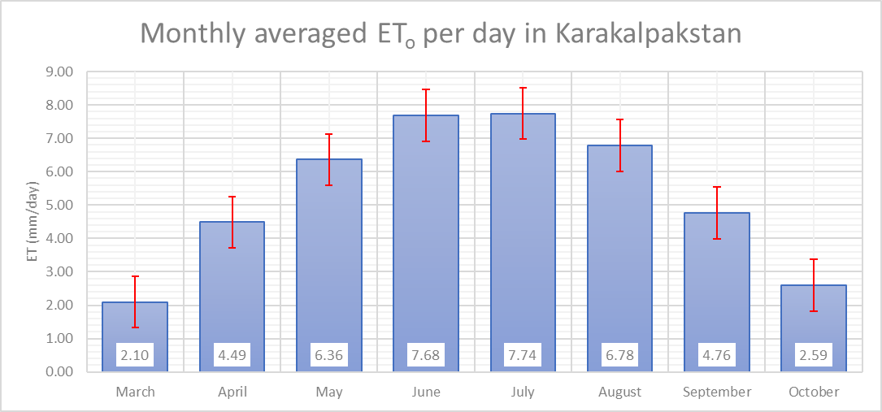

Figure 5 ETo in Karakalpak Republic

Table 4 ETo in districts of Karakalpakstan Republic

|  |  |  |  |  |  |  |  |  |
| --- | --- | --- | --- | --- | --- | --- | --- | --- |
|  | **Mar** | **Apr** | **May** | **Jun** | **Jul** | **Aug** | **Sep** | **Oct** |
| **Karakalpakstan** |  |  |  |  |  |  |  |  |
| Amudaryo | 2.26 | 4.60 | 6.32 | 7.64 | 7.72 | 6.78 | 4.82 | 2.65 |
| Beruniy | 2.23 | 4.60 | 6.41 | 7.78 | 7.91 | 6.95 | 4.92 | 2.68 |
| Chimboy | 2.04 | 4.46 | 6.39 | 7.71 | 7.76 | 6.79 | 4.75 | 2.57 |
| Kegeyli | 2.07 | 4.45 | 6.31 | 7.60 | 7.64 | 6.69 | 4.68 | 2.55 |
| Nukus | 2.17 | 4.54 | 6.33 | 7.60 | 7.64 | 6.70 | 4.73 | 2.61 |
| Qo'ng'irot | 1.99 | 4.32 | 6.18 | 7.42 | 7.44 | 6.49 | 4.52 | 2.45 |
| Qorao'zak | 2.05 | 4.53 | 6.51 | 7.90 | 7.97 | 6.97 | 4.87 | 2.63 |
| Shumanay | 2.16 | 4.54 | 6.35 | 7.63 | 7.65 | 6.71 | 4.75 | 2.61 |
| Taxtako'pir | 2.00 | 4.49 | 6.55 | 7.96 | 8.01 | 7.01 | 4.89 | 2.63 |
| To'rtko'l | 2.25 | 4.69 | 6.60 | 8.07 | 8.24 | 7.25 | 5.13 | 2.78 |
| Xo'jayli | 2.21 | 4.57 | 6.32 | 7.61 | 7.70 | 6.77 | 4.83 | 2.70 |

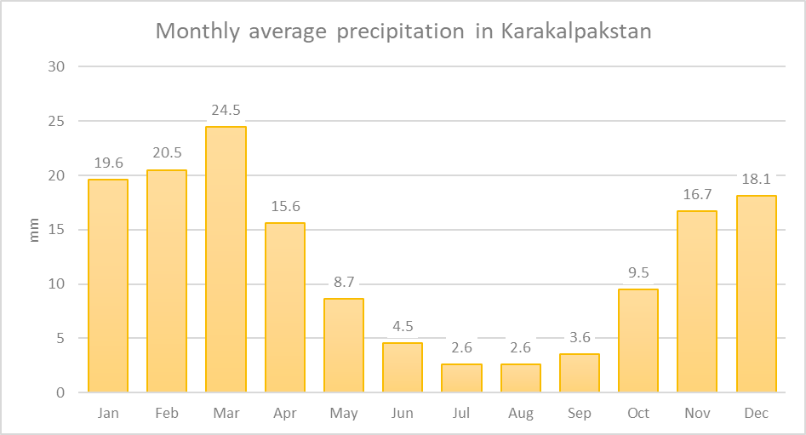

Figure 6 Precipitation in Karakalpakstan Republic

## Andijan

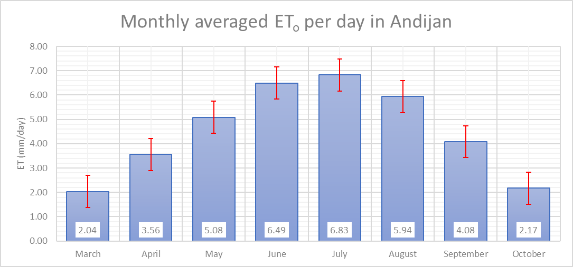

Figure 7 ETo in Andijan

Table 5 ETo in districts of Andijan

|  |  |  |  |  |  |  |  |  |
| --- | --- | --- | --- | --- | --- | --- | --- | --- |
|  | **Mar** | **Apr** | **May** | **Jun** | **Jul** | **Aug** | **Sep** | **Oct** |
| **Andijan** |  |  |  |  |  |  |  |  |
| Asaka | 2.01 | 3.50 | 5.02 | 6.41 | 6.77 | 5.89 | 3.98 | 2.04 |
| Boz | 2.10 | 3.67 | 5.19 | 6.50 | 6.77 | 5.81 | 3.91 | 2.05 |
| Uchkurgan | 2.06 | 3.61 | 5.18 | 6.68 | 7.03 | 6.14 | 4.41 | 2.52 |
| Xarabek | 1.99 | 3.44 | 4.93 | 6.38 | 6.76 | 5.91 | 4.04 | 2.08 |

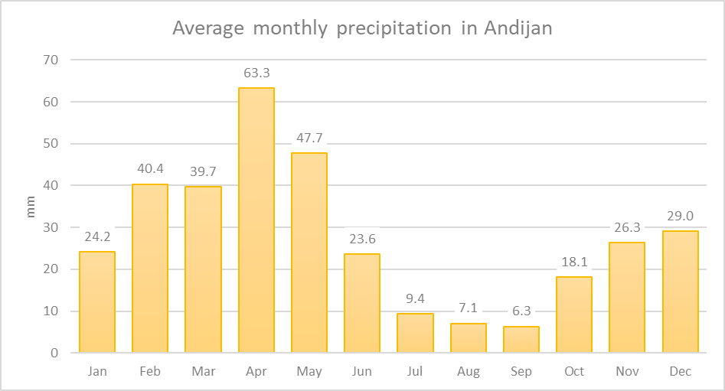

Figure 8 Precipitation in Andijan

## Fergana

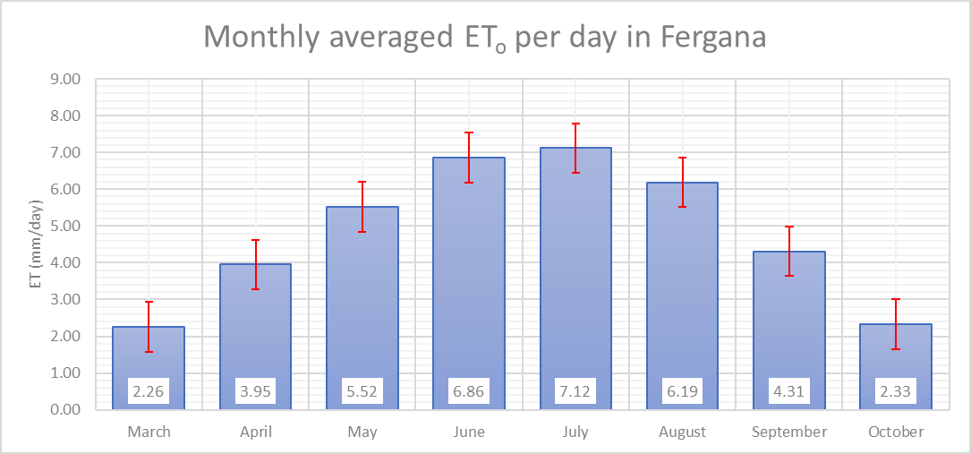

Figure 9 ETo in Fergana

Table 6 ETo in districts of Fergana

|  |  |  |  |  |  |  |  |  |
| --- | --- | --- | --- | --- | --- | --- | --- | --- |
|  | **Mar** | **Apr** | **May** | **Jun** | **Jul** | **Aug** | **Sep** | **Oct** |
| **Fergana** |  |  |  |  |  |  |  |  |
| Altyarik | 2.11 | 3.80 | 5.38 | 6.80 | 7.06 | 6.16 | 4.34 | 2.29 |
| Besharyk | 2.57 | 4.31 | 5.91 | 7.25 | 7.52 | 6.54 | 4.57 | 2.62 |
| Kuva | 1.98 | 3.56 | 5.08 | 6.55 | 6.90 | 6.07 | 4.31 | 2.24 |
| O'zbkeiston | 2.43 | 4.18 | 5.77 | 7.05 | 7.29 | 6.36 | 4.41 | 2.39 |
| Rishtan | 2.25 | 4.00 | 5.60 | 6.92 | 7.14 | 6.20 | 4.32 | 2.31 |
| Ulugnor | 2.20 | 3.84 | 5.38 | 6.60 | 6.80 | 5.79 | 3.92 | 2.12 |

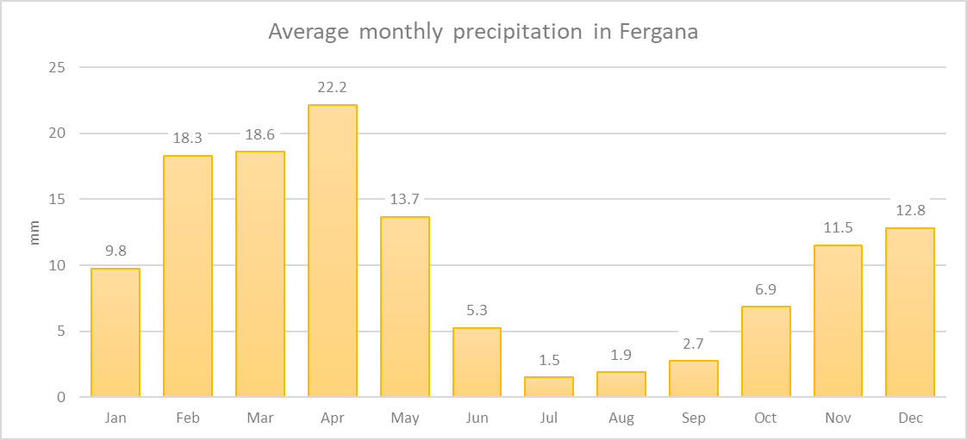

Figure 10 Precipitation in Fergana

## Namangan

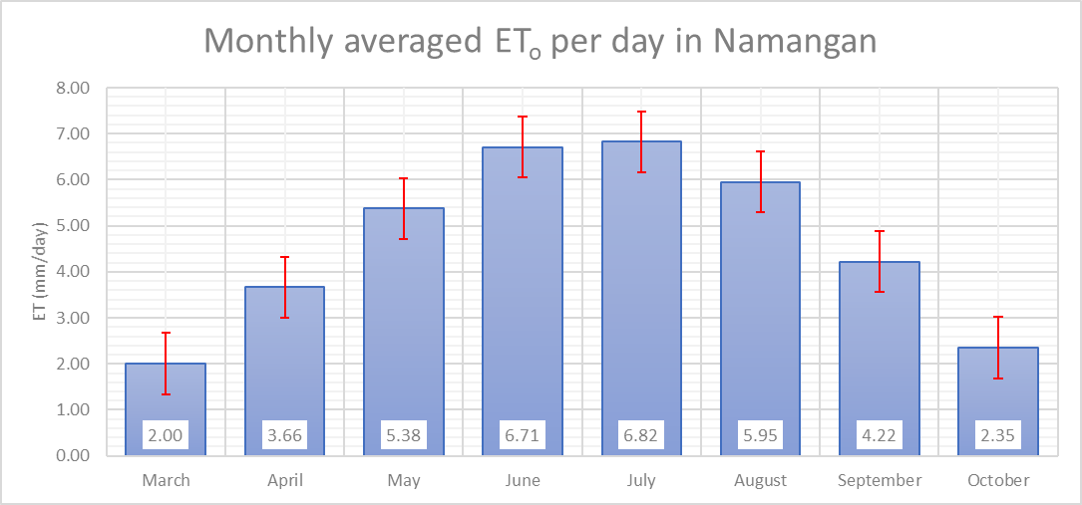

Figure 11 ETo in Namangan

Table 7 ETo in districts of Namangan

|  |  |  |  |  |  |  |  |  |
| --- | --- | --- | --- | --- | --- | --- | --- | --- |
|  | **Mar** | **Apr** | **May** | **Jun** | **Jul** | **Aug** | **Sep** | **Oct** |
| **Jizzakh** |  |  |  |  |  |  |  |  |
| Arnasoy | 1.91 | 3.58 | 5.27 | 6.65 | 6.97 | 6.20 | 4.32 | 2.29 |
| Jizzah | 2.02 | 3.63 | 5.31 | 6.60 | 6.59 | 5.66 | 4.02 | 2.32 |
| Paxtakor | 1.97 | 3.65 | 5.31 | 6.58 | 6.81 | 6.08 | 4.32 | 2.33 |
| Zarbdor | 2.03 | 3.69 | 5.45 | 6.79 | 6.78 | 5.83 | 4.15 | 2.37 |
| Zomin | 2.09 | 3.76 | 5.54 | 6.94 | 6.96 | 5.99 | 4.30 | 2.44 |

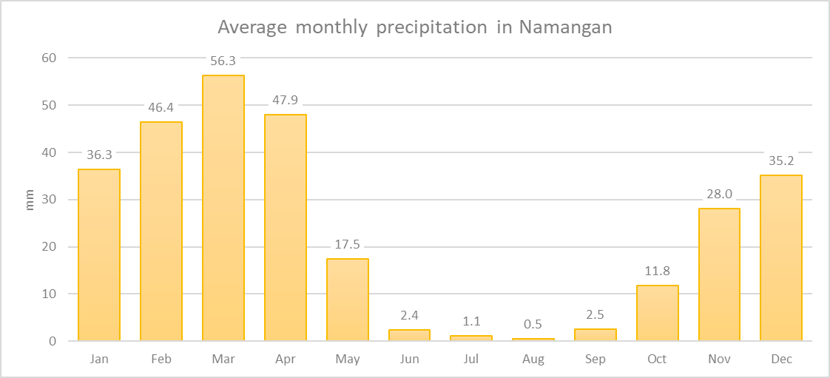

Figure 12 Precipitation in Namangan

## Tashkent

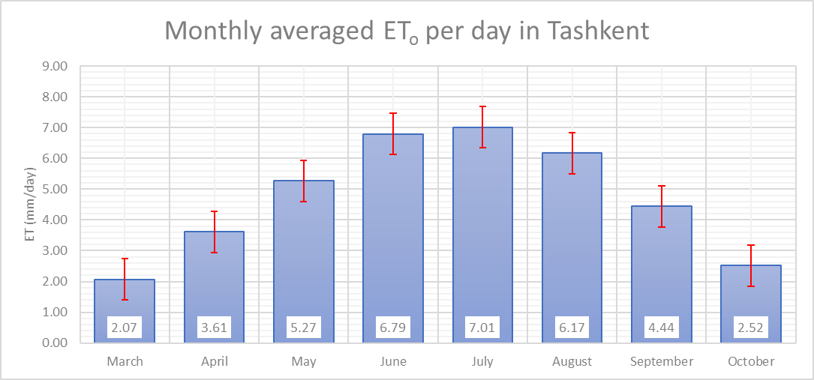

Figure 13 ETo in Tashkent

Table 8 Precipitation in districts of Tashkent

|  |  |  |  |  |  |  |  |  |
| --- | --- | --- | --- | --- | --- | --- | --- | --- |
|  | **Mar** | **Apr** | **May** | **Jun** | **Jul** | **Aug** | **Sep** | **Oct** |
| **Tashkent** |  |  |  |  |  |  |  |  |
| Buka | 2.03 | 3.51 | 5.07 | 6.39 | 6.51 | 5.70 | 4.13 | 2.37 |
| Parkent | 1.89 | 3.32 | 4.85 | 6.44 | 6.85 | 6.09 | 4.34 | 2.41 |
| Toytepa | 2.15 | 3.68 | 5.41 | 7.05 | 7.33 | 6.48 | 4.68 | 2.65 |
| Yalangch | 2.20 | 3.83 | 5.56 | 7.08 | 7.26 | 6.37 | 4.61 | 2.68 |
| Yangiyul | 2.09 | 3.71 | 5.47 | 6.97 | 7.11 | 6.23 | 4.45 | 2.48 |

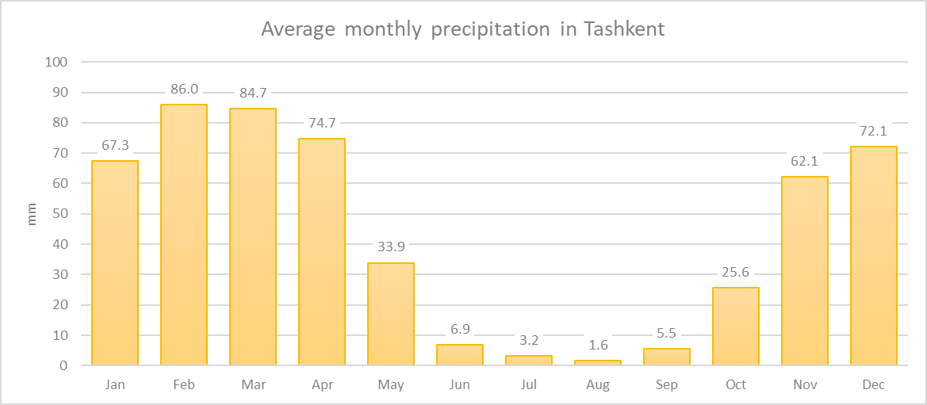

Figure 14 Precipitation in Tashkent

## Syrdarya

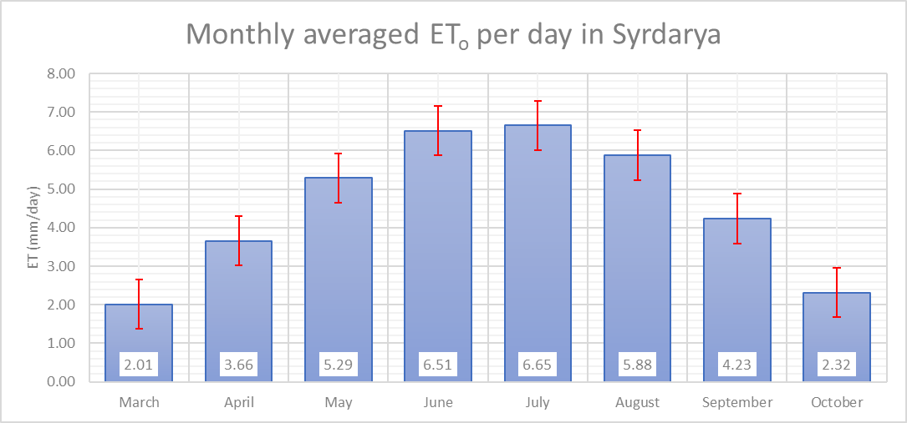

Figure 15 ETo in Syrdarya

Above report was gathered from Havast area – the only information we were able to find in this region. Expanding observation to other fields of Syrdarya may give us different picture.

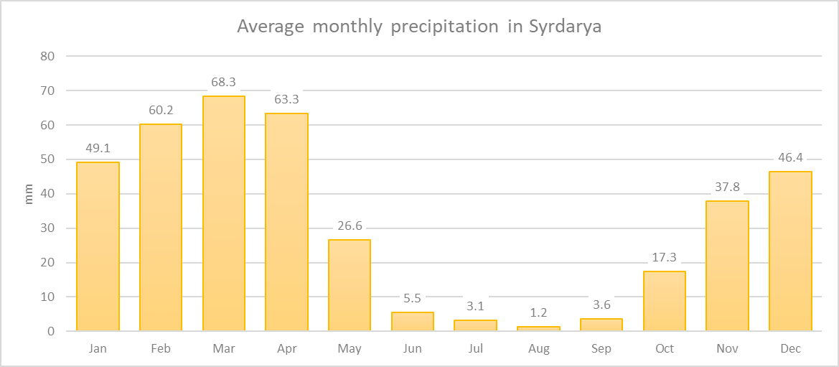

Figure 16 Precipitation in Syrdarya

## Jizzakh

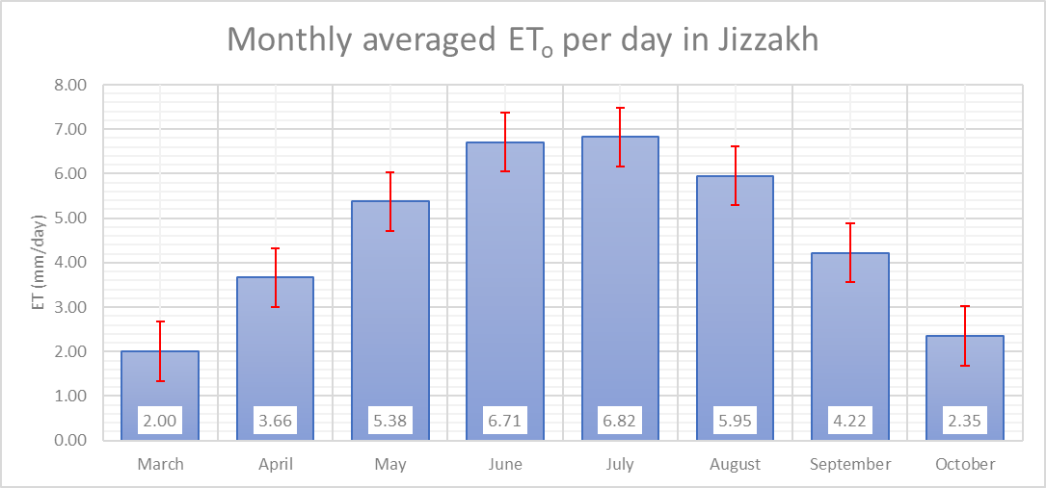

Figure 17 ETo in Jizzakh

Table 9 ETo in districts of Jizzakh

|  |  |  |  |  |  |  |  |  |
| --- | --- | --- | --- | --- | --- | --- | --- | --- |
|  | **Mar** | **Apr** | **May** | **Jun** | **Jul** | **Aug** | **Sep** | **Oct** |
| **Jizzakh** |  |  |  |  |  |  |  |  |
| Arnasoy | 1.91 | 3.58 | 5.27 | 6.65 | 6.97 | 6.20 | 4.32 | 2.29 |
| Jizzah | 2.02 | 3.63 | 5.31 | 6.60 | 6.59 | 5.66 | 4.02 | 2.32 |
| Paxtakor | 1.97 | 3.65 | 5.31 | 6.58 | 6.81 | 6.08 | 4.32 | 2.33 |
| Zarbdor | 2.03 | 3.69 | 5.45 | 6.79 | 6.78 | 5.83 | 4.15 | 2.37 |
| Zomin | 2.09 | 3.76 | 5.54 | 6.94 | 6.96 | 5.99 | 4.30 | 2.44 |

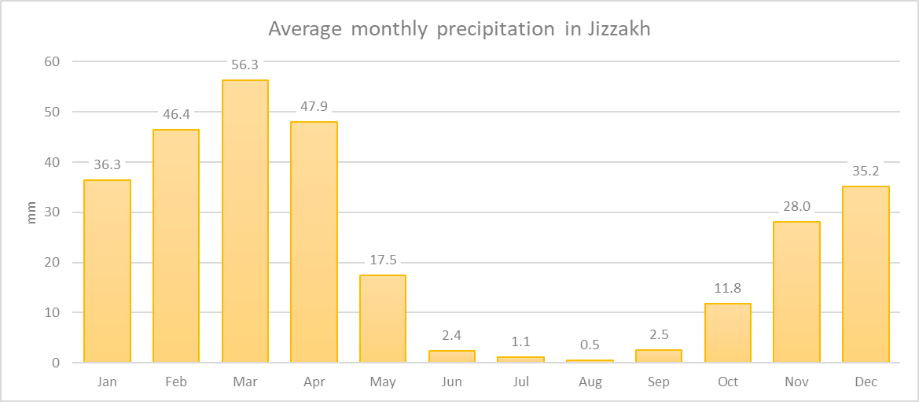

Figure 18 Precipitation in Jizzakh

## Samarkand

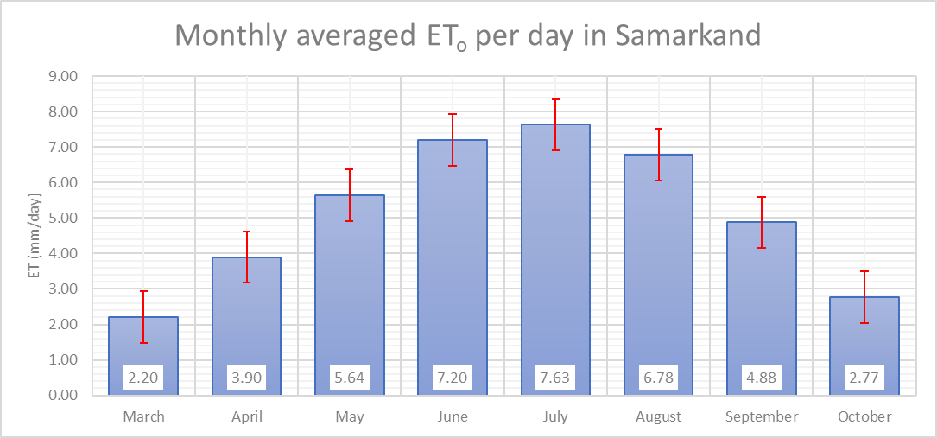

Figure 19 ETo in Samarkand

Table 10 ETo in districts of Samarkand

|  |  |  |  |  |  |  |  |  |
| --- | --- | --- | --- | --- | --- | --- | --- | --- |
|  | **Mar** | **Apr** | **May** | **Jun** | **Jul** | **Aug** | **Sep** | **Oct** |
| **Samarkand** |  |  |  |  |  |  |  |  |
| Bulungur | 2.26 | 3.94 | 5.64 | 7.08 | 7.36 | 6.50 | 4.70 | 2.72 |
| Pastdargom | 2.17 | 3.91 | 5.75 | 7.35 | 7.86 | 7.04 | 5.03 | 2.80 |
| Payariq | 2.22 | 3.93 | 5.69 | 7.21 | 7.62 | 6.79 | 4.89 | 2.77 |
| Urgut | 2.17 | 3.81 | 5.50 | 7.16 | 7.67 | 6.81 | 4.88 | 2.79 |

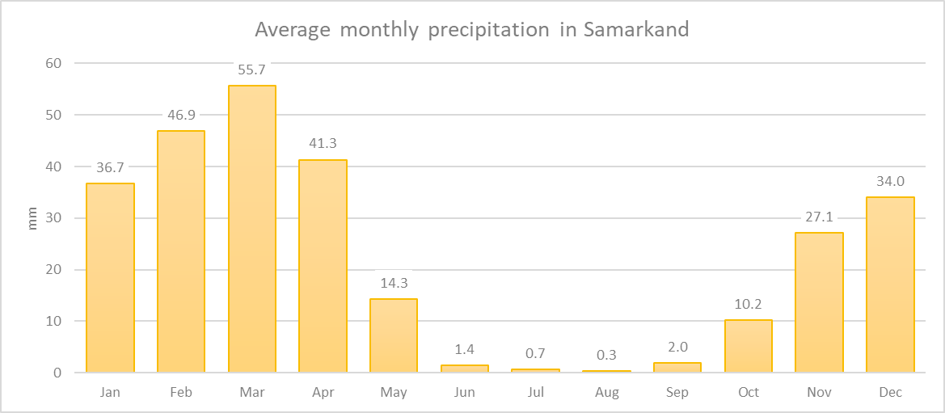

Figure 20 Precipitation in Samarkand

## Kashkadarya

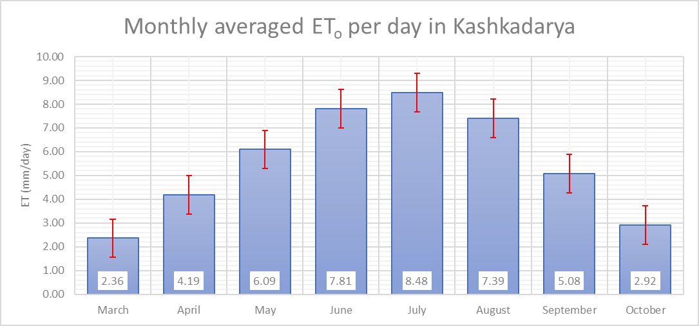

Figure 21 ETo in Kashkadarya

Table 11 ETo in districts of Kashkadarya

|  |  |  |  |  |  |  |  |  |
| --- | --- | --- | --- | --- | --- | --- | --- | --- |
|  | **Mar** | **Apr** | **May** | **Jun** | **Jul** | **Aug** | **Sep** | **Oct** |
| **Kashkadarya** |  |  |  |  |  |  |  |  |
| Chodshar | 2.40 | 4.27 | 6.20 | 7.91 | 8.63 | 7.49 | 5.10 | 2.92 |
| Kitob | 2.06 | 3.70 | 5.48 | 7.21 | 7.81 | 6.91 | 4.88 | 2.77 |
| Mirishkor | 2.49 | 4.39 | 6.38 | 8.23 | 9.03 | 7.96 | 5.42 | 3.05 |
| Qarshi | 2.50 | 4.39 | 6.31 | 7.91 | 8.45 | 7.22 | 4.93 | 2.92 |

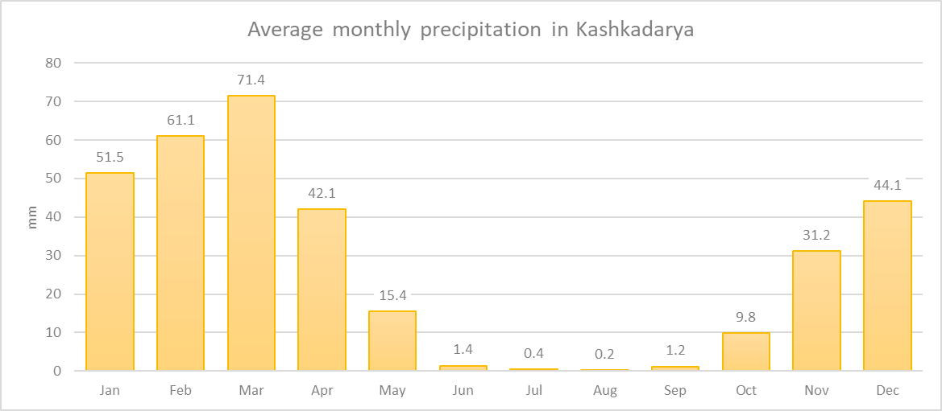

Figure 22 Precipitation in Kashkadarya

## Surkhandarya

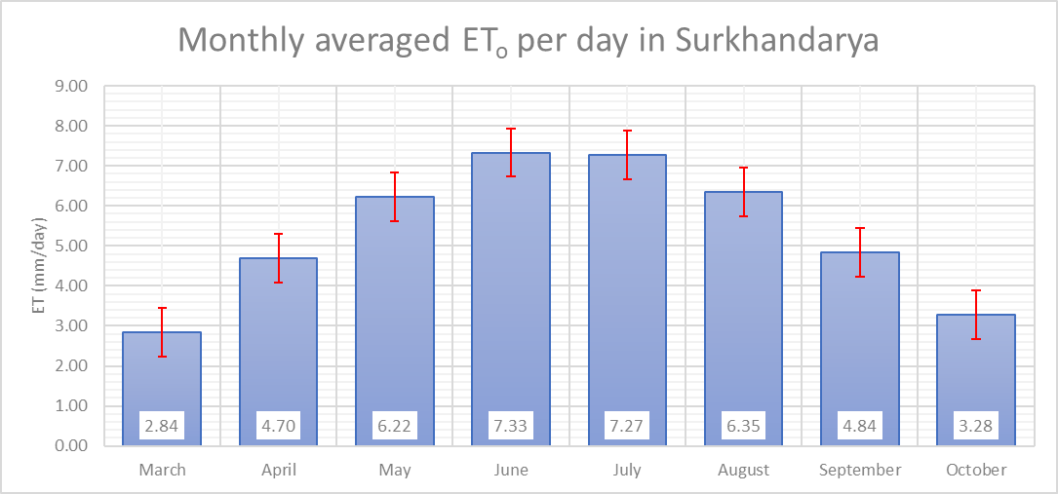

Figure ETo in Surkhandarya

Table ETo in districts of Surkhandarya

|  |  |  |  |  |  |  |  |  |
| --- | --- | --- | --- | --- | --- | --- | --- | --- |
|  | **Mar** | **Apr** | **May** | **Jun** | **Jul** | **Aug** | **Sep** | **Oct** |
| **Surkhandarya** |  |  |  |  |  |  |  |  |
| Khodzha-Kiya | 2.90 | 4.79 | 6.29 | 7.31 | 7.19 | 6.23 | 4.76 | 3.27 |
| Takiya | 3.20 | 5.18 | 6.65 | 7.53 | 7.27 | 6.29 | 4.88 | 3.47 |
| Uchkula | 2.42 | 4.12 | 5.72 | 7.16 | 7.36 | 6.53 | 4.88 | 3.11 |

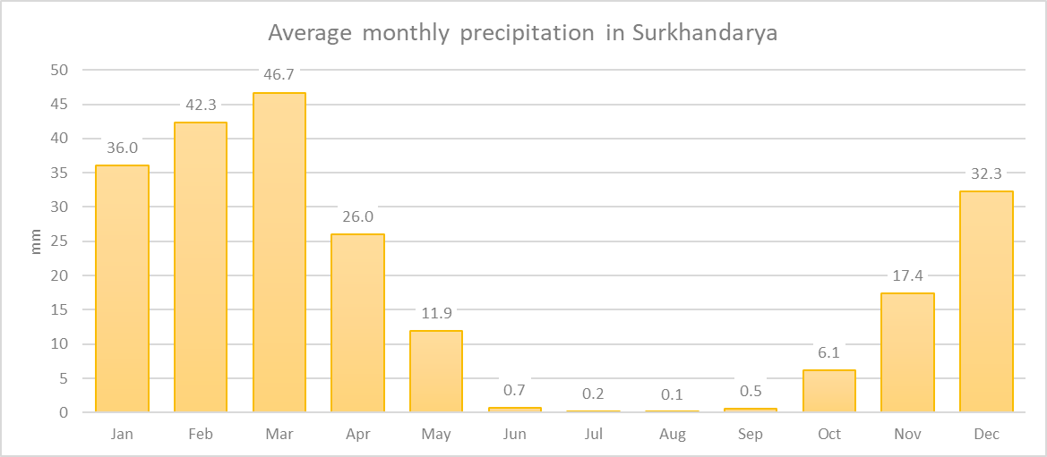

Figure Precipitation in Surkhandarya

## Navoiy

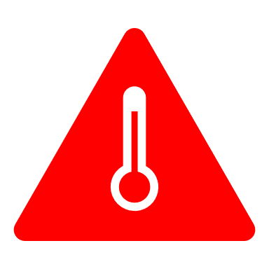

Record!

Highest ETo was calculated in Navoiy region. During July average ETo was 9.88mms/day

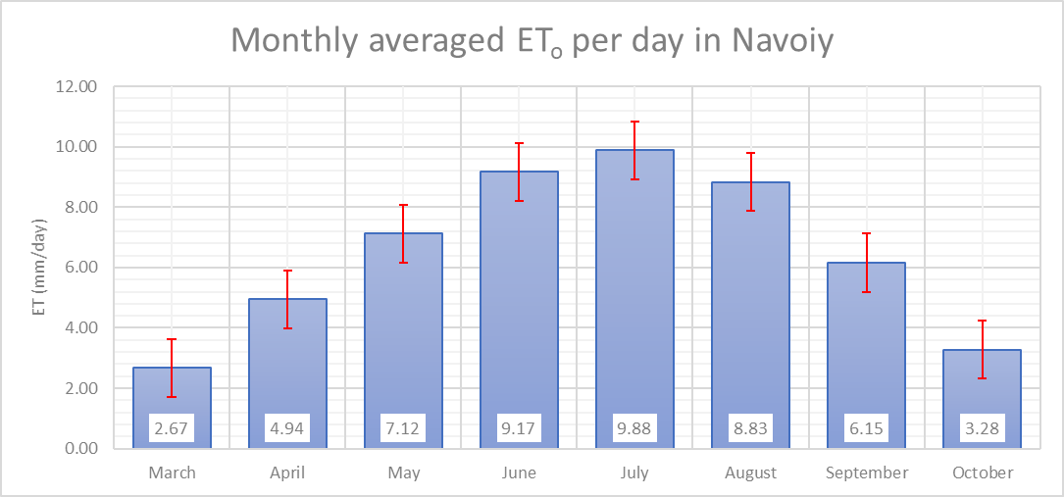

Figure ETo in Navoiy

Kyzyltepa is the only district in Navoiy we were able to analyze climate data for. Since Navoiy is a vast area more locations must be analyzed.

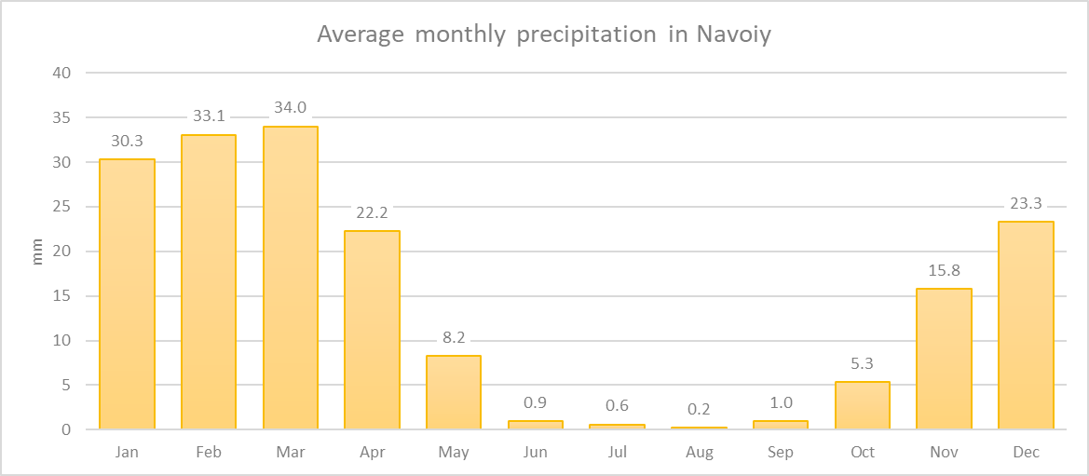

Figure Precipitation in Navoiy

## Bukhara

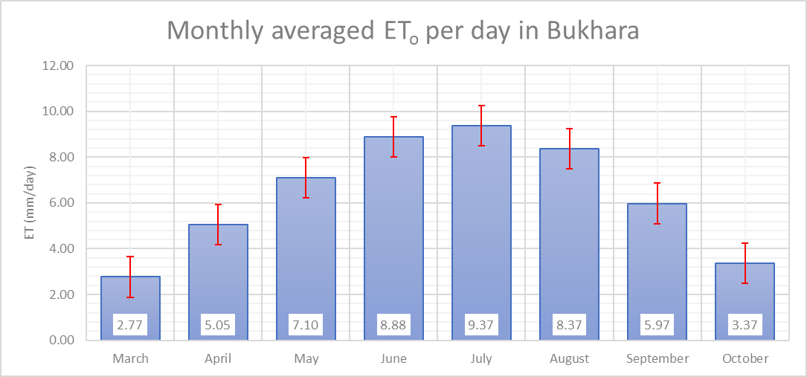

Figure ETo in Bukhara

Table ETo in districts of Bukhara

|  |  |  |  |  |  |  |  |  |
| --- | --- | --- | --- | --- | --- | --- | --- | --- |
|  | **Mar** | **Apr** | **May** | **Jun** | **Jul** | **Aug** | **Sep** | **Oct** |
| **Bukhara** |  |  |  |  |  |  |  |  |
| Buryabab | 3.31 | 5.33 | 6.83 | 7.68 | 7.38 | 6.41 | 4.99 | 3.57 |
| Gijduvon | 2.59 | 4.92 | 7.12 | 9.13 | 9.80 | 8.80 | 6.20 | 3.31 |
| Jondor | 2.73 | 5.05 | 7.16 | 9.11 | 9.73 | 8.72 | 6.14 | 3.34 |
| Kuyuchukurak | 2.63 | 4.99 | 7.16 | 9.13 | 9.78 | 8.78 | 6.21 | 3.35 |
| Romitan | 2.63 | 5.00 | 7.15 | 9.09 | 9.68 | 8.69 | 6.14 | 3.34 |
| Sarxar | 2.71 | 5.02 | 7.16 | 9.15 | 9.82 | 8.81 | 6.17 | 3.32 |

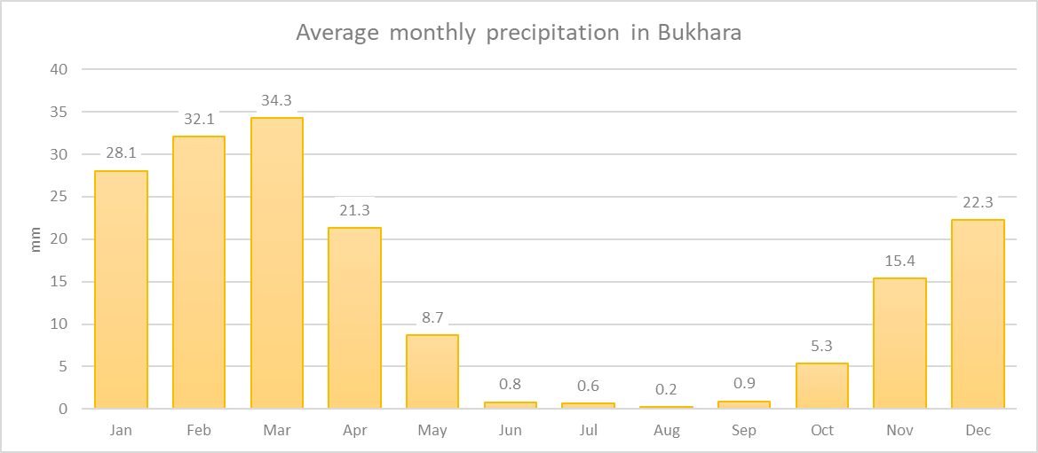

Figure Precipitation in Bukhara

## Khorezm

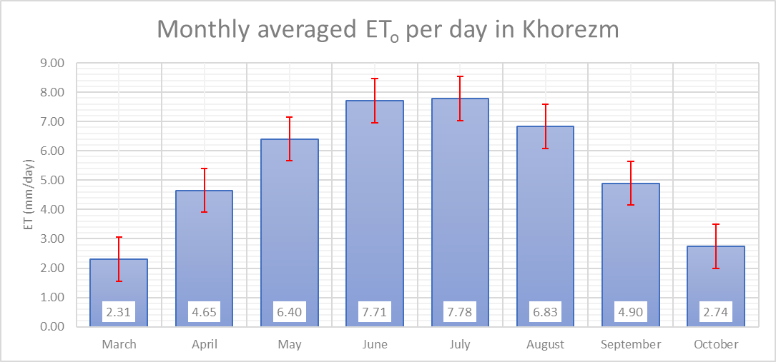

Figure ETo in Khorezm

Table ETo in districts of Khorezm

|  |  |  |  |  |  |  |  |  |
| --- | --- | --- | --- | --- | --- | --- | --- | --- |
|  | **Mar** | **Apr** | **May** | **Jun** | **Jul** | **Aug** | **Sep** | **Oct** |
| **Khorezm** |  |  |  |  |  |  |  |  |
| Dashovuz[3] | 2.19 | 4.57 | 6.37 | 7.67 | 7.70 | 6.77 | 4.82 | 2.67 |
| Xiva | 2.44 | 4.75 | 6.45 | 7.76 | 7.85 | 6.90 | 4.98 | 2.83 |
| Yangiarik | 2.43 | 4.72 | 6.42 | 7.73 | 7.86 | 6.90 | 4.96 | 2.80 |

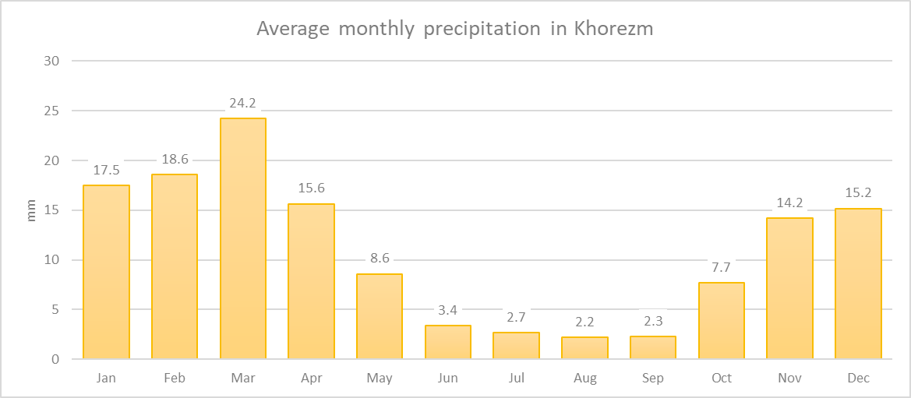

Figure Precipitation in Khorezm

# Bibliography

|  |  |
| --- | --- |
| [1] | UN-FAO, Crop evapotranspiration - Guidelines for computing crop water requirements - FAO Irrigation and drainage paper 56, Rome: FAO, 1998. |
| [2] | Texas A&M University, "Global Weather Data for SWAT," 08 2014. [Online]. Available: http://globalweather.tamu.edu. [Accessed 02 10 2020]. |
| [3] | "УзГидроМет," [Online]. Available: http://www.meteo.uz. |
| [4] | UN-FAO, Effective rainfall in irrigated agriculture. Irrigation and drainage paper 25, 1978. |
| [5] | IAEA.org, "REVISED FAO METHODOLOGY FOR CROP REQUIREMENT," [Online]. Available: https://inis.iaea.org/collection/NCLCollectionStore/_Public/29/062/29062763.pdf. |
| [6] | University of California, "Understanding Your Orchard's Water Requirements," 2007. [Online]. Available: http://fruitandnuteducation.ucdavis.edu/files/165618.pdf. [Accessed 16 October 2020]. |
| [7] | UAN-FAO, Crop Water Requirements. Irrigation and drainage paper 24, Rome: UN-FAO, 1977. |
| [8] | Bahodir & Sons, Ф/Х, "Экин сув талабини аниқлашнинг текин усули," 06 09 2020. [Online]. Available: https://youtu.be/3c6CI07YF9E. [Accessed 16 10 2020]. |

1. <https://github.com/sherzodr/penmon>
2. <https://github.com/sherzodr/agriclimuz>
3. “Dashovuz” in located in Turkmenistan. Since it’s closely bordered with Khorezm we felt it was appropriate to include in Khorezm’s ETo study.