Quiz #3 Introduction to Algorithms (05/13/2016)

Name: ID#: Score:

- [14 %] Maximum Subarray:
You are given a one dimensional array that may contain both positive and negative integers, find the sum of contiguous subarray of numbers which has the largest sum. Given an array of integers a[1, . . . , n], compute
For example, MaxSubarray ([31, −41, 59, 26, -53, 58, 97, −93, −23, 84]) = 187.
  - [10 %] Describe a dynamic programming algorithm (pseudo code) to find the largest sum of maximum subarray.

  - [4%] Given an array [−6, 12, −7, 0, 14, −7, 5] as input. What is the largest sum of maximum subarry.
19
- (12%) Calculate the minimum number of multiplications necessary to find the matrix product ABCDE. The dimensions of each of the matrices are listed below:
Matrix Dimensions
A 2x4
B 4x3
C 3x2
D 2x5
E 5x1
- What is the minimum number of multiplications to compute matrix product ABCDE?
36
- What is the optimal parenthesization of ABCDE?
A(B(C(DE)))

- [74 %] Please use bottom-up recursive dynamic programming algorithm to find the optimal solution in the following problems. Please show your answers in the dynamic programming tables which are filled by applying recurrence relations are shown in text book.
  - (9 %) Given two sequences MNOPQRS and NABPQCS, find a longest subsequence common substring.

 |  | M | N | O | P | Q | R | S
 | 0 | 0 | 0 | 0 | 0 | 0 | 0 | 0
N | 0 | 0 | 1 | 1 | 1 | 1 | 1 | 1
A | 0 | 0 | 1 | 1 | 1 | 1 | 1 | 1
B | 0 | 0 | 1 | 1 | 1 | 1 | 1 | 1
P | 0 | 0 | 1 | 1 | 2 | 2 | 2 | 2
Q | 0 | 0 | 1 | 1 | 2 | 3 | 3 | 3
C | 0 | 0 | 1 | 1 | 2 | 3 | 3 | 3
S | 0 | 0 | 1 | 1 | 2 | 3 | 3 | 4

  - (15%) Let us consider the 0-1 knapsack problem given by the following data with knapsack’s capacity = 5, please find the most valuable subset of the items that fit into the knapsack using following 0-1 knapsack dynamic programming algorithm.

Item | weight | value
1 | 2 | $4
2 | 3 | $5
3 | 4 | $6
4 | 5 | $10
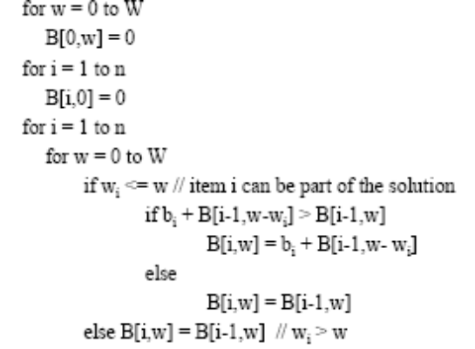
B[i, w] table
Capacity W
Item | 0 | 1 | 2 | 3 | 4 | 5
0 | B[0,0] = 0 | 0 | 0 | 0 | 0 | 0
1 | 0 | 0 | 4 | 4 | 4 | 4
2 | 0 | 0 | 4 | 5 | 5 | 9
3 | 0 | 0 | 4 | 5 | 6 | 9
4 | 0 | 0 | 4 | 5 | 6 | 10

  - [34 %] Determine the cost and the structure of an optimal binary search tree for a set of n = 7 distinct keys with the probabilities in Table 1. If you do not remember what p_{i} and q_{i} represents, here are some hints. You are given a sequence K = {k₁, k₂, ..., k₇} of 7 distinct keys in sorted order (so that k₁ < k₂ < ... < k₇). For each key k_{i}, we have a probability p_{i} that the search will be k_{i}. Some searches may be for values not in K, and so we also have 7 + 1 “dummy keys” d₀, d₁, ..., d₇ representing values not in K. In particular, d₀ represents all values less than k₁, d_{n} represents all values greater than k_{n}, and for i = 1, 2, ..., 6 the dummy key d_{i} represents all values between k_{i} and k_{i+1}. For each dummy key d_{i}, we have a probability q_{i} that a search will correspond to d_{i}. Use the recursive function as following to obtain expected cost of searching an optimal binary search tree:
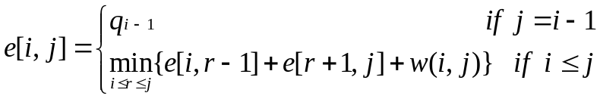
The recursive results of w[i, j] are given in table 2. The recursive results e[i, j] of containing the keys k_{i}, …, k_{j} are shown in Table 3. Table 4 root[i, j] contains index r for which k_{r} is the root of an optimal search tree containing keys k_{i}, …, k_{j}.
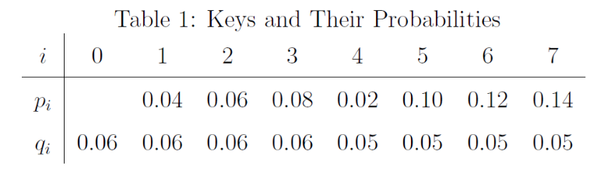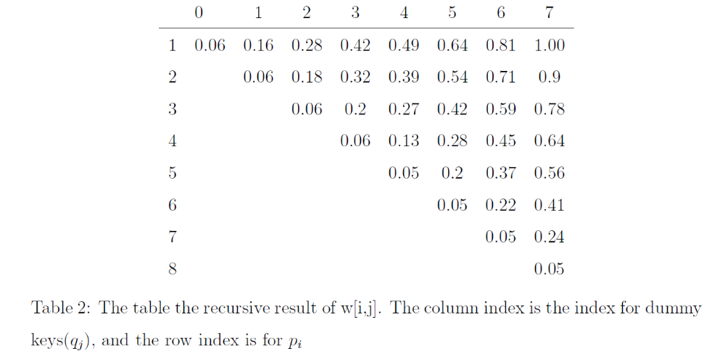

c.1. [28 %] Table 3: The table the recursive result of e[i, j]. The column index is the index for dummy keys(q_{j}), and the row index is for p_{i}
 | 0 | 1 | 2 | 3 | 4 | 5 | 6 | 7
1 | 0.06 | 0.28 | 0.62 | 1.02 | 1.34 | 1.83 | 1.42 | 3.12
2 | 0 | 0.06 | 0.30 | 0.68 | 0.93 | 1.41 | 1.96 | 2.61
3 | 0 | 0 | 0.06 | 0.32 | 0.57 | 1.04 | 1.48 | 2.13
4 | 0 | 0 | 0 | 0.06 | 0.24 | 0.57 | 0.99 | 1.55
5 | 0 | 0 | 0 | 0 | 0.05 | 0.30 | 0.72 | 1.20
6 | 0 | 0 | 0 | 0 | 0 | 0.05 | 0.32 | 0.78
7 | 0 | 0 | 0 | 0 | 0 | 0 | 0.05 | 0.34
8 | 0 | 0 | 0 | 0 | 0 | 0 | 0 | 0.05

Table 4: The table the recursive result of root[i, j]. The column index is kj, and the row index is for ki
 | 1 | 2 | 3 | 4 | 5 | 6 | 7
1 | 1 | 2 | 2 | 2 | 3 | 3 | 5
2 | 0 | 2 | 3 | 3 | 3 | 5 | 5
3 | 0 | 0 | 3 | 3 | 4/5 | 5 | 5
4 | 0 | 0 | 0 | 4 | 5 | 5 | 6
5 | 0 | 0 | 0 | 0 | 5 | 6 | 6
6 | 0 | 0 | 0 | 0 | 0 | 6 | 7
7 | 0 | 0 | 0 | 0 | 0 | 0 | 7

c.2. [6 %] What is the optimal binary search tree?
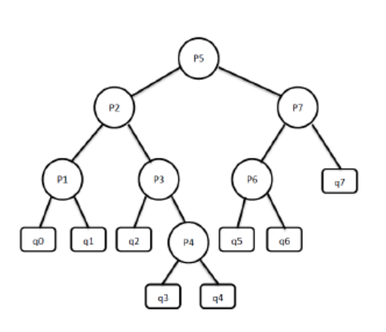
  - (16%) A carpenter has a piece of wood of a certain length that must be cut at positions a₁, a₂ ..., a_{n} where a_{i} is the distance from the left end of the original piece of wood. Notice that after making the first cut, the carpenter now has two pieces of wood; after making the second cut, the carpenter has three pieces of wood, etc. Assume that the cost of making a cut in a piece of wood of length l is equal to l, and is the same no matter which position in that piece of wood is being cut. Let L be the length of the original piece of wood. Give a 120 meter wood with 4 cut points at position a₁, a₂ ..., a₄ = {12, 25, 66, 100} meter, use bottom-up recursive dynamic programming algorithm to find the minimum total cost for making all the cuts and the order in which to make the cuts that minimizes the total cost.

- Cost table
j
i | 0 (0) | 1 (12) | 2 (25) | 3 (66) | 4 (100) | 5 (120)
0 | 0 | 0 | 25 | 91 | 191 | 265
1 | 0 | 0 | 0 | 54 | 142 | 216
2 | 0 | 0 | 0 | 0 | 75 | 149
3 | 0 | 0 | 0 | 0 | 0 | 54
4 | 0 | 0 | 0 | 0 | 0 | 0
2. Cut table
j
i | 1 | 2 | 3 | 4 | 5
0 | 0 | 1 | 2 | 3 | 3
1 | 0 | 0 | 2 | 3 | 3
2 | 0 | 0 | 0 | 3 | 3
3 | 0 | 0 | 0 | 0 | 4
4 | 0 | 0 | 0 | 0 | 0

