Software Architecture & Design Specification
Project: Command-line based Inventory Management System
Version: 1.0
Authors: IdeaForge Team
Date: 14-11-2025
Status: Active

Revision History
Version | Date | Author
1.0 | 22-08-2025 | IdeaForge Team

Approvals
Role | Name | Signature/Date
Course Coordinator: | Aravind Srinath
Team Member 1: | Ranjita Haravi  PES1UG23CS473 | Ranjita Haravi
Team Member 2: | Sheshagiri S  PES1UG24CS832 | Sheshagiri S
Team Member 3: | Sonu R  PES1UG24CS834 | Sonu R
Team Member 4: | Shruthana J PES1UG24CS833 | Shruthana J

1. Introduction

1.1 Purpose
This document specifies the architecture and design of the Command-line based Inventory Management System (IMS).

1.2 Scope
The IMS provides stock management, supplier tracking, and order processing for small businesses through a command-line interface.

1.3 Audience
Developers, QA Engineers, System Integrators, Maintenance Technicians, Shop Owners, Store Managers, and Stock Handlers.

1.4 Definitions
CLI: Command Line Interface
SKU: Stock Keeping Unit
PO: Purchase Order
SO: Sales Order

2. Document Overview

2.1 How to use this document
This document provides architectural deliverables including UML diagrams, API design, and design rationale for IMS.

2.2 Related Documents
• Software Requirements Specification (SRS)
• Requirements Traceability Matrix (RTM)
• Test Plan

3. Architecture

3.1 Goals & Constraints
Goals: Usable via CLI, reliable local storage, secure admin access, ≤2s response time.
Constraints: Command-line only, single-user mode, local database (CSV/SQLite).

3.2 Stakeholders & Concerns
Shop Owners: usability, reliability
Staff: easy CLI commands
Admins: security, backups
Developers: modular design
Regulators: data integrity

3.3 Component (UML) Diagram

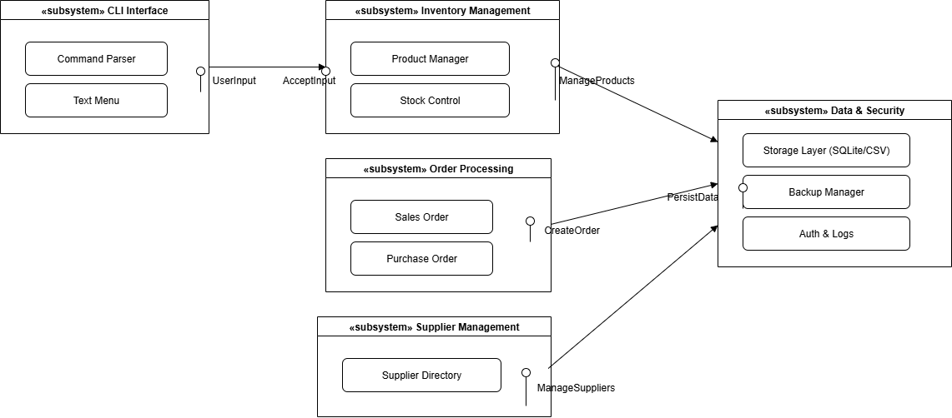

3.4 Component Descriptions
- CLI UI: handles user input/output
- Product Manager: manages SKUs and stock levels
- Order Processor: manages sales/purchase orders
- Supplier Manager: stores supplier details
- Storage Layer: persists data locally (CSV/SQLite)
- Backup & Security: manages backups, login security, and logs

3.5 Chosen Architecture Pattern and Rationale
A layered architecture is chosen for separation of concerns: CLI interface, business logic, and persistence layers. This makes the IMS simple, modular, and easy to maintain.

3.6 Technology Stack & Data Stores
Languages: Python/C++
Database: SQLite/CSV files
Environment: Windows/Linux/MacOS
Interface: CLI

3.7 Risks & Mitigations
Risk: Data loss → Mitigation: daily backups
Risk: Unauthorized access → Mitigation: admin login with hashed passwords
Risk: Performance bottleneck → Mitigation: optimize file/database queries

3.8 Traceability to Requirements
INV-F-001 (Add Product) → Product Manager
INV-F-010 (Sales Order) → Order Processor
INV-F-020 (Supplier Management) → Supplier Manager
INV-NF-002 (Data Persistence) → Storage Layer

3.9 Security Architecture
Threat Modeling (STRIDE):
- Spoofing → Admin login with hashed passwords
- Tampering → Backups encrypted
- Information Disclosure → Minimized supplier data stored
- DoS → Efficient CLI command handling
- Elevation of Privilege → Role-based restrictions

4. Design

4.1 Design Overview
IMS is structured in 3 layers: CLI interface, business logic modules (product/order/supplier), and persistence (SQLite/CSV).

4.2 UML Sequence Diagrams
Sequence Diagram 1: Add Product
Sequence Diagram 2: Process Sales Order
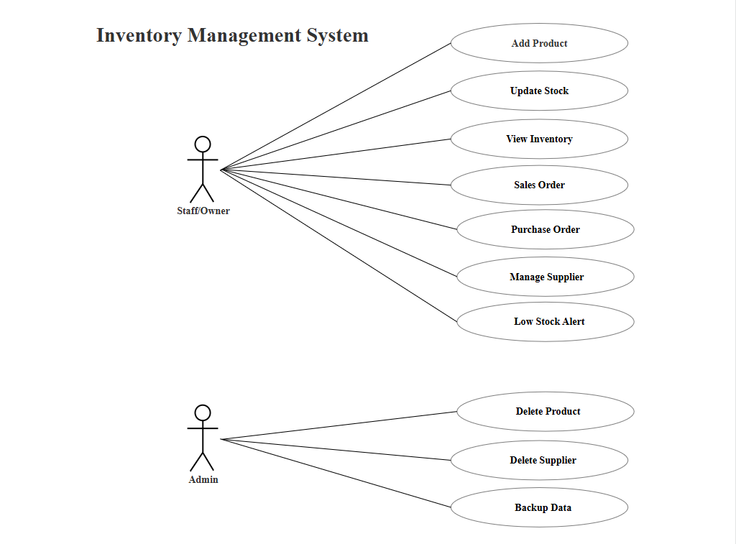

4.3 API Design
Component Interface Example:
Function: add_product(sku, name, qty)
Input: SKU, product name, quantity
Output: success/failure
Function: create_sales_order(order_id, sku, qty)
Input: Order ID, SKU, qty
Output: success/failure, updated stock

4.4 Error Handling, Logging & Monitoring
Errors: Invalid commands return help text
Logs: Admin actions logged with timestamps
Monitoring: Daily backup status and error frequency tracked

4.5 UX Design
CLI prompts with clear instructions, text-based menus, and confirmation messages for actions.

4.6 Open Issues & Next Steps
Planned enhancements: multi-user access, GUI interface, cloud backup integration.

5. Appendices

5.1 Glossary
CLI: Command Line Interface
SKU: Stock Keeping Unit
PO: Purchase Order
SO: Sales Order
RTM: Requirements Traceability Matrix

5.2 References
IEEE 42010, OWASP Security Guidelines, NIST SP 800-160, SRS Document

5.3 Tools
Draw.io, PlantUML, SQLite CLI tools

