Object detection using Yolov3 on Google Colab

In this project we will learn how to train [YOLOv3](https://pjreddie.com/darknet/yolo/) on a custom dataset using the [Darknet](https://pjreddie.com/darknet/) framework. After following this will be having enough knowledge about object detection and you can just tune it according to your need and play.

**What is Object detection and why it is getting some much attention?**

* Object detection is a computer vision technique for locating instances of objects in images or videos. Object detection algorithms typically leverage machine learning and deep learning to produce meaningful results. When humans look at images or video, we can recognize and locate objects of interest within a matter of moments. The goal of object detection is to replicate this intelligence using a computer.
* The use cases are endless, be it Tracking objects, Video surveillance, Pedestrian detection, Anomaly detection, People Counting, Self-driving cars or Face detection, the list goes on.
* After labeling all the images place the images and labels files in the same folder and make a zip file of that folder and upload it to google drive.
* Now open google colab and run the cells one by one

**Step-1:**

Open google colab new notebook and mount your drive. And check the folders present in the drive by using ls command.

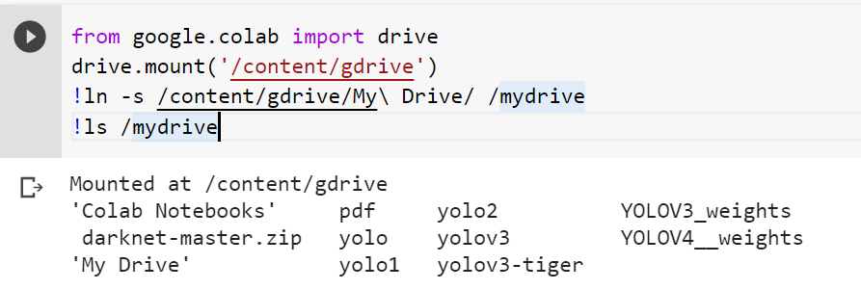

**Step-2:**

Installing Darknet

Darknet is an open-source neural network framework supports CPU and GPU computation. Darknet can also by downloaded directly in google colab for this project we will directly download in colab but just download it either from chrome or using cmd and save it in a directory.

**For downloading using Command prompt use the below command:**

git clone <https://github.com/pjreddie/darknet>

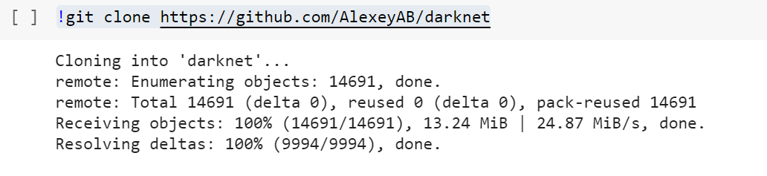

Preparing YoloV3 configuration files

**Now we have to make changes to the file we have downloaded, This include steps as follows:**

* Copy yoloV3-tiny cfg from [here](https://github.com/pjreddie/darknet/blob/master/cfg/yolov3-tiny.cfg). And make the following changes
* 1. change line no: 3 to ‘batch=24’, this means we will be using 24 images for every training step.
* 2. change line no: 4 to ‘subdivisions=8’, the batch will be divided by 8 to decrease GPU requirements.
* 3. change in line no: 135,177 to ‘classes=1’ (this value denotes the number of object classes we have.
* 4. change line no: 127,171 to filters=(classes+5)*3 in our case ‘filter=18’
* Rename and save the file and upload it to the drive

**Step-3:**

change the directory to darknet and change makefile to have GPU and OPENCV enabled.

If you are using GPU, change GPU from 0 to 1 and if you have installed OpenCV set OPENCV to “1”, otherwise not need.

Save the Makefile and run the command in the root directory to start the build process.

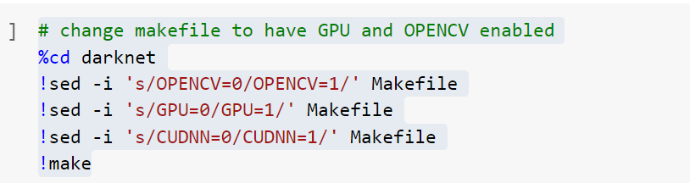

**Step-4:**

We need to create “**obj.names**” which its name implies that it contains names of classes, and the file “**obj.data**” which contains parameters needed for training. Here we directly create the two files in colab for this project. Replace tiger with the classes on which you are training. Change the backup folder (drive folder) to the folder where you want to save the weights.



**Sample info present in obj.data**

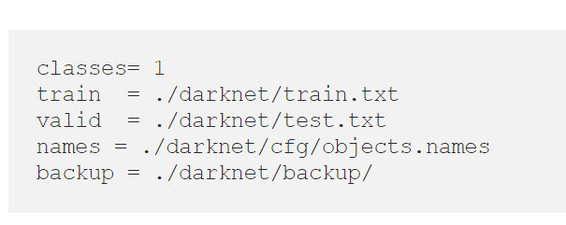

**Sample info present in obj. names**

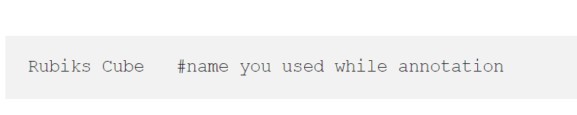

**Step-5:**

Installing Darknet.53.conv.74

darknet53.conv.74.weights contains the weights for the DarkNet network* originally trained for classification on the ImageNet dataset, which is used as the pre-trained feature extractor (backbone) for YOLOv3. To use this for detection the additional weights which are only present in the YOLOv3 network are randomly initialized prior to training.

*darknet53.conv.74.weights refers to the fact that only the weights for the convolutional layers are included, excluding the weights for the final fully connected layer which outputs the class probabilities for classification. There is a separate file called darknet53.weights which includes *all* the weights.



**Step-6:**

Unzip the image folder and store it in present data directory which is a sub directory of current working directory.



**Store the paths of the txt files in the variable txt_file_paths**

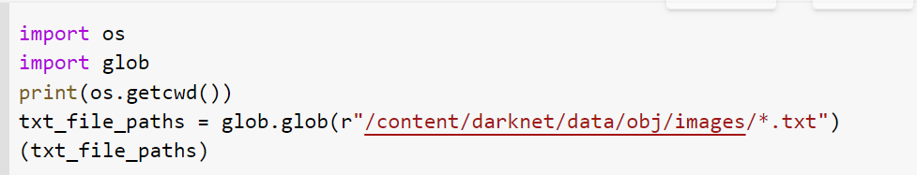

**By using the above txt_file_paths we will format the data and then again write to the same file.**

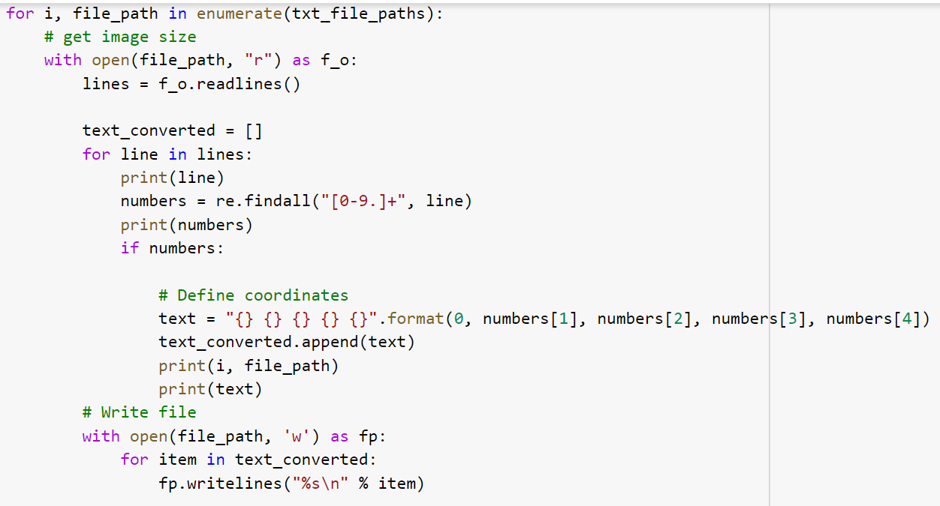

**Sample output of the above code**



**Creating a list of all the image paths**

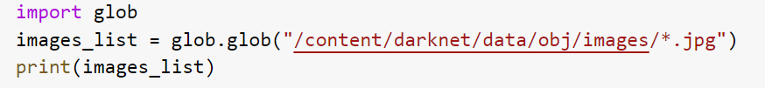

**writing the paths of all the images in the train.txt file and storing the train.txt file in data folder of cwd.**

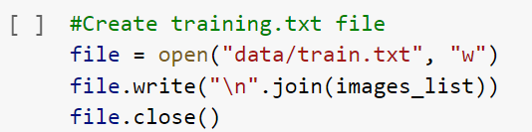

**Copying the cfg file from our google drive and storing into the cfg folder of cwd. Change the path and the name of the folder w.r.to your data**



**Step-7:**

**Start Training**

Time for the fun part! Enter the following command into your terminal and watch your GPU do what it does best.



**References:**

**For understanding about the cfg file:**

<https://stackoverflow.com/questions/50390836/understanding-darknets-yolo-cfg-config-files/50696918>

**queries related to darknet53 and retraining the model**

<https://github.com/pjreddie/darknet/issues/1878#:~:text=darknet53.-,conv.,data%20you%20can%20use%20darknet53>.

**What is darknet?**

https://www.predictiveanalyticstoday.com/darknet/#:~:text=8.0-,Darknet%20is%20an%20open%20source%20neural,written%20in%20C%20and%20CUDA.&text=The%20framework%20features%20You%20Only,%25%20on%20COCO%20test%2Ddev.