1. Create a folder, I chose “DisplayTabIdAndURL”

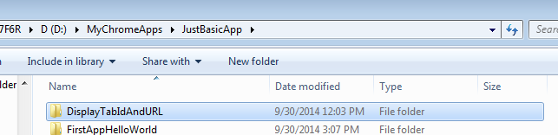

1. Copy the manifest.json , hello.png file and TabBackGround.js , as shown

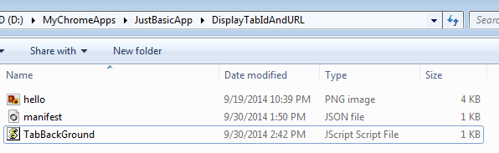

1. Go to chrome browser, Click on  icon on the extreme right of the browser.

Select Tool -> Extensions -> Click on the developer mode

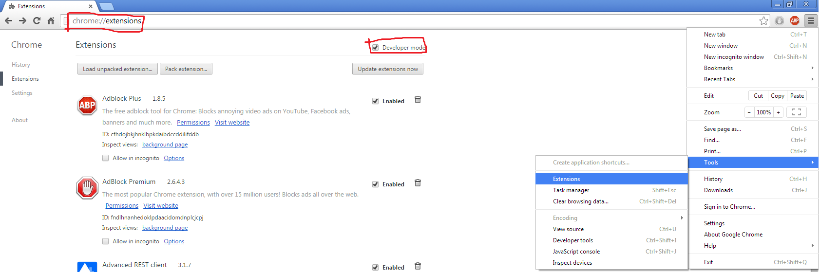

1. Click on Select “Load unpacked extensions”.
2. This is will open a pop up. Navigate to extension directory, select it and click OK.

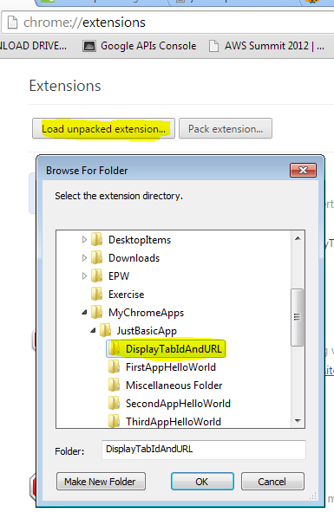

This is will load the app, as highlighted in the above screenshot.

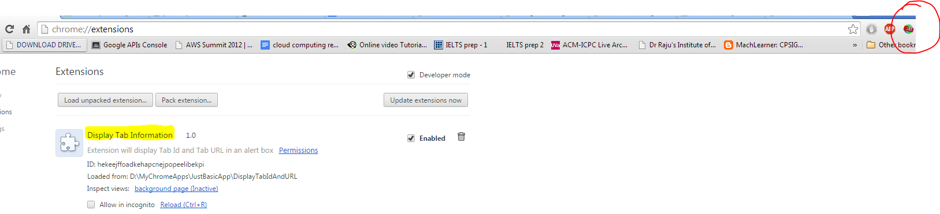

6.) Make sure that the extension is enabled.

Next just presses ALT+A(on windows platform) and "Command+Shift+Y" (on mac platform).

Click OK on a couple of alert boxes.

Then you can see the Tab Id and Tab URL of the current tab. For more questions or comments send me a mail on [shesharpplusplus@gmail.com](mailto:shesharpplusplus@gmail.com)

As shown ☺

