Introduction : The aim of this app is to give the introduction to background pages. Background pages are event driven or they are persistent. In this app, background pages has been added to respond to event on new tab and update of a tab. The event triggers an alert box ☺ - Short and simple.

Let’s get started

1. Add the folder , I chose ThirdAppHelloWorld

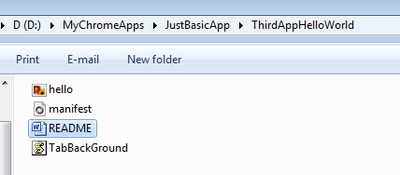

1. Copy and paste the files as indicated. Leave ‘README’ ☺
2. Go to chrome://extensions tab, enable the developer mode. Click ‘Load Unpacked Extension’.
3. Once you have done that, you can see the notification that new background has been added.
4. When you open a new tab, you will see alert box like ,

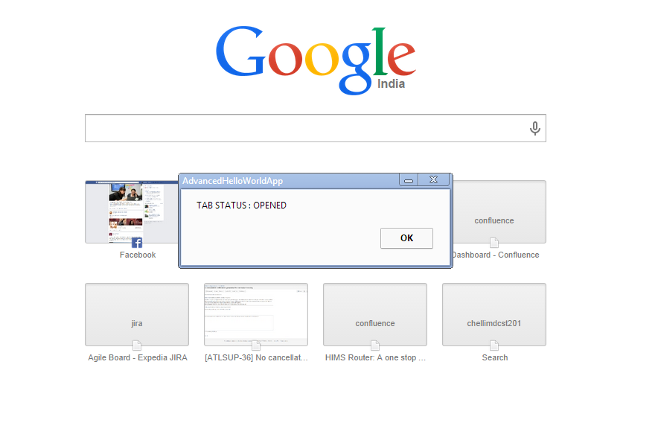

1. Type a keyword in the URL, say search facebook or search for New Yorker. You will see the following alert box as the page gets updated. 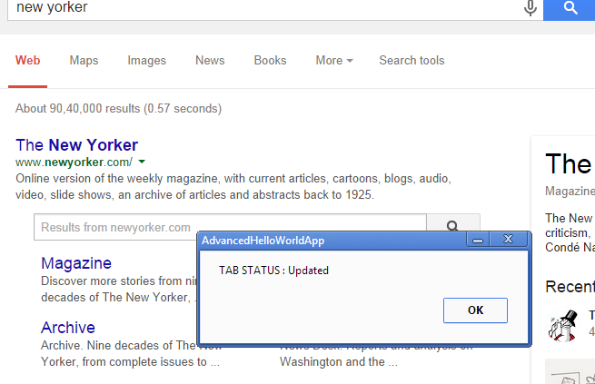

For more info or comments , drop a mail at shesharpplusplus@gmail.com