1. Create a folder, I chose “SaveBookmarks”

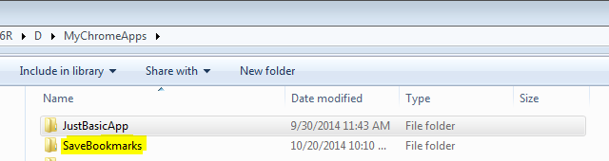

1. Copy the manifest.json , hello.png file and SaveBookmarks.js , as shown

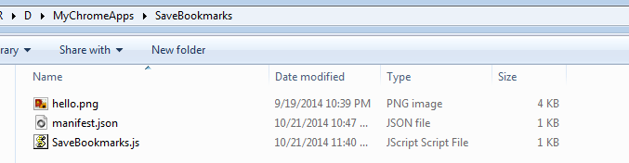

1. Go to chrome browser, Click on  icon on the extreme right of the browser.

Select Tool -> Extensions -> Click on the developer mode

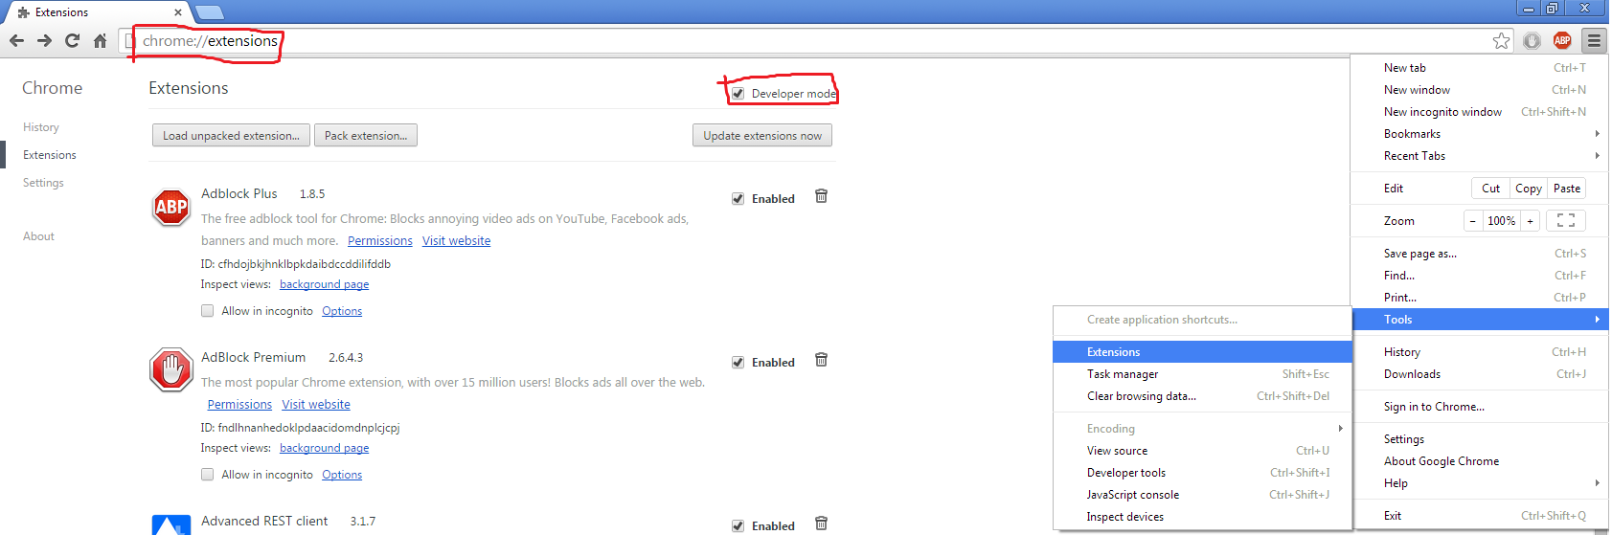

1. Click on Select “Load unpacked extensions”.
2. This is will open a pop up. Navigate to extension directory, select it and click OK.

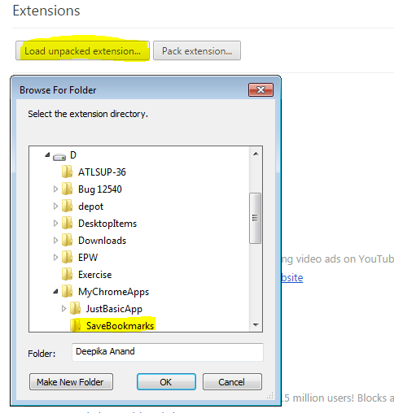

This is will load the app, as highlighted in the above screenshot.

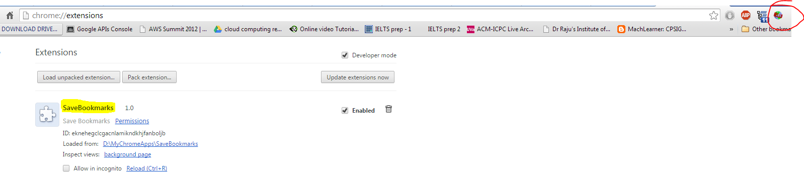

6.) Make sure that the extension is enabled.

Next just presses the icon highlighted in the image above. This will save all the tabs open in the current window to a newly created folder in bookmark hierarchy – “Other Bookmarks” , as shown below

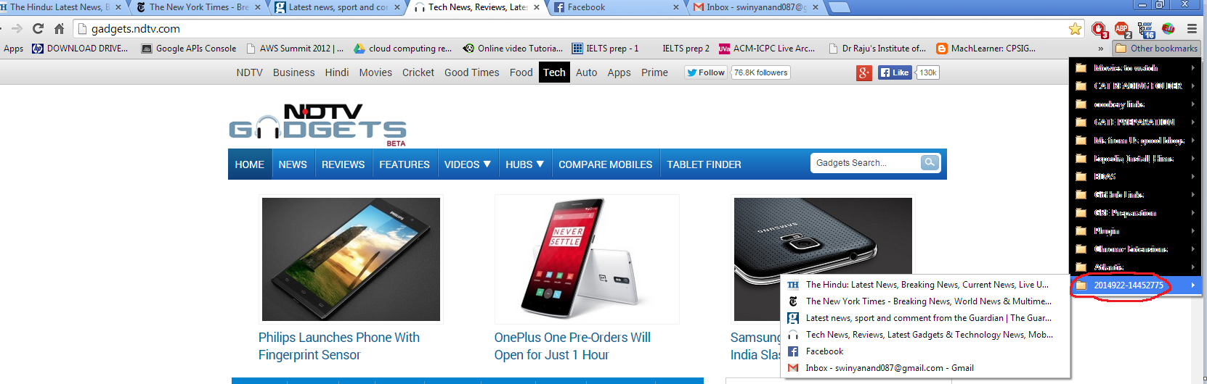

The newly created folder(as highlighted above) will have name of the format “YYYY+ MM + DD + DATE + HOURS + SECONDS + MILLISECONDS”

The same links can be seen form the bookmark manager of the chrome

Go to “chrome://bookmarks/” then click on the new folder created

