To refer the directory structure and basics refer to the previous version of HelloWorld chrome extension

from <https://github.com/shesharpplusplus/ChromeExtensions.git>

NOTE : The difference between this extension and the simple HelloWorld extension(<https://github.com/shesharpplusplus/ChromeExtensions.git>) is that in the simple extension the message to be displayed in helloworld.html was hardcoded in the body section itself however , in this a “little advanced” extension the message to be displayed in the body section is taken from helloworld.js

1. Create a folder ex : SecondAppHelloWorld

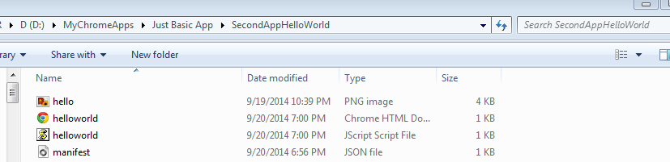

1. Copy and paste hello.png, helloworld.html, helloworld.js
2. Go to chrome browser, Click on  icon on the extreme right of the browser.

Select Tool -> Extensions -> Click on the developer mode

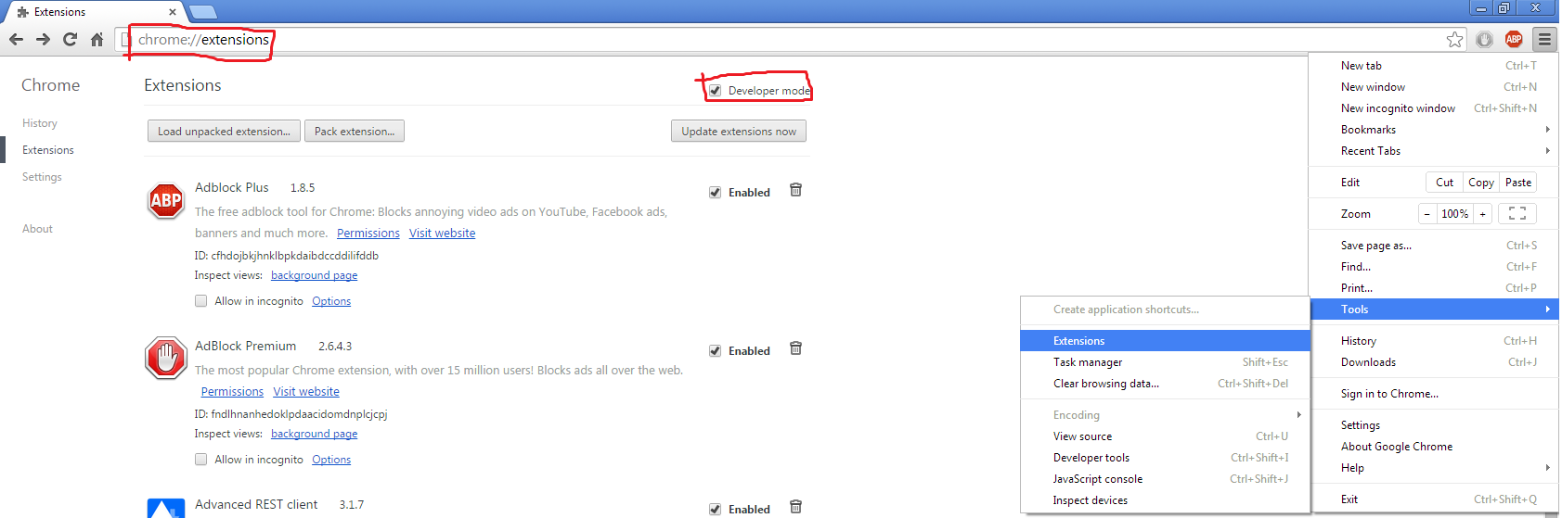

1. Click on Select load unpacked extensions

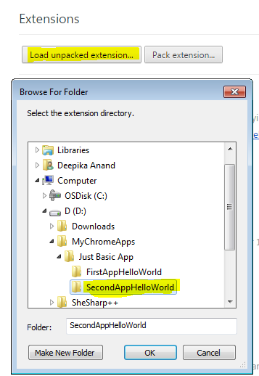

1. Click on load Unpacked Extension, this is will open a pop up. Navigate to App folder , select it and click Ok.
2. Click on the  icon. This should open a pop saying with a pink background and black text.

As shown ☺

