1. Create a folder, I chose FirstAppHelloWorld

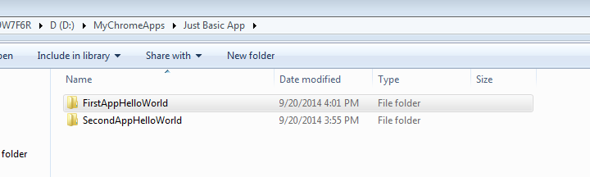

1. Copy the manifest.json , helloworld.html, hello.png file, as shown

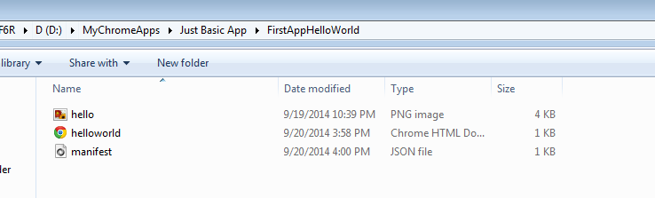

1. Go to chrome browser, Click on  icon on the extreme right of the browser.

Select Tool -> Extensions -> Click on the developer mode

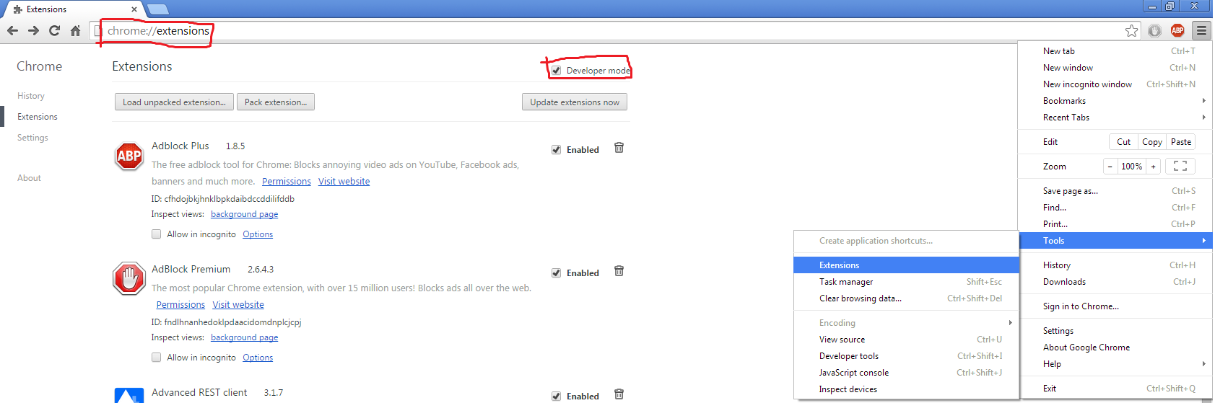

1. Click on Select load unpacked extensions

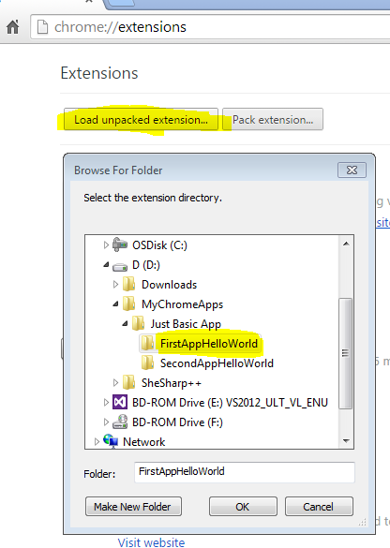

1. Click on load Unpacked Extension, this is will open a pop up. Navigate to App folder , select it and click Ok.

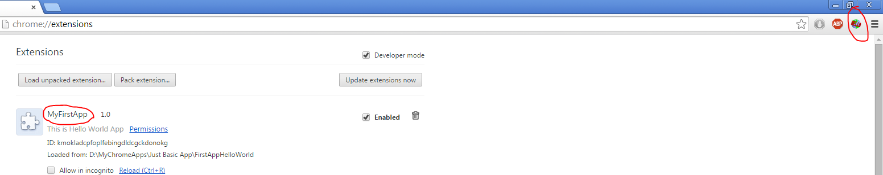

This is will load the app, as highlighted in the above screenshot.

1. Click on the  icon. This should open a pop saying with a pink background and black text.

As shown ☺

