CSA0406 Operating Systems - Assignment 2 (CO2)
Q3 Threads
6 marks | Multithreaded program, measured speed-up per pool size, evaluation of thread models

What the question requires
- Explain the thread model and what threads share and keep private.
- Compare user-level and kernel-level threads and the three multithreading models.
- Write a multithreaded program and measure the speed-up for several thread counts.
- Evaluate the result and justify the design.

Model
Threads of one process share the code, the global data and heap, the open file descriptors and the working directory. Each thread has its own stack, registers, program counter and scheduling state. On Linux, pthreads are one-to-one with kernel tasks, so a blocking call blocks only the calling thread and 8 threads really do run on 8 logical CPUs.
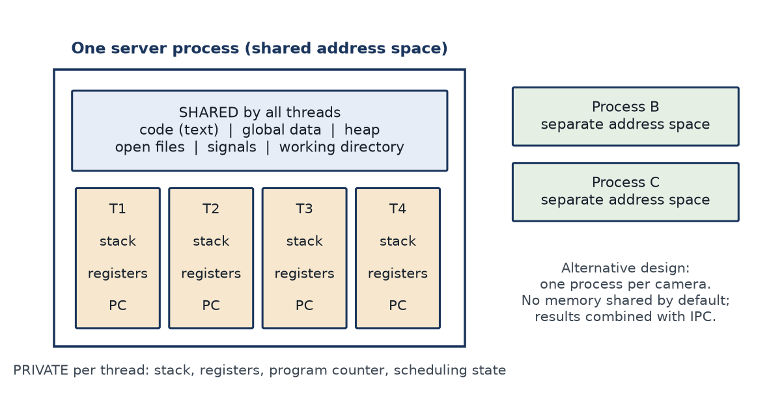
Figure 7 Shared and private parts of a multithreaded process.

Measured speed-up
The program analyses 64 cameras x 40 frames, each frame doing the same deterministic CPU-bound transform, in four modes: sequential, one thread per camera, and pools of 4, 8 and 16 workers. Every mode must produce the same checksum.
Mode | Threads | Time (ms) | Speed-up | Efficiency | Check
sequential | 1 | 1051.1 | 1.00 | 1.00
thread per camera | 64 | 378.9 | 2.77 | 0.04 | checksum OK
thread pool | 4 | 287.5 | 3.66 | 0.91 | checksum OK
thread pool | 8 | 217.1 | 4.84 | 0.61 | checksum OK
thread pool | 16 | 214.0 | 4.91 | 0.31 | checksum OK
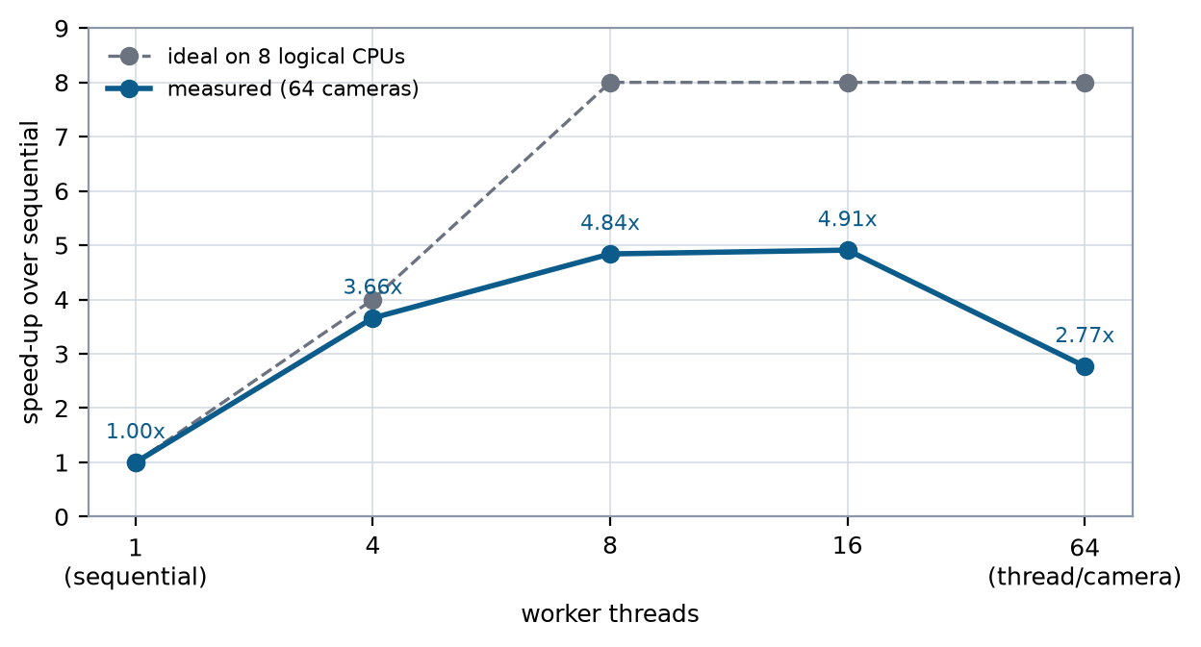
Figure 8 Measured speed-up against the ideal on an 8-thread machine.

Evaluation
The pool scales to 3.66x with four threads (91 % efficiency) and then flattens at 4.84x (8 threads) and 4.91x (16 threads). One thread per camera is worse (2.77x) because 64 runnable threads on 8 CPUs add scheduling and cache pressure. From S(8) = 4.84, Amdahl's law gives a serial fraction of about 9 %, which is accounted for by thread creation, the final checksum reduction and shared memory bandwidth. The design conclusion is a pool sized to the physical core count, not to the number of cameras.
The shared-counter experiment shows why the pool needs synchronisation: eight threads adding 500,000 each to an unprotected long lost 1,600,588 of the expected 4,000,000 updates, while a mutex and a C11 atomic both produced the exact total.
== Q3: shared counter updated by 8 threads x 500000 increments ==

no protection threads= 8 expected=4000000 actual=2399412 lost=1600588
pthread mutex threads= 8 expected=4000000 actual=4000000 lost=0
C11 atomic threads= 8 expected=4000000 actual=4000000 lost=0

The unprotected counter loses updates because counter++ is three
machine instructions (load, add, store) and the scheduler can
interleave two threads between the load and the store.

