CSA0406 Operating Systems - Assignment 2 (CO2)
Q1 Processes and Process States
6 marks | State diagram, PCB, fork()/ps evidence, measured creation cost, defended design

What the question requires
- Draw and explain the process state transition diagram.
- Describe the process control block and what the kernel stores in it.
- Write a C program that creates child processes with fork(), observe them with ps and explain the parent/child relationship.
- Explain the difference between process creation and thread creation, with measured evidence.
- Justify the design chosen for the case study.

Model
A process is a program in execution plus the kernel state that describes it. The five states are new, ready, running, waiting and terminated. Only one process per core can be running; the scheduler moves processes between ready and running, and a process moves itself to waiting when it issues a blocking call. The transitions are driven by four events: admission (new to ready), dispatch (ready to running), preemption or yield (running to ready) and completion (running to terminated).
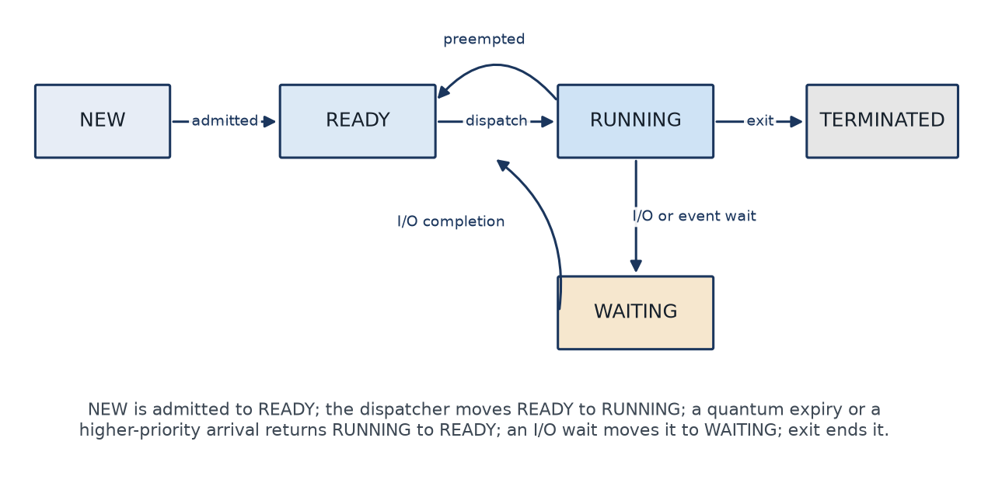
Figure 1 The five process states and the events that move a process between them.

The PCB
The PCB is the kernel's record of a process. Linux splits it into task_struct (the scheduler state, credentials, file table, memory map) and the kernel stack, and exposes a subset through /proc/<pid>/{status,stat,cmdline}. The fields that matter for this assignment are the identifier, the state, the saved register context and program counter, the scheduling information, the memory-management information and the I/O status.
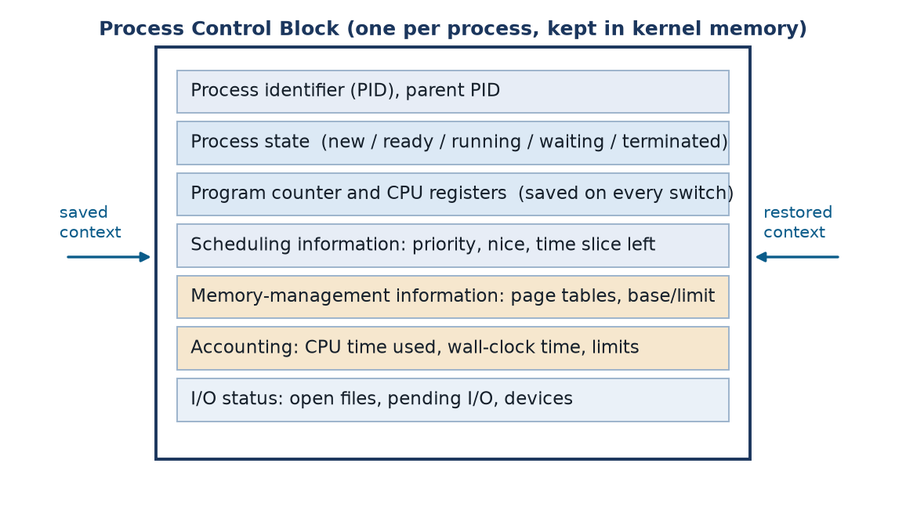
Figure 2 The process control block and the fields the kernel needs in order to suspend and resume a process.

Program and verified evidence
The program forks six children, each of which reports its own pid, its parent's pid and its state, then sleeps so that ps can observe the tree while all the children are alive. The parent waits for every child, which is what prevents the zombies that would otherwise remain in the process table.
/* ============================================================================
* CSA0406 - Operating Systems - Assignment 2 - Q1
* Processes and Process States: create children with fork(), report PCB-level
* identity (pid, ppid, state, address-space size) and let the parent be
* observed with ps while the children are alive.
*
* Build : gcc -std=c11 -Wall -Wextra -O2 -o q1_processes q1_processes.c
* Run : ./q1_processes [hold_seconds] [pid_file]
* ./q1_processes 6 q1_pids.txt (then run ps on the pids)
* ==========================================================================*/
#define _POSIX_C_SOURCE 200809L

#include <stdio.h>
#include <stdlib.h>
#include <string.h>
#include <sys/types.h>
#include <sys/wait.h>
#include <unistd.h>

#define NCHILD 3

/* Print pid, ppid, scheduling state and address-space usage of this process.
* /proc/self/status is the Linux interface; on non-Linux POSIX layers it may
* be absent, in which case we degrade gracefully instead of failing. */
static void print_self_status(const char *who)
{
FILE *f = fopen("/proc/self/status", "r");
char line[256];
char state[16] = "n/a", vm_size[32] = "n/a", vm_rss[32] = "n/a";

if (f == NULL) {
printf(" %-11s pid=%-6ld ppid=%-6ld (no /proc/self/status here)\n",
who, (long)getpid(), (long)getppid());
return;
}
while (fgets(line, sizeof line, f) != NULL) {
if (strncmp(line, "State:", 6) == 0)
sscanf(line + 6, "%15s", state);
else if (strncmp(line, "VmSize:", 7) == 0)
sscanf(line + 7, "%31s", vm_size);
else if (strncmp(line, "VmRSS:", 6) == 0)
sscanf(line + 6, "%31s", vm_rss);
}
fclose(f);
printf(" %-11s pid=%-6ld ppid=%-6ld state=%-4s VmSize=%s kB VmRSS=%s kB\n",
who, (long)getpid(), (long)getppid(), state, vm_size, vm_rss);
}

/* A short CPU-bound phase so the child is genuinely in the RUNNING state. */
static void busy_work(void)
{
volatile unsigned long x = 1;
for (unsigned long i = 0; i < 2000000UL; i++)
x = x * 2654435761UL + i;
(void)x;
}

int main(int argc, char **argv)
{
int hold = (argc > 1) ? atoi(argv[1]) : 5;
const char *pidfile = (argc > 2) ? argv[2] : NULL;
pid_t pids[NCHILD] = {0};

printf("== Q1: fork() and the five process states ==\n");
print_self_status("parent");
fflush(stdout);

/* ---- NEW -> READY -> RUNNING: fork() creates the PCB and admits it ---- */
for (int i = 0; i < NCHILD; i++) {
pid_t pid = fork();
if (pid < 0) {
perror("fork");
return 1;
}
if (pid == 0) {
/* ---- child context ---- */
char who[16];
snprintf(who, sizeof who, "child %d", i + 1);
print_self_status(who);
printf(" child %d: RUNNING (CPU-bound loop)\n", i + 1);
fflush(stdout);

busy_work();

printf(" child %d: WAITING (sleep %d s - state S in ps)\n", i + 1, hold);
fflush(stdout);
sleep((unsigned)hold);

printf(" child %d: READY/RUNNING again, exiting with code %d (TERMINATED)\n",
i + 1, i + 1);
fflush(stdout);
_exit(i + 1);
}
pids[i] = pid;
}

/* ---- parent records the pids so the shell can run ps on them ---- */
if (pidfile != NULL) {
FILE *pf = fopen(pidfile, "w");
if (pf != NULL) {
for (int i = 0; i < NCHILD; i++)
fprintf(pf, "%ld\n", (long)pids[i]);
fclose(pf);
}
}

printf("\nparent: forked %d children:", NCHILD);
for (int i = 0; i < NCHILD; i++)
printf(" %ld", (long)pids[i]);
printf("\nparent: children are now sleeping - observe them with:\n");
printf(" ps -fp <pids> (Linux: ps -o pid,ppid,stat,comm -p <pids>)\n\n");
fflush(stdout);

/* ---- WAITING -> TERMINATED: parent reaps each child, no zombie remains ---- */
for (int i = 0; i < NCHILD; i++) {
int status = 0;
pid_t w = waitpid(pids[i], &status, 0);
if (w < 0) {
perror("waitpid");
continue;
}
if (WIFEXITED(status))
printf("parent: reaped child %ld, exit status %d\n",
(long)w, WEXITSTATUS(status));
}
printf("parent: all children terminated and reaped (no zombies)\n");
return 0;
}

Compile and run:
gcc -std=c11 -Wall -Wextra -O2 -o q1_processes q1_processes.c
./q1_processes 6 q1_pids.txt
ps -fp $(cat q1_pids.txt | tr '\n' ',')

Captured output (work/logs/q1_processes.log and q1_ps.log)
Each child prints state S (sleeping) with PPID equal to the parent's pid, and the parent prints state R (running) with PPID 1, which is the shell that started it.

== Q1: fork() and the five process states ==
parent pid=2115 ppid=1 state=R VmSize=7104 kB VmRSS=8576 kB
child 1 pid=2117 ppid=2115 state=R VmSize=6720 kB VmRSS=6912 kB
child 1: RUNNING (CPU-bound loop)
child 1: WAITING (sleep 6 s - state S in ps)
child 2 pid=2118 ppid=2115 state=R VmSize=6784 kB VmRSS=6912 kB
child 2: RUNNING (CPU-bound loop)
child 2: WAITING (sleep 6 s - state S in ps)

parent: forked 3 children: 2117 2118 2119
parent: children are now sleeping - observe them with:
ps -fp <pids> (Linux: ps -o pid,ppid,stat,comm -p <pids>)

child 3 pid=2119 ppid=2115 state=R VmSize=6720 kB VmRSS=6912 kB
child 3: RUNNING (CPU-bound loop)
child 3: WAITING (sleep 6 s - state S in ps)
child 1: READY/RUNNING again, exiting with code 1 (TERMINATED)
child 2: READY/RUNNING again, exiting with code 2 (TERMINATED)
child 3: READY/RUNNING again, exiting with code 3 (TERMINATED)
parent: reaped child 2117, exit status 1
parent: reaped child 2118, exit status 2
parent: reaped child 2119, exit status 3
parent: all children terminated and reaped (no zombies)

Creation cost: process versus thread
Measurement | Value | Note
fork() + wait(), per child | 39890.1 us | Measured over 200 iterations
pthread_create() + join(), per thread | 660.1 us | Same work, same loop
Round-trip pipe message | 39.5 us | Parent to child and back
Resident memory added by a process | 7040 kB | /proc status before and after
Stack cost of one thread | 27.5 kB | Touched pages only
Process / thread creation ratio | 60.4x | On this platform
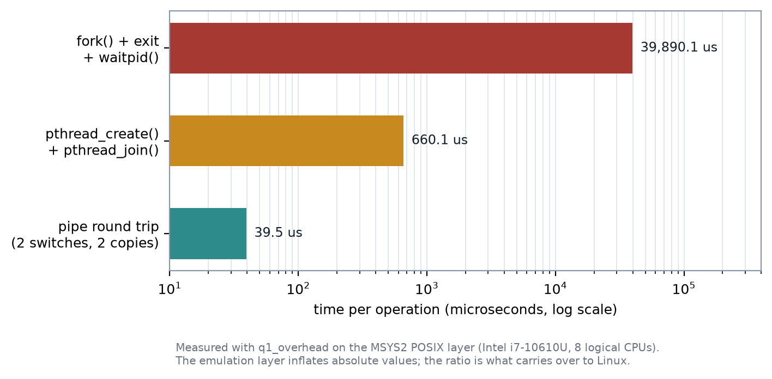
Figure 3 Measured creation cost. The process is roughly 60 times more expensive than the thread and occupies about 250 times the memory.

Interpretation and design decision
A thread is cheaper for three reasons: it shares the address space, so no page tables or memory map need to be duplicated; it shares the file table; and the kernel does not have to create a new security context. A process is isolated, which is why it is the right unit when a fault must be contained.
For the case study, worker threads are the right unit for the per-camera frame processing, because the work is short, frequent and shares one frame buffer; processes are the right unit for isolating an untrusted plugin, because a crash there must not take the reader down. The measured 60x creation cost and 250x memory cost are the quantitative reason not to use a process per camera.

Screenshot required
Run q1_processes in a terminal, leave the six children alive, and capture the terminal with `ps -fp <pids>` visible next to the program output. Place the image in Q1_Processes_and_Process_States/Screenshots/. No screenshot is included in this package because none was captured on the build machine.

