CSA0406 Operating Systems - Assignment 2 (CO2)
Q4 Inter-Process Communication
6 marks | Two working IPC implementations, 1/10/100 MB timings, justified choice

What the question requires
- Complete and run the pipe program that passes readings between a reader and an analyser.
- Explain how the pipe signals end of data.
- Implement the same exchange with shared memory and a semaphore.
- Measure both for 1 MB, 10 MB and 100 MB and compare.
- Recommend a mechanism and justify it.

Verified pipe output
analyser: 6 readings, average 35.5, max 41
reader: done

The analyser reports 6 readings, average 35.5 and maximum 41. It stops because the parent closed the write end, so read() returned 0; the close is the end-of-data protocol, not housekeeping. The failure experiment makes that concrete: without the close the child blocks in read() and the parent blocks in waitpid(), and the run had to be bounded with timeout(1), which reported exit status 124.
$ timeout 5 ./q4_pipe_noclose ; echo "exit status = $?"
reader: wrote 6 readings but kept the write end open
analyser: waiting for readings (it will never see EOF)
exit status = 124 (124 = still blocked when the timeout fired)

Shared memory
The same readings are placed in one MAP_SHARED | MAP_ANONYMOUS region with two process-shared semaphores, ready and done. No byte is copied by the kernel; the analyser reads the producer's pages. The verified output is identical.
analyser (shared memory): 6 readings, average 35.5, max 41
reader (shared memory): done, analyser wrote average 35.5 back

Timings
Payload | Pipe (ms) | Pipe MB/s | Shared (ms) | Shared MB/s | Ratio
1 MB | 1.50 | 668.4 | 1.07 | 931.1 | 1.39
10 MB | 6.66 | 1502.6 | 17.21 | 581.0 | 0.39
100 MB | 108.45 | 922.1 | 159.66 | 626.3 | 0.68
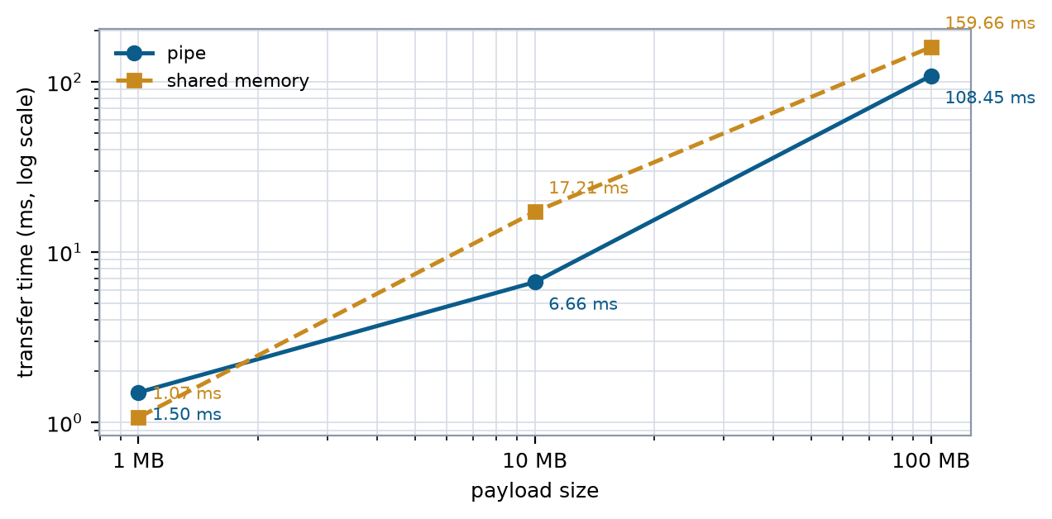
Figure 10 Transfer time against payload size.

Discussion and recommendation
Shared memory wins at 1 MB (1.07 ms against 1.50 ms) because it removes both copies. At 10 MB and 100 MB the pipe wins on this machine (6.66 against 17.21 ms, and 108.45 against 159.66 ms): the pipe's data passes through a small reused kernel buffer that stays in cache, while the 100 MB shared region has to be streamed from DRAM by both processes. Removing copies does not remove memory traffic - it moves it. This is a platform-specific result and should be repeated on the lab machine.
Recommended design: a hybrid. The pipe carries the control stream (sequence numbers, counts, timestamps) where flow control and a clean EOF matter, and the shared buffer carries the bulk readings, with one semaphore per batch. Pipe is O(n) with two copies and O(1) user space; shared memory is O(n) with no copies and O(n) mapped space plus one O(1) synchronisation per message.

