CSA0406 Operating Systems - Assignment 2 (CO2)
Q2 CPU Scheduling
8 marks | Gantt charts and averages for five policies, Round Robin program, quantum study, recommendation

What the question requires
- Compute waiting and turnaround times for FCFS, SJF, SRTF, priority and Round Robin, with Gantt charts.
- Complete and run the Round Robin program and check the computed averages.
- Study the effect of the time quantum.
- Compare the policies on a realistic mixed workload.
- Recommend a policy and justify it.
The process set is P1..P4 with arrival times 0, 1, 2, 3, burst times 8, 4, 9, 5 and priorities 3, 1, 4, 2 (lower number = higher priority).

Results for the five policies
Policy | Average turnaround | Average waiting | Average response
FCFS | 15.25 | 8.75 | 8.75
SJF | 14.25 | 7.75 | 7.75
SRTF | 13.00 | 6.50 | 4.25
Priority | 14.25 | 7.75 | 7.75
RR q=3 | 20.00 | 13.50 | 3.00
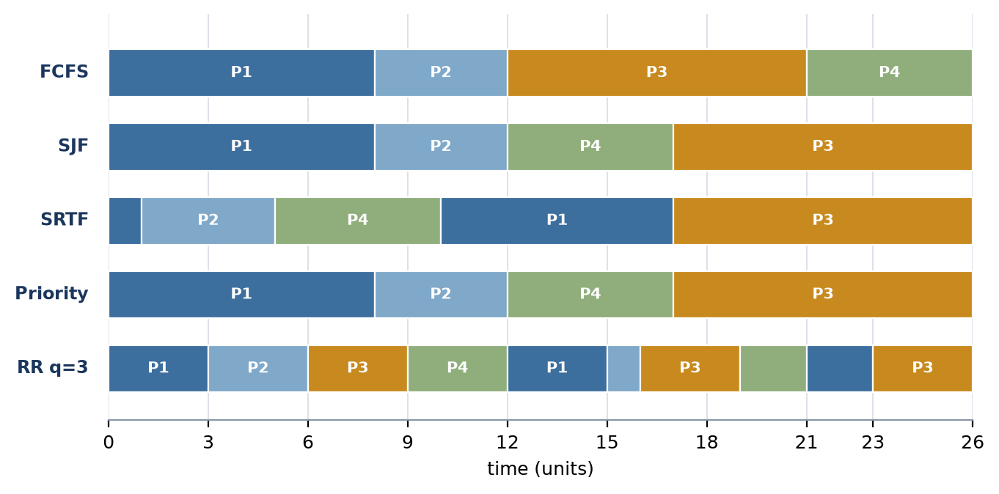
Figure 4 Gantt charts for the five policies. Round Robin preempts every 3 units; SRTF preempts P1 as soon as the shorter P2 arrives.

Round Robin verified output
The completed program prints the Gantt chart, the per-process table and the averages. The values match the hand calculation exactly: average turnaround 20.00 and average waiting 13.50 for q = 3.
Gantt: P1(0-3) P2(3-6) P3(6-9) P4(9-12) P1(12-15) P2(15-16) P3(16-19) P4(19-21) P1(21-23) P3(23-26)
Process TAT WT
P1 23 15
P2 15 11
P3 24 15
P4 18 13
Average TAT = 20.00, average WT = 13.50

Quantum study
Quantum | Avg waiting | Avg turnaround | Avg response | Switches | Max ready queue
q = 1 | 12.50 | 19.00 | 0.75 | 26 | 3
q = 2 | 12.75 | 19.25 | 2.00 | 14 | 3
q = 3 | 13.50 | 20.00 | 3.00 | 10 | 3
q = 5 | 11.00 | 17.50 | 5.50 | 6 | 3
q = 10 | 8.75 | 15.25 | 8.75 | 4 | 3
q = 20 | 8.75 | 15.25 | 8.75 | 4 | 3
The submitted program was also run with quantum 1 and quantum 20, as the question asks: at quantum 1 it prints 26 slices with average TAT 19.00 and WT 12.50; at quantum 20 the Gantt chart collapses to the four FCFS blocks with average TAT 15.25 and WT 8.75. The transcript is Output/q2_rr_quantum.log.
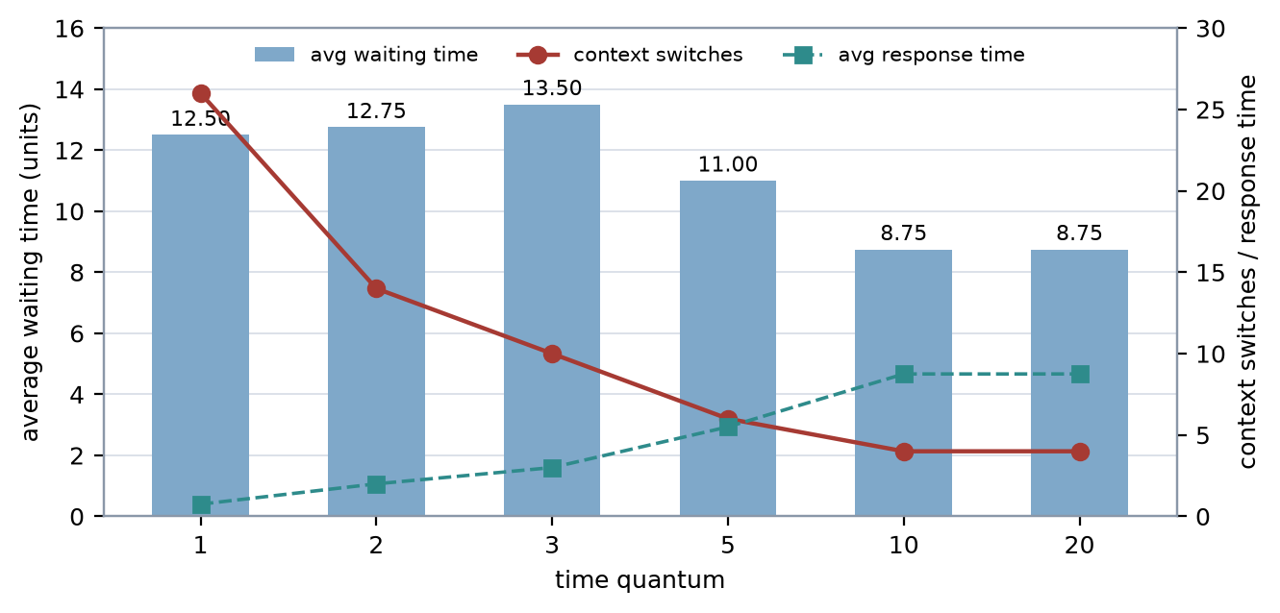
Figure 5 Response time falls as the quantum falls, while the number of context switches rises. The averages converge to FCFS as q grows past the longest burst.
The trade-off is explicit in the table. A quantum of 1 gives the best response time (0.75) with 26 switches; a quantum of 10 or more degenerates to FCFS (average WT 8.75, TAT 15.25) with four switches. A quantum of 3 is what the supplied program uses, and quantum 5 is the best compromise on this job set (WT 11.00 with 6 switches).

Realistic mixed workload
Policy | Short-job wait | Short-job TAT | Long-job wait | Long-job TAT | Switches
FCFS | 1925.12 | 1927.12 | 1764.50 | 2964.50 | 12
SJF (non-preemptive) | 1175.12 | 1177.12 | 1767.00 | 2967.00 | 12
SRTF | 0.00 | 2.00 | 1771.00 | 2971.00 | 20
Round Robin (q=3) | 2.88 | 4.88 | 3532.00 | 4732.00 | 1608
MLFQ (q=2/16/64, boost 1000) | 0.00 | 2.00 | 1976.00 | 3176.00 | 53
This is where the textbook ranking breaks down. FCFS and SJF give the short jobs a wait of 1925 and 1175, SRTF gives 0, and Round Robin gives 2.88 but 1608 switches. MLFQ achieves SRTF-quality response for the short jobs (0.00) while keeping the long jobs at 1976, with only 53 switches - the best overall trade-off, and the reason it is the recommended policy.
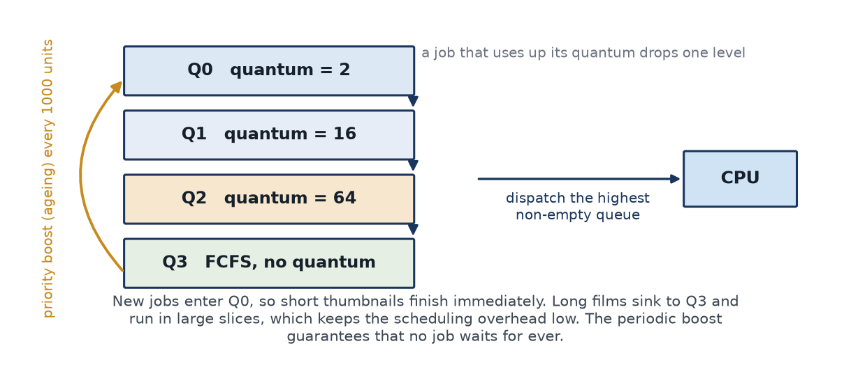
Figure 6 MLFQ: short jobs finish in the top queue, long jobs sink and are boosted periodically so that they cannot starve.

Recommendation
MLFQ with a periodic boost (every 1,000 units) and three queues of quantum 2, 16 and 64. It gives short interactive work near-SRTF response, keeps the switch count low, and the boost bounds the waiting time of long jobs, which strict priority cannot do: the starvation run never completes the 60-unit job under strict priority, whereas ageing completes it at t = 309.

