CSA0406 Operating Systems - Assignment 2 (CO2)
Q6 Deadlock Handling and the Banker's Algorithm
13 marks | Characterise, compare, apply, predict, measure, defend

The six parts
- A (2): the four necessary conditions and the resource-allocation graph.
- B (3): compare prevention, avoidance, detection and ignoring for this cluster.
- C (4): complete and run the Banker's algorithm; safe sequences and request decisions.
- D (1): predict the running time before implementing.
- E (1): measure and compare with the prediction.
- F (2): defend the final design.

A The four conditions
Condition | In the cluster
Mutual exclusion | A GPU or a licence is assigned to one job at a time.
Hold and wait | A job holds two GPUs while waiting for a third.
No preemption | The scheduler cannot take a GPU back; a job must finish or be killed.
Circular wait | A waits for a licence held by B, B for storage held by C, C for a GPU held by A.
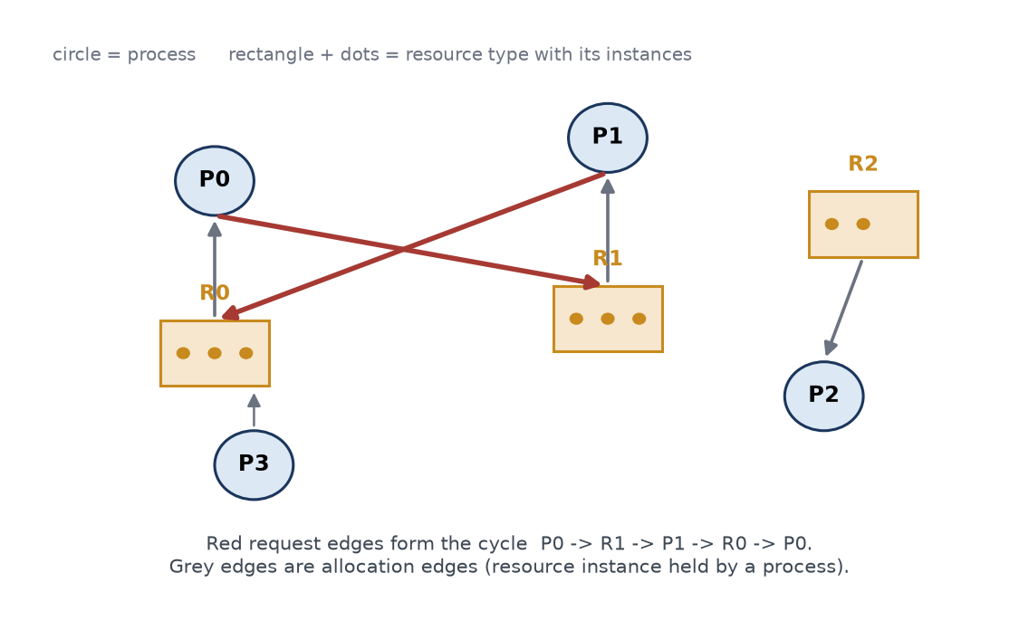
Figure 13 The request edges close the cycle P0 -> R1 -> P1 -> R0 -> P0. With single instances a cycle is necessary and sufficient for deadlock.

B Comparison, evaluated
Strategy | Cost | Verdict for this cluster
Prevention | None at run time; lost utilisation | Cheap and provable: enforce one global resource order. Keeps resources idle too long if jobs must acquire everything up front.
Avoidance | O(m x n^2) per decision; needs declared maxima | Best fit for batch jobs with declared demands: never deadlocks, allows dynamic requests, yields a proof.
Detection | O(m x n^2) per scan plus lost work | Backstop for jobs with unknown demands; an aborted 12-hour job loses 12 hours.
Ignoring | Zero | Ruled out: the cluster already stalls until an administrator intervenes.

C Banker's algorithm applied
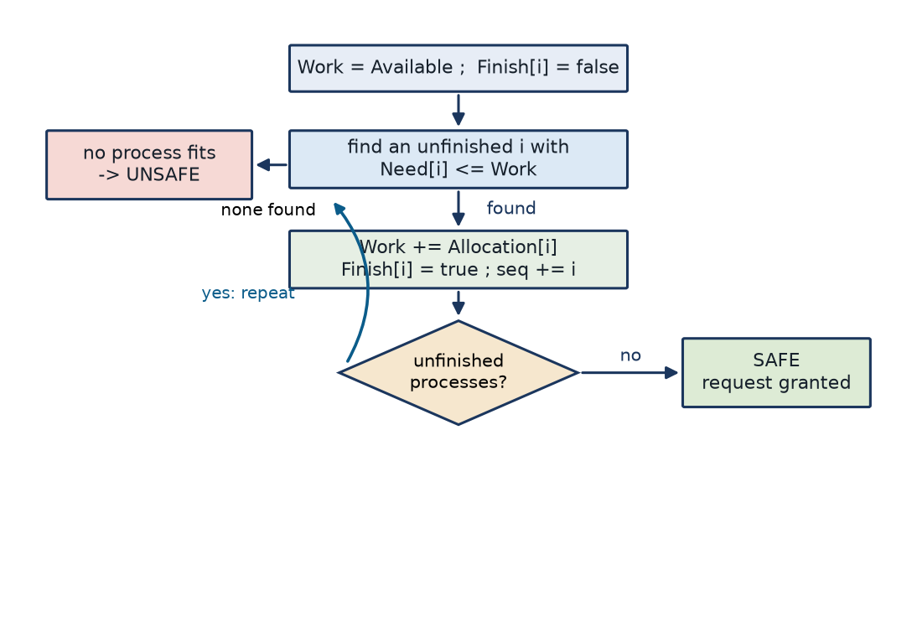
Figure 14 The safety algorithm: finish a process only if Need <= Work, then return its allocation to Work.
initial state safe: P1 P3 P4 P0 P2
P1 request: granted, safe sequence P1 P3 P4 P0 P2
P4 request: must wait (not available)
P0 request: denied (unsafe)

Hand check: Need = Max - Allocation, Available = (3, 3, 2). P1 finishes (Work 5, 3, 2), P3 (7, 4, 3), P4 (7, 4, 5), P0 (7, 5, 5), P2 (10, 5, 7). P1's request is granted. P4's (3, 3, 0) must wait because only 2 units of R0 are free.
P0's (0, 2, 0) request is legal in isolation but leaves Work = (2, 1, 0): P0 needs 7 of R0, P1 needs 2 of R1, P2 needs 6 of R0, P3 needs 1 of R2 and P4 needs 4 of R0, so no process can finish on the first pass and the state is unsafe. The grant consumes the last two units of R1, the only resource P1 could have used to finish and release its three R0 units.

D and E Prediction and measurement
Prediction: O(m x n^2) time and O(m x n) space. The outer loop runs at most n times, each pass scans n processes, and each test compares m counters. Testable consequences: ten times more processes should cost about a hundred times more, and twice the resource types about twice the time.
n | m | Per check (us) | ns per need check
10 | 3 | 0.26 | 1.55
100 | 3 | 30.54 | 2.02
1000 | 3 | 2773.19 | 1.85
5000 | 3 | 74423.41 | 1.98
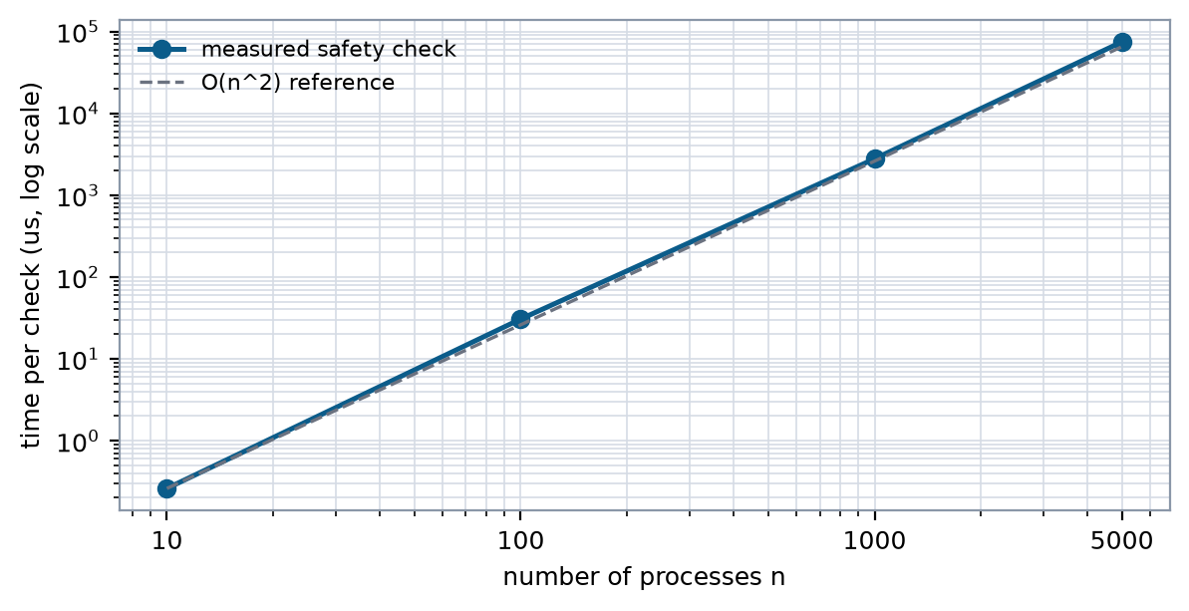
Figure 15 Measured cost against the O(n^2) reference, normalised at n = 10.
The time per check grows 0.26 -> 30.54 -> 2,773 -> 74,423 us for n = 10, 100, 1,000 and 5,000, while ns per need comparison stays between 1.55 and 2.02: the quadratic prediction holds. Tripling m from 3 to 6 to 12 multiplied the time by 1.8 and 1.6.

F Defended design
Batched avoidance at admission points for jobs with declared maxima, prevention by a fixed resource order for shared infrastructure, and periodic detection as a backstop with checkpointing before any abort. The measured 2.8 ms per check at n = 1,000 is why the checks are batched rather than run per request. The honest weakness: the guarantee depends on truthful maximum declarations, which users writing their own job scripts may not provide - which is exactly why detection is retained.

