CSA0406 Operating Systems - Assignment 2 (CO2)
Q5 Process Synchronisation
11 marks | Derived design, semaphore code, test evidence, measured locking decision

What the question requires
- Derive a synchronisation design from the three critical-section requirements.
- Explain and evaluate Peterson's solution.
- Complete the bounded-buffer program with semaphores and test it.
- Compare monitors, readers-writers, dining philosophers and lock granularity.
- Make and defend a measured locking decision.

Requirements and measured evidence
Requirement | How the design satisfies it
Mutual exclusion | Binary semaphore or mutex around every seat-counter update; the shared-counter experiment loses 40 % of updates without one.
Progress | Wait/signal blocks only competing processes; the naive flag-only lock deadlocked (timeout 124), which is what a non-progress design looks like.
Bounded waiting | FIFO semaphore queues plus ageing: strict priority never completed the 60-unit job, ageing completed it at t = 309.

Peterson's solution
The plain volatile version is not safe on a modern processor. Over 2,000,000 entries it produced 2 mutual-exclusion violations in 0.65 s, because the store to flag[i] can be reordered with respect to the load of flag[j]. Compiled with C11 seq_cst atomics it produced 0 violations over the same 2,000,000 entries; compiled without the turn variable it deadlocked and had to be killed by timeout (124).
== Q5: Peterson's solution, 2 threads x 1000000 entries ==
variant: Peterson with plain volatile variables

critical-section entries : 2000000
mutual-exclusion violations: 2
elapsed : 648.6 ms
RESULT: mutual exclusion BROKEN

== Q5: Peterson's solution, 2 threads x 1000000 entries ==
variant: Peterson with C11 seq_cst atomics (memory barriers)

critical-section entries : 2000000
mutual-exclusion violations: 0
elapsed : 578.8 ms
RESULT: mutual exclusion held

$ timeout 10 ./q5_peterson_naive 200000 ; echo "exit status = $?"
== Q5: Peterson's solution, 2 threads x 200000 entries ==
variant: NAIVE (only flag[], no turn variable)

exit status = 124 (124 = both threads stayed in the wait loop)

Bounded buffer
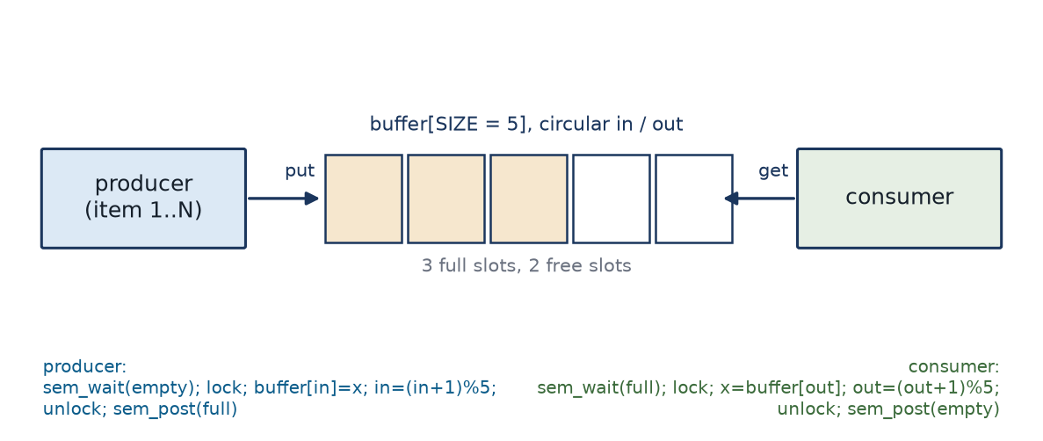
Figure 11 Counting semaphores plus one mutex: the layout that satisfies all three requirements without deadlock.
The supplied program prints exactly the expected line: items consumed 20, sum 210, and 100 consecutive runs of the same binary all printed that line. The generalised test with 4 producers and 4 consumers passed 100 of 100 runs with the exact sum 2,001,000. Removing only the mutex leaves the semaphores working but corrupts the index pair: 12 of 20 runs correct, with 271 duplicate and 271 lost items.
== Q5: 4 producers / 4 consumers, mutex in place ==
buffer 5 slots, 500 items per producer, 100 repetitions

run 1: produced exactly once 2000/2000, consumed exactly once 2000/2000, duplicates 0, missing 0, sum 2001000 (expected 2001000)
run 2: produced exactly once 2000/2000, consumed exactly once 2000/2000, duplicates 0, missing 0, sum 2001000 (expected 2001000)
run 3: produced exactly once 2000/2000, consumed exactly once 2000/2000, duplicates 0, missing 0, sum 2001000 (expected 2001000)

RESULT: 100/100 runs correct (PASS)

== Q5: 4 producers / 4 consumers, mutex REMOVED ==
buffer 5 slots, 500 items per producer, 20 repetitions

run 1: produced exactly once 2000/2000, consumed exactly once 1998/2000, duplicates 1, missing 1, sum 2001494 (expected 2001000)
run 2: produced exactly once 2000/2000, consumed exactly once 2000/2000, duplicates 0, missing 0, sum 2001000 (expected 2001000)
run 3: produced exactly once 2000/2000, consumed exactly once 2000/2000, duplicates 0, missing 0, sum 2001000 (expected 2001000)
run 6 FAILED: consumed once 1996/2000, duplicates 2, missing 2, sum 2000821 (expected 2001000)
run 7 FAILED: consumed once 1850/2000, duplicates 75, missing 75, sum 1998944 (expected 2001000)
run 8 FAILED: consumed once 1982/2000, duplicates 9, missing 9, sum 2004597 (expected 2001000)
run 10 FAILED: consumed once 1996/2000, duplicates 2, missing 2, sum 2002457 (expected 2001000)
run 11 FAILED: consumed once 1860/2000, duplicates 70, missing 70, sum 1899738 (expected 2001000)
run 14 FAILED: consumed once 1778/2000, duplicates 111, missing 111, sum 2007441 (expected 2001000)
run 18 FAILED: consumed once 1998/2000, duplicates 1, missing 1, sum 2001972 (expected 2001000)

RESULT: 12/20 runs correct (FAIL)
total duplicate consumptions 271, total lost items 271

Lock granularity, measured
Lock scope | Time (ms) | Updates/s | Correct | Speed-up
one global lock | 24801.1 | 64,513 | OK | 7.51
one lock per train | 3303.4 | 484,352 | OK | 7.51
one lock per coach | 393.1 | 4,070,156 | OK | 63.09
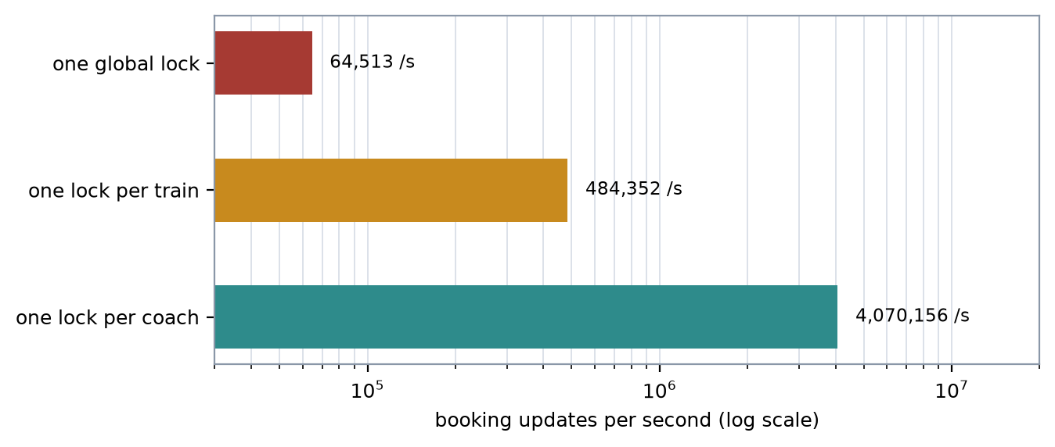
Figure 12 Throughput against lock granularity: 63x from one global lock to one lock per coach.
Decision: one mutex per coach. A booking touches exactly one coach, so that is the smallest unit that keeps the seat bitmap consistent; train and system totals are updated with atomic counters, which avoids taking a second lock. The global lock is 63x slower and the per-train lock is 8.4x slower than the per-coach lock for no benefit. The cost is 64 mutexes instead of one, plus a fixed lock order for anything spanning coaches.

Atomics versus spin locks versus mutexes
Method | Threads | Time (ms) | ns/update | CPU (s) | Correct
mutex | 1 | 15.5 | 154.9 | 0.00 | OK
atomic | 1 | 1.4 | 14.2 | 0.00 | OK
spinlock | 1 | 2.3 | 23.0 | 0.00 | OK
mutex | 4 | 6472.0 | 16180.0 | 4.22 | OK
atomic | 4 | 9.5 | 23.8 | 0.05 | OK
spinlock | 4 | 41.7 | 104.2 | 0.12 | OK
mutex | 16 | 25951.1 | 16219.4 | 16.73 | OK
atomic | 16 | 43.3 | 27.1 | 0.22 | OK
spinlock | 16 | 336.0 | 210.0 | 1.45 | OK
Use an atomic when the critical section is one variable (27.1 ns at 16 threads); a short spin lock when the section is a few instructions (210 ns at 16 threads, but 1.45 s of CPU wasted); a mutex or semaphore when the section is long or may block (16,219 ns per update at 16 threads on this platform). The booking transaction is long and I/O-bound, so it must sleep, not spin.

