Software

Requirements Specification

for

Machine Learning in Diabetes

Version 1.0

Prepared by

Sheshadri m

**1.Introduction:**

Document Purpose: To detect if the person is suffering from diabetes using glucose and blood pressure as features and Diabetes as label.

Product Scope: helps to check if a person has diabetics

Intended Audience: Developer, Tester

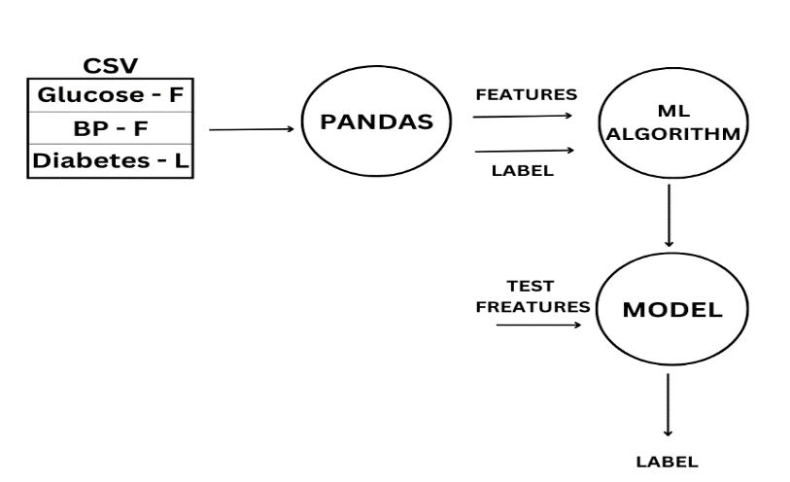

**2.Overall Description:**

Product Overview:

Product Functionality:

R1: Download data in CSV format

R2: Using pandas extract features and label from CSV file

R3: Build ML Model using ML Algorithm

R4: Predict and analyze

**3.Functional Requirements:**

Using pandas extract features and label from CSV file

Build ML Model using ML Algorithm

**4.Other Requirements:** N/A