Data Cleaning & Visualization Project
Intern Submission — Due 14 Aug 2026

1. Objective
Work on a raw dataset to clean, process, and visualize insights. The goals were to handle missing values, outliers, and duplicates; use Python libraries (Pandas, Matplotlib, Seaborn) for processing and visualization; and produce a dashboard summarizing key findings.

2. Dataset
A retail sales dataset with 1,225 raw records was used, containing the kinds of data-quality issues typically found in real exports: missing values, duplicate rows, inconsistent text formatting, mixed date formats, and price/quantity outliers.

3. Data Cleaning Steps

3.1 Standardizing text fields
- Category values arrived with inconsistent casing and spacing (e.g. "electronics", "ELECTRONICS ", "Home and Kitchen") and were normalized to a single consistent form.

3.2 Parsing dates
- Order dates were exported in three different formats (YYYY-MM-DD, DD/MM/YYYY, MM-DD-YYYY) and were parsed into a single consistent datetime column.

3.3 Removing duplicates
- 25 exact duplicate order records were identified and removed.

3.4 Handling missing values
- Region and Payment Method (categorical): filled with "Unknown" / the most frequent value.
- Customer Rating (numeric, roughly symmetric): filled with the column median.
- Unit Price (numeric, varies strongly by category): filled with the median price within each product category, not the overall median.
- 204 missing values were imputed in total across four columns.

3.5 Handling outliers
- Outliers were detected using the IQR (interquartile range) method and capped rather than dropped, to avoid losing otherwise-valid orders.
- Unit Price outliers were capped per category (not globally), since Electronics and Books have very different natural price ranges — a global threshold would have wrongly flagged normal high-value Electronics orders.
- Quantity outliers (a handful of orders with 50+ units, likely data-entry errors) were capped to a realistic range.

4. Key Findings
Metric | Value
Total orders (cleaned) | 1200
Total revenue | ₹1,13,85,128
Average order value | ₹9,488
Top category by revenue | Electronics (₹73,53,501)
Top region by order volume | North
Most common payment method | Cash on Delivery
Average customer rating | 3.97 / 5

- Electronics drives the largest share of revenue by a wide margin, despite not having the most orders — its higher price point outweighs volume.
- North and South regions each account for roughly a quarter of orders; the small remaining slice reflects originally-missing region data now labeled "Unknown".
- Cash on Delivery and Credit Card are the two most common payment methods, followed closely by UPI, Debit Card, and Net Banking.
- Unit prices are right-skewed with a secondary cluster around ₹8,000–10,000, mostly from Electronics orders.
- Median customer ratings sit around 4.0 across all categories, with Beauty and Books showing a slightly wider spread of low outlier ratings.

5. Visualization Dashboard
The dashboard below summarizes six views of the cleaned dataset: monthly revenue trend, revenue by category, order share by region, unit price distribution, orders by payment method, and customer rating by category.
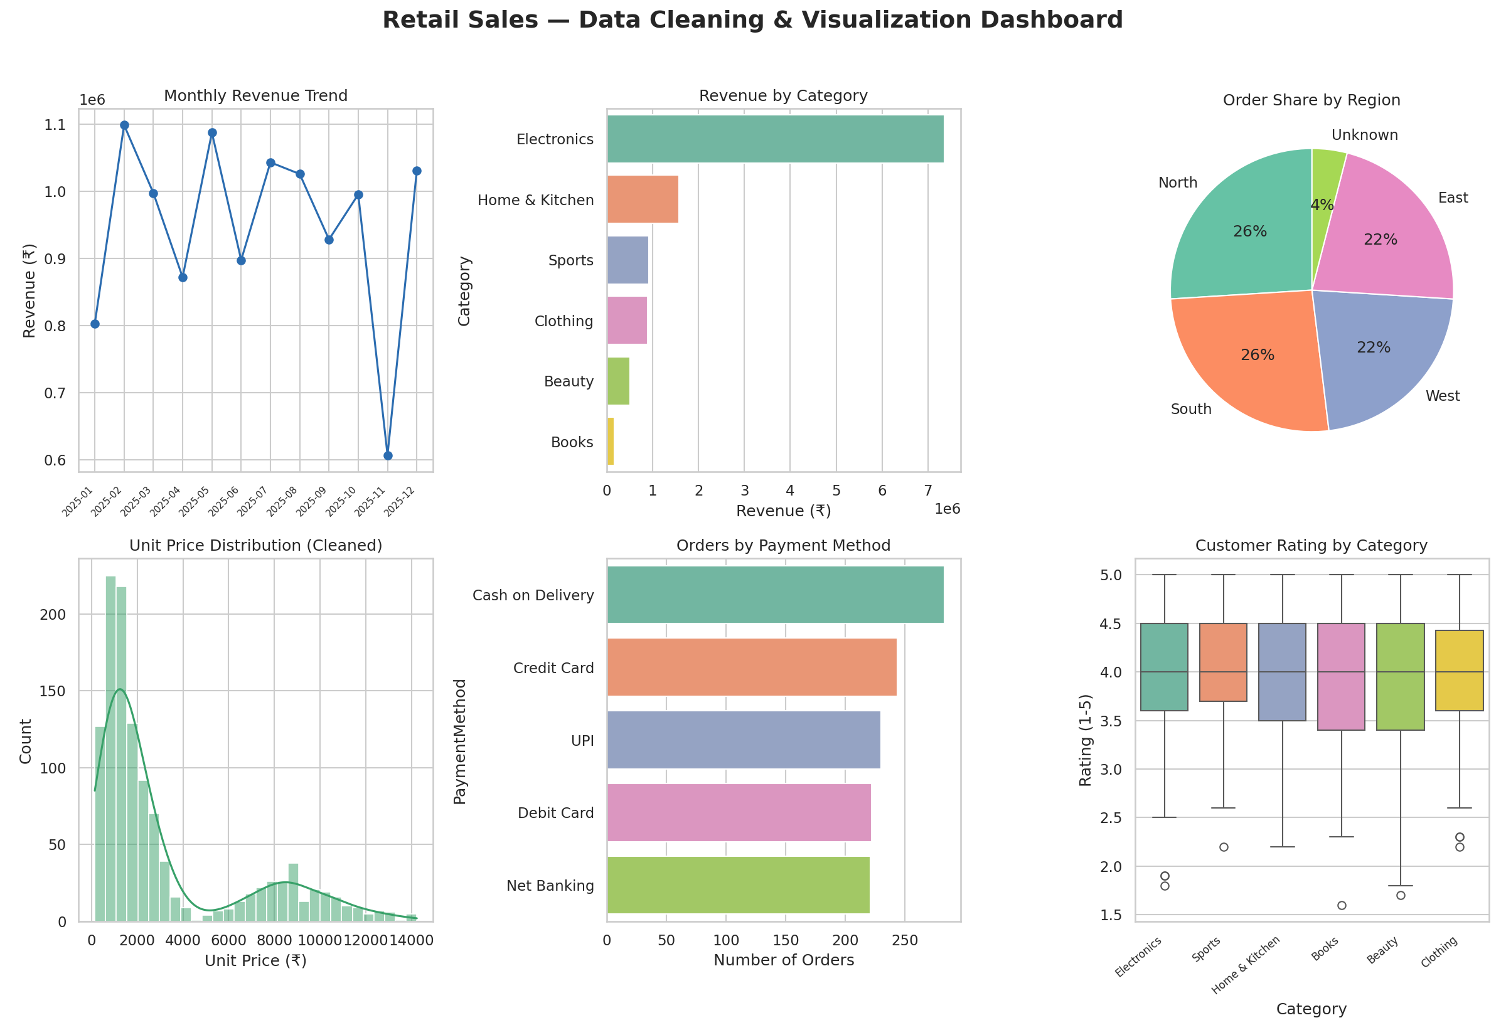

6. Tools & Deliverables
- Python (Pandas, NumPy, Matplotlib, Seaborn)
- Data_Cleaning_Visualization_Project.ipynb — full, executed notebook with code, commentary, and output
- raw_sales_data.csv — original raw dataset
- cleaned_sales_data.csv — cleaned, analysis-ready dataset
- dashboard.png — final visualization dashboard
- cleaning_log.txt — step-by-step log of every cleaning operation performed

7. Learning Outcome
This project reinforced a practical, end-to-end data preprocessing and visualization workflow: diagnosing data-quality issues, choosing appropriate (and category-aware) cleaning strategies rather than one-size-fits-all rules, and communicating findings clearly through a visual dashboard.

