Scikit-learn

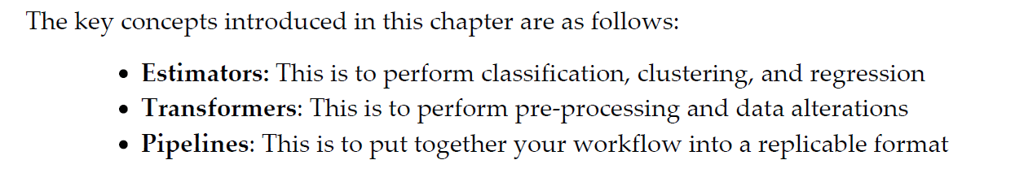

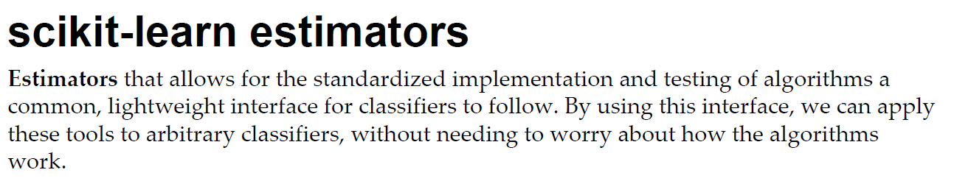

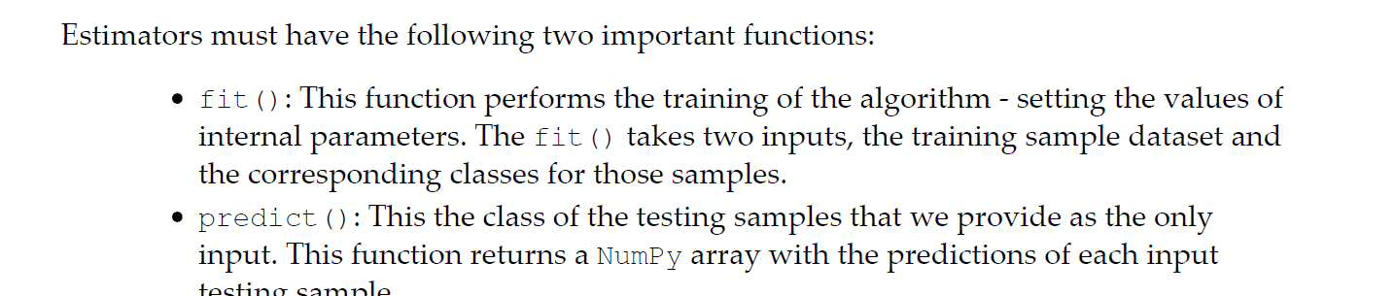

Transformers :

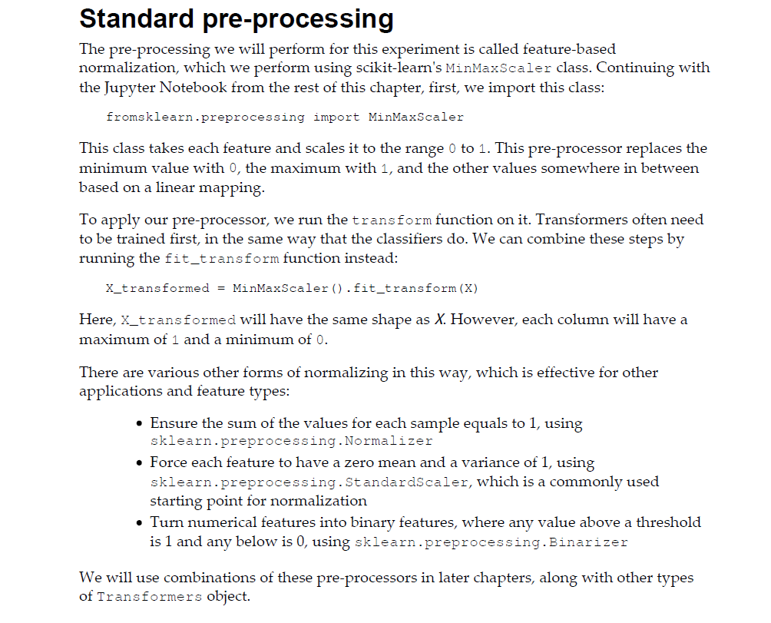

Pipelines :

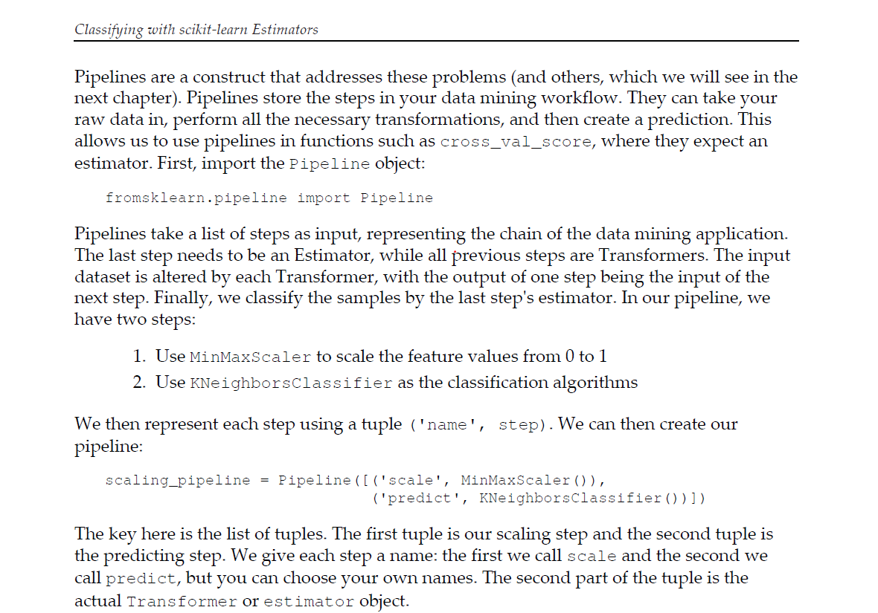

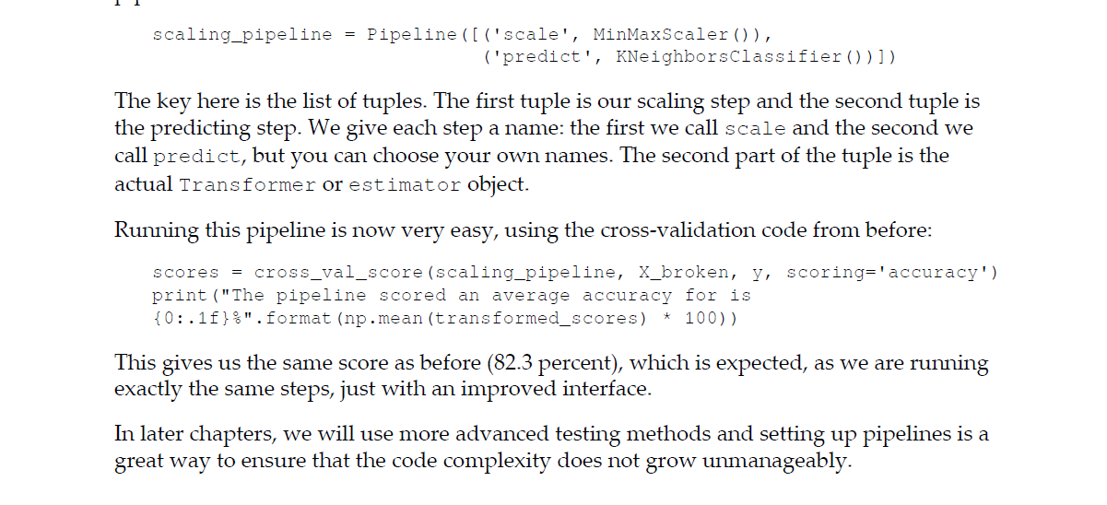

Score = accuracy

<https://scikit-learn.org/stable/modules/model_evaluation.html>

Random state

random_state is used for initializing the internal random number generato. using same random_state will ensure producing same result every time program is rum.

If random_state is None or np.random, then a randomly-initialized RandomState object is returned.

If random_state is an integer, then it is used to seed a new RandomState object.

If random_state is a RandomState object, then it is passed through.

This is to check and validate the data when running the code multiple times. Setting random_state a fixed value will guarantee that same sequence of random numbers are generated each time you run the code. And unless there is some other randomness present in the process, the results produced will be same as always. This helps in verifying the output.

Cross fold -

