Index
1. BigQuery Gold Table
2. BigQuery Schema
3. Cloud Function Requirements
4. Cloud Function Code
5. Data Quality Query

CODE:
In Step2:
BigQuery: SQL Query to Create the gold analytics table
CREATE TABLE IF NOT EXISTS `snappy-mapper-498509-e0.analytics_lakehouse.currency_rates_gold`
(
base_currency STRING,
target_currency STRING,
exchange_rate NUMERIC,
rate_date DATE,
ingested_at TIMESTAMP)PARTITION BY rate_date
CLUSTER BY target_currency, base_currency;

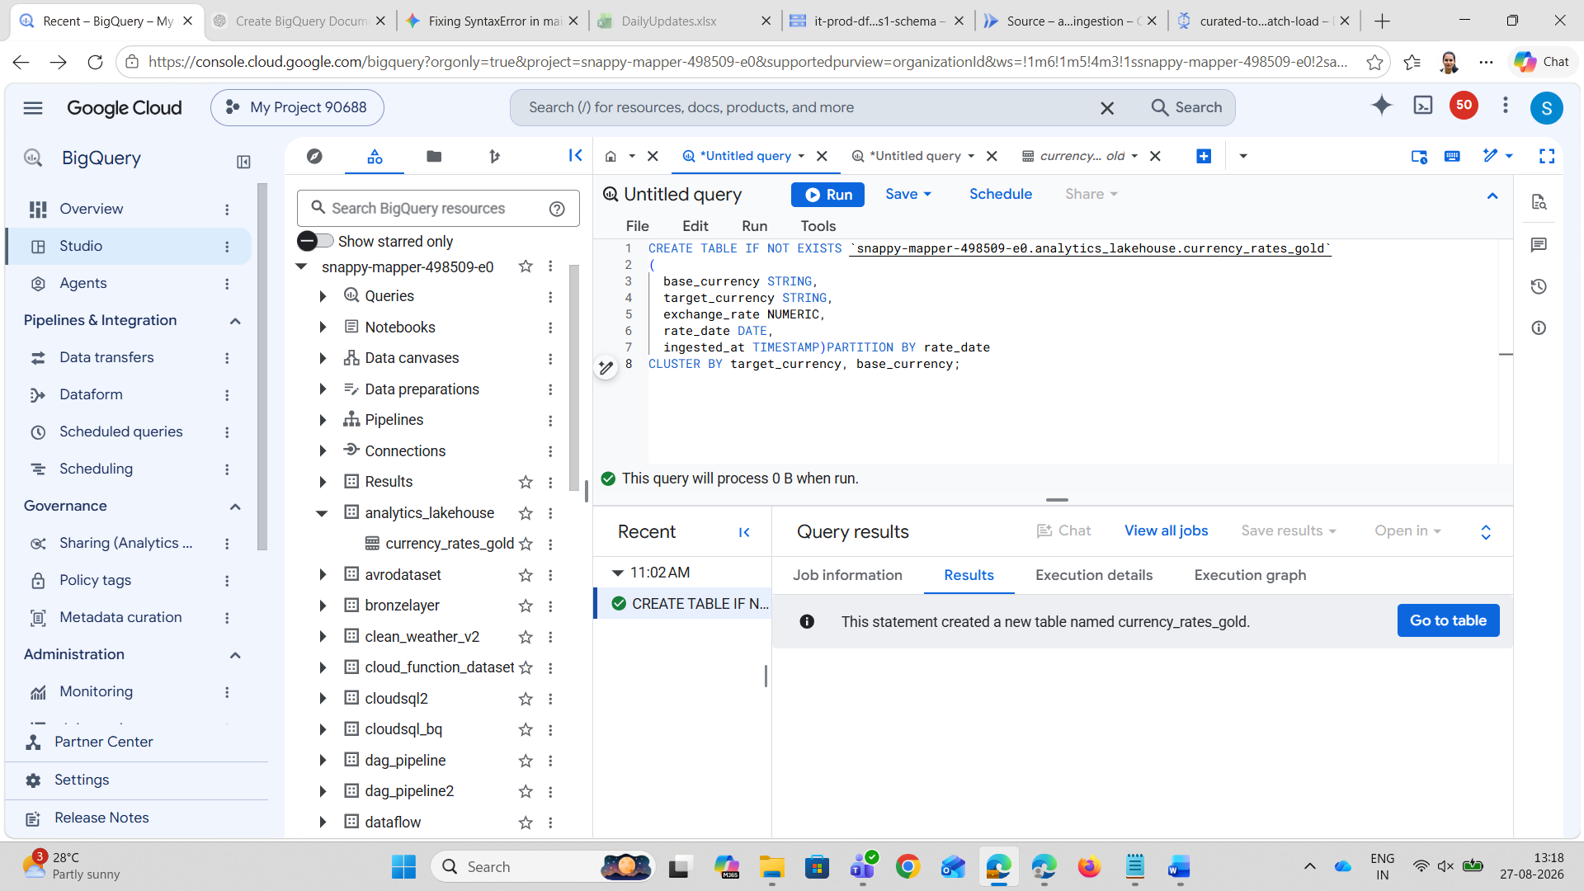

In Step3:
Upload schema.json via Cloud Storage UI:
{
"BigQuery Schema": [
{"name": "base_currency", "type": "STRING", "mode": "NULLABLE"},
{"name": "target_currency", "type": "STRING", "mode": "NULLABLE"},
{"name": "exchange_rate", "type": "NUMERIC", "mode": "NULLABLE"},
{"name": "rate_date", "type": "DATE", "mode": "NULLABLE"},
{"name": "ingested_at", "type": "TIMESTAMP", "mode": "NULLABLE"}
]
}

In Step4:
requirements.txt:
functions-framework>=3.0.0
google-cloud-storage>=2.0.0
requests>=2.28.0
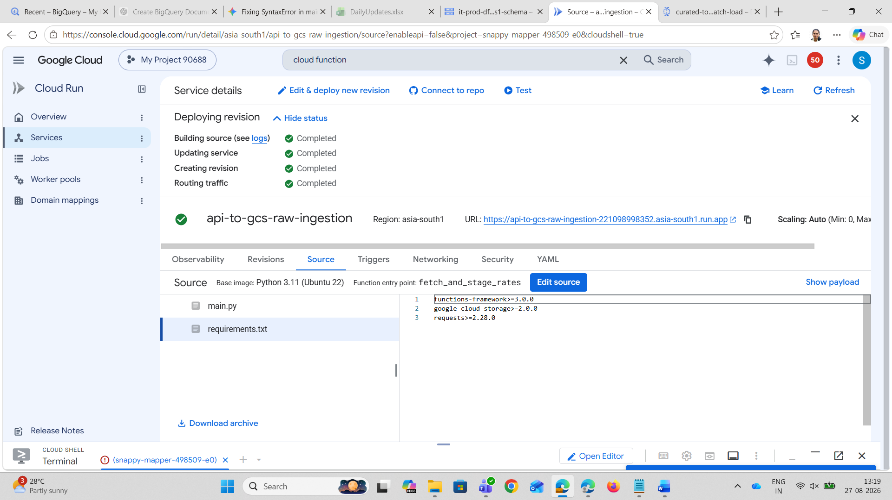

main.py:
import datetime
import json
import functions_framework
import requests
from google.cloud import storage

PROJECT_ID = "snappy-mapper-498509-e0"
LANDING_BUCKET = "it-prod-landing-as1-raw" # Bronze
CURATED_BUCKET = "it-prod-curated-as1-clean" # Silver
API_URL = "https://open.er-api.com/v6/latest/USD"

@functions_framework.http
def fetch_and_stage_rates(request):
# 1. Fetch live rates from external API
response = requests.get(API_URL, timeout=30)
response.raise_for_status()
raw_api_payload = response.json()
rates_data = raw_api_payload.get("rates", {})

target_currencies = ["EUR", "INR", "GBP", "JPY", "AUD", "CAD", "SGD", "CHF", "CNY", "AED"]
client = storage.Client(project=PROJECT_ID)
landing_bkt = client.bucket(LANDING_BUCKET)
curated_bkt = client.bucket(CURATED_BUCKET)

base_time = datetime.datetime.now(datetime.timezone.utc)
staged_files = []

# 2. Process 5 consecutive days
for day_offset in range(5):
simulated_time = base_time - datetime.timedelta(days=day_offset)
rate_date_str = simulated_time.strftime("%Y-%m-%d")
now_ts = datetime.datetime.now(datetime.timezone.utc).isoformat()
time_tag = int(simulated_time.timestamp())

# --- A. WRITE UNMODIFIED RAW DATA TO BRONZE / LANDING ---
raw_partition = simulated_time.strftime("raw_events/year=%Y/month=%m/day=%d/hour=%H")
raw_blob = landing_bkt.blob(f"{raw_partition}/raw_payload_{time_tag}.json")
raw_blob.upload_from_string(json.dumps(raw_api_payload), content_type="application/json")

# --- B. WRITE CLEANSED, VALIDATED DATA TO SILVER / CURATED ---
curated_records = [
{
"base_currency": "USD",
"target_currency": curr,
"exchange_rate": round(float(rates_data.get(curr, 1.0)) * (1.0 + (day_offset * 0.002)), 4),
"rate_date": rate_date_str,
"ingested_at": now_ts
}
for curr in target_currencies if curr in rates_data
]

curated_partition = simulated_time.strftime("curated_events/year=%Y/month=%m/day=%d/hour=%H")
curated_filename = f"{curated_partition}/rates_{time_tag}.jsonl"
curated_jsonl = "\n".join([json.dumps(r) for r in curated_records])

curated_blob = curated_bkt.blob(curated_filename)
curated_blob.upload_from_string(curated_jsonl, content_type="application/x-ndjson")
staged_files.append(curated_filename)

return f"Successfully generated 5 days of data into Bronze ({LANDING_BUCKET}) and Silver ({CURATED_BUCKET}).", 200
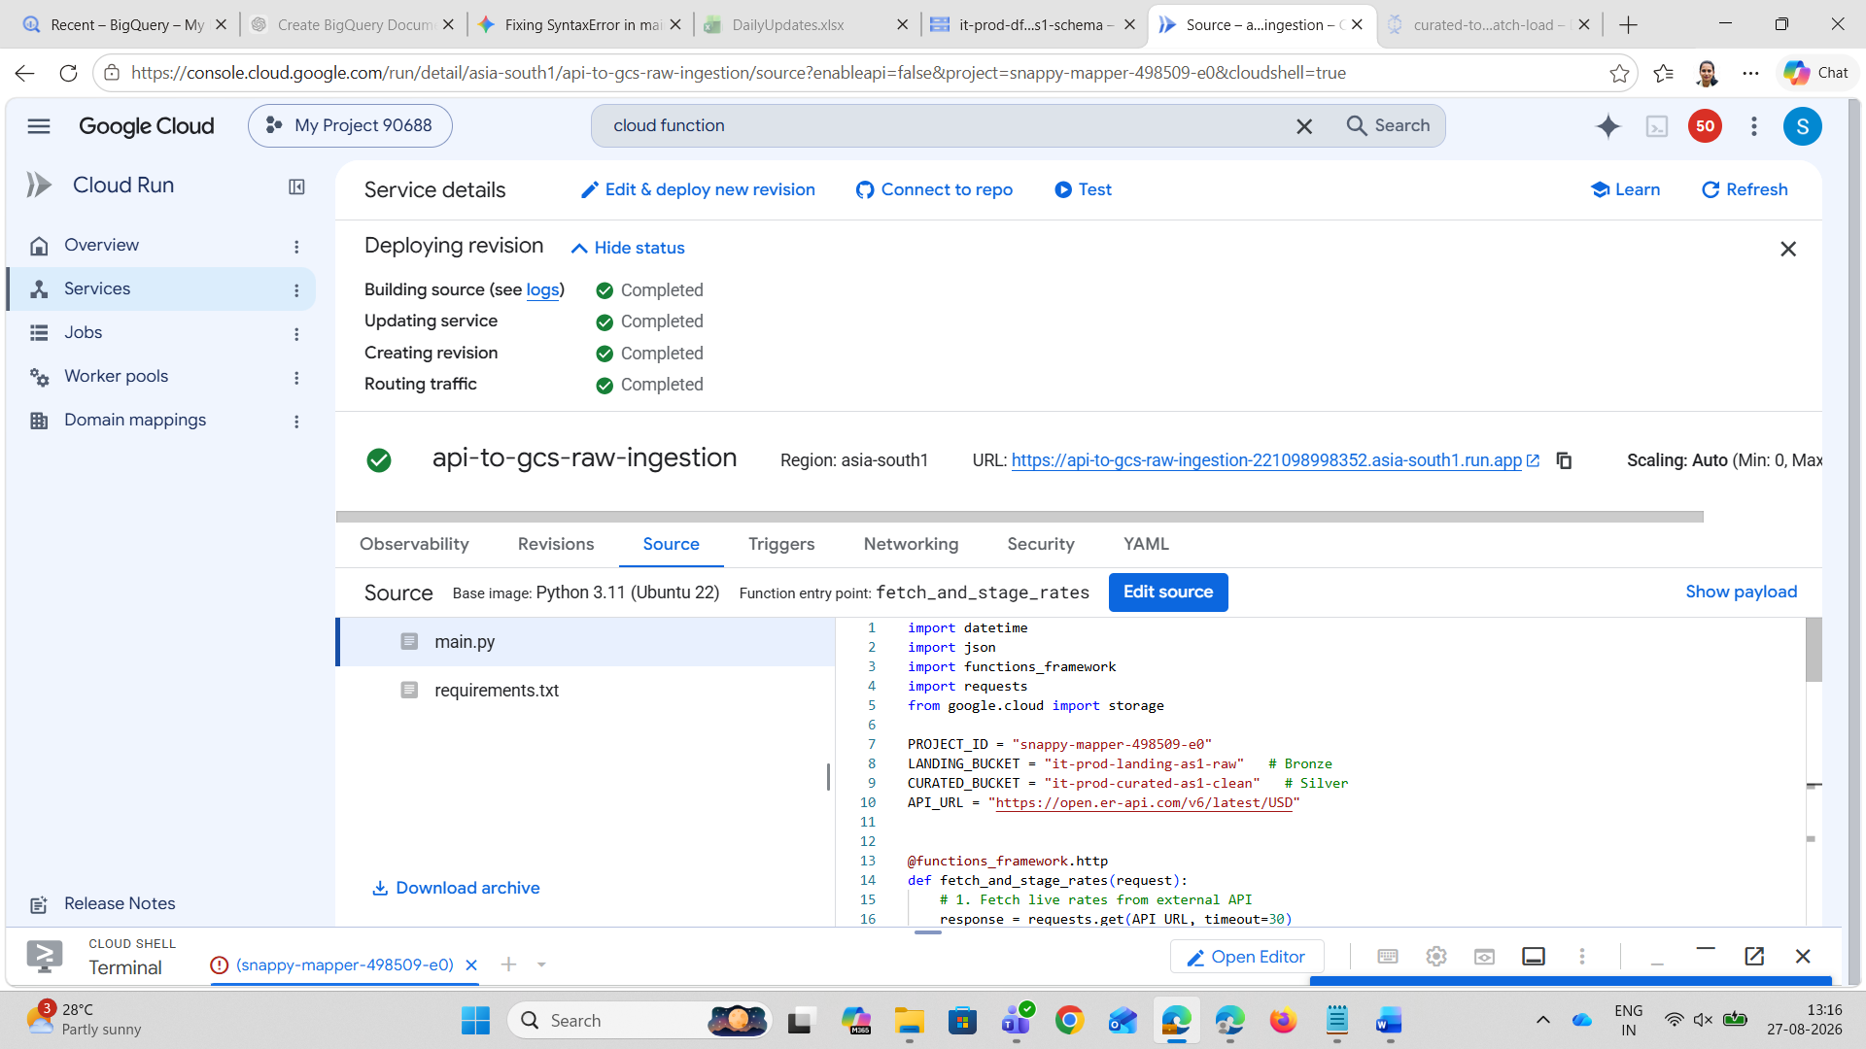
In step6:
Verify End-to-End Data Quality in BigQuery Studio (Web UI)

SELECT
rate_date,
COUNT(*) AS curated_records_count,
ROUND(AVG(exchange_rate), 4) AS avg_exchange_rate,
MIN(ingested_at) AS first_ingested
FROM ` snappy-mapper-498509-e0.analytics_lakehouse.currency_rates_gold`GROUP BY rate_dateORDER BY rate_date DESC;
