End-to-End Serverless FX (Foreign Exchange) Data Lakehouse Pipeline on GCP

Index
1. Project Overview & Aim
2. Tools and Managed Services
3. End-to-End Dataflow & Medallion Architecture
4. Step-by-Step Implementation
5. Conclusion

Aim:
ETL, Data Flow & Medallion Architecture Focus- "To design and implement a scalable 3-tier Medallion architecture (Bronze $→$ Silver $→$ Gold) on Google Cloud that ingests raw REST API payloads, enforces structural data cleansing via serverless compute (Cloud Functions), stages partitioned JSONL objects in Cloud Storage, and loads validated records into partitioned BigQuery analytical tables using Apache Beam/Dataflow batch processing."

Tools & Managed Services:
- Open Exchange Rates API (External Source): Provides live and historical USD-based currency exchange rates via REST endpoints.

- Cloud Functions 2nd Gen (Ingestion & Pre-processing): Executes a serverless Python runtime that extracts API payloads and concurrently transforms and writes Bronze and Silver datasets.

- Cloud Storage / GCS (Object Storage & Data Lake): Hosts decoupled object storage tiers across three distinct buckets (Landing/Bronze, Curated/Silver, and Scratch/Staging).

- Cloud Dataflow / Apache Beam (Distributed Batch ETL): Executes managed, distributed batch jobs using a predefined template to enforce JSON schemas and load curated files into BigQuery.

- BigQuery Studio (Lakehouse Warehouse / Gold): Serves as the high-performance analytical engine hosting the final partitioned and clustered Gold fact table.

- Cloud IAM (Governance & Security): Enforces least-privilege access control by managing roles across Cloud Functions, Cloud Storage, Dataflow workers, and BigQuery datasets.

End-to-End Dataflow & Medallion Architecture
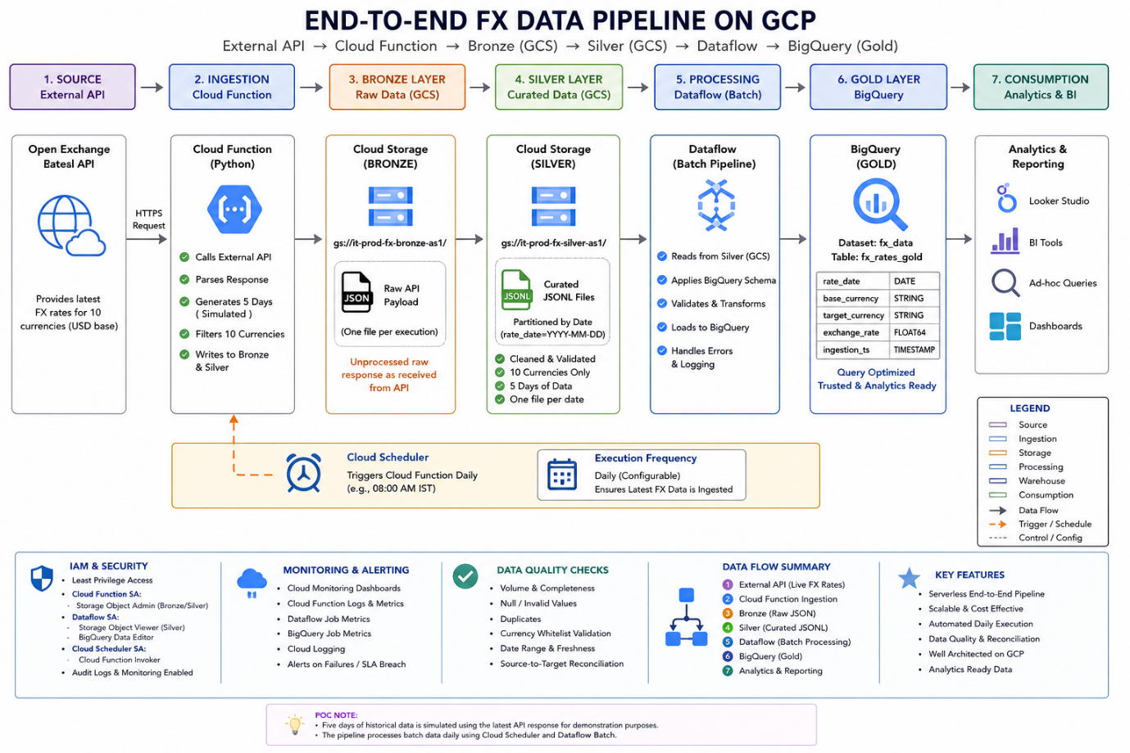

1. External Ingestion Tier (The Data Source)
- What it is: A free public website/API that provides foreign currency exchange rates (USD compared to EUR, INR, GBP, etc.).
- Role: It acts as the raw supplier of numbers for the pipeline.

2. Ingestion & Transformation Runtime (The Worker)
- What it is: A lightweight, serverless piece of Python code running on Google Cloud Functions.
- Role: It wakes up, calls the API to grab the latest currency data, and splits the data into two versions:
  - An untouched copy for safety.
  - A cleaned, well-formatted copy for analytics.

3. Cloud Storage Tiers (The Filing Cabinets / Data Lake)
Instead of dumping everything into one folder, the pipeline uses three separate Cloud Storage buckets following the Medallion Pattern:
- Bronze Bucket (it-prod-landing-as1): Stores the exact, raw JSON data as it came from the website. Nothing is changed. If anything goes wrong in the future, you can always re-read this original data.
- Silver Bucket (it-prod-curated-as1): Stores the cleaned data formatted as JSON Lines (.jsonl). Unnecessary fields are removed, currencies are filtered, and values are properly labeled.
- Scratch Bucket (it-prod-df-scratch-as1): A helper workspace that holds the blueprint (schema.json) and temporary staging files.

4. Batch Processing Engine (The Heavy Lifter)
- What it is: Google Cloud Dataflow (powered by Apache Beam).
- Role: It automatically spins up worker machines to read the cleaned files from the Silver bucket, checks every row against the schema blueprint (schema.json) to prevent bad data, and pushes everything into BigQuery in parallel.

5. Gold Serving Layer (The Final Dashboard / Warehouse)
- What it is: A table (currency_rates_gold) inside Google BigQuery.
- Role: The final destination where clean, trustworthy data lives.
  - It is Partitioned by Date, meaning queries only scan specific days instead of the whole database (saving time and money).
  - It is Clustered by Currency, making searches for specific currencies like INR or EUR almost instant for reports, charts, and dashboards.

Step-by-Step Implementation of Pipeline:
Step 1: Create the 3 Cloud Storage Buckets (Web UI)
- Open Navigation Menu (☰) > Cloud Storage > Buckets.
- Click + Create for each bucket (Settings: Region $\rightarrow$ asia-south1 (Mumbai), Storage Class $\rightarrow$ Standard, Access Control $\rightarrow$ Uniform):
  - it-prod-landing-as1-raw $\rightarrow$ Raw Ingestion (Bronze)
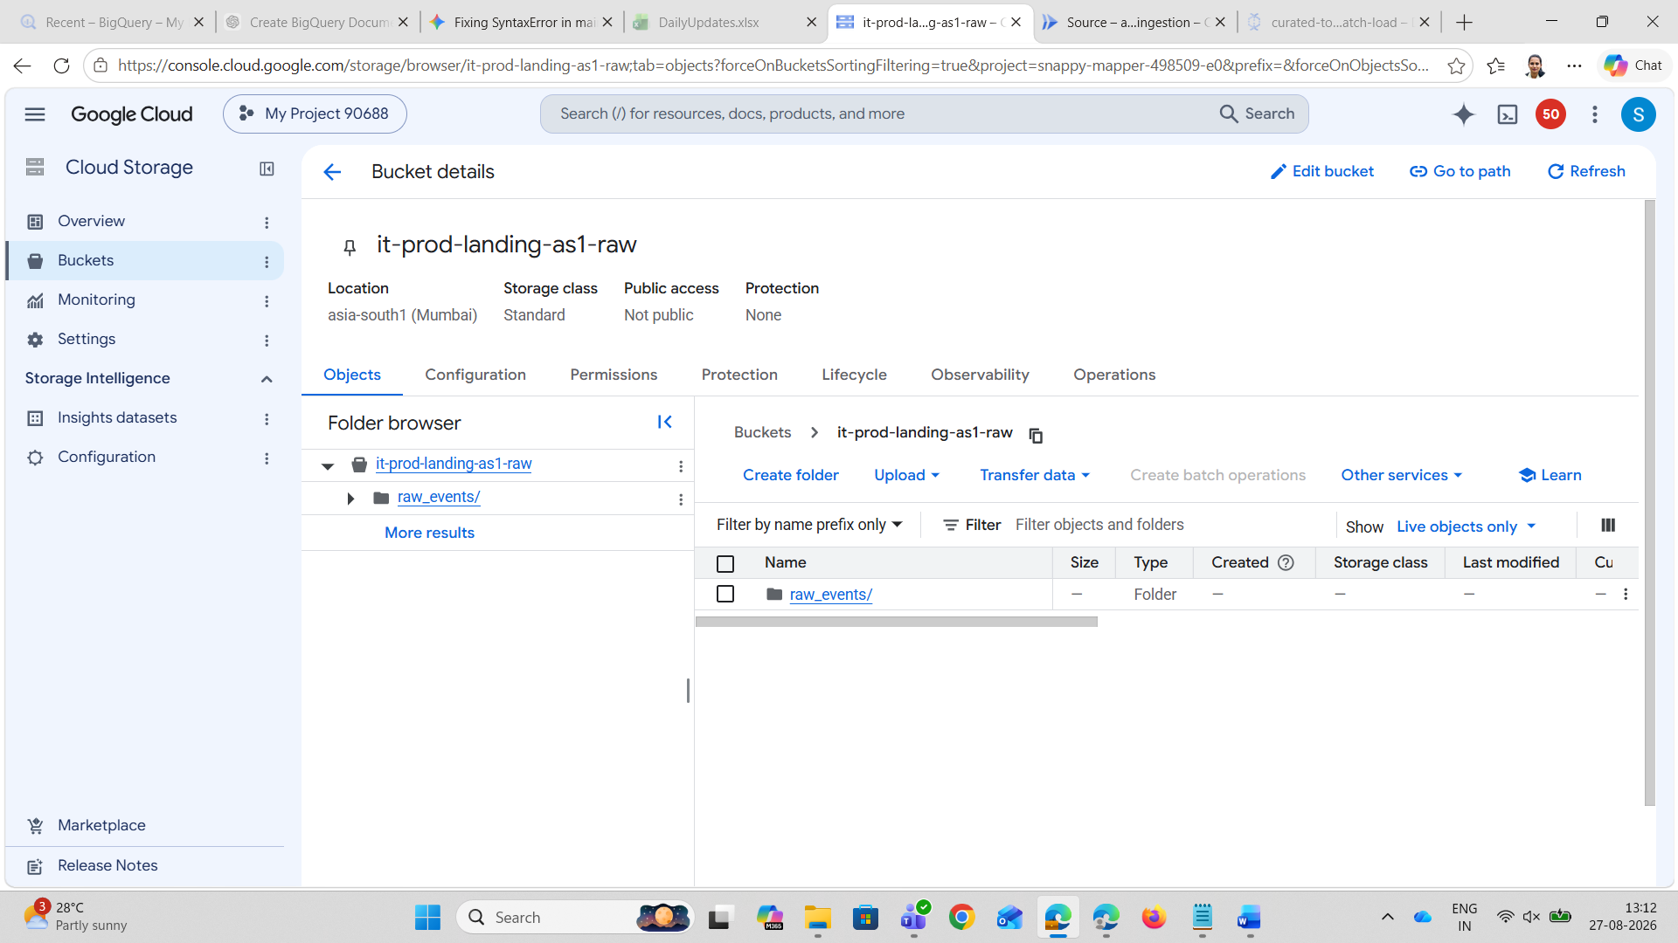
  - it-prod-curated-as1-clean $\rightarrow$ Cleansed & Formatted (Silver / Curated)
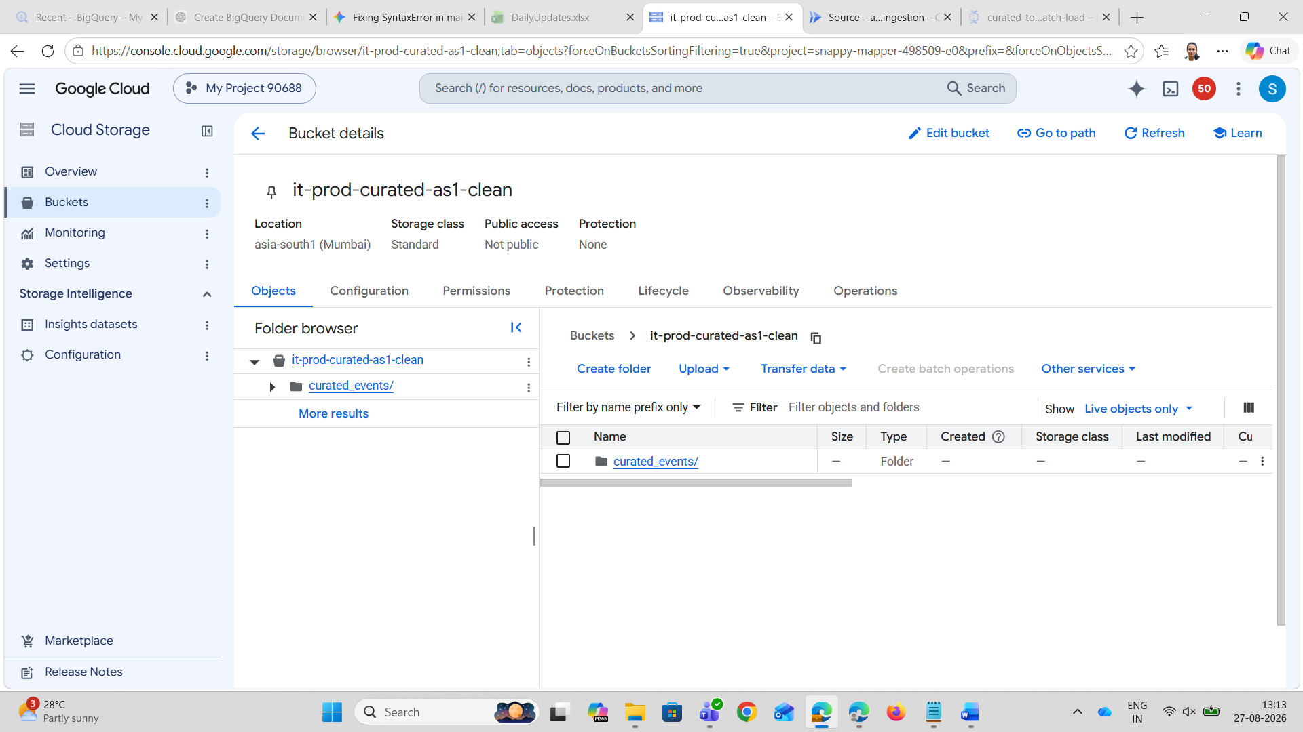

  - it-prod-df-scratch-as1-schema $\rightarrow$ Dataflow Temp & Staging
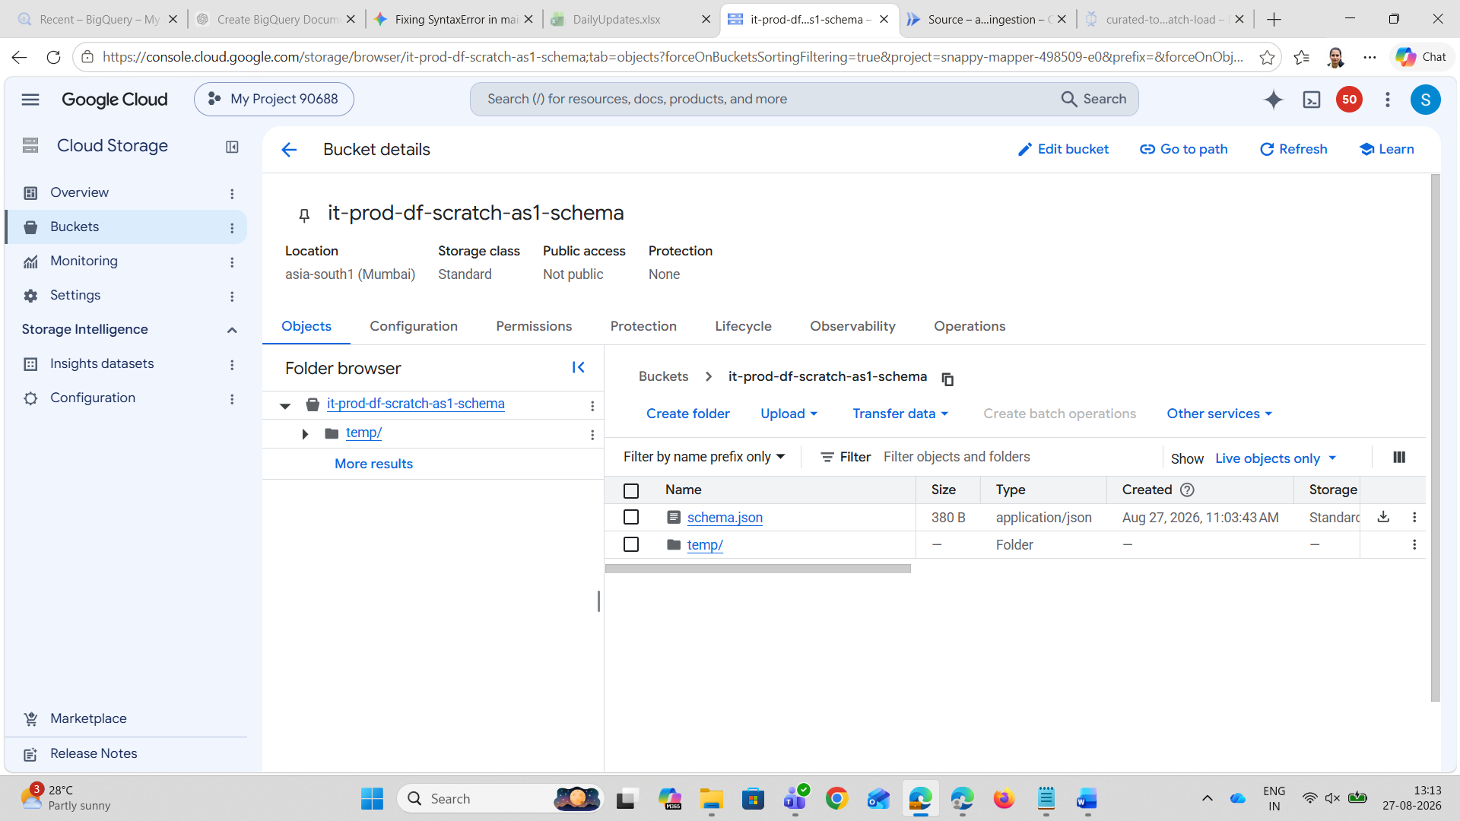
Step 2: Create the BigQuery Gold Table (Web UI)
- Navigate to Navigation Menu (☰) > BigQuery > BigQuery Studio.
- Create dataset analytics_lakehouse (Region: asia-south1).
- Run this DDL in a query tab to create the gold analytics table: Take the query from code Documentation
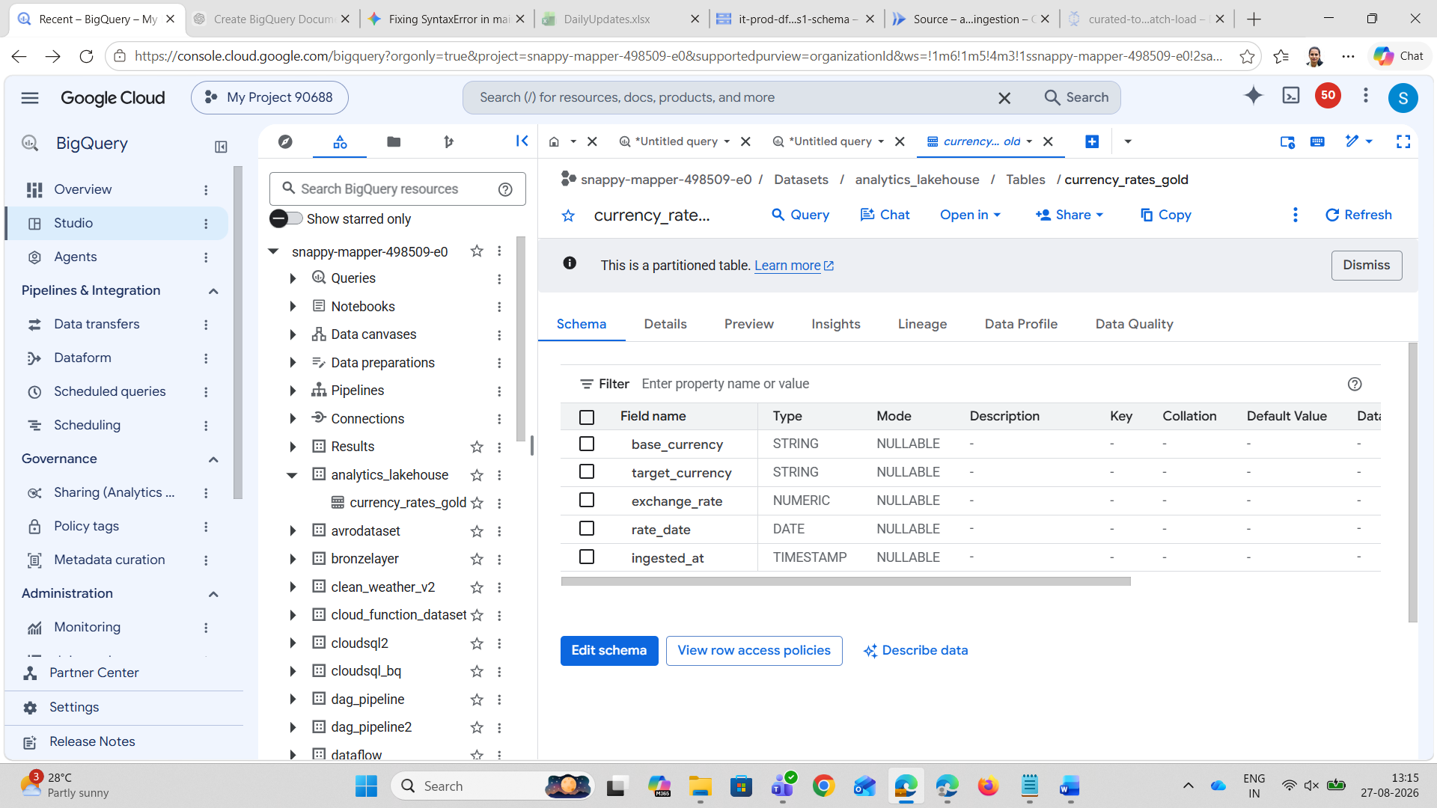

Step 3: Upload schema.json via Cloud Storage UI
- Save a local file on your computer named schema.json: Take code from Code Documentation
- In the GCP Console, open Cloud Storage > Buckets > it-prod-df-scratch-as1.
- Click Upload files and upload schema.json.
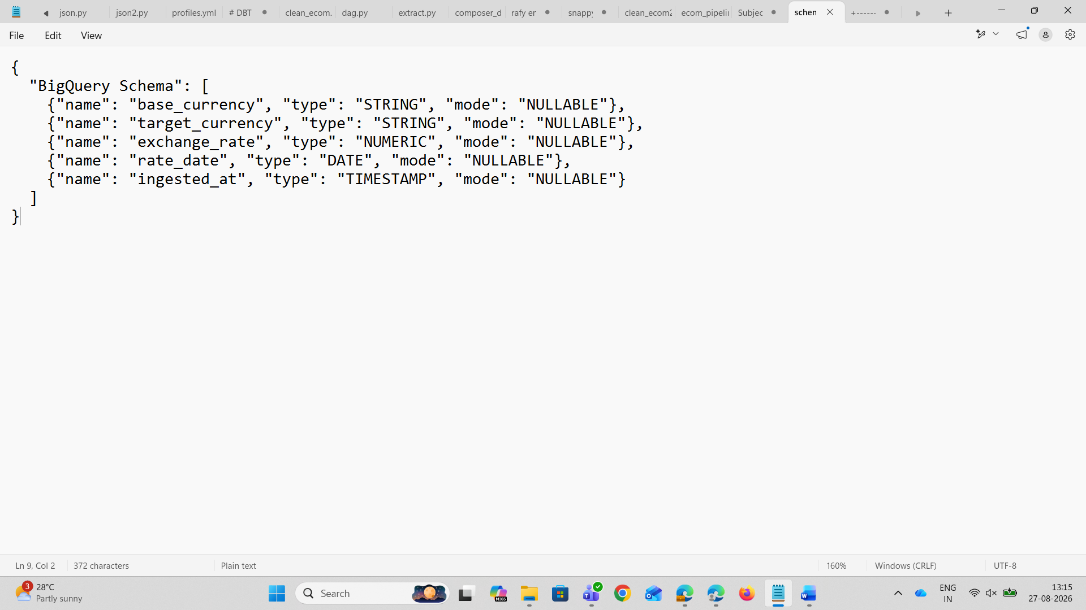

Step 4: Deploy Multi-Zone Ingestion Function (Cloud Functions Web UI)
This updated Cloud Function writes the unprocessed raw JSON to Bronze (it-prod-landing-as1) AND simultaneously validates, standardizes, and writes the cleansed data to Silver (it-prod-curated-as1).
- Go to Navigation Menu (☰) > Cloud Functions.
- Click + Create Function:
  - Environment: 2nd gen
  - Function name: api-to-gcs-raw-ingestion
  - Region: asia-south1 (Mumbai)
  - Trigger type: HTTPS
  - Under Runtime service account, select: 54903645206-compute@developer.gserviceaccount.com
  - Click Next.
- In the code configuration:
  - Runtime: Python 3.11
  - Entry point: fetch_and_stage_rates
  - In requirements.txt, paste: Take the code from code documentation
- In main.py, paste: Take the code from code documentation
- Click Deploy.
- Once deployed, click the Testing tab $\rightarrow$ click Run test.
- Verify in UI:
  - Go to Cloud Storage > it-prod-landing-as1: raw .json files exist under raw_events/.
  - Go to Cloud Storage > it-prod-curated-as1: clean partitioned .jsonl files exist under curated_events/day=22/ through day=26/.
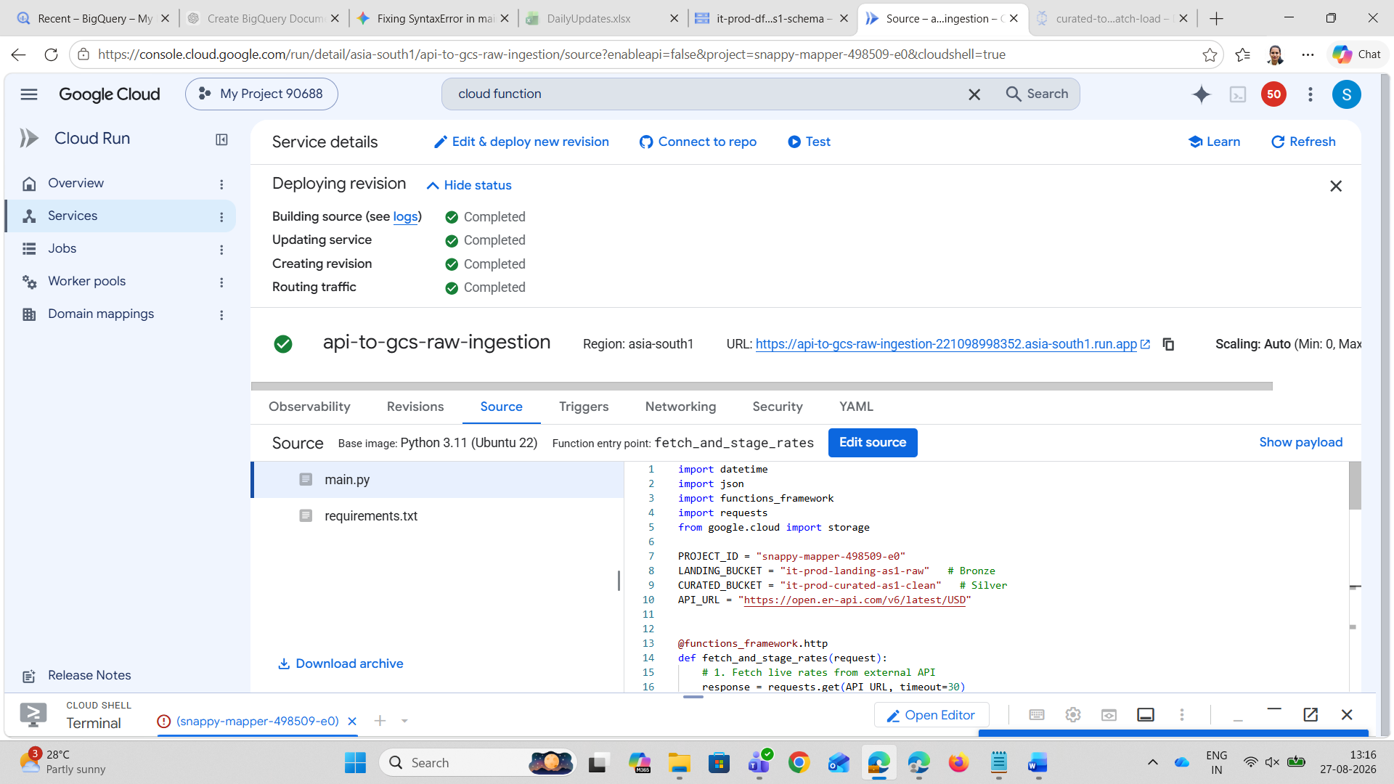
Step 5: Run Dataflow Job from Curated Zone to BigQuery (Web UI)
- Go to Navigation Menu (☰) > Dataflow > Jobs.
- Click + Create Job From Template:
  - Job name: curated-to-gold-batch-load
  - Regional endpoint: asia-south1 (Mumbai)
  - Dataflow template: Text Files on Cloud Storage to BigQuery (Batch)
- Enter the parameters (reading directly from the Curated bucket):
  - Cloud Storage Input File(s):
gs://it-prod-curated-as1/curated_events/*/*/*/*/*.json*
- Cloud Storage location of your BigQuery schema file:
gs://it-prod-df-scratch-as1/schema.json
- BigQuery output table:
snappy-mapper-498509-e0:analytics_lakehouse.currency_rates_gold
- Temporary directory for BigQuery loading process:
gs://it-prod-df-scratch-as1/temp
- Expand Optional parameters:
  - Temporary location: gs://it-prod-df-scratch-as1/temp
  - Service account email: 54903645206-compute@developer.gserviceaccount.com
  - Worker zone: asia-south1-a
  - Worker machine type: e2-standard-2
- Click Run job.
- Wait for the Dataflow job to finish with status Succeeded.
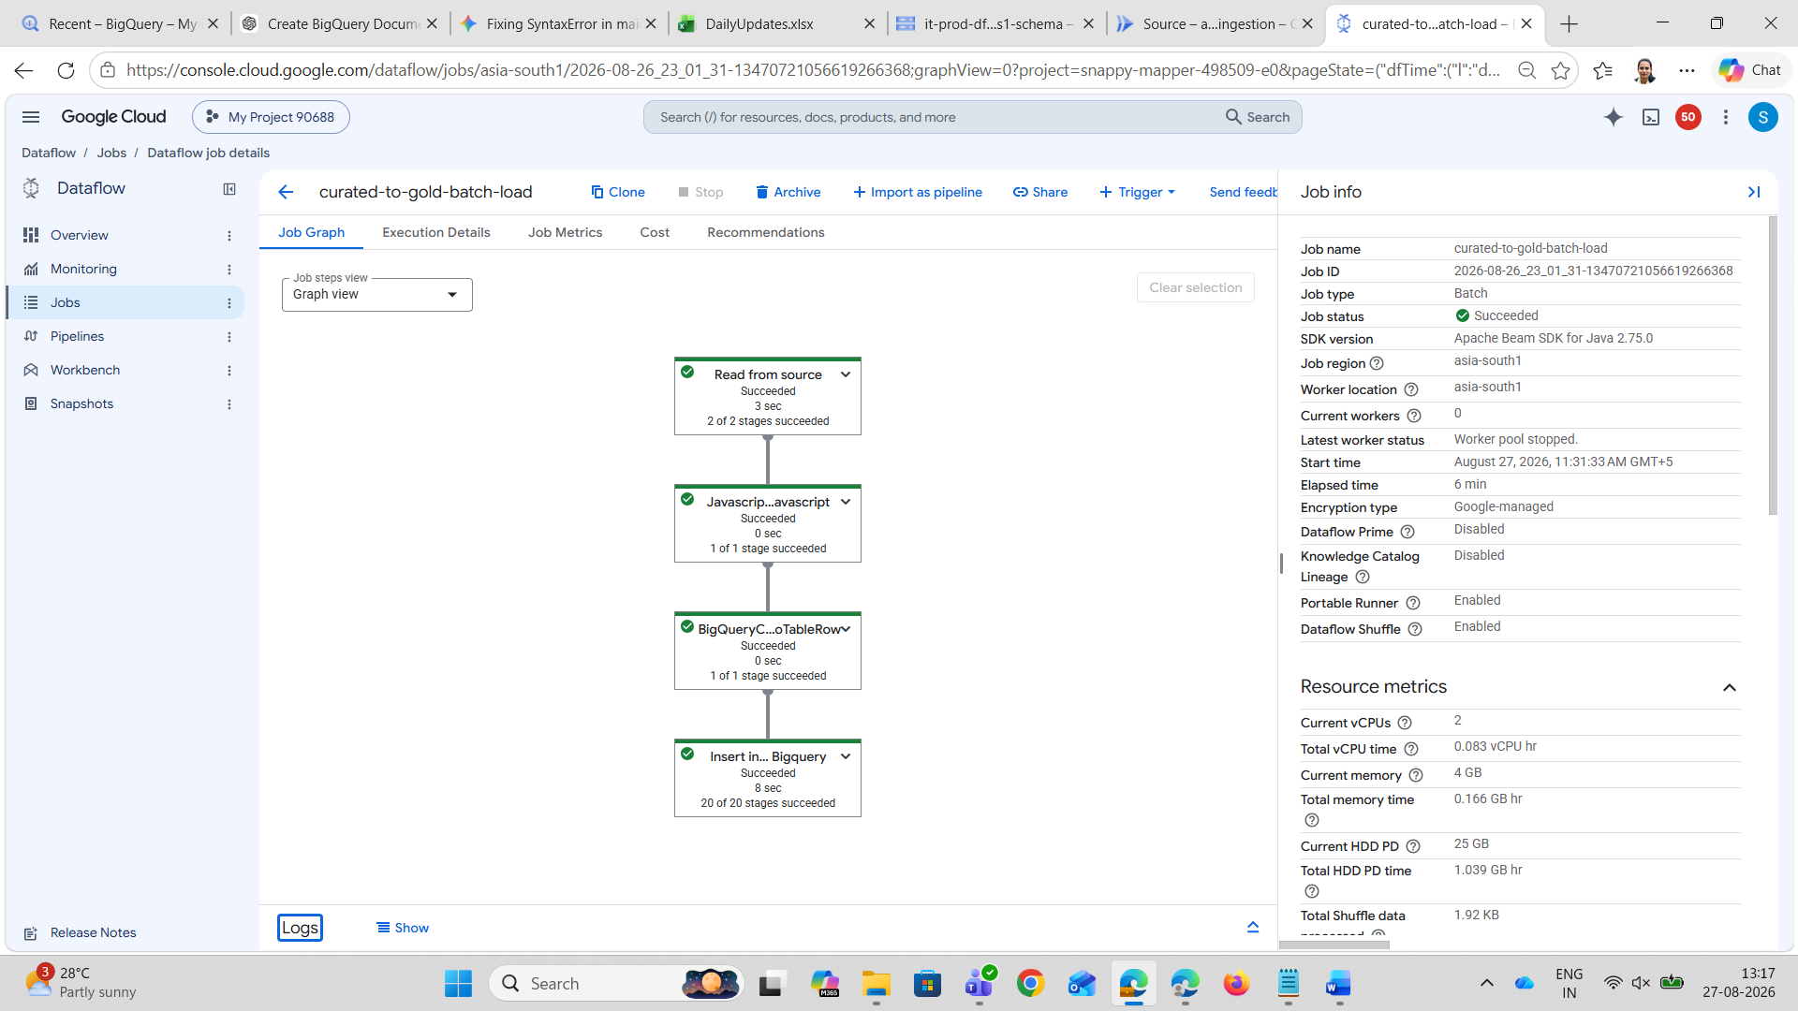
Step 6: Verify End-to-End Data Quality in BigQuery Studio (Web UI)
Open BigQuery > BigQuery Studio and run: Take the code from code documentation
This completes the true 3-tier architecture entirely through the GCP Web UI:
- Bronze (it-prod-landing-as1): Holds raw immutable API payloads.
- Silver (it-prod-curated-as1): Holds cleansed, validated, partitioned records.
- Gold (analytics_lakehouse.currency_rates_gold): High-performance analytical table.

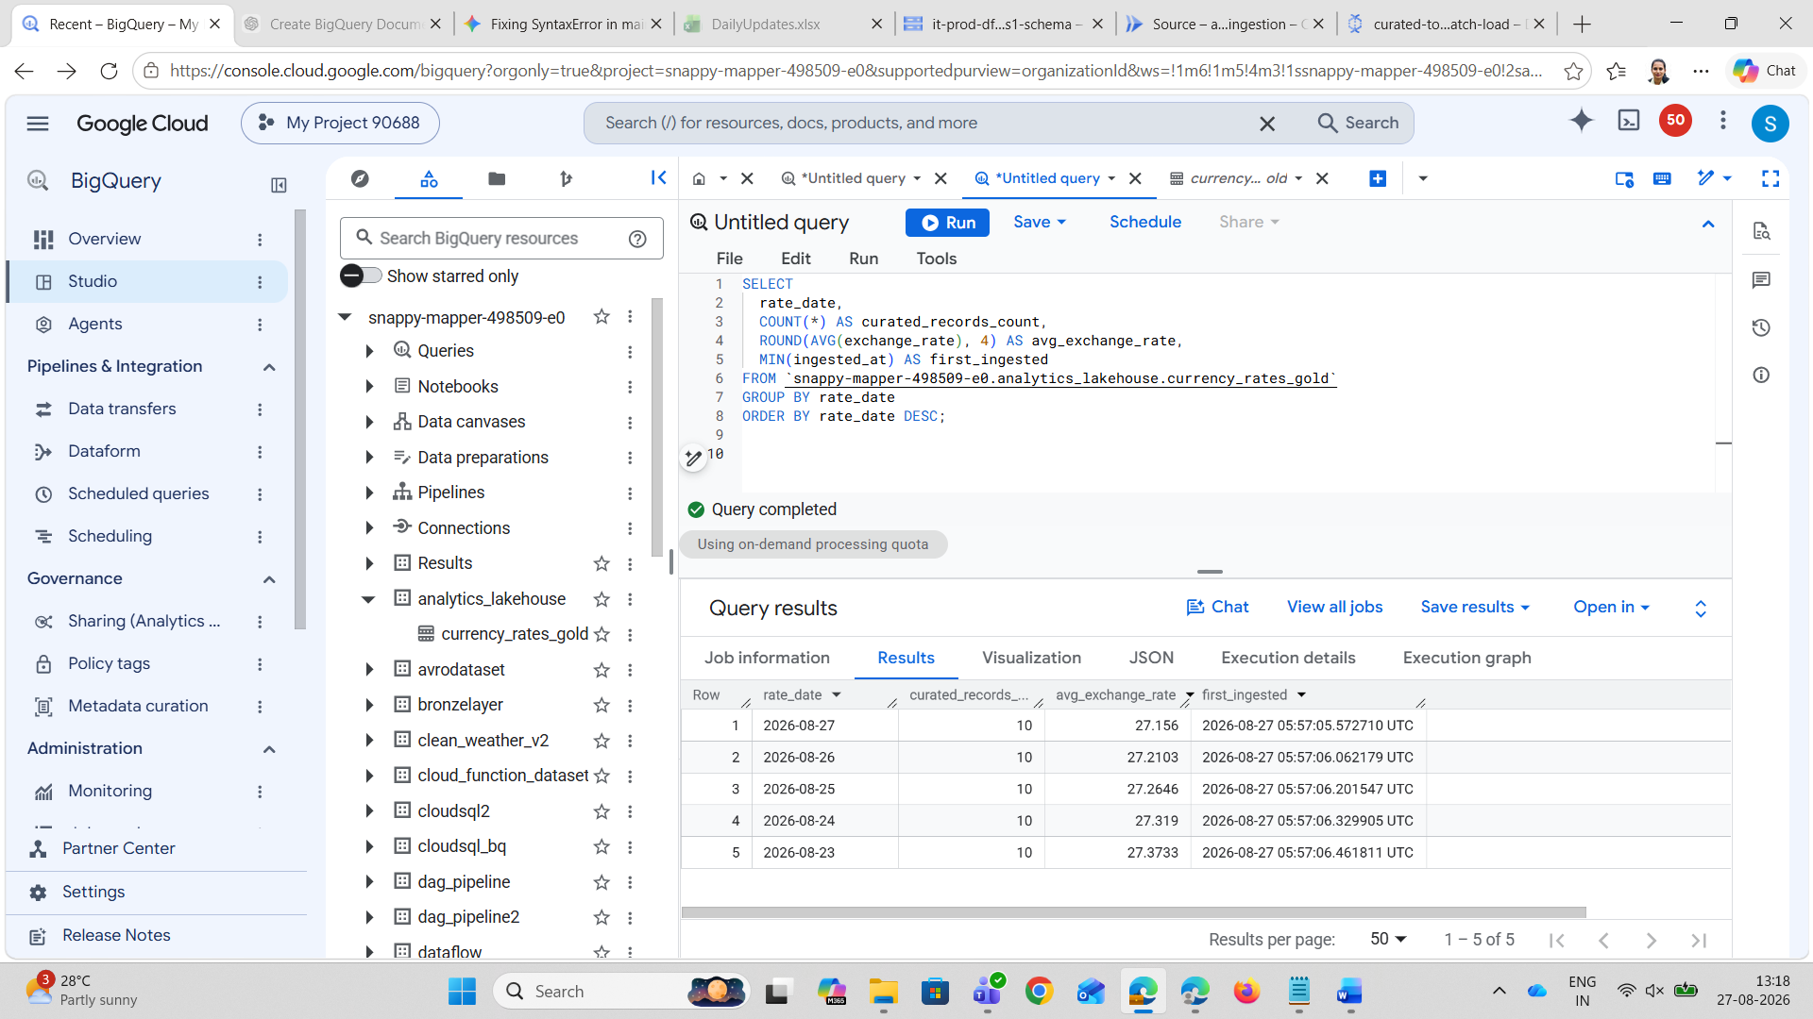
Step 7:
(Automation) mentioning Cloud Scheduler configured with an HTTP trigger (using OIDC token auth) to run the pipeline automatically on a daily cron schedule.

