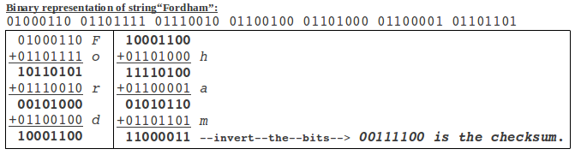
Caleb Faruki
Dr. Xiaolan Zhang
CISC3595 Data Comm & Networks
December 1, 2013
Homework 7
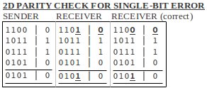
1.

For single-bit errors, using 2D parity checking, we can identify a single-bit error and correct it easily.

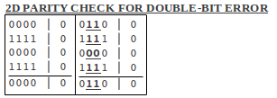

For double-bit errors, we can identify the column within which bad bits reside. However, without identifying the row in which parity does not check out, we cannot correct the bad bits.

2.
3. Consider the 7-bit generator, G=10011, and suppose that D has the value 1011001010. What is the value of R?

G = 10011
D = 1011001010
R = ?

G = r+1 bits, therefore, r = 4 bits.

Choose 4 bits such that <1011001010,R> is exactly divisible by G mod 2.

4. In this problem, we explore properties of CRC. For the generator G=1011, answer the following:
a. Why can it detect any 1-bit error in data D?
b. Can the above G detect any odd number of bit errors? Why?

5. Consider 3 LANs interconnected by 2 routers as shown in figure below:
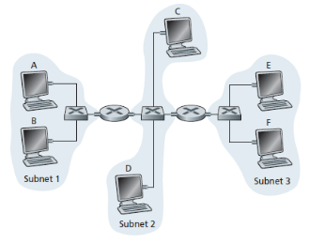
a. Assign IP addresses to all interfaces. For Subnet 1, use addresses of form 192.168.1.xxx; for Subnet 2, use 192.168.2.xxx; for Subnet 3 use 192.168.3.xxx.

b. Assign MAC addresses to all of the adapters.

c. Consider sending an IP datagram from Host F to Host B. Suppose all ARP tables are up-to-date. Enumerate all the steps, as done for the single-router example in Section 5.4.1.

d. Repeat (c), now assuming that ARP table in the sending host is empty (the rest are up-to-date)

e. Suppose Host A sends a datagram to Host F. Give the source and destination MAC addresses in the frame encapsulating this IP datagram as the frame is transmitted (i) from A to the left router, (ii) from the left router to the right router, (iii) from the right router to F. Also give source and destination IPs in the IP datagram encapsulated within the frame at each of these points in time.

6. Consider the following network setting:
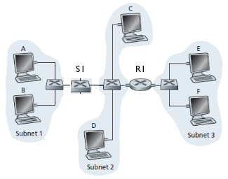
a. Consider sending an IP datagram from Host E to Host F. Will Host E ask router R1 to help forward the datagram? Why? In the Ethernet frame containing the IP datagram, what are the source and destination IP and MAC addresses?

b. Suppose E would like to send an IP datagram to B, and assume that E's ARP cache does not contain B's MAC address. Will E perform an ARP query to find B's MAC address? Why? In the Ethernet frame (containing IP datagram destined to B) that is delivered to router R1, what are the source and destination IP and MAC addresses?

c. Suppose Host A wants to send IP datagram to Host B, and neither A's ARP cache contains B's MAC address nor B's ARP cache contains A's MAC address. Further, suppose that switch S1's forwarding table contains entries for Host B and router R1 only. Thus, A will broadcast an ARP request message. What actions will switch S1 perform once it receives the ARP request message? Will router R1 also receive this ARP request message? If so, will R1 forward the message to Subnet 3? Once Host B receives this ARP request message, it'll send back an ARP request message back to Host A. But will it send an ARP query message to ask for A's MAC address? Why? What will switch S1 do once it receives an ARP response message from Host B?

