**LAB 1: PASSWORDLESS AUTHENTICATION:**

172.16.51.29 master

172.16.51.128 client

172.16.51.37 client1

**Step 1: resolve the hostnames in /etc/hosts**

**Step 2: Generate SSH key-pair in master**.

**> ssh-keygen -t rsa**

**Step 3: Copy the Public key to Remote Machines that is Client1 and Client2**

This can be done using the following command:

**>sudo ssh-copy-id msis@client**

**> sudo ssh-copy-id msis@client1**

**Step 4: Login into the remote machines and set permissions**

**ssh msis@client1"chmod 700 ~/.ssh && chmod 600 ~/.ssh/authorized_keys"**

**ssh msis@client"chmod 700 ~/.ssh && chmod 600 ~/.ssh/authorized_keys"**

**Step 3.1: Make sure to allow firewall to accept SSH traffic**

**Sudo ufw allow ssh (on both master and client)**

**Step 4: Test password less logins into the remote machines through ssh**

**_____________________________________________________________________________**

**LAB 2: NFS (NETWORK FILE SHARE):**

**172.16.51.29** **master**

**172.16.51.37** **client**

**Steps:**

**1.Set up NFS server on master machine:**  
On the host server, install the nfs-kernel-server package, which will allow you to share your directories.

**>sudo apt update**

**>sudo apt-get install nfs-kernel-server**

2)Creating a Directory to Share

**> sudo mkdir /var/nfs/test**

3) NFS will translate any root operations on the client to the **nobody:nogroup** credentials as a security measure. Therefore, you need to change the directory ownership to match those credentials.

**> sudo chown nobody:nogroup /var/nfs/test**

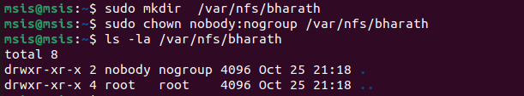

4)Opening the NFS exports configuration file in a text editor.

**> sudo nano /etc/exports**

5)Adding the Directory to Export in configuration

**>/var/nfs/test <target-ip>(type of permissions)**

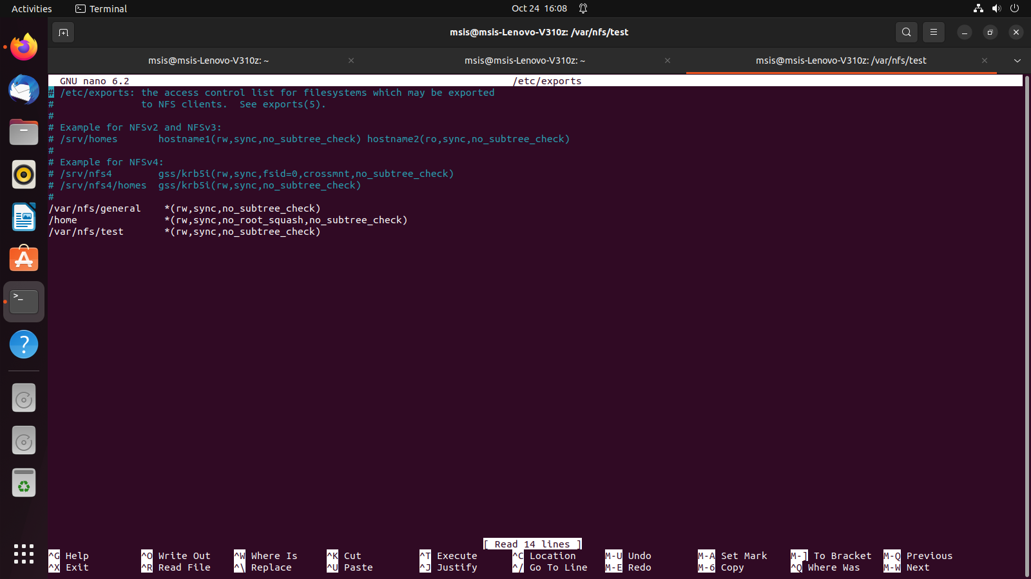

Use the below command to apply the changes in the exports file

**> sudo systemctl restart nfs-kernel-server**

**6) Adjusting Firewall Settings on the host**

Check if the firewall is enabled to accept nfs traffic,  
if not allow it using below command

**> sudo ufw allow from client_ip to any port nfs**

**7) Creating mounting points and directories on the client**

On the client server, we need to install a package called nfs-common

**>sudo apt update**

**>sudo apt install nfs-common**

**>sudo mkdir /mnt/nfs/tes**

**> sudo mount 172.16.51.65:/var/nfs/test /mnt/nfs/tes/**

**>df –h to check the mounts**

**___________________________________________________________________________**

**LAB 3: FREENAS INSTALLATION AND SETUP:**

## **1. Introduction**

FreeNAS, now known as TrueNAS CORE, is a powerful open-source network-attached storage (NAS) operating system based on FreeBSD. This document provides a step-by-step guide to install and set up FreeNAS in a VirtualBox environment.

## **2. Prerequisites**

* **Software Requirements**:
  + **VirtualBox**: Ensure you have the latest version of VirtualBox installed.
  + **FreeNAS ISO**: Download the FreeNAS ISO from the TrueNAS website.
* **System Requirements**:
  + At least **8GB of RAM** (more is recommended for optimal performance).
  + At least **20GB of disk space** for the FreeNAS installation.

## **3. Creating a New Virtual Machine**

### Step 1: Open VirtualBox

1. Launch **VirtualBox** on your system.
2. Click on **New** to create a new virtual machine.

### Step 2: Configure the VM

* **Name**: Enter "FreeNAS".
* **Type**: Select *BSD*.
* **Version**: Choose *FreeBSD (64-bit)*.

### Step 3: Allocate Memory

* Allocate at least **8GB of RAM(Recommended)** and click **Next**.  
  but we select 2GB due to system constraints
* Set **Processor** to at least two cores for better performance.

### Step 4: Create a Virtual Hard Disk

1. Choose **Create a virtual hard disk now** and click **Create**.
2. Select **VDI (VirtualBox Disk Image)** and click **Next**.
3. Choose **Dynamically allocated** storage.
4. Set the disk size to **16GB** or more and click **Create**.

## **4. Configuring Virtual Machine Settings**

### Step 1: System Settings

1. Click on **Settings** for the FreeNAS VM.
2. Under **System** > **Motherboard**, uncheck the **Floppy** option.

### Step 3: Network Settings

1. Go to **Network**.
2. Set **Adapter 1** to **Bridged Adapter** to allow network access. (as multiple IPs cannot be assigned to single port, as it's Blocked by network.)

## **5. Booting and Installing FreeNAS**

### Step 1: Start the Virtual Machine

1. Start the FreeNAS virtual machine.
2. When prompted, select **Install/Upgrade** to initiate the installation process.

### Step 2: Installation

1. Choose the **Virtual hard drive** created earlier as the installation target.
2. Confirm installation prompts and set a root password when prompted.

### Step 3: Reboot

1. Once the installation is complete, reboot the VM.
2. Remove the FreeNAS ISO from the virtual drive in the **Storage Settings** to avoid re-installation.

## **6. Initial Setup and Configuration**

### Step 1: Accessing the Web Interface

1. After rebooting, note the displayed FreeNAS IP address.
2. Open a web browser and navigate to http://<FreeNAS-IP-Address>.
3. Log in with the username root and the password set during installation.

### Step 2: Creating Storage Pools

1. In the FreeNAS dashboard, navigate to **Storage** > **Pools**.
2. Click **Add** to create a storage pool.
3. Select your virtual hard disk and configure the pool settings.

### Step 3: Configuring Network Shares

1. Go to **Sharing**.
2. Choose either **Windows (SMB)** or **Apple (AFP)** or **Linux(NFS)** or **WebDAV** shares based on your environment.
3. Specify the directory to share and set permissions.
4. Creating WebDAV: Select WebDAV from Sharing tab, and add new sharing, select the folder to be used the select save
5. Enable WebDAV service and configure it from services tab:  
   A screenshot of a computer

   Description automatically generated
6. Access ir using the <IP>:port/name of WebDAV sharing  
   Here 192.168.0.121/Neehar
7. Crating windows mount:

**Map the Network Drive**:

* In File Explorer, click on **This PC** in the left sidebar.
* Select **Map network drive** from the top menu.
* Choose a **Drive letter** you want to assign to the shared folder.
* In the **Folder** field, enter the network path:

1. Mounting NFS :

