# Test Automation

# <http://automationpractice.com/>

**BDD: Java Maven Cucumber Selenium Webdriver Setup**

Java + Junit + Cucumber + Selenium +Maven + Apache POI

This repo contains the Maven setup for Cucumber (BDD)-Selenium for scenarios to Register, Sign-in in <http://automationpractice.com/> .

**Design Pattern**: Page Object Model (***PageFactory***)

**Data Driven Approach:** Implemented using cucumber scenario outline and Apache POI utilities.

**Scenario Picked for testing:**

* User should be able to register using a valid email address
* While registering, if the email address is incorrect. User should see an error message

**Tags Used:**

@invalid_emailAddress @NegativeScenario

**Scenario:** Registering with invalid email address and email address already in use.

@valid_emailAddress @valid_registration @PositiveScenario

**Scenario:** Register with valid email address and other required details

**Folder Structure:**

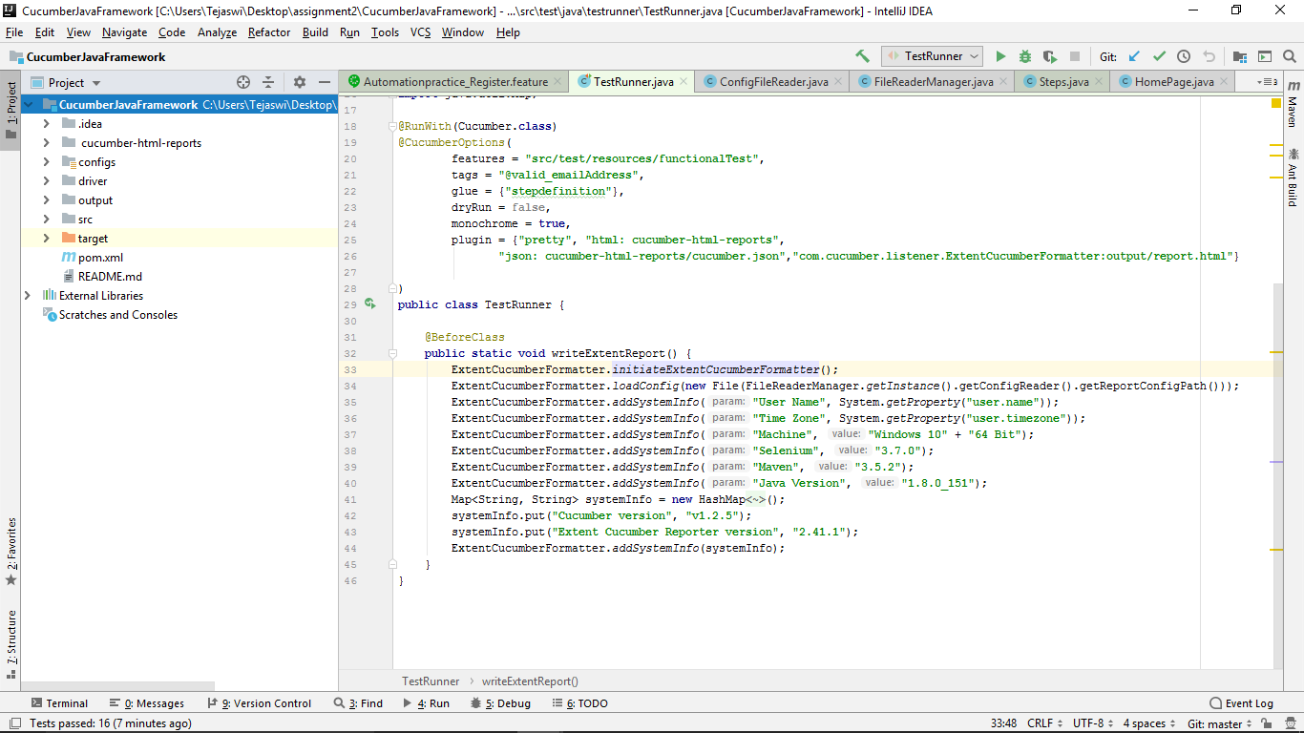 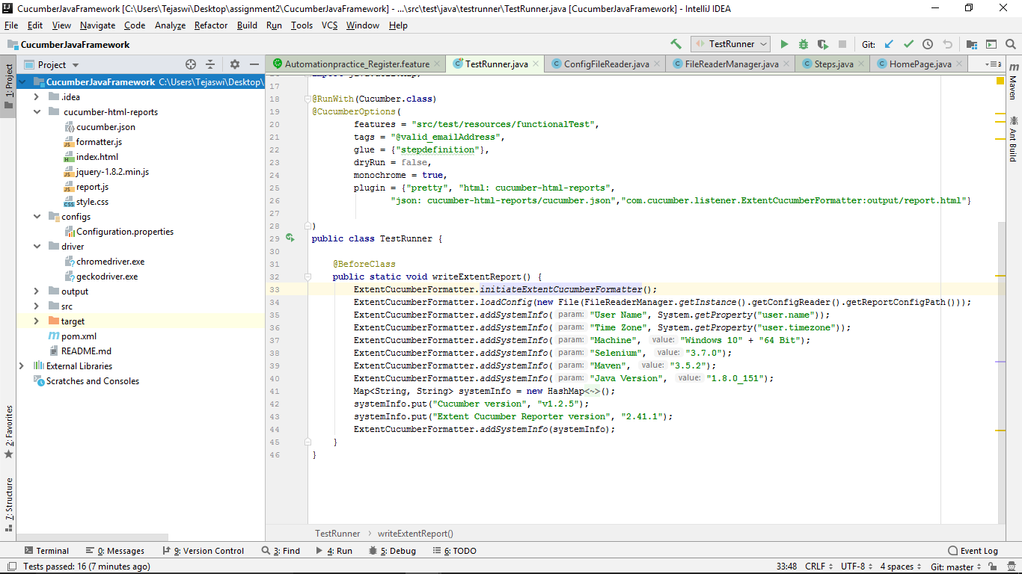

**Cucumber Html reports**

**Config file**

**Drivers**

**Overall Structure**

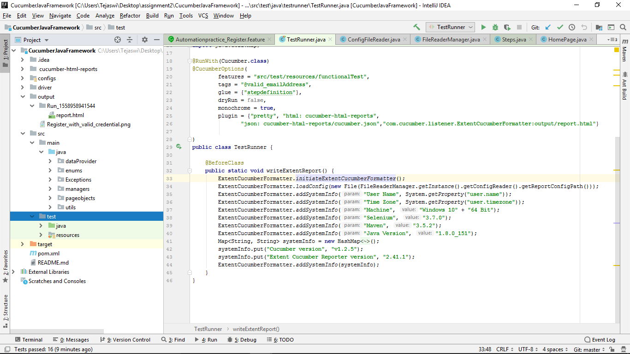 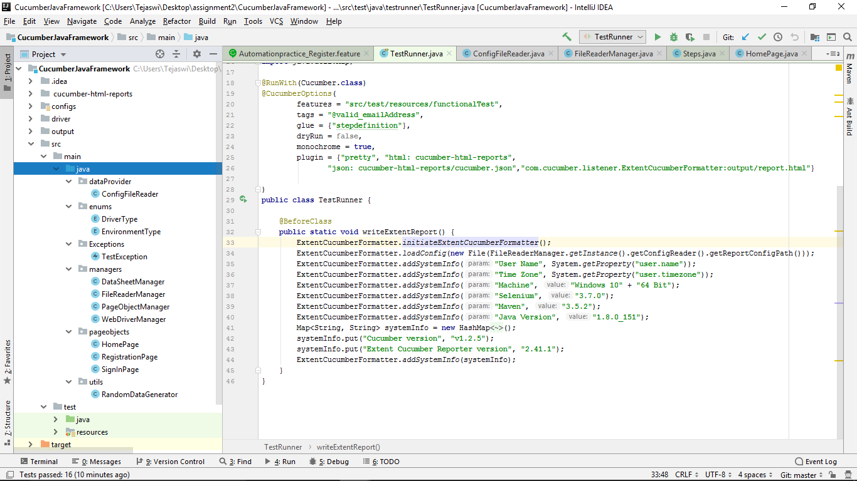

**Cucumber-extent Reports**

**Error Screenshots**

**Page Objects Model**

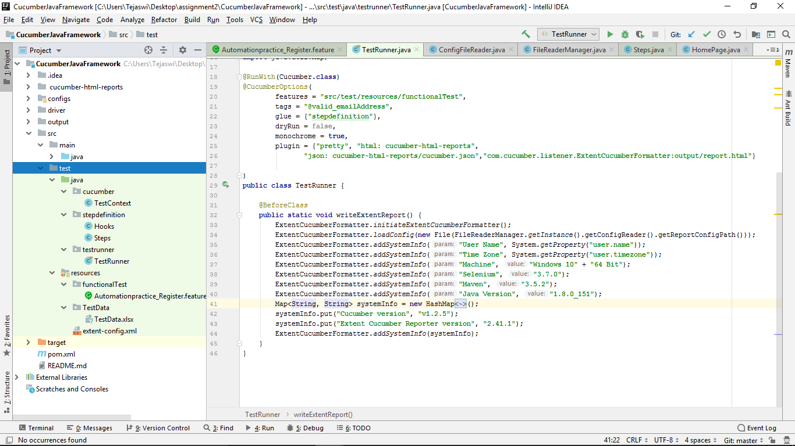

**StepDef and Hooks**

**Test Runner**

**Feature files**

**Test Data sheet**

**Page Objects Model**

**Setup**

**Install on Local Machine**

Install Java & Maven on your local machine

Git clone the below repo and set up the same in an IDE.

* [git@github.com:shetty4989/CucumberJavaFramework.git](mailto:git@github.com:shetty4989/CucumberJavaFramework.git)

**To Run** (Maven command line)

# enable profile id 'Browser_Chrome' with -P prod or -D browser=chrome

***mvn clean test -P Browser_Chrome***

***mvn clean test -D browser=chrome***

# enable profile id 'Browser_Firefox' with -P prod or -D browser=firefox

***mvn clean test -P Browser_Firefox***

***mvn clean test -D browser=firefox***

# Using **cucumber.options** to run a particular test-case(s) based on tag(s) dynamically

***mvn test -Dcucumber.options="--tags @invalid_emailAddress"***

#Clubbing above 2 configurations triggering @invalid_emailAddress scenario on firefox browser

***mvn test -P Browser_Firefox -Dcucumber.options="--tags @invalid_emailAddress"***

**Html Reporting**: Cucumber Inbuilt reporting + Cucumber Extent Reports

