PROJECT REPORT

ON

Analysis of Swiggy Food Delivery System
A Case-Based Comparative Study of Software Development Life Cycle Models in Food Delivery System

Submitted to

NMAM INSTITUTE OF TECHNOLOGY, NITTE
(Off-Campus Centre, Nitte Deemed to be University, Nitte - 574 110, Karnataka, India)

In partial fulfillment of the requirements for the award of the

Degree of Bachelor of Technology

in

INFORMATION SCIENCE AND ENGINEERING

By

Ashwith v Shetty | NNM24IS046

Under the guidance of

Dr. JASON ELROY MARTIS
Associate Professor


2025 – 2026
# Introduction

The creation of contemporary large-scale digital platforms that support millions of users concurrently depends heavily on software engineering. Digital services like online meal delivery services have become a necessary component of daily life due to the quick rise in smartphone usage and internet connectivity. By enabling customers to place food orders from restaurants without physically visiting them, these systems offer accessibility, efficiency, and convenience. One of the most popular and cutting-edge food delivery services in India among these systems is Swiggy.

The Swiggy Food Delivery System is a sophisticated, dispersed, and real-time software system that combines a number of technologies, such as database management systems, cloud computing, GPS tracking, mobile applications, and secure payment gateways. The system needs to process and manage thousands of users at once. orders in real time and guarantee dependable and safe transactions. To do this right we need to plan carefully. We have to design it put it into action and then make sure it keeps working. This is what the people who make software do. They have to be very careful when they make a program. The software engineering people have to plan, design, implement and maintain the software engineering.

The Software Development Life Cycle or SDLC gives us a way to make and manage software systems in a way. These methods help make sure that Software Development Life Cycle systems are good, safe and work well. We have Software Development Life Cycle models, like Waterfall, Incremental and Spiral. Each of these Software Development Life Cycle models has its way of managing software development and we choose one based on how complicated the system is, what it needs to do and what kind of risks it has.

The Swiggy Food Delivery System is the main subject of this report's SDLC model analysis. It looks at the software development processes, risk management techniques, system requirements, and emerging technologies. Additionally, the report assesses various SDLC models and determines which model is best suited for creating and managing the Swiggy system.
# Context
Swiggy was established in 2014 with the goal of streamlining food delivery services by utilizing digital platforms to link patrons and eateries. Before websites like Swiggy came along Food delivery services were only available to restaurants that handled their own Food delivery. This old way of doing things had some problems. For example you could not track your Food delivery in time. The people, in charge of Food delivery did not do a job of managing the deliveries. Also there were not restaurants to choose from. These were some of the downsides of this way of doing Food delivery services.

Swiggy changed the way food is delivered. They made a website that connects people who want to order food, restaurants and delivery people. When you want to order food from a restaurant you can do things like place an order pay for it in a way track where your food is and look at the menu. Restaurants can use a system to get orders change their menus and see what is happening with the orders. The people who deliver the food use an app on their phone that uses GPS to find the people who ordered food and get the orders to them. Swiggy made it easier for people to get food from restaurants.

The Swiggy system has a lot of parts that work together. There are applications, for customers and delivery partners. Then there are web applications that help with restaurant management. The Swiggy system also has servers that take care of order processing. It uses cloud infrastructure so it can handle a lot of users.. It has databases to store all the system data. All these things make the Swiggy system work smoothly and effectively for the Swiggy system.

The system has to deal with a lot of data. This includes customer profiles, restaurant menus order details, payment transactions and delivery tracking data. The system must always be available and secure. It also has to perform. If the system is slow or fails it can hurt the business. Make customers unhappy. The system has to handle customer profiles and restaurant menus and other data without any problems.

Principles of software engineering are essential for guaranteeing system performance and dependability. Developing such complex systems requires careful requirement analysis, system design, testing, and maintenance. Software development life cycle (SDLC) models offer organized methods for overseeing software development and guaranteeing system quality.

# Objectives
This report's main goal is to use software engineering principles and Software Development Life Cycle models to analyze the Swiggy Food Delivery System. The purpose of the report is to understand how large-scale software systems are made, used and taken care of in life. This report is about large-scale software systems. It wants to figure out how they work in practical settings, with large-scale software systems.

When we look at Software Development Life Cycle models like the Waterfall Model, the Incremental Model and the Spiral Model it is very helpful. Each Software Development Life Cycle model has its way of making software. The main goal of this report is to find the Software Development Life Cycle model, for the Swiggy system by looking at these Software Development Life Cycle models. The Swiggy system needs a Software Development Life Cycle model to be created and managed properly.

The report also wants to help us understand what the requirements engineering process is about. This process is, about figuring out what the software needs to do which is called requirements and what the software needs to be, which is called non-functional requirements. Understanding the requirements engineering process is another goal of the report. The report wants to make sure we know how to determine these non-functional requirements.

The system has a lot of features. These features include things like user registration, where a person can sign up to use the system. The system also allows people to order food, which's a big part of it. When people order food they need to pay for it so the system has payment processing. After the food is ordered and paid for the system lets people track the delivery of their food, which's really helpful.

The things that the system can do, like user registration and food ordering and payment processing and delivery tracking are what we call requirements.

The system also needs to be fast and safe and able to handle a lot of users which's what we call system performance and security and scalability and dependability. These are -functional requirements of the system.

The study also looks at ways to find out what people need like doing surveys talking to people and watching what they do. These things help the people who make the system really understand what the system needs to do and what the users need from the system.

I want to learn more about checking if the requirementsre correct. This includes things like testing and getting feedback from users. Checking the requirements is important because it makes sure the system works the way it should and that the users are happy, with it. Requirement validation is what we call this process. It is very important for the system to function properly and meet the user expectations of the system.

The study also looks at how DevOps techniques and Agile methodology can make software development more productive. Agile methodology allows for improvement and iterative development of software. This means that software developers can keep making software better and better. DevOps techniques make it easier to maintain systems monitor them and deploy software. DevOps techniques and Agile methodology are really important, for software development.

The report also looks at how new technologies like cloud computing, GPS tracking, and artificial intelligence can enhance system performance and user experience.
# Scope
This report's scope includes a thorough examination of the Swiggy Food Delivery System from the standpoint of software engineering. The report checks out the architecture, the way it was developed how it is maintained and what the system can do. It looks at the architecture and the development process. Also the maintenance tactics and the system functionality.

This report looks at the parts that make up a system like databases and backend servers and cloud infrastructure and mobile applications. These things all work together to make sure people get service they can count on. The report checks out how databases and backend servers and cloud infrastructure and mobile applications all do their job to deliver service.

The system requirements are looked at in the report. This includes things like user registration and restaurant browsing and food ordering and payment processing and delivery tracking. We also look at important things, like system security and performance and scalability and dependability of the system requirements.

This report looks at how good different SDLC modelsre for making the Swiggy system. We look at each Swiggy system model to see what is good, about it and what is not. We also check if the Swiggy system model can be used in situations and if it can handle problems that may come up. The Swiggy system models are checked for how they can manage risks too.

The study also looks at the methods that people use to develop software especially when it comes to checking if the requirements are correct and finding out what the requirements are, for software development.

The study also looks at cutting-edge technologies like cloud computing, GPS tracking, and artificial intelligence that are utilized in the Swiggy system.
# Methodology
This report's methodology entails examining software engineering concepts and using the Swiggy Food Delivery System as a case study. I got my information from documentation and research articles and online resources and software engineering textbooks. The information was gathered from documentation. I also looked at research articles and online resources. Software engineering textbooks were also used to gather the data. The data was gathered from these sources:

* documentation

* research articles

* online resources

* software engineering textbooks.

When we look at how they make software we see that some methods are better than others. We think about how they can adapt to changes handle problems that might come up and work with big systems. So we took a look at different SDLC models to see which ones are the best. We compared the SDLC models to find the ones that work the best for large-scale systems, like how they can change when needed and handle risks. The SDLC models were examined to see how well they fit with systems.

To understand how the system works and what it needs to do we looked at what the system needs. The system quality is defined by things that're not about what the system does but rather how it does it. On the hand the things the system can do are defined by what the system is supposed to do. We are talking about system functionality and system performance requirements when we talk about the system. The system quality attributes are important for the system. They are defined by the non-functional requirements of the system. The system features are also important, for the system. They are defined by the functional requirements of the system.

We looked at ways to gather what people need from a system. This includes things like sending out surveys talking to people, in interviews and watching how they do things. These methods help people who build systems figure out exactly what is needed. They want to make sure they get it right so the system works well for the people who will use it. The people who build systems use these techniques to gather the system requirements.

To make sure the system is correct we need to check if it does what it is supposed to do. We looked at ways to do this such as getting feedback from the users testing the system and testing a prototype of the system. This way we can see if the system is working the way it should be. We want to make sure the system is correct and we are doing this by using these requirement validation techniques, like user feedback, system testing and prototype testing.

System issues and risk management techniques are also covered in the report. In order to ensure system reliability and prevent system failures, risk management is crucial.

# Comparison and Analysis of Software Process Models

# Incremental Development Model
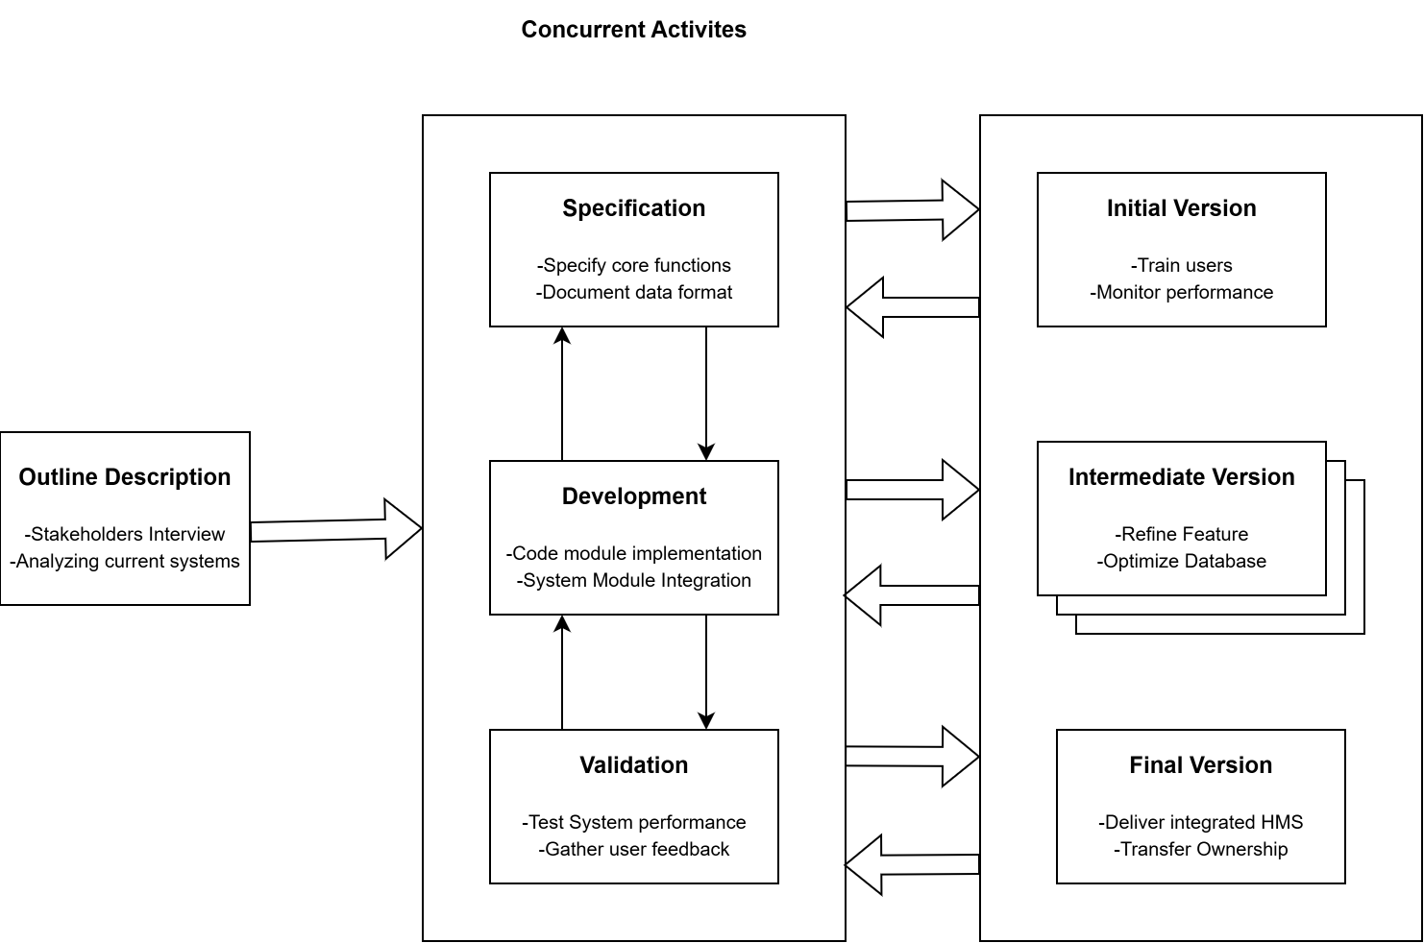

Functional Requirements: Because it enables software to be developed and delivered in smaller functional units known as increments, the incremental model is ideal for the Swiggy systemWhen the system gets an upgrade it can do things and has more features. For example the first upgrade might let users register and login. The next upgrade might let users look at menus and browse restaurants. The system might also get features like ordering food paying for it tracking deliveries and even giving users suggestions, for what to order. The system gets better with every upgrade like being able to track deliveries and make payments.

With this method, developers can produce functional software early on and make incremental improvements. While new features are being developed, users can begin using the system. This lowers development risks and raises user satisfaction.
Non-Functional Requirements: The Incremental Model permits developers to gradually enhance system security, performance, and scalability; developers can optimize system security and performance in later increments, ensuring continuous improvement of system quality;

Risk and Change Management: The Incremental Model effectively supports system updates and changes; Swiggy continuously adds new features, so this model offers flexibility and adaptability; Time and Cost Constraints: The Incremental Model permits faster software deployment and lowers development risks; it also permits better resource management.

Advantages:
* Flexible development approach
* Early delivery of functional software
* Supports system updates and improvements

Disadvantages:
* Needs careful planning and design
* Integration of increments may be complex

# Spiral Model:
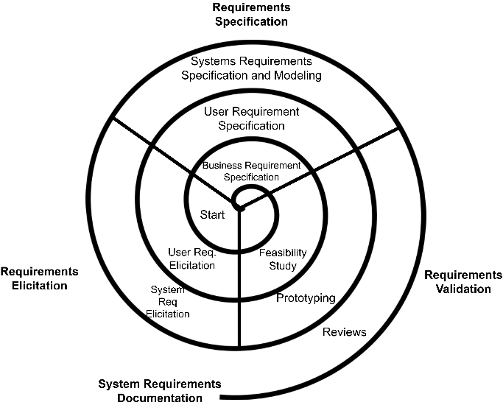
Applicability of the Swiggy Food Delivery System
Functional Requirements:
Continuous improvement and iterative development are encouraged by the Spiral Model. It enables developers to construct the system over several iterations. Requirement analysis, design, implementation, and testing are all included in each cycle.
Non-functional Requirements:
Through ongoing testing and validation, the Spiral Model enhances system performance, security, and dependability.
Management of Risk and Change:
Risk management is a major component of the Spiral Model. Early in the development process, developers recognize and control risks. Systems that handle sensitive data and real-time transactions, like Swiggy, require this.
Cost and Time Restraints:
The Spiral Model guarantees high-quality software development despite its higher cost.
Benefits:
* Outstanding risk control
* Superior software development* An adaptable and iterative methodology
Drawbacks:
* Pricey
* Difficult to handle

# Waterfall Model: 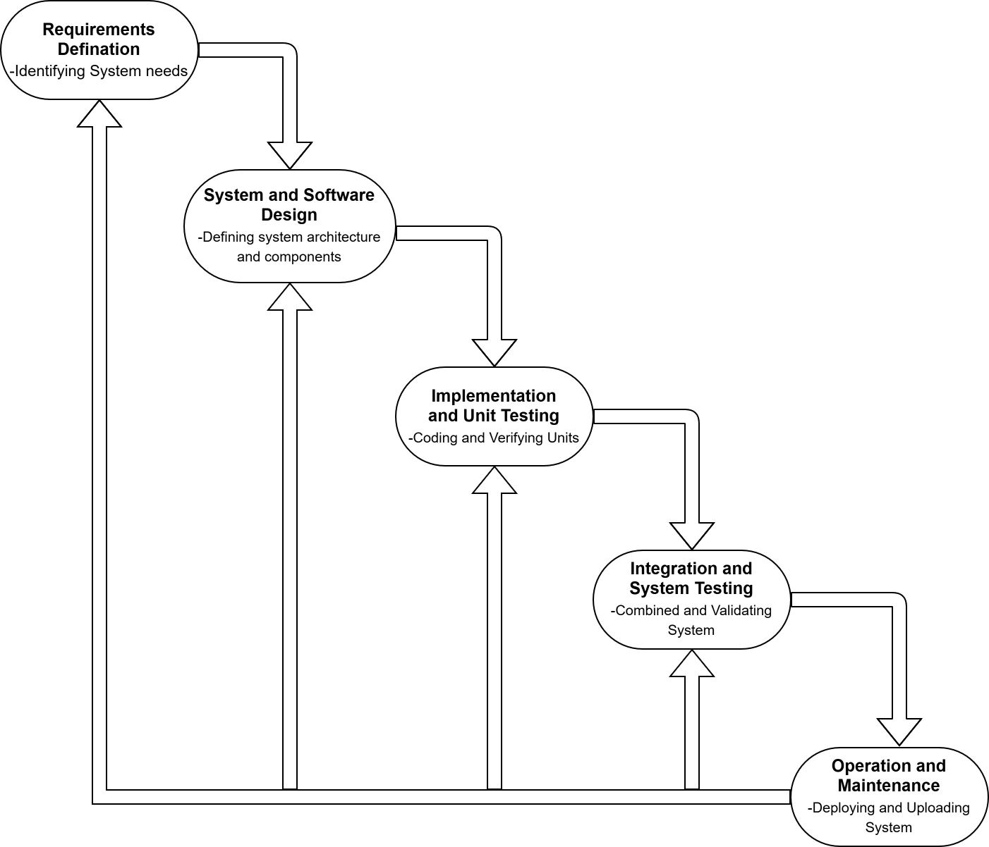

Applicability of the Swiggy Food Delivery System
Functional Requirements:
The Waterfall Model employs a step-by-step development methodology. Before going on to the next phase, each one must be finished.
Non-functional Requirements:
The Waterfall Model guarantees organized development and appropriate documentation.
Management of Risk and Change:
Frequent changes are not supported by the Waterfall Model.
Cost and Time Restraints:
Modifications could lengthen the time and cost of development.
Benefits:
* Clear-cut and simple to comprehend
* A methodical approach
Drawbacks:
* Not adaptable
* Changes that are hard to implement # Requirements Engineering Process # Simplified Requirements Document

# Requirements Engineering Process

# Simplified Requirements Document
Functional Requirements: System features and operations are defined by functional requirements. Users must be able to sign up, log in, browse restaurants, place orders, pay, and follow deliveries through the Swiggy system.
Non-functional Requirements: Performance, security, scalability, and dependability are examples of system quality attributes that are defined by non-functional requirements.

# Techniques for Eliciting Requirements:
Gathering system requirements from stakeholders, including clients, developers, and company managers, is known as requirement elicitation. Interviews aid in comprehending the needs of users. Many users' opinions are gathered through surveys. Observation aids in the comprehension of system usage trends.
These methods guarantee precise requirement identification.
# Techniques for Eliciting Requirements:
Gathering system requirements from stakeholders, including clients, developers, and company managers, is known as requirement elicitation. Interviews aid in comprehending the needs of users. Many users' opinions are gathered through surveys. Observation aids in the comprehension of system usage trends.
These methods guarantee precise identification of requirements.
# Potential Challenges:
Performance problems, security threats, and system scalability are some of the difficulties the Swiggy system faces. System overload may result from high user traffic. User data may be compromised by security threats.
Risk management and system design must be done correctly.

# Overcoming Obstacles:
System scalability is enhanced by cloud computing. User data is protected by secure payment systems. System problems are found and fixed by system monitoring.
System dependability is ensured by proper maintenance.
# Extending the Considerations of the SDLC:
Agile methodology increases the flexibility and speed of development. DevOps enhances system maintenance, monitoring, and deployment.
System efficiency is increased by these procedures. # Integration with Emerging Technologies
Food recommendations are enhanced by artificial intelligence. Performance and scalability are enhanced by cloud computing. GPS tracking increases the precision of deliveries.
The functionality of the system is improved by these technologies.

# IoT (Internet of Things):
The term "Internet of Things" (IoT) describes a network of physically connected objects that use sensors and internet connectivity to gather and share data. Smartphones, GPS trackers, smart sensors, and connected cars are examples of IoT devices.

Internet of Things or IoT for short is really good at collecting and checking data as it happens. IoT devices are very helpful in keeping an eye on the people who deliver food and the conditions they deliver in. This makes the process of delivering food more efficient for companies like Swiggy. IoT devices make it easier for these companies to keep track of things. IoT is very useful in food delivery systems, like Swiggy.

Internet of Things devices give us information all the time and they talk to the servers that are, behind the scenes. This means we can see what is going on in the system and make choices because Internet of Things devices are always telling us what is happening.

Automation, efficiency, and system intelligence are all enhanced by IoT. It aids companies in performance enhancement, user experience improvement, and operation monitoring.
# Internet of Things Applications in the Swiggy Food Delivery System:
Tracking Deliveries in Real Time: Delivery partners can be tracked in real time thanks to IoT devices like GPS trackers Customers can use applications to see where their stuff is being delivered. This makes customers trust the company more because they can see the delivery location. Customers like to know where their things are and when they will get them so mobile applications are very helpful, for this.

The Internet of Things makes it possible for companies to pick the delivery people for each job. They do this by looking at how important the delivery's where it needs to go and what the traffic is, like. This means that deliveries get done faster and people can do work in the same amount of time. The Internet of Things really helps with delivery management.

Vehicle Surveillance is really important. It helps us keep an eye on how our vehiclesre doing. We can see how well they are performing how fuel they are using and when they need to be fixed. We use sensors to get all this information. These sensors are connected to the internet so we can see everything that is going on with our vehicles. This helps us save money because we do not have to spend much on fuel and repairs. It also helps keep our delivery partners safe which is very important, to us. Vehicle Surveillance is a deal because it helps us take good care of our vehicles and the people who drive them.

Monitoring of Temperature: When food is being delivered the temperature of the food can be checked by Internet of Things sensors. This ensures that the food is safe to eat and that it is quality. The temperature of the food is very important so the Internet of Things sensors are used to monitor the temperature of the food during delivery.

System Surveillance: Real-time system performance data is provided by IoT devices. This aids developers in swiftly locating and fixing system problems.
# Data Security Using Blockchain Technology:
Data can be safely stored and managed with blockchain, a distributed and secure digital ledger technology. Blocks of data are put on a blockchain. These blocks of data are then connected to each other by codes called cryptographic methods. This is what makes the blockchain work with the blocks of data. The blocks of data, on the blockchain are really important because they are connected in a way using these cryptographic methods.

Blockchain technology is very safe because the data, in it cannot be easily changed or deleted. This makes the system more trustworthy. It also prevents people from messing with the data. Blockchain technology really helps to keep the data secure. That is why people trust the system more. The fact that blockchain technology stops people from altering the data is a deal.

The thing about blockchain technology is that it is not controlled by one entity. This means that the data is stored in different places. So when we talk about blockchain technology we can see that it is really good for keeping our data safe and making sure that the data is always available. This is because the data in blockchain technology is not just, in one place.

Blockchain enhances digital systems' security, trust, and transparency.
# Blockchain Applications in the Swiggy Food Delivery System:
Processing Payments Securely: Payment transactions can be made securely and transparently with blockchain technology This makes sure that people can buy things without worrying about their money. It also helps to stop people from taking money that does not belong to them. This is what guarantees financial transactions and stops payment fraud.

Data Protection: We keep things like what you have bought how you paid for it and your personal details safe, with the help of blockchain. The blockchain is what protects your order history, your payment information and your customer information.

Order Monitoring is really helpful. It lets us see what is happening with our orders. This is because of blockchain technology. We can keep a record of everything that happens in the system. It is safe. Order Monitoring makes sure that we can track our orders easily.

Verification of Identity: The Blockchain is really good at stopping fraud. It can also confirm that delivery partners are who they say they are. The Blockchain helps to make sure that delivery partners are genuine and it does this by checking their identity. This is a help because it stops people from pretending to be someone they are not. The Blockchain and its ability to verify identity is very useful, for stopping fraud and confirming the identity of delivery partners.
Transparency in the Supply Chain: Blockchain can monitor the delivery and preparation of food. Food quality and safety are enhanced as a result.

# Different Life Cycle Models for Software Development:
Software development also makes use of other SDLC models, including the Prototyping Model, V-Model, and RAD Model, in addition to the Waterfall, Incremental, and Spiral models.
These models offer various development methodologies according to the complexity and requirements of the system.

# Model Prototyping:
Prior to starting full development, a functional prototype of the system must be created using the Prototyping Model. An early iteration of the system that exhibits functionality is called a prototype.
Prototypes are made by developers using the original specifications. Users give feedback and test the prototype. Based on user feedback, developers make improvements to the system.
Developers can better grasp system requirements with the aid of this model.
Benefits:
* Enhances comprehension of requirements
* Lowers the risks of development
* Increases user participation
* Aids in the early detection of system problems
Drawbacks:
* Could raise the cost of development
* More work is needed to develop prototypes.
* A poorly designed prototype could have an impact on the finished system.
Swiggy applications:
Mobile applications and other user interface elements can be designed using the prototyping model. Prior to final development, developers can generate prototype applications and gather user feedback.

# Verification and Validation Model, or V-Model:
The Waterfall Model is expanded upon by the V-Model. At every stage of development, it emphasizes validation and verification.
Verification guarantees the system's proper development. Validation guarantees that the right system is created.
There is a testing phase for every stage of development.
Benefits:
* Enhances the quality of the system
* Early identification of flaws in the system
* A rigorous testing methodology
* Assures dependable software
Drawbacks:
* Less adaptable
* Difficult to manage changes in requirements
* Costly for intricate systems
Swiggy applications include: Payment systems, database systems, and backend servers are among the system components that can be tested using the V-Model. It guarantees the accuracy and dependability of the system.

# Rapid Application Development Model, or RAD Model:
Rapid prototyping and reusable components are key components of the RAD Model, which emphasizes quick software development.
Rapid system development and deployment are key components of this model.
To create software fast, developers utilize pre-built components.
Benefits
* Quick development
* Better user reviews
* Less time spent developing
* Great adaptability
Drawbacks:
* Needs knowledgeable developers
* Unsuitable for extremely large systems
* Needs careful preparation
Swiggy applications include:
Mobile application features like ordering, tracking, and restaurant browsing can be developed using the RAD Model.

# Conclusion:
Due to its size and complexity, the Swiggy Food Delivery System necessitates the use of appropriate software engineering techniques. Software development life cycle (SDLC) models offer organized methods for software development management.
The Spiral Model offers superior risk management, flexibility, and continuous improvement, making it the most appropriate of the various SDLC models. System performance, scalability, and dependability are guaranteed by software engineering.
The Swiggy system's long-term success is guaranteed by the appropriate application of emerging technologies and SDLC models.

# Appendix:
# Tools for Requirements Management:
Developers can better manage, monitor, and assess system requirements with the aid of requirements management tools.
Among the examples are:
JIRA:
JIRA is a popular tool for managing projects, tracking requirements, and tracking bugs.
Rational Doors by IBM:
This tool facilitates the management of intricate system documentation and requirements.
Trello:
Trello is used to track requirements and manage projects.
DevOps on Microsoft Azure:
This tool facilitates process management for development, testing, and deployment.
These tools increase the effectiveness of requirement management and system development.

## Glossary:
Engineering Software:
software development using engineering principles.
SDLC:
The life cycle of software development is really important. It tells us about the stages that software development goes through. The life cycle of software development is, like a map that shows us what to do when we are making software.

The stages of software development are part of the life cycle of software development. We need to follow these stages to make sure our software is good and works well. The life cycle of software development helps us do this.

A prerequisite:

Something that a system needs to work is called a requirement. A system has things that it cannot function without these things are requirements. The system requires these things to be, in place so that it can do what it is supposed to do. The requirement is a feature or condition that the system needs.

Functional Need:

The system has a lot of features. This tells you what the system can do. The system is very useful because of its features. The features of the system are what make it work well. The system has things that it can do and these are its features.

Non-functional prerequisite:
outlines the quality and performance characteristics of the system.

Cloud computing:
offers computer services via the internet.
The concept of artificial intelligence
This thing called technology helps machines act like they are smart like people. It makes machines able to do things that usually people do. Technology like this is really good, at making machines mimic intelligence.

IoT:
We have a network of devices that are all connected to each other. These devices share information with one another. The network and the devices in it work together to make this happen. The network and the devices are really good, at sharing information.

Blockchain:
The digital ledger is a kind of technology. This technology is digital. It is distributed. The digital ledger technology is also very secure. We are talking about the ledger technology here. It is a technology that's good, at keeping things safe. The digital ledger technology is secure.

The prototype
software system in its early stages.

Validation:
makes sure the system is constructed correctly.
Verification:
makes sure the right system is constructed.
Model RAD:
Model for Rapid Application Development.

# Reference:
1. Bruce R. Maxim and Roger S. Pressman. A Practitioner's Perspective on Software Engineering. McGraw-Hill Education, 8th Ed., 2015.
2. Ian Sommerville. Software Engineering. Pearson Education, 10th Ed., 2016.
3. Ian Sommerville and Gerald Kotonya. Methods and Strategies for Requirements Engineering. Publications, Wiley, 1998.
4. Pankaj Jalote. Software Engineering: An Integrated Approach. Springer, Third Edition, 2005.
5. Alan Dennis, Roberta Roth, and Barbara Haley Wixom. Design and Analysis of Systems. Wiley, 2015, 6th Ed.
6. The IEEE Computer Society. IEEE Press, 2014; Guide to the Software Engineering Body of Knowledge (SWEBOK).
7. Sommerville, Ian. Case Studies and Notes on Software Engineering, Pearson Education.
8. The official Swiggy website.
9. Amazon Web Services (AWS) is accessible at: [https://www.swiggy.com](https://www.swiggy.com). Concepts and Services of Cloud Computing. accessible via [https://aws.amazon.com/what-is-cloud-computing/](https://aws.amazon.com/what-is-cloud-computing/)
10. Documentation of Google Cloud.
11. Microsoft Azure Documentation can be found at [https://cloud.google.com/docs](https://cloud.google.com/docs). [https://learn.microsoft.com/en-us/azure/](https://learn.microsoft.com/en-us/azure/)
12. Nakamoto, Satoshi. Bitcoin: A Peer-to-Peer Electronic Cash System, 2008. (See Blockchain)
13. Information on IBM Blockchain. accessible at: [https://www.ibm.com/blockchain]
14. Oracle: Database Concepts and Architecture (https://www.ibm.com/blockchain). Software Engineering Research Papers, IEEE Xplore Digital Library, is accessible at: [https://docs.oracle.com](https://docs.oracle.com). accessible at: [https://ieeexplore.ieee.org](https://ieeexplore.ieee.org)
15. Overview of Software Development Life Cycle Models by Gartner Research. accessible at: [https://www.gartner.com]
16. Cisco (https://www.gartner.com). An Overview of the Internet of Things (IoT). GeeksforGeeks: Software Engineering and SDLC Tutorials is accessible at: [https://www.cisco.com](https://www.cisco.com). Accessible via: [https://www.geeksforgeeks.org/software-engineering/]TutorialsPoint. Software Engineering and SDLC Models (https://www.geeksforgeeks.org/software-engineering/)
17. The following URL is accessible: [https://www.tutorialspoint.com/software_engineering/](https://www.tutorialspoint.com/software_engineering/)
18. Martin Fowler. Agile Software Development Practices and Principles. obtainable at: [https://martinfowler.com](https://martinfowler.com)

