Similar for both Linked List and Doubly Linked List according to my code implementation

In Bubble Sort the

No. of Exchanges<=No. of Comparisons (because each time the comparison is made, but only when the prior element is greater than the later element will the exchange/swap happen.) So number of Comparison will be equal to or greater than No of exchanges in each scenario.

Suppose input is (i=1)

47031 25153 12485 13150

Comparison 1:

47031>25153 if True then Exchange

Exchange 1:

Position 1: 25153

Position 2: 47031

After swap 1

25153 47031 12485 13150

Comparison 2:

47031>12485 if true then exchange

Exchange 2:

Position 2: 12485

Position 3: 47031

After swap 2

25153 12485 47031 13150

Comparison 3:

47031>13150 if true then exchange

Exchange 3:

Position 3: 13150

Position 4: 47031

After swap 3:

25153 12485 13150 47031

Now the for loop has done 1 pass and the largest element will be in it place.

In next iteration(i=2)

Again it will start comparing from position 1 upto position n-pass(ie.4-1)

Comparison 4:

25153>12485 if true then exchange

Exchange=4

Swapped elements on their positions

12485 25153 13150 47031

Comparison 5:

25153>13150 if true then exchange

Exchange =5

Swapped elements on their positions

12485 13150 25153 47031

Next iteration i=3

Comparison 6

12485>13150 if true then exchange

But here the exchange won’t happen since condition is false

So we have are sorted list as follows:

12485 13150 25153 47031

So total no of exchange was 5 and the comparison will be always greater than or equal to the no. of exchanges.

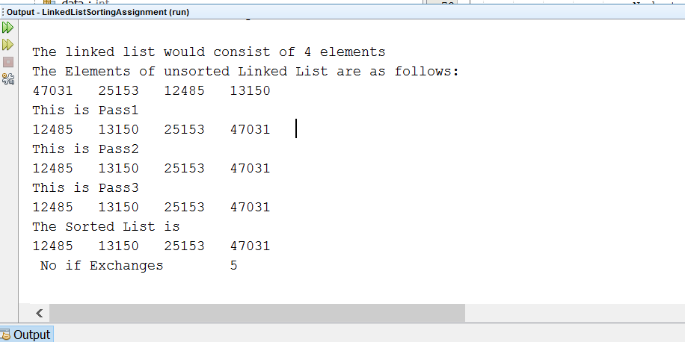

Node Traversal

If there are N items in the LinkedList /Doubly LinkedList

The first time we traverse all the N(size) nodes while comparing each one with the other.

Next time it will be N-1 (size-pass)

Next time it will be N-2 and it goes on till it becomes N-N(pass=N)