<doc_instructions>

<analysis>

Task: Creative Pattern Mining

Level: Mid-level Abstraction

Scope: Ideation Reference

Instructions:

- Analyze the approved ideas to extract creative insights, idea structures, humor styles, and visual storytelling patterns.

- Identify recurring themes, tonality, and engagement devices that led to approval.

- Summarize these learnings clearly and suggest **new fresh idea prompts** aligned with the patterns but not repetitive.

- Treat this document as a **positive benchmark** to inform and inspire future creative generation.

</analysis>

</doc_instructions>

**Britannia Croissant | Feb Content 2025**

**Hygiene Posts**

**Concept 1:** Pushing the product through a humorous format.

**Format:** Reel

**Visual:** A person holding a croissant in their hand. The copy is on the top center of the visual.

**Visual reference:** <https://www.instagram.com/reel/C9SgNXBR3m1/?igsh=eDVkcG1sbHh4anZp>

**Copy:**

This is a cookie. If you see a croissant, then you love me.

**Concept 2:** Pushing the product as people’s favourite, in a humorous way.

**Format:** GIF

**Visual:** A close-up shot of a person’s / cat’s face with its pupils dramatically dilating until they’re almost fully black. In the reflection of its eyes, we then show Britannia Croissant.

**Visual reference:** <https://tenor.com/view/%C5%9Fa%C5%9Fk%C4%B1n-gif-19746690>

**AI assistant VO + Copy:** Pupils can expand by 55% when you see something you love

**Concept 3:** Moms usually treat guests' kids with chocolates or snacks that are dear to you, without even asking. Using this insight, we create a humorous reel.

**Format:** Reel

**Visual:** We see three cats: one is a smiling mom with a bindi, dupatta, and sindoor; the second is an angry child with a cap and a watch; and the third is a grinning baby cat with an empty Britannia croissant wrapper. In the background, a living room is set with snack plates. The copy is at the top.

**Visual reference:** <https://www.instagram.com/reel/DD9Zy6FzoKC/?igsh=djFjcDFzN2d1cWZi>

**Audio reference:** <https://www.youtube.com/shorts/36W2N-lPyIk>

**Copy:**

Guests ka bachha mummy ko cute lag gaya

(mera chupaya hua snack usse de diya)

**Concept 4:** Even when we have snacks at home we get attracted to ordering. Using this insight we integrate our product.

**Format:** Reel

**Visual:** We see a person lazying on a sofa scrolling through dessert options to order from, as the camera pans to a croissant packet that has an eyes and mouth filter applied and is lipsyncing to the audio.

**Audio reference:** <https://www.instagram.com/reel/DDw4e4RzHKg/?igsh=MWNrMHE1N2lxdXRhcg%3D%3D>

**Wall copy:** Can’t skip. Won’t skip!

**Concept 5:** Pushing the product through a fun reel format.

**Format:** Reel

**Visual:** We see a screen split into two halves. On the left side, we see a blank white screen and on the right side, we see a skinny guy's torso taped with two croissants as abs. The audio comes as a copy. The question comes on the blank screen and the answer comes on the right side.

**Visual reference:** <https://www.instagram.com/reel/DEXZnPTyA1f/>

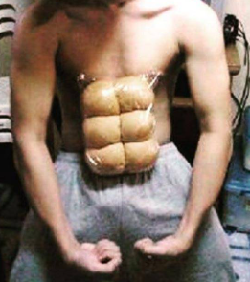

**Audio reference:** <https://www.instagram.com/reels/audio/1075265067617241/>

**Left-side copy:**

Toh bade bhai🤔💭

Yeh jo size hai aapka💪🏻✨

Woh steroids se hai ya

Natural hai?💉🫣

**Right-side copy:**

Nahi bhai genetics hai🧬

Bas thoda bohot liya jata hai💉🙈

Woh sabhi chalta hai🛺

Par kaafi time hogaya hard work karte huye🤸🏻‍♂️

Apna laga rehta hu🏋🏻‍♂️

Logo ko lagta hai kuch inject kiya💉

Par abhi kuch nahi🙈🫶🏻

**Concept 6:** Pushing the product through a fun reel format.

**Format:** Reel

**Visual:** We see a person sitting on the sofa with their legs folded and putting on their earphones as an intense fight plays in the background. They calmly tear open a croissant and eat it with delight.

**Audio reference:** <https://www.youtube.com/watch?v=dpONc-9Zbqw>

**Copy:**

Ghar main kalesh ho raha hai

Par mujhe kya mera toh snacktime hai!🥰

**Concept 7:** Pushing the product to draw engagement through a fun post.

**Format:** Static

**Visual:** We see a Britannia croissant with A, B, and C placed from left to right. The copy is on the top center of the visual on a white band.

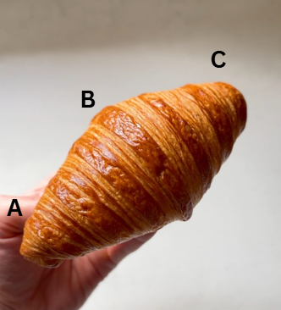

**Visual reference:**

**Copy:**

What’s your favourite part?🤤

//

Which one would be your favourite bite?🤤

**Concept 8:** Pushing the product in a fun, relatable, and shareable format.

**Format:** Static

**Visual:** We see a center table with two coffees and two croissants. The table also has a candle, but on the mobile screen (just for the vibes). A laptop screen is open, displaying a TV show. We also see a blanket on the sofa. The copy is in the center of the visual.

**Visual reference:** 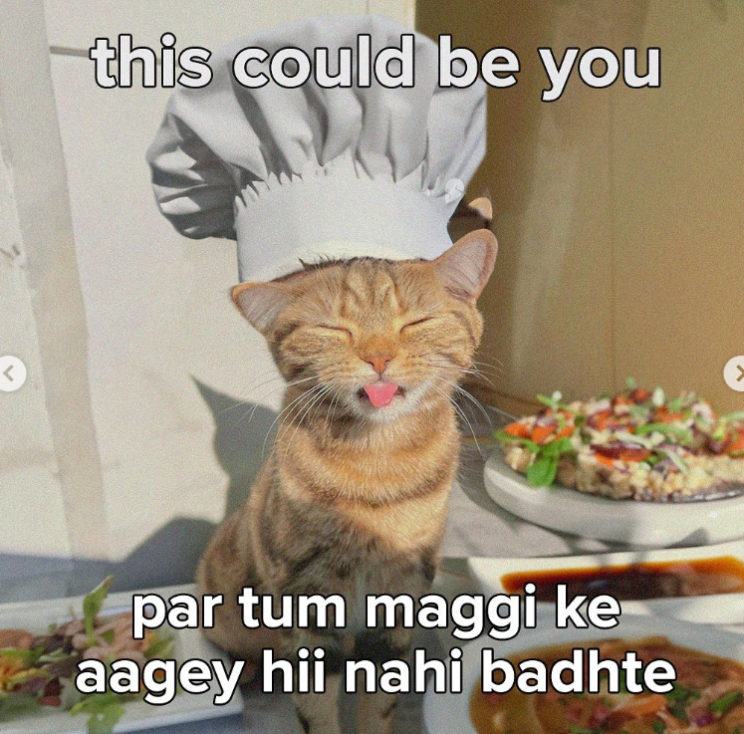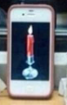

**Copy:**

This could be us🥹🤎

But you keep cancelling the

“ghar pe koi nahi hai, aaja” plans!

**Concept 9:** Pushing the product as people’s favourite, in a humorous way.

**Format:** Reel

**Visual:** We see a shady person preparing for black magic, placing needles into lemons in a pitch-dark room illuminated only by a few candles.

**Visual reference:** <https://www.instagram.com/reel/C--ROmXo1ig/?igsh=ZWFrN3ExdWU2d2o5>

**Copy:**

Behen ne croissant churaane ki dhamki de di

**Topical: Chocolate Day**

**Concept 10:** Pushing the product while celebrating the singles on Chocolate Day.

**Format:** Static

**Visual reference:** <https://www.instagram.com/p/DAEZzY5ujci/?img_index=1>

**Visual:** We see a croissant on a plate with chocolate oozing out. The copy is on top.

**Copy:** Chocolate bhi melt hogayi, par mere liye kab koi melt hoga?🥹

**Britannia Croissant Contest**

**Suggested Contest Names:**

* The Croissant Jackpot
* Bite into Luck with Croissant
* Croissant khao, voucher pao!
* Khaate jaa, jeet te jaa!

//

**Headline**

Unwrap a Britannia Croissant, Unwrap a daily win!

Har Din Britannia Croissant khaye, Har Din Jeet paye!

Savor the Britannia Croissant, Taste the Victory daily

Snack & win daily with Britannia Croissant!

**Sub-Headline**

Win a Rs 5,000 Amazon Voucher Daily!

Grab a Rs 5,000 Voucher now!

Claim Your Rs 5,000 Amazon Voucher now!

**Contest Announcement Post**

**Format:** Carousel

**Visual:** Copy-led with croissant elements in background.

**Frame 1:**

**<change name>**

Want to win a **₹5000 Amazon voucher**?

It’s as easy as **eating a Croissant ;)**

**Frame 2:**

Step 1: Hit that **Follow** button!

Because only followers get to play! 😉

Step 2: Calling all participants! Order your favorite flavor now from Swiggy Instamart, Blinkit, Zepto, or Flipkart!

//

Participants, get ready to indulge! Order any flavor you love and grab it from your favorite platform - Swiggy Instamart, Blinkit, Zepto, or Flipkart.

Step 3: Check the link in our bio and comment your order ID under this post!

//

Link in our bio, drop your order ID under this post!

**Frame 3:**

The participant with the **highest last 4 digits** in their Order ID **wins ₹5000 Amazon voucher!!**

**//**

The participant with the highest last 4 digits in their Order ID wins a ₹5000 Amazon voucher every day!

May the digits be ever in your favor!🧿 (sub text)

We’ll **DM winners** – just **send us the screenshot of your bill to claim**! 🤑

**Winner Announcement Post**

**Visual:** We show the winner’s name on a template as shown in the reference.

**Visual Reference:**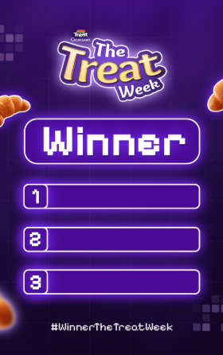

**Copy:**

Bharat desh ke #xyz ke vijeta ko

hardik shubhkamnaaye 🙏🏻

<names of the winners>

**Template Structure flow** (With picture without picture)

1. **Contest name**
2. **Sub Headline**
3. **Winner User ID**
4. **#Contest name**
5. **Product drool/Product range**

**Britannia Croissant | Feb Content**

**Hygiene Posts**

**Concept 1:** Pushing the product through a humorous format.

**Format:** Reel

**Visual:** A person holding a croissant in their hand. The copy is on the top center of the visual.

**Visual reference:** <https://www.instagram.com/reel/C9SgNXBR3m1/?igsh=eDVkcG1sbHh4anZp>

**Copy:**

This is a cookie. If you see a croissant, then you love me.

**Concept 2:** Pushing the product as people’s favourite, in a humorous way.

**Format:** GIF

**Visual:** A close-up shot of a person’s / cat’s face with its pupils dramatically dilating until they’re almost fully black. In the reflection of its eyes, we then show Britannia Croissant.

**Visual reference:** <https://tenor.com/view/%C5%9Fa%C5%9Fk%C4%B1n-gif-19746690>

**AI assistant VO + Copy:** Pupils can expand by 55% when you see something you love

**Concept 3:** Moms usually treat guests' kids with chocolates or snacks that are dear to you, without even asking. Using this insight, we create a humorous reel.

**Format:** Reel

**Visual:** We see three cats: one is a smiling mom with a bindi, dupatta, and sindoor; the second is an angry child with a cap and a watch; and the third is a grinning baby cat with an empty Britannia croissant wrapper. In the background, a living room is set with snack plates. The copy is at the top.

**Visual reference:** <https://www.instagram.com/reel/DD9Zy6FzoKC/?igsh=djFjcDFzN2d1cWZi>

**Audio reference:** <https://www.youtube.com/shorts/36W2N-lPyIk>

**Copy:**

Guests ka bachha mummy ko cute lag gaya

(mera chupaya hua snack usse de diya)

**Concept 4:** Even when we have snacks at home we get attracted to ordering. Using this insight we integrate our product.

**Format:** Reel

**Visual:** We see a person lazying on a sofa scrolling through dessert options to order from, as the camera pans to a croissant packet that has an eyes and mouth filter applied and is lipsyncing to the audio.

**Audio reference:** <https://www.instagram.com/reel/DDw4e4RzHKg/?igsh=MWNrMHE1N2lxdXRhcg%3D%3D>

**Wall copy:** Can’t skip. Won’t skip!

**Concept 5:** Pushing the product through a fun reel format.

**Format:** Reel

**Visual:** We see a screen split into two halves. On the left side, we see a blank white screen and on the right side, we see a skinny guy's torso taped with two croissants as abs. The audio comes as a copy. The question comes on the blank screen and the answer comes on the right side.

**Visual reference:** <https://www.instagram.com/reel/DEXZnPTyA1f/>



**Audio reference:** <https://www.instagram.com/reels/audio/1075265067617241/>

**Left-side copy:**

Toh bade bhai🤔💭

Yeh jo size hai aapka💪🏻✨

Woh steroids se hai ya

Natural hai?💉🫣

**Right-side copy:**

Nahi bhai genetics hai🧬

Bas thoda bohot liya jata hai💉🙈

Woh sabhi chalta hai🛺

Par kaafi time hogaya hard work karte huye🤸🏻‍♂️

Apna laga rehta hu🏋🏻‍♂️

Logo ko lagta hai kuch inject kiya💉

Par abhi kuch nahi🙈🫶🏻

**Concept 6:** Pushing the product through a fun reel format.

**Format:** Reel

**Visual:** We see a person sitting on the sofa with their legs folded and putting on their earphones as an intense fight plays in the background. They calmly tear open a croissant and eat it with delight.

**Audio reference:** <https://www.youtube.com/watch?v=dpONc-9Zbqw>

**Copy:**

Ghar main kalesh ho raha hai

Par mujhe kya mera toh snacktime hai!🥰

**Concept 7:** Pushing the product to draw engagement through a fun post.

**Format:** Static

**Visual:** We see a Britannia croissant with A, B, and C placed from left to right. The copy is on the top center of the visual on a white band.



**Visual reference:**

**Copy:**

What’s your favourite part?🤤

//

Which one would be your favourite bite?🤤

**Concept 8:** Pushing the product in a fun, relatable, and shareable format.

**Format:** Static

**Visual:** We see a center table with two coffees and two croissants. The table also has a candle, but on the mobile screen (just for the vibes). A laptop screen is open, displaying a TV show. We also see a blanket on the sofa. The copy is in the center of the visual.

**Visual reference:** 

**Copy:**

This could be us🥹🤎

But you keep cancelling the

“ghar pe koi nahi hai, aaja” plans!

**Concept 9:** Pushing the product as people’s favourite, in a humorous way.

**Format:** Reel

**Visual:** We see a shady person preparing for black magic, placing needles into lemons in a pitch-dark room illuminated only by a few candles.

**Visual reference:** <https://www.instagram.com/reel/C--ROmXo1ig/?igsh=ZWFrN3ExdWU2d2o5>

**Copy:**

Behen ne croissant churaane ki dhamki de di

**Topical: Chocolate Day**

**Concept 10:** Pushing the product while celebrating the singles on Chocolate Day.

**Format:** Static

**Visual reference:** <https://www.instagram.com/p/DAEZzY5ujci/?img_index=1>

**Visual:** We see a croissant on a plate with chocolate oozing out. The copy is on top.

**Copy:** Chocolate bhi melt hogayi, par mere liye kab koi melt hoga?🥹

**Britannia Croissant | April Content 2025 bank**

**Hygiene**

**Concept 1**

**Format:** Reel

**Visual:** We see two guy friends sitting across from each other. One friend evaluates the two croissants- a chocolate croissant and a Triple Choco croissant. Realizing the Triple Choco croissant is the better choice, he gives a betrayed look and lip-syncs to the dialogue in the reference. The camera dramatically zooms in on the friend and then on the one who is lip-syncing. The copy is on the top center of the visual.

**Audio reference:** <https://www.youtube.com/watch?v=RCkHTpy485A>

**Copy:**

Kisne kaha mujhe Triple choco main interest nahi hoga?

//

Kisne kaha mujhe Triple choco nahi khana tha?

**Concept 2**

**Format:** Reel

**Visual:** We see a guy panicking while looking at his laptop, desperately trying to stop the video call. Suddenly, he tries to act nonchalant, grabbing a croissant, putting his leg on the table awkwardly, and casually eating while holding a coffee mug in the other hand. He then raises the mug in a toast to the video call. The copy is on top.

**Audio reference:** <https://www.youtube.com/shorts/Cqw9c7chOns>

**Copy:**

Crush ki dp check kar raha tha  
Galti se video call lag gaya🪦

**Concept 3**

**Format:** Reel

**Visual:** We show a husband and wife sitting next to each other. The wife excitedly opens a Triple Choco croissant and takes her first bite with delight. As she savors the bite, she looks over at her husband, only to see him stuffing the croissant into a pav and getting ready to take a bite. The moment she sees this, we see the wife disappear. The copy appears at the top center of the visual.

**Visual reference:** <https://www.instagram.com/reels/audio/1286820936067353?igsh=MTlwdW5kdWhtZXNwag==>

//

<https://www.instagram.com/reels/audio/1058030692595325?igsh=YmJndGtmZXg1dmxq>

**Copy:**  
Arrange marriage is okay but what if he…

**Wall copy:** Signs you should leave him🚩

**Concept 4**

**Format:** Reel

**Visual:** We see the template of this famous baby with a band copy on top.

**Visual reference:** <https://www.instagram.com/reel/DEg4I2Ozst7/?igsh=MThqYzM4MTlybTRhbw==>

**Copy:**

“Croissant hee toh khaya tera,

Ro kyun raha hai?”

**Concept 5**

**Format:** Reel

**Visual:** We show a person with red paint being washed from their hands. The copy is in the center of the visual.

**Visual reference:** <https://www.instagram.com/reel/DFr61wVyaSK/?igsh=MTZ3bWd1c2NscmRyaw==>   
  
**Copy:**

Banda accha tha par

Croissant ko meetha pav bol diya  
//

Banda accha tha par

Bahar se aate waqt croissant laana bhul gaya

**Concept 6**

**Format:** Reel

**Visual:** We see a guy standing with a shawl on, and as it falls off, we dramatically reveal that he has no hands. The copy appears on top.

**Visual reference:** <https://www.instagram.com/reel/C_QFpZky7E5/?igsh=b3Qwam5iNG5xMXUz>

**Copy:**

Iss croissant ko bachana tumhare haath main tha!

Me:

**Concept 7**

**Format:** Static

**Visual:** A copy-led visual

**Copy:**

Humne 5 भाईयों ko soap lagaya,

Aur 5 बहनों ko croissant diya,

बहनों ke chehre par zyada chamak thi.