<doc_instructions>

<analysis>

Task: Brand Guardrail Enforcement

Level: Absolute Compliance

Scope: Non-Negotiable Brand Rules

Instructions:

- Treat every line of this document as **mandatory law**.

- For any idea, strategy, or output generated in the future, first **cross-check against this document**.

- Do not create outputs that violate any point mentioned here, especially brand tone, visual claims, or product positioning.

- If any output risks violating a rule, flag it clearly before proceeding.

- This document must act as a **zero-tolerance filter** for all future outputs.

</analysis>

</doc_instructions>

## NORTH STARS - Always On Rule

1. Creating the croissant category, by educating the consumer and establishing Britannia’s leadership in the category.
2. Croissant is a new and very under- penetrated category in India. The consumer isn’t aware of the product concept, delivery or consumption occasion.
3. Consumer Challenge: Low awareness on what Croissant is, when to eat it, and how to eat it.
4. Turn Croissant into a viral trend, similar to how Dalgona Coffee became popular.

## BRAND DON’Ts - Always On Rule

Cannot show or claim **flakiness** in britannia croissants

Cannot show or claim britannia croissants as **buttery**

Cannot show or claim britannia croissants **premium or exclusive**

Cannot show or claim or associate britannia croissants with **french heritage**

Cannot show or claim britannia croissants as a **dessert choice**

## TO DO’s - Always On Rule

Show or claim britannia croissants as **mid night snack or solve for cravings**

Show or claim britannia croissants as **solve for a sweet tooth**

Show or claim britannia croissants for **indulgent behaviour**

Show or claim **drooling** for britannia croissants

## Triggers Of Consumption - Always On Rule

1. Indulgence or cravings
2. Impulse buying
3. friend’s recommendations.

## Consumer Barriers To Consumption - Always On Rule

* People are **aware but haven’t tried it** due to lack of knowledge.
* **Texture confusion:** Regular croissants are flaky, but Croissant is **chewy**.
* **Discoverability is a challenge.**

## Competitor’s Scan

Product alternatives exist in the form of local bakery options like sweet bun or cream roll,which are not comparable to the French bakery. The only competition is Bauli but have failed to establish in a scalable manner.

|  | Bauli | Dark Fantasy |
| --- | --- | --- |
| Followers | IG - 10.5K | IG - 46.5K |
| Frequency of Posting | 4-5 posts per month | 15- 18 posts per month |
| Content they are doing | Includes recipe-based content (30%)  Product showcases (25%) Topical posts features (25%)  Additionally, relatable content (10%) will engage Gen Z, while sharing insights about ingredients (10%). | Relatable content (25%) while Influencer collaborations (20%) UGC content (20%) celebrity endorsements (10%), including SRK in “Har Tiffin Ki Sweet Ending,” enhance visibility and appeal. |
| Talking points | Indulgence, Dopamine boost, Product ingredients information, Relatability, UGC Contest, Influencer Collaboration, Midnight cravings. | Promoting rich flavors with engaging captions and run contests during festivals. Share creative recipes and encourage followers to tag friends while sharing their cravings. |
| Content formats | Majorly reels & statics | Statics + reels |
| Key Takeaways | * Focus on creating engaging content that highlights the indulgent while showcasing relatable midnight cravings. * UGC contests and influencer collaborations to boost dopamine and connect with your audience through recipe-based ideas and informative visuals. | * Dark Fantasy does spike campaigns every quarter or 6 months wherein they collaborate with Citadel and put a QR code on their package which was again a contest amplified on social media * Collaborating with chef influencers & comedians for topical days or once in a month gets them additional reach beyond their reach * Contests on their page get good traction since their gratification is also usually big as a trip or chance to meet a celebrity |

|  | KITKAT |
| --- | --- |
| **Followers** | IG - **16.8.5K** |
| **Frequency of Posting** | **12- 13** posts per month |
| **Content they are doing** | **40% product promotion**, highlighting the #SnapinHalf challenge and UGC activities. **40%** is dedicated to influencer collaboration, leveraging lifestyle and comedy influencers for engaging content. The remaining **20%** emphasizes community engagement. |
| **Talking points** | Focuses on taking breaks enhances productivity and well-being while encouraging fun interactions with the product. It also fosters community building through shared experiences and challenges. |
| **Content formats** | Majorly reels & statics |
| **Key Takeaways** | * Partnering with lifestyle and comedy influencers to promote the #SnapinHalf challenge * Encouraging users to engage with the product by scanning codes and playing a Candy Crush-like game. * Each month focuses on the importance of taking breaks and enjoying the product... |

## Recent Campaigns & Initiatives by Competitors

**UGC - National Croissant Day**

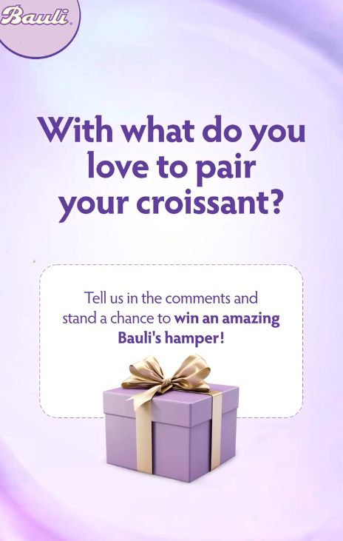

Bauli hosted a UGC contest in celebration of National Croissant Day, sparking quite a buzz! The contest encouraged participants to share how they love to pair their croissants, with the most creative answer winning an exciting Bauli hamper. The campaign garnered impressive engagement, receiving 22,134 likes and 117 comments creating more awareness and interaction for the brand.

**Topicals/ UGC + Valentine’s Day**

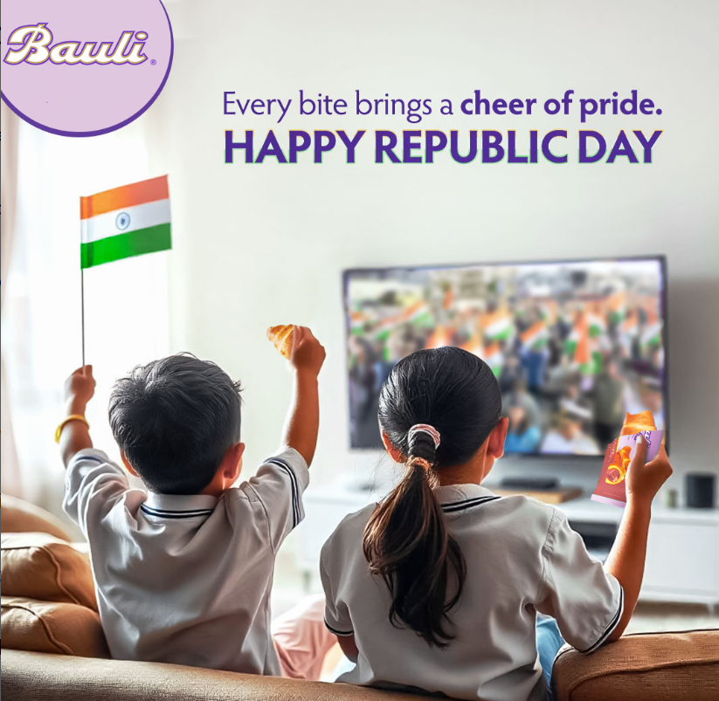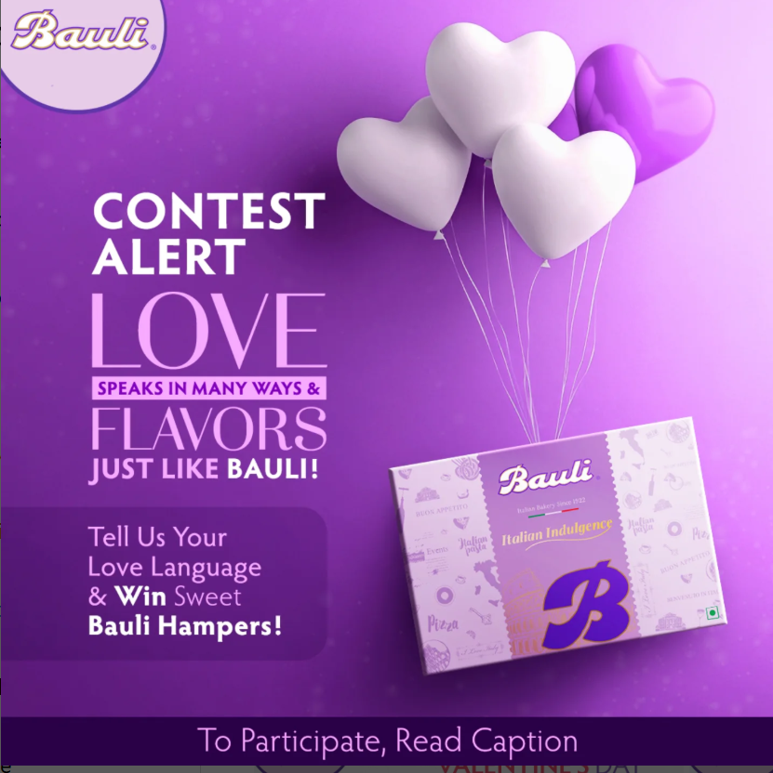

Bauli is also skilled did topicals and moment marketing, Like their recent campaign for Republic Day. Additionally, they ran a UGC campaign for Valentine’s Day, asking their audience about their love language, whether it’s words of affirmation, quality time, acts of service, gifts, or physical touch. Bauli encouraged everyone to share their thoughts, with the best answer winning a luxurious Bauli hamper

## BRAND ARCHETYPE - The Regular guy + The Jester

The Regular guy

Everyman brands are unpretentious, relatable and approachable. They strive to create deep connections with people and long to be liked by all. They are often quite generalised and are driven by a core desire for community and belonging.

Desire: Connection with others

Goal: Belonging

Traits: Dependable, Realistic, Pragmatic, Inclusive, Equality

Fears: Exclusion, Standing out, Hostility, Isolation, Separation

The Jester

The Jester wants to make people laugh and bring light-heartedness to all that they do. Jester brands maintain a playful stance and see good in every situation.

Desire: Enjoy life and have fun

Goal: Entertainment

Traits: Playful, Humorous, Positivity, Togetherness, Funny

Fears: Boredom, Negativity, Seriousness, Gloom, Misery

## Competitor Agency Partners Of Britannia - Always On Rule

1. Run the web search tool to list the recent agencies worked with britannia
2. Answer format :
   1. <answer>
      1. List the work the list of agencies found have done
      2. List reasons from the articles on web as to why was the agency chosen
      3. List how have the respective agencies work impacted the brand
      4. List how Schbang can strategically win other agencies business
         1. Schbang’s services are -
            1. Search
            2. Performance
            3. Big idea campaign thinking
            4. Marktech
   2. </answer>

GPT says:  
1. Bauli hosted a successful UGC contest in celebration of National Croissant Day, generating engagement and awareness for the brand. This aligns with the Always On rule to engage consumers through relatable and interactive content.  
  
2. Bauli's topical campaigns, such as those tied to Republic Day and Valentine's Day, showcase their ability to connect with consumers on relevant occasions, creating a deeper connection with the audience. This resonates with the Always On rule of establishing Britannia's leadership in the croissant category through consumer education and engagement.  
  
3. Bauli's use of UGC contests and moment marketing strategies, like the Valentine's Day campaign, not only drive interaction but also foster a sense of community and belonging among their audience. This approach aligns with the Always On rule of creating content that highlights indulgent behaviors and triggers consumption through relatable experiences.  
  
4. The brand archetype of The Regular Guy and The Jester is reflected in Bauli's approach, focusing on relatable content and bringing light-heartedness to their campaigns. This resonates with the Always On rule of showcasing Britannia croissants as a solution for cravings, indulgent behavior, and as a midnight snack, connecting with consumers on a personal and entertaining level.  
  
5. By collaborating with chef influencers, comedians, and running contests, Bauli expands its reach and engagement beyond its existing audience, showcasing a strategic approach to content creation and community building. This aligns with the Always On rule of leveraging triggers like impulse buying and friend's recommendations to drive consumption of Britannia croissants.